

Firmware Version: | 2.55rc515
Published Date: | 2010/07/27

Content:
Upgrading Instructions: 2
Upgrading by using Web-UI 2
New Features: 2
Changes of MIB & D-View Module: 2
Problems Fixed: 3
Known Issues: 3
Related Documentation: 3

Revision History and System Requirement:
Firmware Version | Date | Model | Hardware Version
2.55rc515 | 2010/07/27 | DWL-3200AP | B1, B2

Upgrading Instructions:
D-Link AP supports firmware upgrading via Web-UI. You may download the firmware from D-Link web site http://tsd.dlink.com.tw.

Upgrading by using Web-UI
- Connect a work station to the LAN port of Access Point.
- Open the web browser of work station and entering the IP address of the AP. The system
default IP address is 192.168.0.50.
- Enter administrator’s username and password, user name is “admin” and leave
the password field blank by default.
To update the AP's firmware, click Maintenance > Firmware and SSL Certification Upload

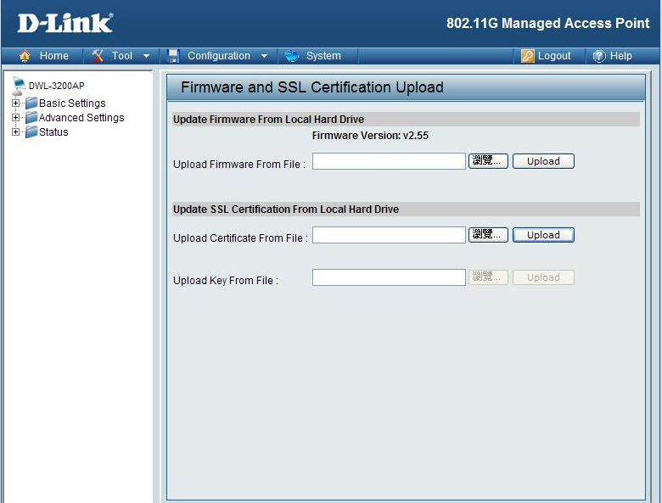

New Features:
- [SNMP] Reveal/Set the login username & password for telnet/WEB via SNMP.
- [F/W] Enable/Disable the Web Management via CLI.
- Add Internal station connection by SSID.
- Support DosKey(compatible with PUTTY in Linux/Windows OS).

Changes of MIB & D-View Module:
None

Problems Fixed:
Firmware Version | Problems Fixed
V2.55 | - [FW] When AP mode is WDS with AP or WDS, some of the traps can't be received.  - [Web] Remove the extra item of internal station connection.  - [web] Limit invalid MAC addresses in MAC address filter.  - [FW] When domain name's length is 64,there will show some unnecessary message in DHCP client  - [FW] The "Internal Station Connection" function, after reboot the function will change to enabled  - [Web] Limit invalid MAC addresses in WDS MAC & DHCP MAC.  - [Web] Limit the first byte of WINS and DNS to 1-223.  - [Web] Disable Ethernet to WLAN Access error;  - [SNMP] User can input empty string.

Known Issues:
Firmware Version | Known Issues
V2.55 | None

Related Documentation:
- DWL-3200AP User Manual v2.50

