DWR-925W user manual

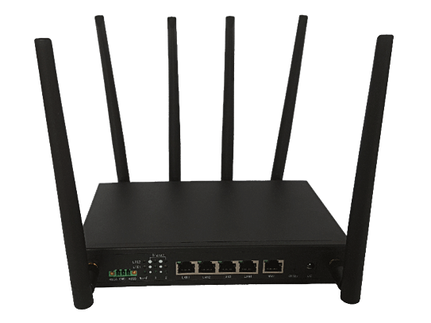
Table of Contents
1. Starting Setup in the Web UI 8
2. button 8
3. Status 9
3.1. Basic Info 9
3.2. Device Info 9
3.3. Clients List 10
3.4. Routing Table 10
4. Network 11
4.1. Lan 11
4.2. Wan 11
4.2.1 lan mode 11
4.2.2 WAN mode 11
4.2.3 DHCP 12
4.2.4 Static IP 12
4.2.5 PPPoE 12
4.3. WLAN 13
4.3.1 2.4G WLAN 13
4.3.2 5G WLAN 16
4.4. 3G/4G Modem 18
4.4.1 Summary Info 18
4.4.2 Edit modem config 20
4.4.3 Edit modem bridge config 21
4.5. Dns 21
4.6. Link Backup 21
4.6.1 Summary Info 21
4.6.2 Edit link backup config 22
4.7. Load Balance 23
4.7.1 Summary Info 23
4.7.2 Edit Load Balance config 23
4.8. DHCP Server 25
4.8.1 static ip for devices. 25
4.8.2 Custom dhcp server info 25
5. Applications 26
5.1. ICMP Check 26
5.2. Ddns 27
5.3. DTU 28
5.3.1 Dtu server work mode 28
5.3.2 Dtu client work mode 30
5.4. Timing Task 32
5.5. SMS 33
5.5.1 Inbox 33
5.5.2 Outbox 33
5.5.3 New Message 33
5.6. Data Cap 34
5.7. USSD 35
6. VPN 36
6.1. VPND 36
6.1.1 pptp or l2tp entry 36
6.1.2 Add tunnel entry 36
6.1.3 View tunnle entry 37
6.2. Tunnel 38
6.3. IPsec 39
6.3.1 View ipsec entry connect status 39
6.3.2 add ipsec entry connect status 40
6.4. OpenVpn 44
7. Forward 46
7.1. nat 46
7.1.1 view info 46
7.1.2 Add DNAT 46
7.1.3 Add SNAT 47
7.2. Routing 48
7.2.1 view info 48
7.2.2 Add Static Route 48
7.2.3 Add Policy Route 48
7.3. RIP 50
7.3.1 View RIP Info 50
7.3.2 Add Neighbor 50
7.3.3 Add Network 50
7.4. OSPF 52
7.4.1 View OSPF Info 52
7.4.2 Add OSPF Network 52
7.4.3 Add OSPF Neighbor 53
7.4.4 Add OSPF Interface 53
7.5. Qos 54
7.5.1 View Qos Info 54
7.5.2 Add Qos Entry 54
8. Security 56
8.1. IP Filter 56
8.1.1 View Filter Info 56
8.1.2 Add Filter Entry 56
8.2. Domain Filter 58
8.2.1 View Domain Filter 58
8.2.2 Add Domain Filter 58
8.3. MAC Filter 59
8.3.1 View MAC Filter 59
8.3.2 Add MAC Filter 59
8.4. DDOS 59
9. Management 60
9.1. Local Log 60
9.2. Remote Log 61
9.3. NTP Server 61
9.3.1 Enable ntp system time 61
9.3.2 Enable manual system time 62
9.4. Service Control 64
9.5. Account 64
9.6. Diagnostics 65
9.7. Upgrade/Settings 65

Starting Setup in the Web UI
It is easy to configure and manage the DWR-925W with the web browser.
Step1. To access the configuration utility, open a web-browser and enter thedefault IP address
http://192.168.0.1in the web address field of the browser.

After a moment, a login window will appear. Enter admin for the User Name and Password, both in lower case letters. Then click the Log In button or press the Enter key.
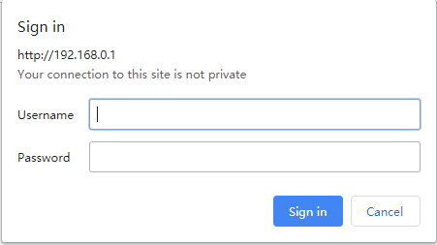

Figure 1-1 Login Window

Default IP Address: 192.168.0.1
Default User Name: admin
Default Password: admin

button

Object | Description
Add | Add entry or config info.
Mod | Edit config
Del | Delect entry
View | View status
En | Enable this function
Dis | Disable this functon
Enable | Enable this function
Disable | Disable this functon

Status

Basic Info
On this page, you can view information about the Internet status of the DWR-925W, include modem1 modem 2, lan,wan information.
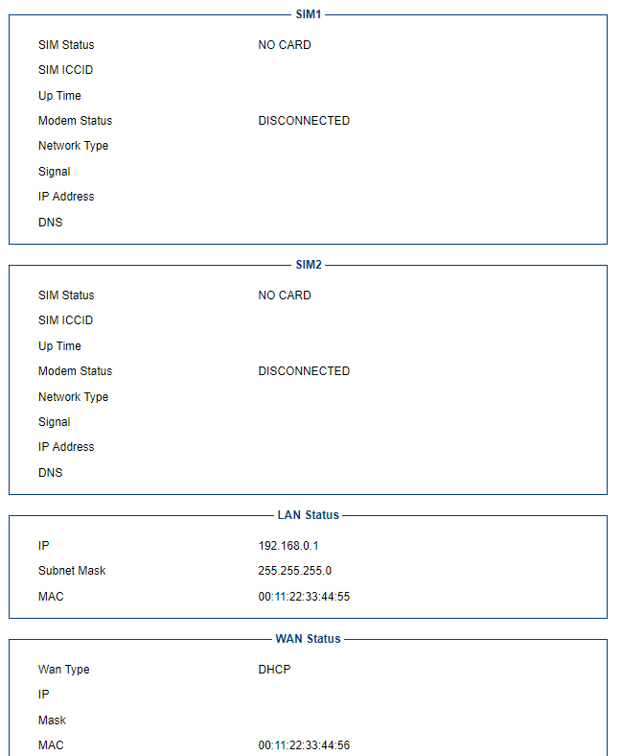

Device Info
You can view base information about DWR-925W.
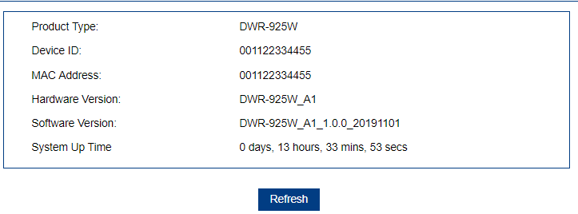

Clients List
This page shows the IP addresses and host names of all the PCs in your network
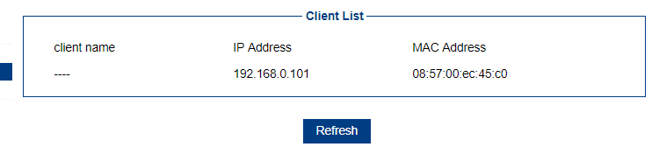

Routing Table
This page shows the system route info , include manual configuration static route and policy route

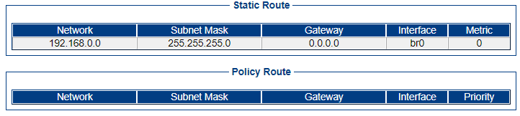

Network

Lan
On this page, you can configure the local network for router.
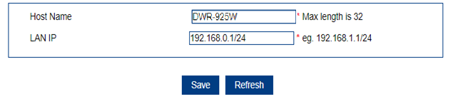
Object | Description
Host Name | Router show host name inf dhcp.
LAN IP | Local network.

Wan
On this page, you can configure the parameters of the WAN interface.
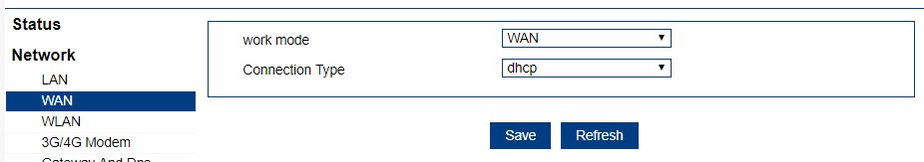

lan mode
When select lan mode, the wan port will work as a lan port. And select wan mode , you can configure
Dhcp , pppoe ,static ip for wan port.
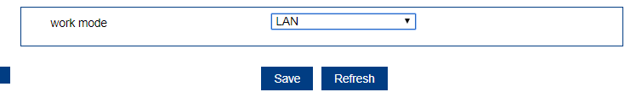

WAN mode
wan connection can be configured as difference mode, such as
DHCP router mode, PPPoE router mode, Static router mode, this will more helpful for user to meet different environment usage.

DHCP
Choose “DHCP” and the router will automatically obtain IP addresses, subnet masks and gateway addresses from your ISP.
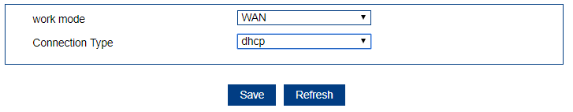

Static IP
If your ISP offers you static IP Internet connection type, select “Static IP " and then enter IP address, subnet mask, provided by your ISP in the corresponding fields.
Note:primary DNS and secondary DNS information and gateway you need to separate configuration on menu of Gateway And Dns.
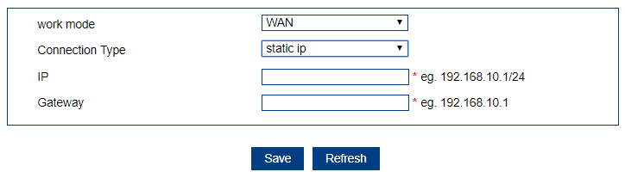

Object | Description
IP | Enter the WAN IP address/Subnet Maskprovided by your ISP. Inquire your ISP ifyou are not clear.
Gateway | Enter the WAN Gateway IP address provided by your ISP. Inquire your ISP ifyou are not clear.

PPPoE

Select PPPoE, if your ISP is using a PPPoE connection and provide you with PPPoE user name and password information.
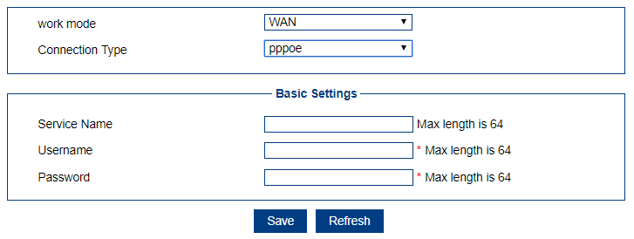

Object | Description
Username | Enter the User Name provided by your ISP.
Password | Enter the password provided by your ISP.
Service Name | Type the name of this router.

WLAN

2.4G WLAN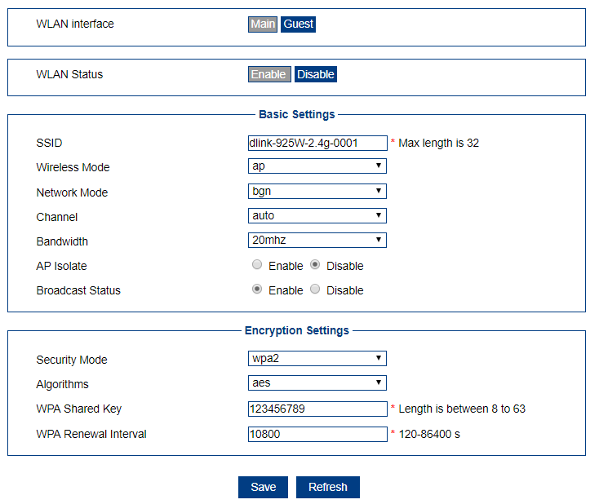
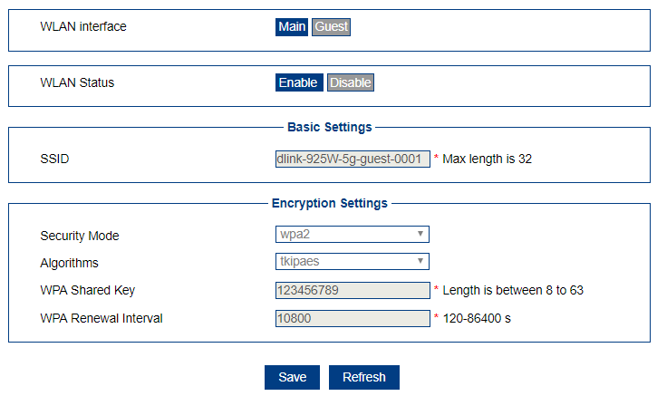
Object | Description
WLAN interface | You may choose to Main or Guest interface, If selecet Guest interface,the Channel, Wireless mode and Bandwidth must be the same as the Main interface
Enable | You may choose to enable or disable Wireless function.
SSID(Wi-Fi Name) | Set a name (SSID) for your wireless network. The ID of the wireless network. User can access the wireless network through it only. However, if you switch to Client Mode, this fieldbecomes the SSID of the AP you want to connectwith.  Default: DWR-925W-2.4G-XXXX  (“X” means the last 4 digits of the MAC address.)
Wireless Mode | Ap ,station or bridge mode.
Network Mode | IEEE 802.11 standardbgn ,bg, b
Channel | For an optimal wireless performance, you may select the least interferential channel. It is advisable that you select an unused channel or “Auto” to let device detect and select the bestpossible channelforyourwirelessnetworktooperateonfromthe  drop-down list.
Bandwidth | 20mhz or 40mhz
AP Isolate | isolate data between wifi 2.4g and 5g
Broadcast Status | Broadcast ssid
Security Mode | Select the security mode from the Security Mode dropdown list. There are 3 options in the Security Mode dropdown list:  - disable  - WPA  - WPA2
Algorithms | aes or tkip
WPA Shared Key | Enter the Wi-Fi password
WPA Renewal Interval | Key renew time

5G WLAN

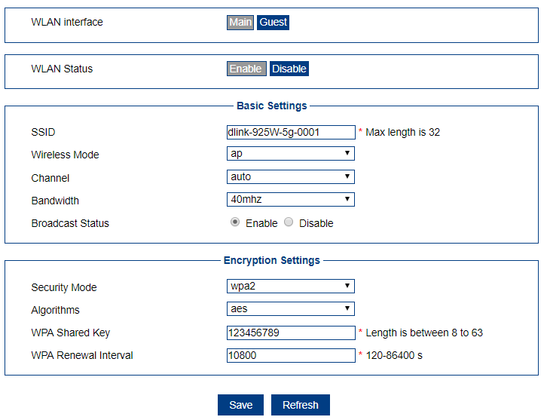

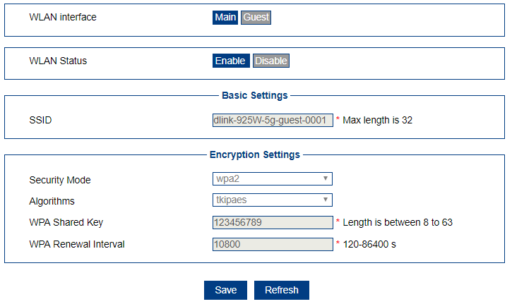
Object | Description
WLAN interface | You may choose to Main or Guest interface, If selecet Guest interface,the Channel, Wireless mode and Bandwidth must be the same as the Main interface
Enable | You may choose to enable or disable Wireless function.
SSID(Wi-Fi Name) | Set a name (SSID) for your wireless network. The ID of the wireless network. User can access the wireless network through it only. However, if you switch to Client Mode, this fieldbecomes the SSID of the AP you want to connectwith.  Default: DWR-925W-5.8G-XXXX  (“X” means the last 4 digits of the MAC address.)
Wireless Mode | Ap ,station or bridge mode.
Channel | For an optimal wireless performance, you may select the least interferential channel. It is advisable that you select an unused channel or “Auto” to let device detect and select the bestpossible channelforyourwirelessnetworktooperateonfromthe  drop-down list.
Bandwidth | 20mhz , 40mhz or 80mhz
Broadcast Status | Broadcast ssid
Security Mode | Select the security mode from the Security Mode dropdown list. There are 4options in the Security Mode dropdown list:  - wep  - disable  - WPA  - WPA2
Algorithms | aes or tkip
WPA Shared Key | Enter the Wi-Fi password
WPA Renewal Interval | Key renew time

3G/4G Modem

Summary Info
This page is used to configure the parameters for LTE network .
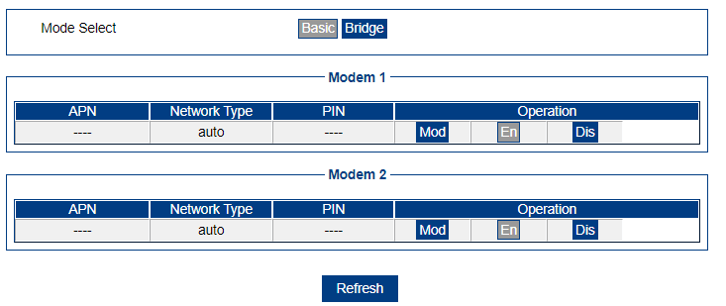

Edit modem config
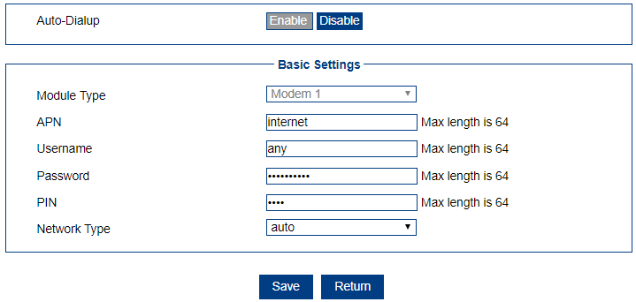
Object | Description
Enable | Enable or disabled mobile network
APN | Enter the APN from ISP. If not set ,system will try to auto get apn
Username | Enter the user name.
Password | Enter the password
PIN | If the SIM card has set PIN, please enter the PIN here.
Network Type | atuo ,lte, 3g,2g mode.

Edit modem bridge config
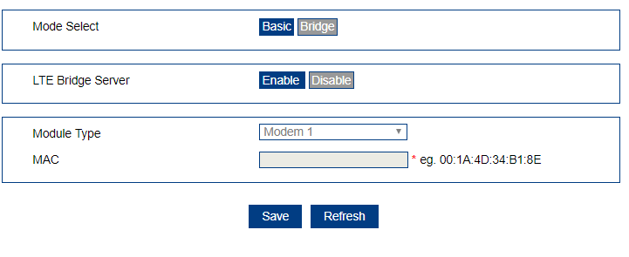
Object | Description
Enable | Enable or disabled mobile bridge network
Module Type | Which 4g interface is associated to select the bridge mode
MAC | The host Mac that needs to bridge the Internet, such as a PC, or a connected router

Dns
Select the system default gateway and dns infomation. This can manual setup static dns.
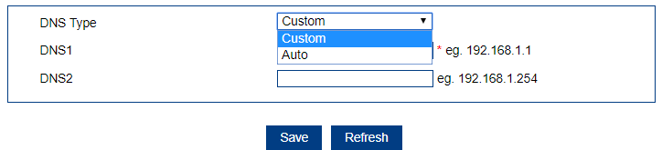
Object | Description
DNS Type | If auto , system dns will using default gateway wan’dns,  Custom will manual set system dns
DNS1 | Manual set system dns1
DNS2 | Manual set system dns2

Link Backup

Summary Info
This page is used to display status information for muti wan network link backup.
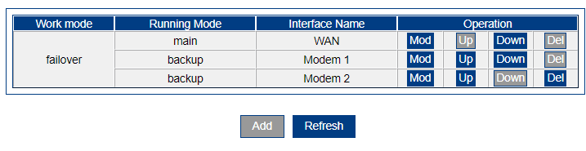

Edit link backup config
This page is used to configure the parameters for muti wan network link backup .

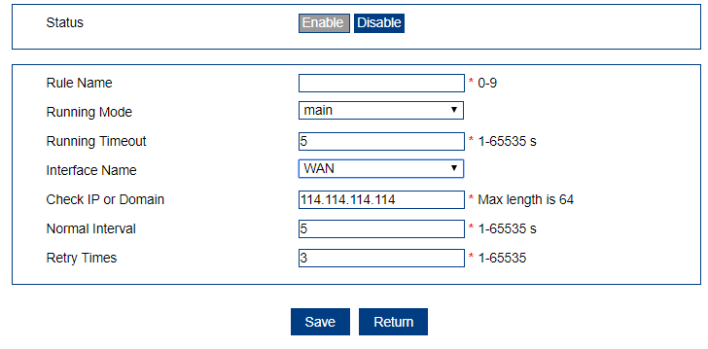
Object | Description
Rule name | Entry name.
Running Mode | Work as main or backup link.
Running Timeout | If the main link, the stable time of the main link; If for the backup link, said the link the shortest working hours.
Interface name | Which interface working
Check ip or domain | Icmp to check ip or domain
Normal interval | How long to a time
Retry times | Try fail times.

Load Balance

Summary Info
This page is used to display status information for Load Balanced.
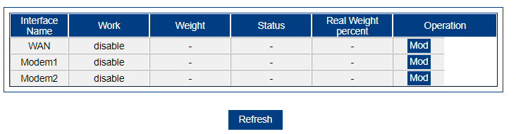

Edit Load Balance config
This page is used to configure the parameters for Load Balance config .

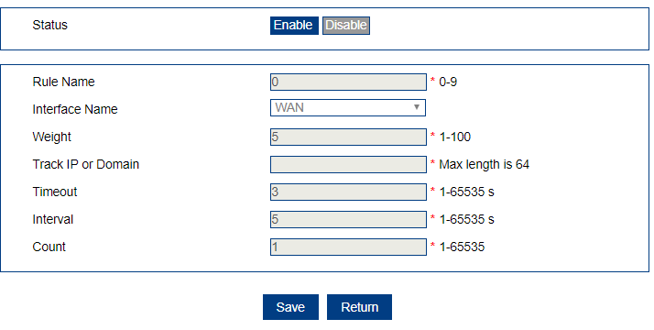

Object | Description
Status | Enable or disabled Current network interface load balanaced
Rule name | Entry name.
Interface name | Which interface working
Weight | Setting current network interface weight load balanaced
Timeout | If the main link, the stable time of the main link; If for the backup link, said the link the shortest working hours.
ip or domain | Icmp to check ip or domain
interval | How long to a time
Count | Try fail times.

DHCP Server

static ip for devices.

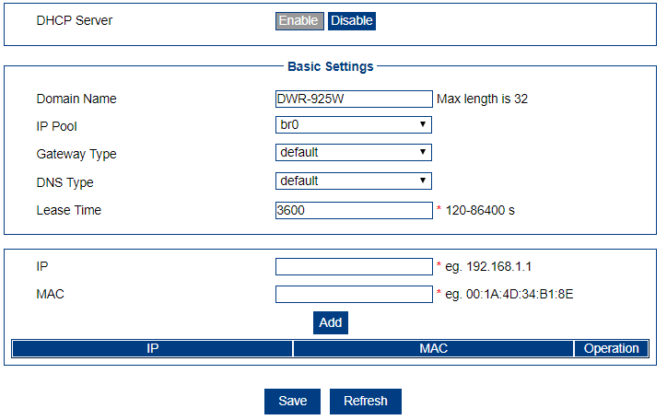

Object | Description
Ip | Ip binding to mac.
MAC | Device of this Mac will give static ip

Custom dhcp server info

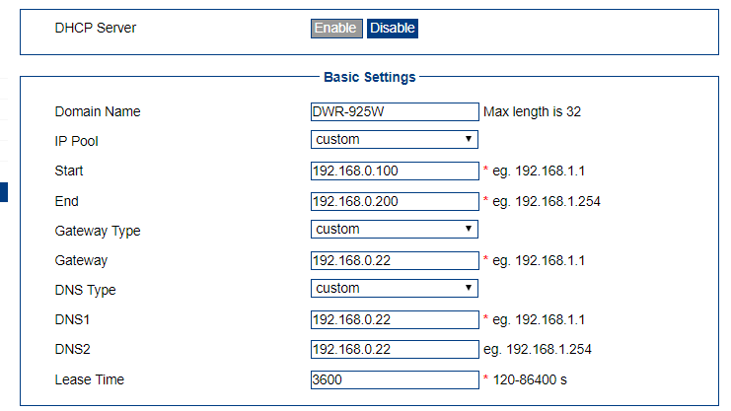

Object | Description
Ip Pool | custom
Start | Dhcp server pool start address
End | Dhcp server pool end address
Gateway Type | custom
Gateway | Dhcp Lease for devices gateway
DNS Type | custom
DNS1 | Dhcp Lease for devices dns
DNS2 | Dhcp Lease for devices dns
Lease Time | Dhcp lease time

Applications

ICMP Check

Icmp check network status and do action.
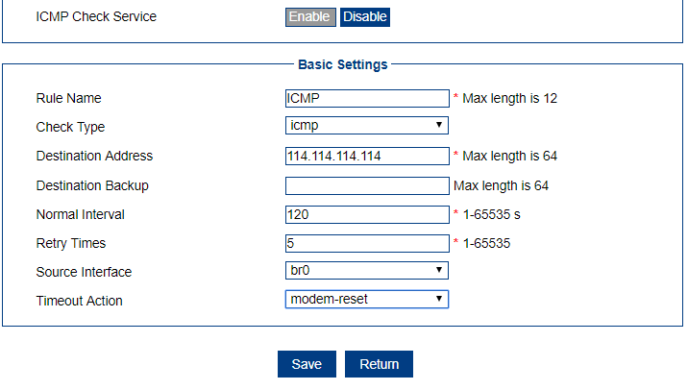
Object | Description
Rule Name | Entry name
Check Type | Icmp or domain
Destination Address | Ping main address
Destination Backup | If main address icmp fial , check backup address
Normal Interval | Ping period
Retry Times | Ping fail retry times
Source Interface | Check interface
Timeout Action | Executive action

Ddns
The dynamic DNS service allows a dynamic public IP address to be associated with a static
host name in any of the many domains, and allows access to a specified host from various
locations on the Internet.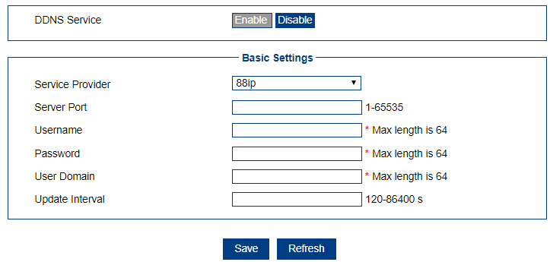

Object | Description
Service Provider | Select server from the drop-down list
Server Port | port
Username | Server login username
Password | Server login password
User Domain | Domain need to translate
Update Interval | Period time to update

DTU

Dtu server work mode
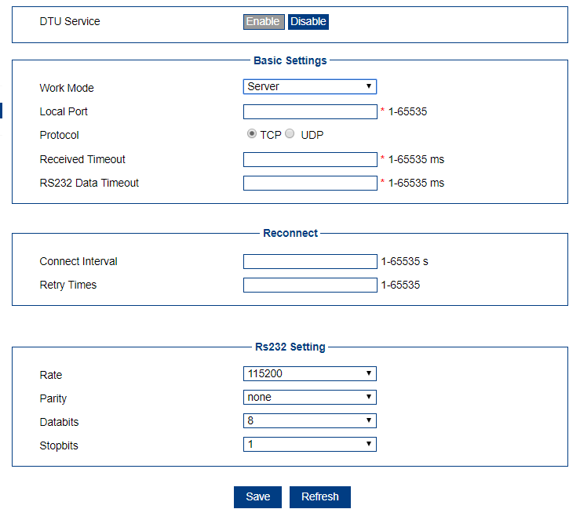

Object | Description
Work Mode | server
Local Port | Server work port
Protocol | Tcp or udp
Received Timeout | Data received timeout
RS232 Data Timeout | Serial port data received timeout
Connect Interval | Try interval time if fail.
Retry Times | Fail times
Rate | Serial port data rate
Parity | Serial port data parity
Databits | Serial port data databits
Stopbits | Serial port data stopbits

Dtu client work mode
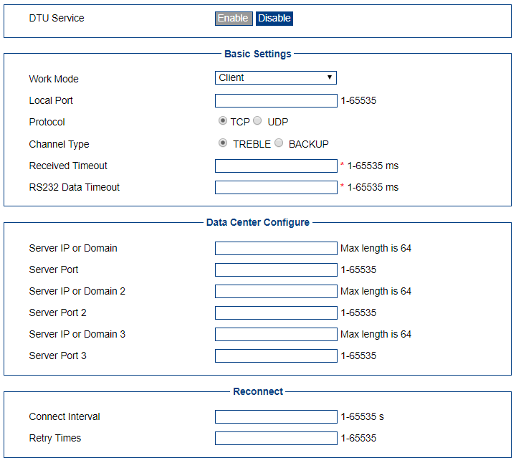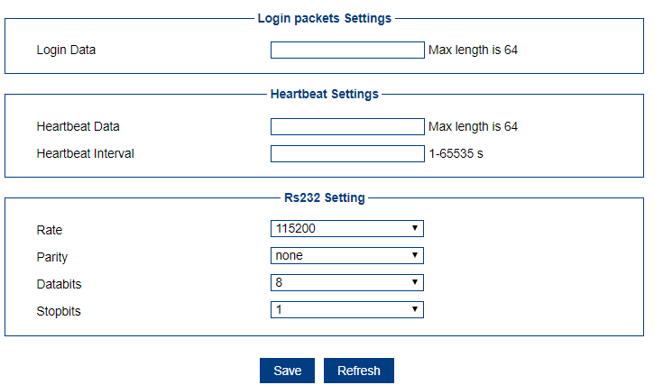
Object | Description
Work Mode | Client mode
Local Port | Client port
Protocol | Tcp or udp
Channel Type | Multi server type
Received Timeout | Data received timeout
RS232 Data Timeout | Serial port data received timeout
Server IP or Domain | Server 1 ip or domain
Server Port | Server 1 port
Server IP or Domain 2 | Server 2 ip or domain
Server Port 2 | Server 2 port
Server IP or Domain 3 | Server 3 ip or domain
Server Port 3 | Server 2 port
Connect Interval | Connect timeout
Retry Times | Fail retry times
Login Data | If server need login check
Heartbeat Data | Keep alive data
Heartbeat Interval | Keep alive time
Rate | Serial port data rate
Parity | Serial port data parity
Databits | Serial port data databits
Stopbits | Serial port data stopbits

Timing Task
This page is used to definition Timing task.
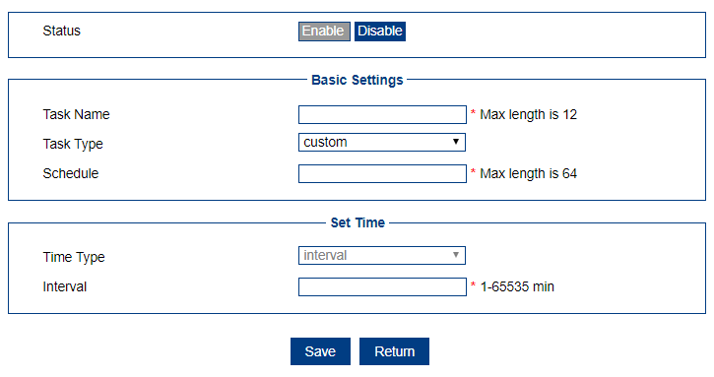

Object | Description
Task Name | name.
Task Type | Reboot or custom
Schedule | If select custom, manual set cmd to exc
Time Type | Time count
Interval | How many min will exc cmd

SMS

Inbox
This page is show inbox message for SMS.
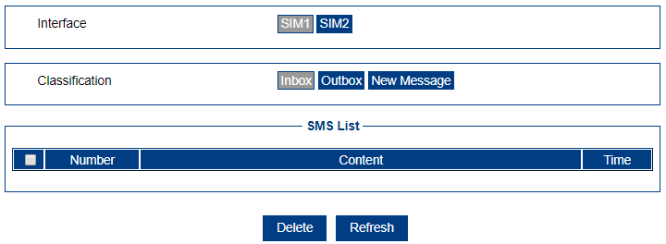

Outbox
This page is show Outbox message for SMS.
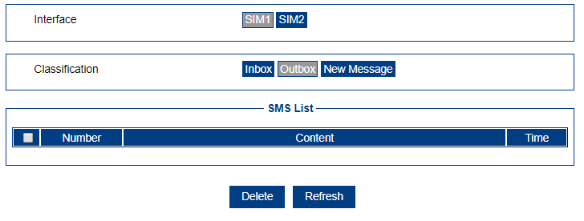

New Message
This page is send a new message for SMS.
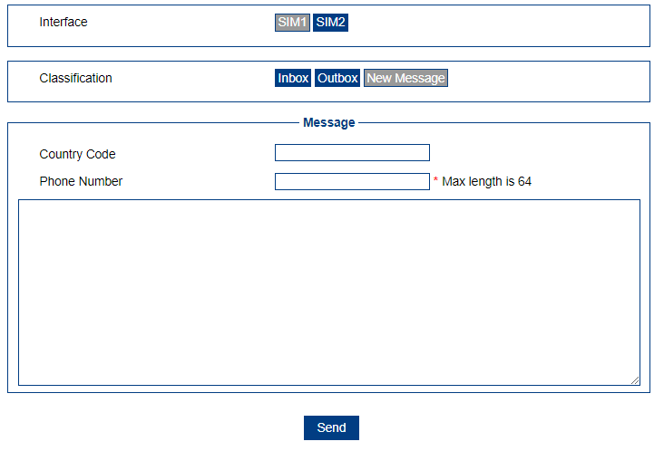

Object | Description
Country Code | Enter the country code.
Phone Number | Enter the phone number.
Text Area | Enter content in text area.

Data Cap
This page is used to definition Use Data cap.
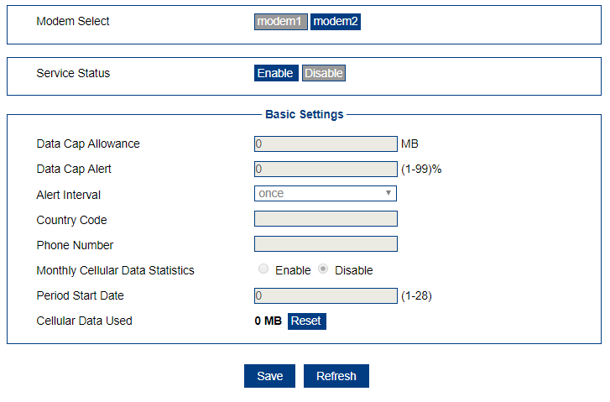

Object | Description
Data Cap Allowance | Enter the maximum allowable cap value
Data Cap Alert | Enter the maximum allowable cap percentage
Alert Interval | Select once,once a day and once a week for power on alert interval
Country Code | Enter the country code
Phone Number | Enter the phone number
Monthly Cellular Data Statistics | Enable or disable Monthly Cellular Data Statistics
Period Start Date | Which days for period start Date
Cellular Data Used | Show the Cellular Data Used, and reset the data

USSD
This page is used to definition USSD(Unstructured Supplementary Service Data Settings).

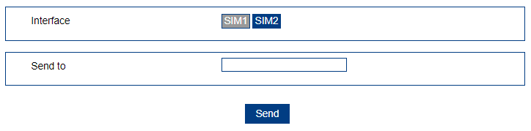

Object | Description
Send to | Enter the data for USSD

VPN

VPND

pptp or l2tp entry
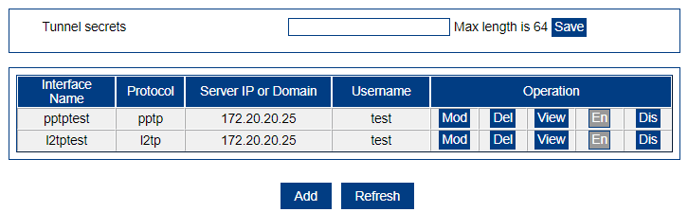

Add tunnel entry
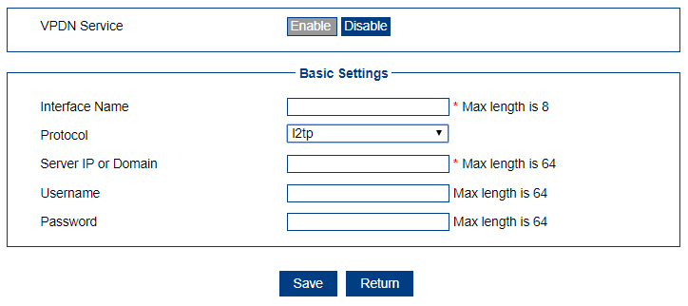
Object | Description
Interface Name | Name of entry
Protocol | L2tp or pptp option select.
Server IP or Domain | Peer ip or domain
Username | username
Password | password

View tunnle entry

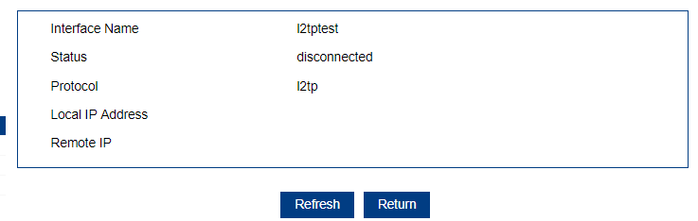
Object | Description
Interface Name | Entry name
Status | Disconnected or connected
Protocol | L2tp or pptp
Local IP Address | Local ip
Remote IP | Remote ip

Tunnel

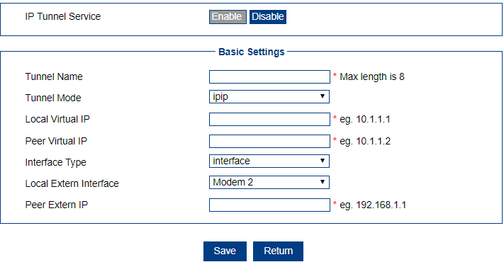

Object | Description
Tunnel Name | Entry name
Tunnel Mode | Ipip , gre ,grem
Local Virtual IP | Local network ip
Peer Virtual IP | Peer network ip
Interface Type | Static ip or interface
Local Extern IP | If select static ip ,manual setup wan ip. Else select which interface
Peer Extern IP | Peer wan ip

IPsec
Show ipsec config infomation

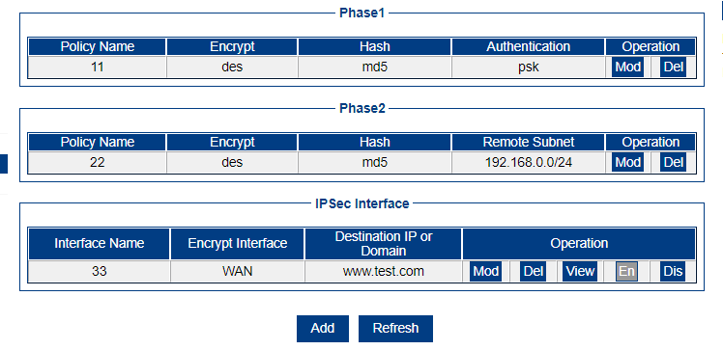

View ipsec entry connect status
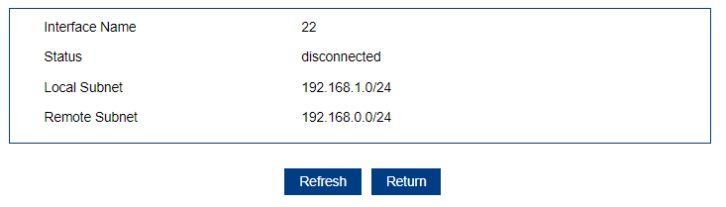
Object | Description
interfacel Name | Entry name
status | Connected or disconnected
Local subnet | Local network
Remote subnet | Peer network

add ipsec entry connect status
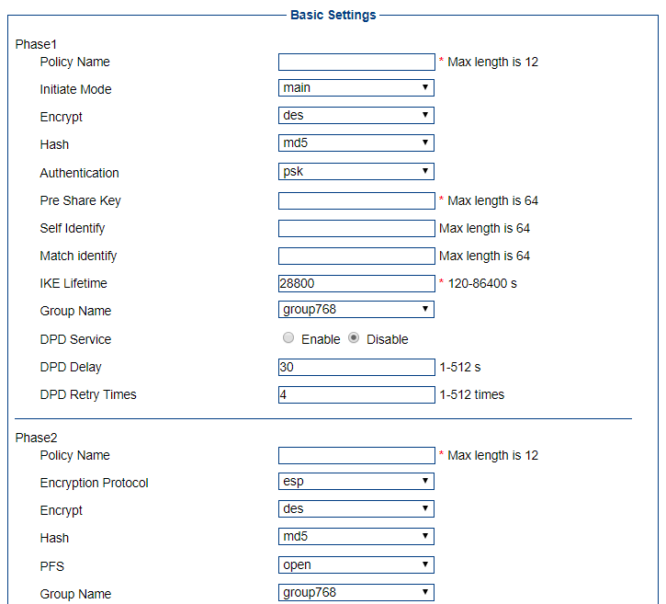
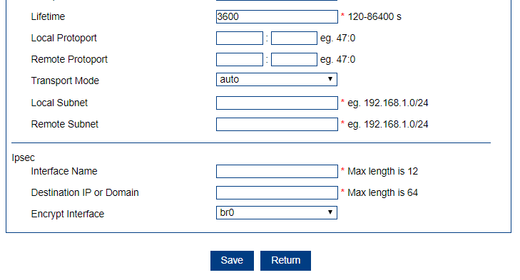

Object | Description
Phase1 | Show the phase1 parameter
Policy Name | Name of entry
Initiate Mode | Ipip , gre or grem tunnel mode
Encrypt | Select encypt type,des 3des aes256/192/128
Hash | Md5,sha1,sha2_256
Authentication | Static ip or interface , if static ip ,manual config option Local Extern Ip. If interface, need select which interface on option Local  Extern Interface.
Pre Share Key | Enter the pre share key
Self Identify | Enter the Self Identify
Match identify | Enter the match Identify
IKE Lifetime | Enter the IKE Lifetime
Group Name | Select group name
DPD Service | Enable or disable service
DPD Delay | Enter the delay
DPD Retry Times | Enter the retry times
Phase2 | Show the phase2 parameter
Policy Name | Name of entry
Encryption Protocol | Esp,ah ,ah+esp
Encrypt | des 3des aes256/192/128
Hash | Md5,sha1,sha2_256
PFS | Open or close
Group Name | Select group name
Lifetime | Enter the Lifetime
Local Protoport | Enter the local port
Remote Protoport | Enter the remote port
Transport Mode | Auto, transport, tunnel
Local Subnet | Enter the local subnet network
Remote Subnet | Enter the remote subnet network
Ipsec | Show the ipsec parameter
Interface Name | Name of interface
Destination IP or Domain | Enter the ip address or domain
Encrypt Interface | Select the interface

OpenVpn

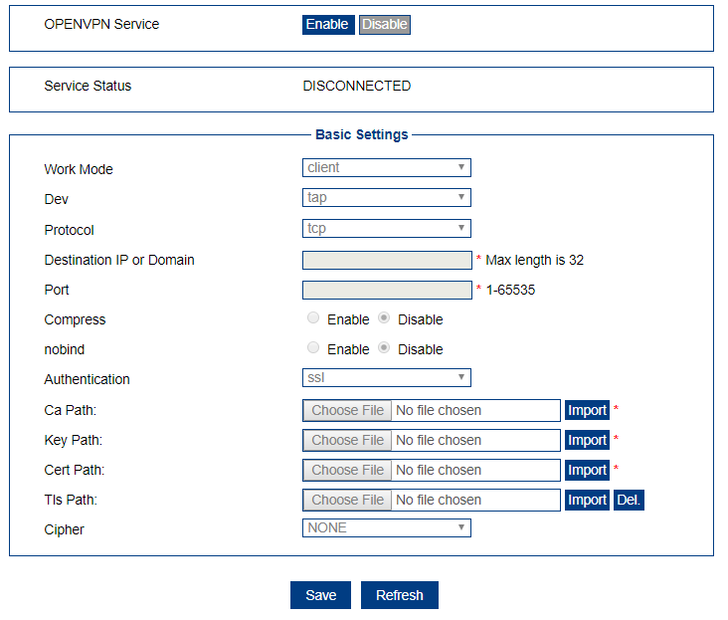

Object | Description
Openvpn service | Enable or Disable the openvpn service
Work Mode | client or multi
Dev | tap or tun,network interface type,tun(OSI Layer 3),tap(OSI Layer 2)
Protocol | tcp or udp
Destination IP or Domain | Enter the ip address or domain
Port | Enter the port
Compress | Enable or disable compress th data
nobind | Enable or disable specific local port
Authentication | ssl or text
Ca | Select a ca file to import ,if not
Key | Select a key file to import ,if not
Cert | Select a cert file to import ,if not
Tls | Select a tls file to import ,if not
Cipher | NONE,BF-CBC,DES-CBC,RC2-CBC,DES-EDE-CBC,DES-EDE3-CBC,DESX-CBC,RC2-40-CBC,CAST5-CBC,RC2-64-CBC,AES-128-CBC,AES-192-CBC,AES-256-CBC,SEED-CBC

Forward

nat

view info
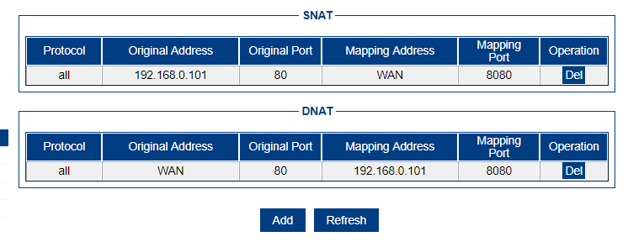

Add DNAT

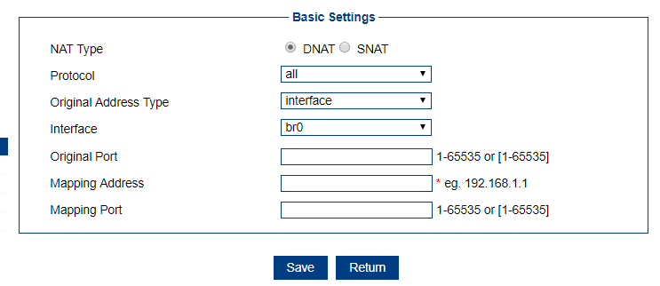

Object | Description
NAT Type | DNAT or SNAT
Protocol | all , tcp ,udp ,icmp
Original Address Type | Interface or static ip
Interface | tcp or udp
Original Address | Enter the original address for wan interface
Original Port | Enter the original port for wan interface
Mapping Address | Enter the mapping ip address
Mapping Port | Enter the mapping port

Add SNAT

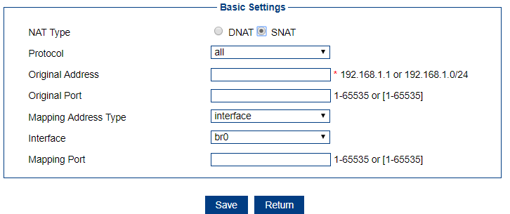
Object | Description
NAT Type | DNAT or SNAT
Protocol | all , tcp ,udp ,icmp
Original Address | Interface or static ip
Original Port | tcp or udp
Mapping Address Type | Select Interface or static ip
Interface | Select the interface
Mapping Address | Enter the mapping ip address
Mapping Port | Enter the mapping port

Routing

view info
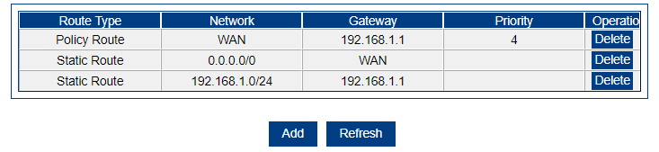

Add Static Route

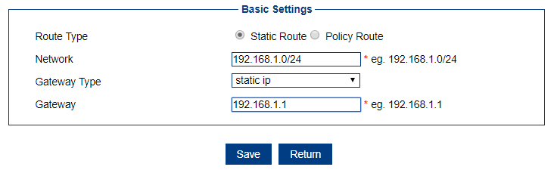

Object | Description
Route Type | Static Route
Network | all , tcp ,udp ,icmp
Gateway Type | Interface or static ip
Gateway | Ip address or interface

Add Policy Route

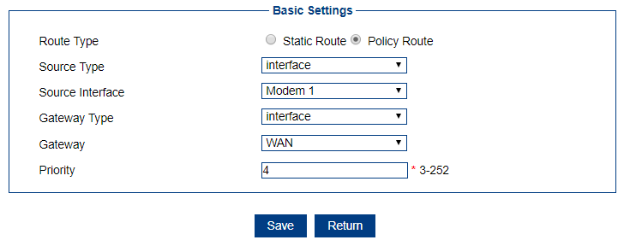

Object | Description
Route Type | Policy Route
Source Type | Interface or static ip
Source Interface | Interface
Network | Ip address
Gateway Type | Interface or static ip
Gateway | Interface or static ip
Priority | cost

RIP
Routing Information Protocol (RIP) is a standard for exchanging routing information between gateways and hosts. RIP is an interior gateway protocol.
Only exchange information with neighboring routers. If the communication between two routers does not pass through the other router, then the two routers are adjacent. The RIP protocol stipulates that no information is exchanged between non-adjacent routers.
● The information exchanged by the router is all the information known by the router. That is, its own routing table.
● Exchange routing information at a fixed time (for example, every 30 seconds), and then the router updates the routing table based on the received routing information.
The "distance" of the RIP protocol is also called "hop count" because the hop count is increased by 1 each time a router passes. RIP believes that a good route is that the number of routers it passes is small, that is, "short distance". RIP allows a path to contain up to 15 routers. Therefore, when "distance" is equal to 16, it is equivalent to unreachable. It can be seen that RIP is only suitable for small Internet.

View RIP Info
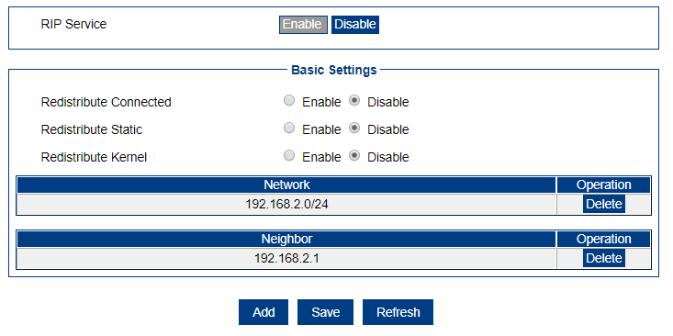
Object | Description
Redistribute Connected | Advertising direct connect routing information
Redistribute Static | Advertising static routing information
Redistribute Kernel | Advertising kernel routing information
Network | display configure direct connect network info
Neighbor | display configure neighbor router ip address

Add Neighbor

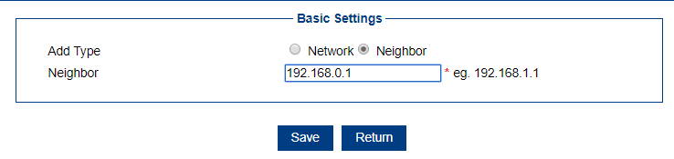
Object | Description
Add Type | Select network or Neighbor
Neighbor | Add a entry,for configure neighbor router ip address

Add Network

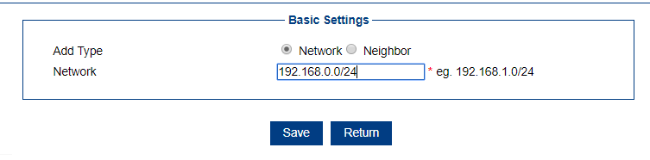
Object | Description
Add Type | Select network or Neighbor
Network | Add a entry,for configure direct connect network info

OSPF
The OSPF routing protocol is a typical link-state routing protocol. It is generally used in the same routing domain. Here, a routing domain refers to an autonomous system, which refers to a group of networks that exchange routing information with each other through a unified routing policy or routing protocol. In this AS, all OSPF routers maintain an identical database describing the structure of the AS. This database stores the state information of the corresponding links in the routing domain. The OSPF router calculates its OSPF routing table through this database.
As a link-state routing protocol, OSPF transmits Link State Advertisement (LSA) to all routers in an area. This is different from distance vector routing protocols. The distance vector routing protocol is to pass part or all of the routing table to its neighboring routers.

View OSPF Info

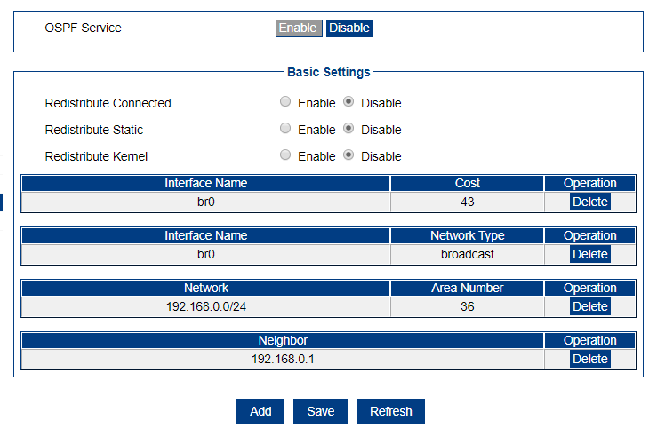
Object | Description
Redistribute Connected | Advertising direct connect routing information
Redistribute Static | Advertising static routing information
Redistribute Kernel | Advertising kernel routing information
Network | display configure direct connect network info
Neighbor | display configure neighbor router ip address

Add OSPF Network

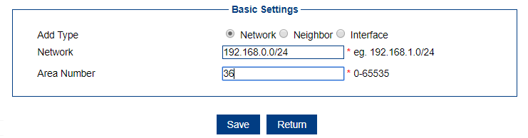

Add OSPF Neighbor
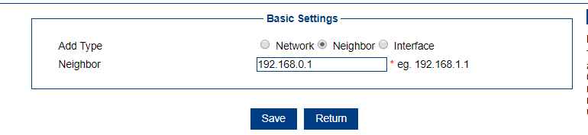

Add OSPF Interface
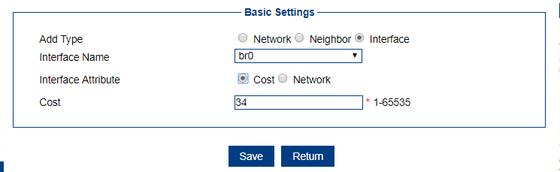

Object | Description
Add Type | Interface
Interface Name | Interface or static ip
Interface Attribute | Cost or network
cost | A cost value
Network Type | Broadcast,non-broadcast,point-to-multipoint,point-to-point

Qos

View Qos Info

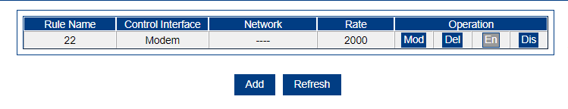

Add Qos Entry
Configure QoS rules to evenly allocate or prioritize bandwidth usage by certain Internet users.

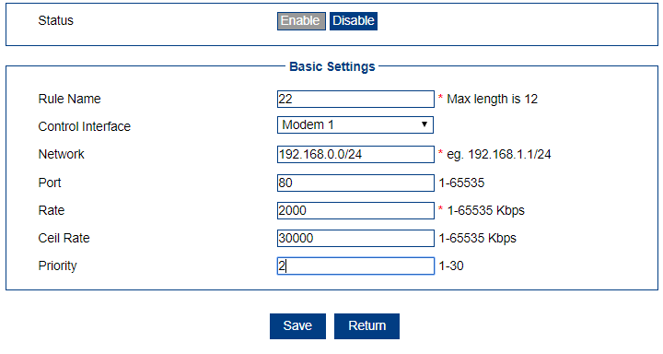

Object | Description
Rule Name | Enter a name for the service
Control Interface | Output data interface
Network | Enter the network mask
Port | Data port
Rate | Limit speed
Ceil Rate | Max buffer speed
Priority | The rule priority

Security

IP Filter

View Filter Info

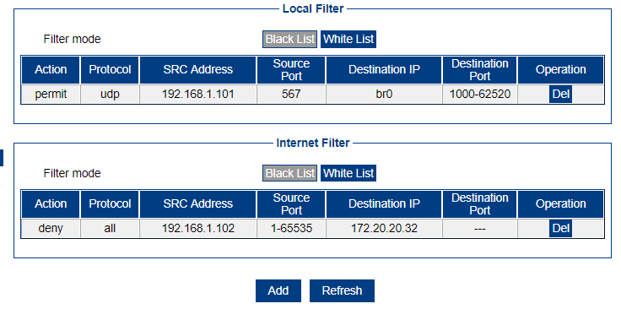

Add Filter Entry

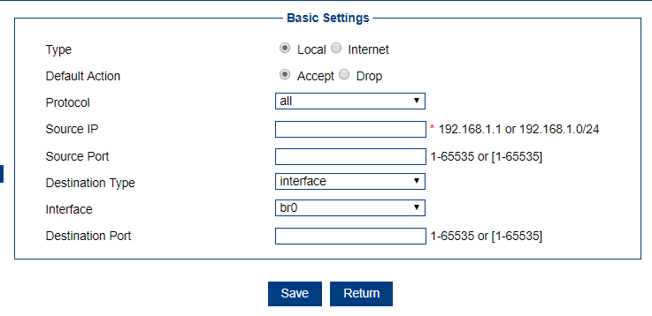

Object | Description
Type | Local or Internet
Default Action | Drop or Accept
Protocol | All, tcp,udp,icmp
Source IP | from ip
Source Port | From port
Destination Type | Interface or any
Interface | Data forward interface
Destination IP | to ip
Destination Port | To ip port

Domain Filter

View Domain Filter

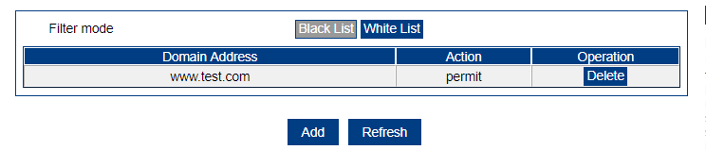

Add Domain Filter

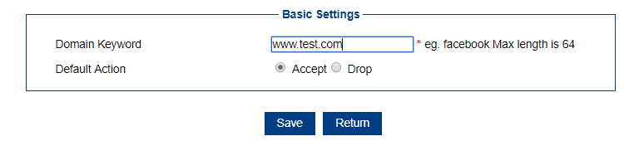

Object | Description
Domain Keyword | Domain string
Default Action | Accept or drop this domain

MAC Filter

View MAC Filter

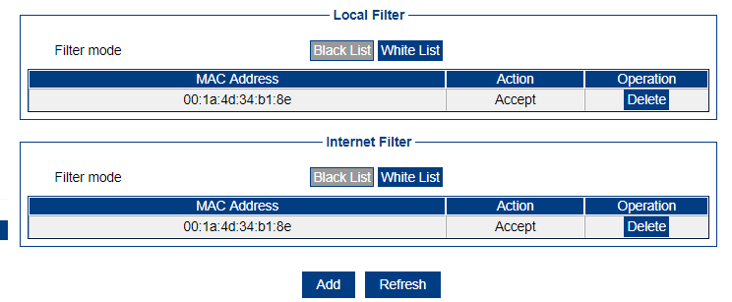

Add MAC Filter

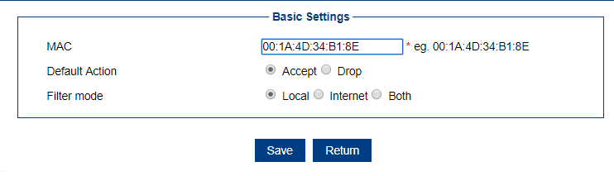
Object | Description
MAC | Select server from the drop-down list
Default Action | Accept or Drop
Filter mode | Local,Internet,Both

DDOS
The page is provides an anti-ddos attack function, which can control sync attacks and ping attacks functions.
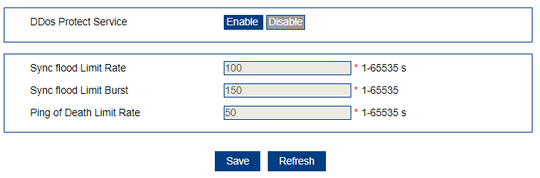
Object | Description
Sync flood Limit Rate | Select server from the drop-down list
Sync flood Limit Burst | Accept or Drop
Ping of Death Limit Rate | Local,Internet,Both

Management

Local Log

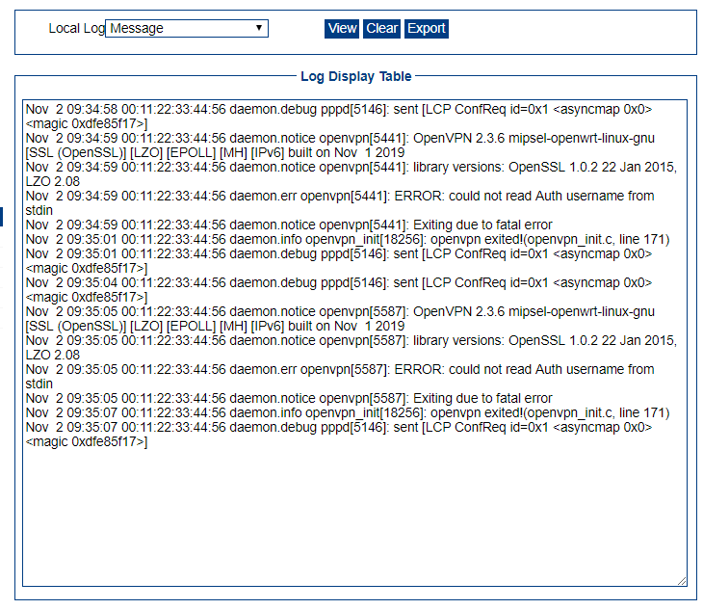

Object | Description
Local Log | Kernel,Application,Message
View | Show log
Clear | Clear log record
Export | Export log to save

Remote Log
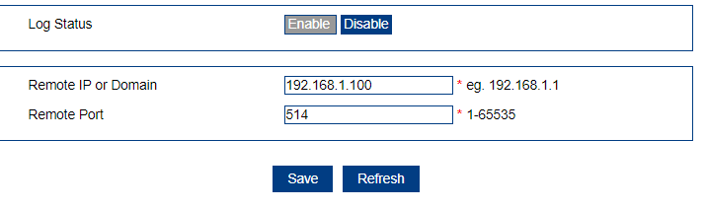

Object | Description
Log Status | Enable or disable “Logging to Syslog Server”
Remote IP or Domain | Syslog server IP address
Remote Port | Server port

NTP Server

Enable ntp system time

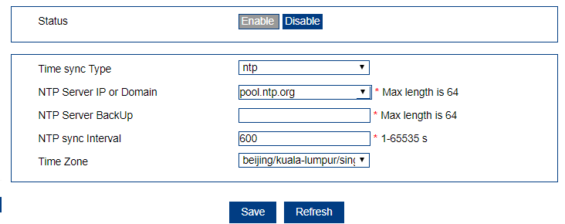

Object | Description
Time sync Type | Sync time from time server
NTP Server IP or Domain | First Time server
NTP Server BackUp | Swich to second time server when first time server sync fail
NTP sync Interval | How to get time from server
Time Zone | Fix time zone
Time Zone Number | If you select customer time zone , you can manual set time zone

Enable manual system time

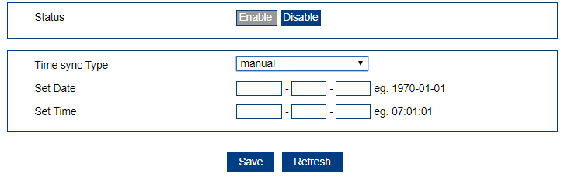

Object | Description
Time sync Type | Manual set system time
Set Date | Which date
Set Time | Which time

Service Control

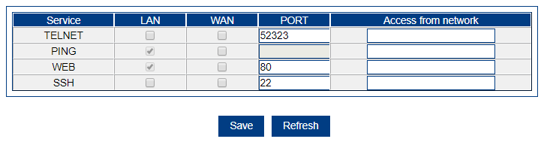

Object | Description
Service Type | The following services can be configured with access permissions
lan | Select to allow lan access
wan | Select to allowwan access
port | Enter the port to allow access
Access from network | Enter the ip to allow access, When multiple IP address are allowed, they can be separated by a separator character "/"

Account

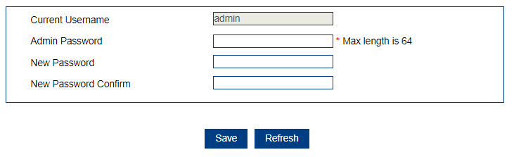

Object | Description
Account Type | Web login account
Current Username | username
Admin Password | password
New Password | New password
New Password Confirm | Confirm new password

Diagnostics

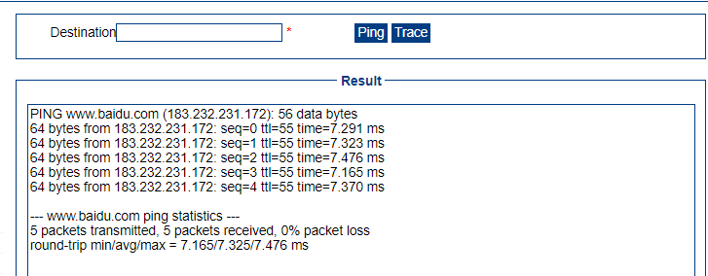

Object | Description
Destination | Ntp or manual
ping | Ping cmd to test network
trace | Trace cmd to test network
result | Show ping or trace cmd result

Upgrade/Settings

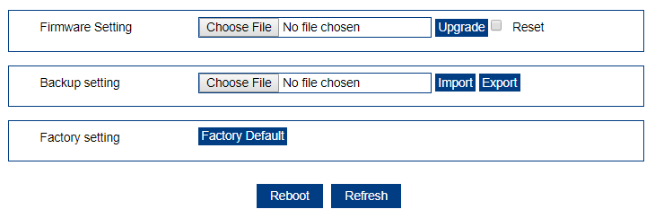

Object | Description
Upgrade | Click this button to start upgrade system
Select | Select the upgrade system bin file or config file
Reset | If select this option when upgrade system , syetem config will restore to factory.
Import | Import a backup config
Export | Export config to backup
Factory Default | Restore system config to factory mode
Reboot | Restart system

