Installation Introductions of DWM-15X series in Ubuntu System

The installation steps of DWM-156 in Ubuntu system are as follows.
- Plug the dongle with SIM card (disable the PIN code first) into the USB port of your computer.
1.1 Check the device with command:
ls /dev/sr*
【Return】
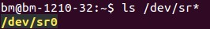

If the system returns as follows, it means the software has been installed before.

Uninstall it with command:
sudo dpkg –r 3g-modem-connection-dtlwg-d310a-i386

[Notice: the red one means the name of the software that has been installed.]

1.2 Mount.
Use command:
sudo mount /dev/sr0 /mnt
【Return】

1.3 Check the result of mount, using command:
cd /mnt
ls
【Return】
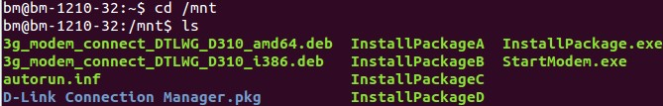

If the system returns as above, then succeed.

- Installation
Install the software with command:
sudo dpkg -i 3g_modem_connect_DTLWG_D310_i386.deb
[Notice: use 3g_modem_connect_DTLWG_D310_i386.deb in 32-bit system and 3g_modem_connect_DTLWG_D310_amd64.deb in 64-bit system]

【Return】
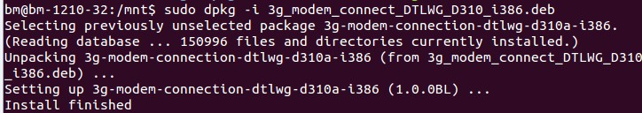

The installations are finished when system prompts “Install finished”.
3. Connect to the Internet
- Dial up
After you finished the installation, please replug the dongle, it will dial up automatically. The dial operation may continue for three minutes, please wait…
- Check the network is connected
You could open your browser, and view the webpage to check.

