**How to set port forwarding on DSR_500**

**[Topology]**:

**Server**(192.168.10.100)-----(192.168.10.1)**DSR-500N**(1.1.1.1)-------**PC**(1.1.1.100)

**[Firmware]:**

Firmware:1.0.1B60

**[Configuration]:**

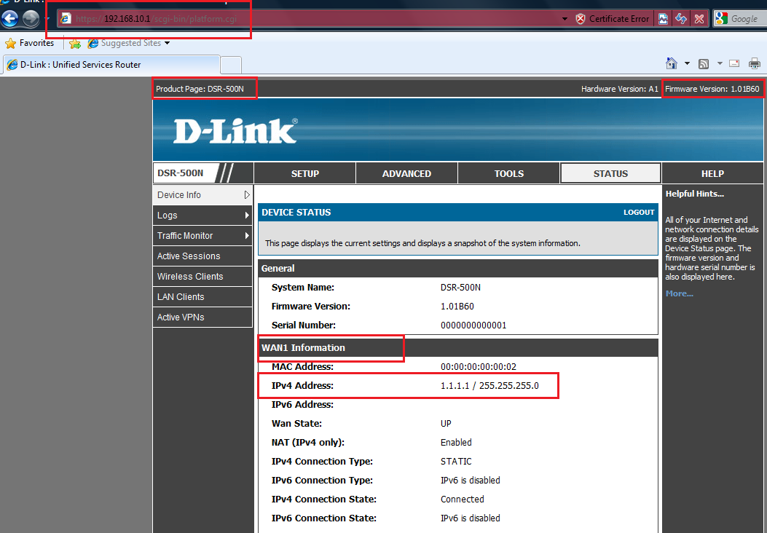

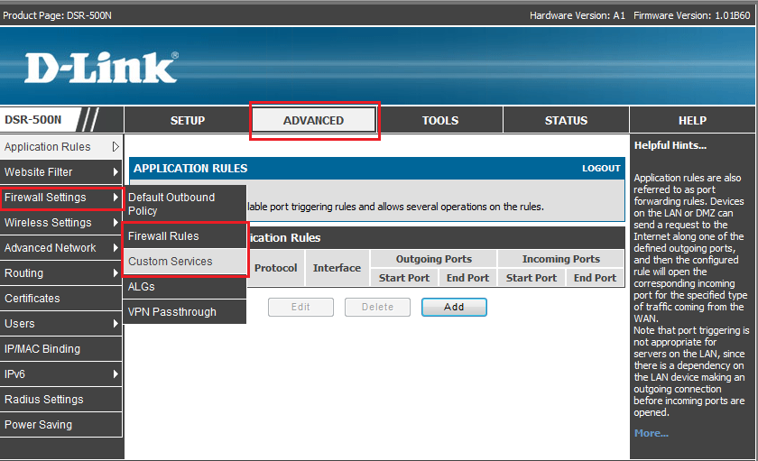

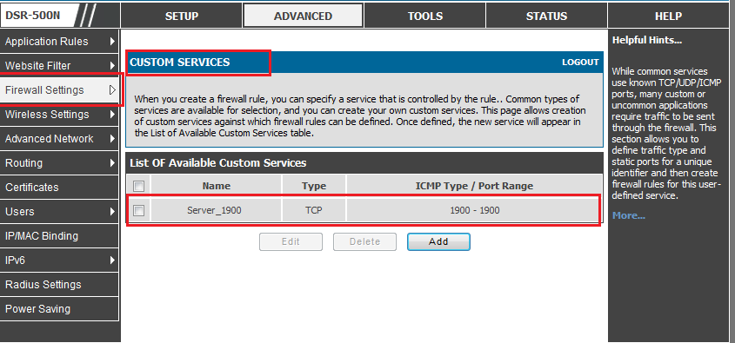

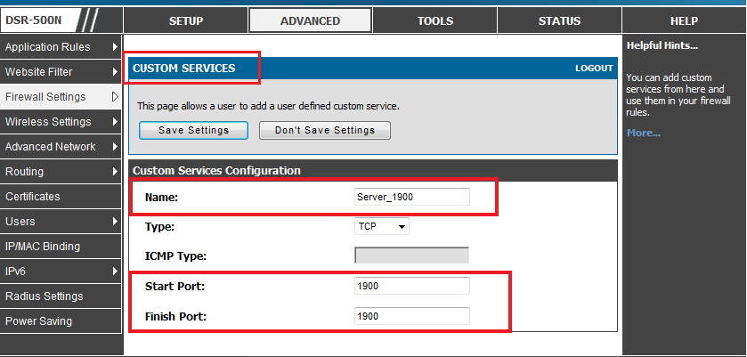

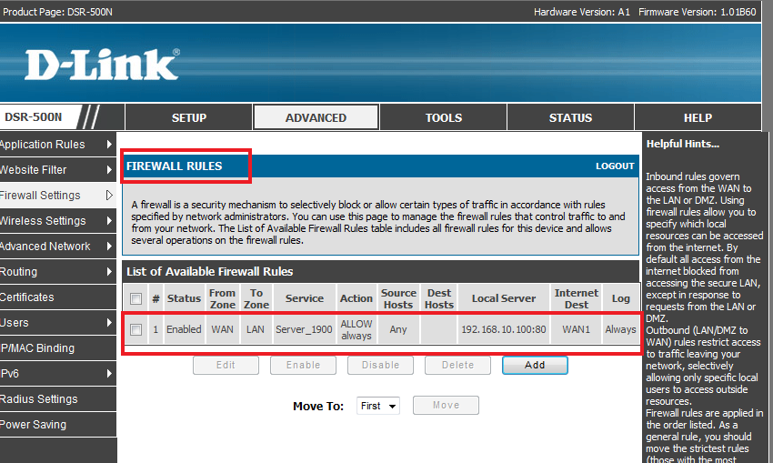

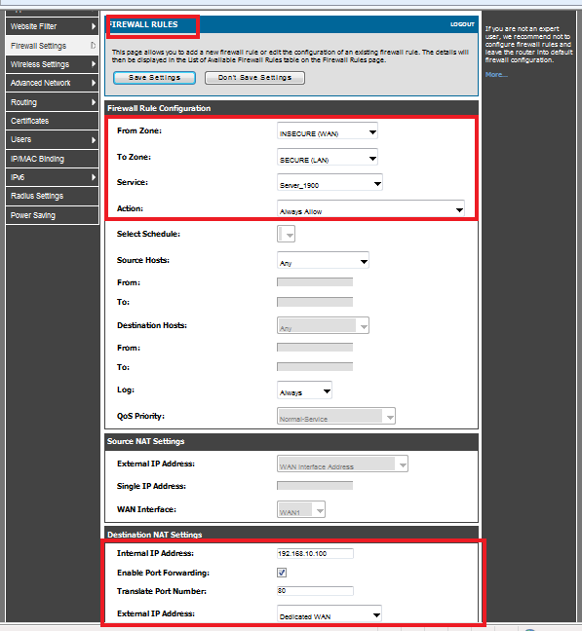

**[Testing result]:**

