How to use Application Control feature to block specific application?

[Topology]
Internet---(WAN)DSR-150N/250N(LAN)---PC

DSR-150/250,150N/250N HW:C1 firmware v.3.13WW&RU
DSR-500/1000 HW:B1,500AC/1000AC HW:A1 firmware v. 3.13WW&RU

[Procedure]
- Go to Security»App Control Policy»Application Control»Auto Upgrade to enbale “Auto Upgrade” to get laster version Package.
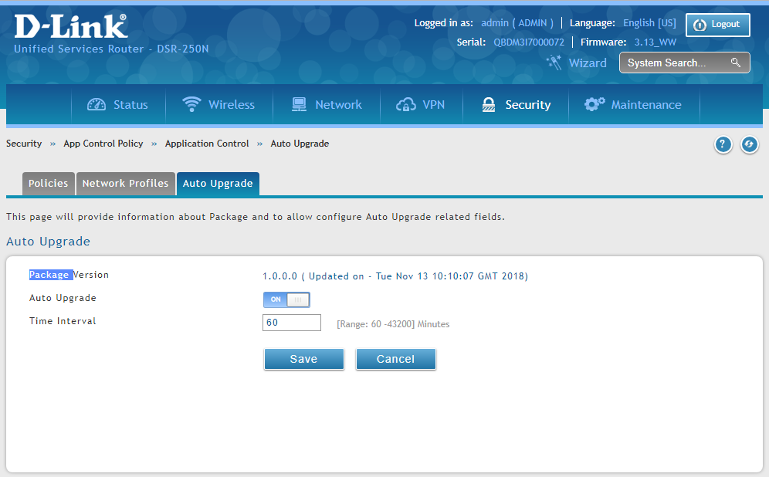
- Go to Security»App Control Policy»Application Control»Policies, check default policy to "always allow".
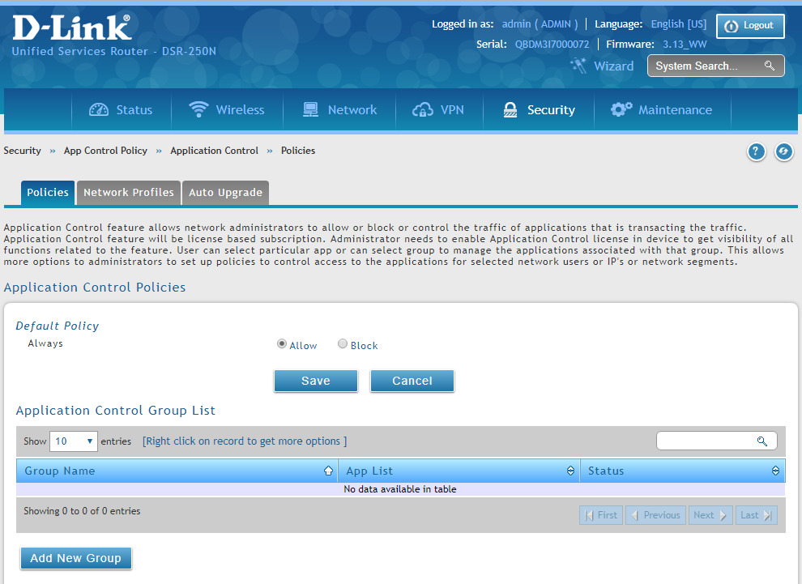
- Add a new group for which you want to block application to list at Application Control Group List.(ex. Youtube&facebook)
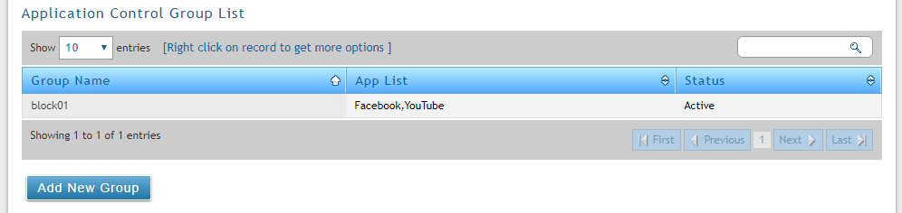

- Add a new Application Policy for which you want to block. (if need config more detailed for what traffic for use it and QOS, please select Policy type for”Feature” to set it)
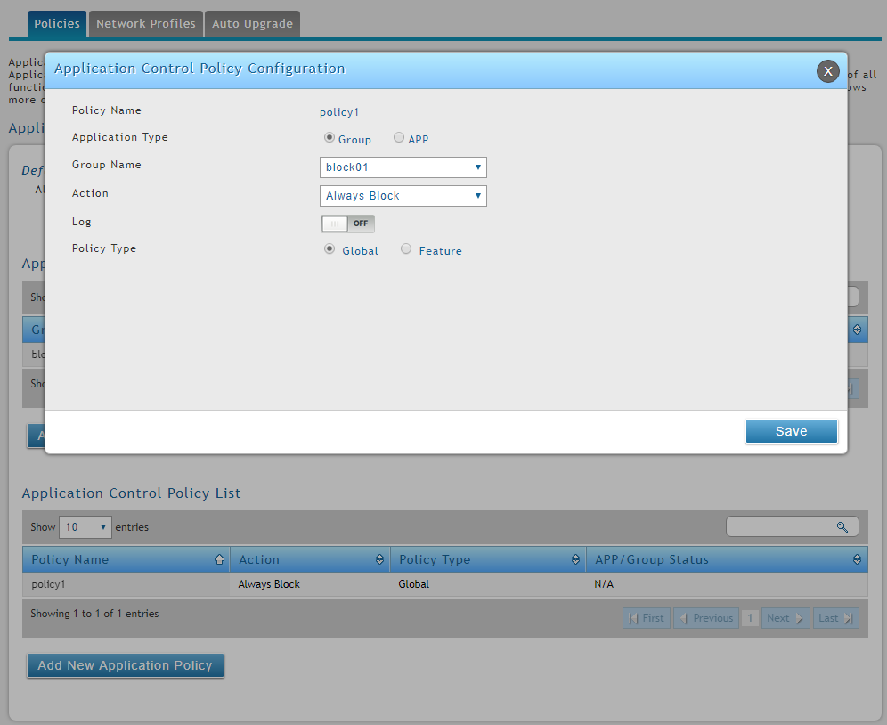

- After settings is being activated, the client is not able to connect to the predefined web service.
(If not, please clear browser cache and then test it again.)

