1. Pre-request:
1. Download HP-1215 driver from HP website.
http://h20000.www2.hp.com/bizsupport/TechSupport/SoftwareIndex.jsp?lang=en&cc=us&prodNameId=22071&prodTypeId=18972&prodSeriesId=25563&swLang=8&taskId=135&swEnvOID=228

2. PS-Link V1.21
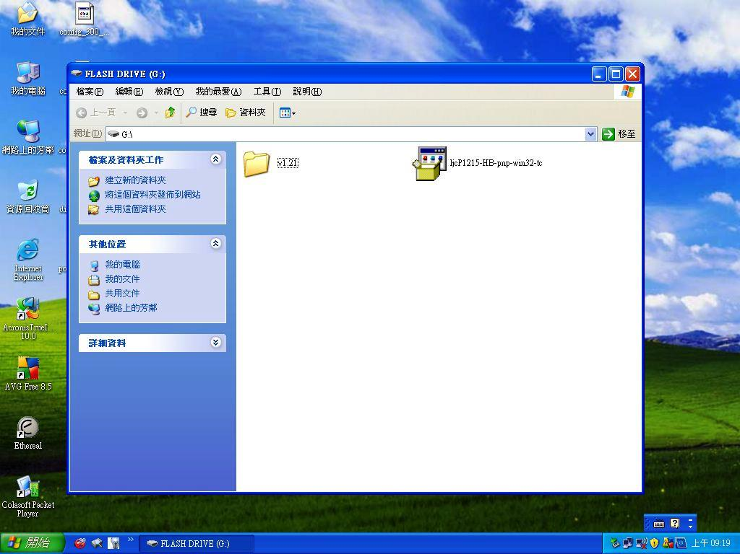
2. Start to install
Environment:
NB: XP SP3 IP:124.195.130.100
DPR-1020 with f/w: 1.03 IP:124.195.130.104
DIR-685 with f/w: 1.00 IP:124.195.130.1

Topology:
NB ---(Lan1)---DIR-685 (DHCP server)
|
DPR-1020---(Lan2)------------

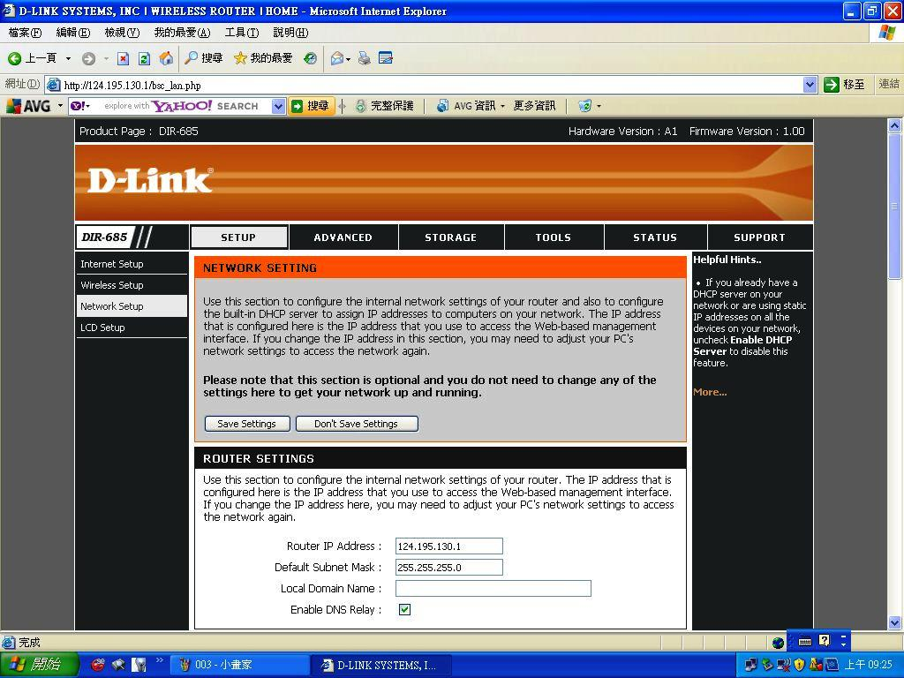
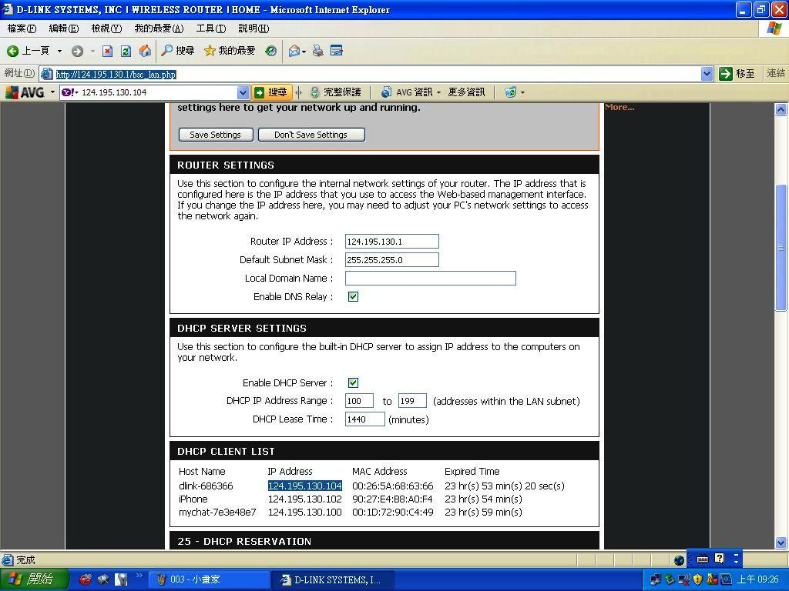

Make sure that we can get DPR-1020
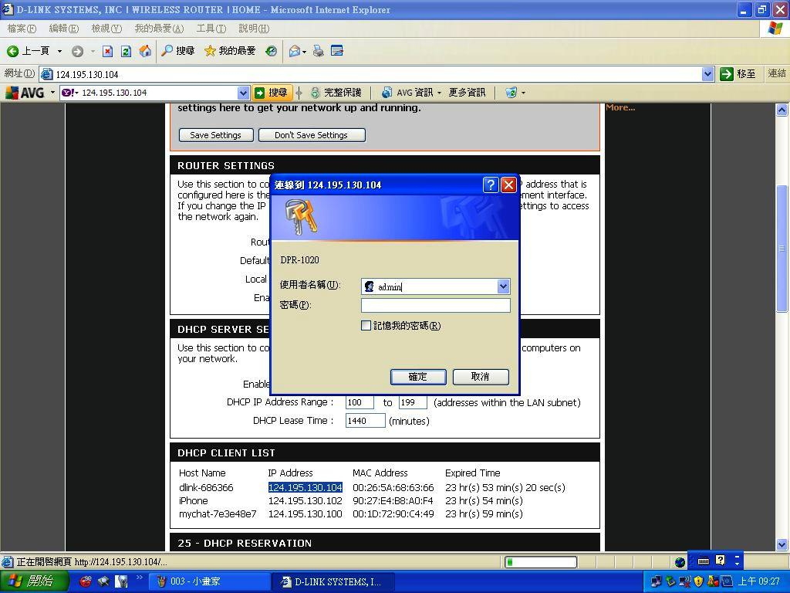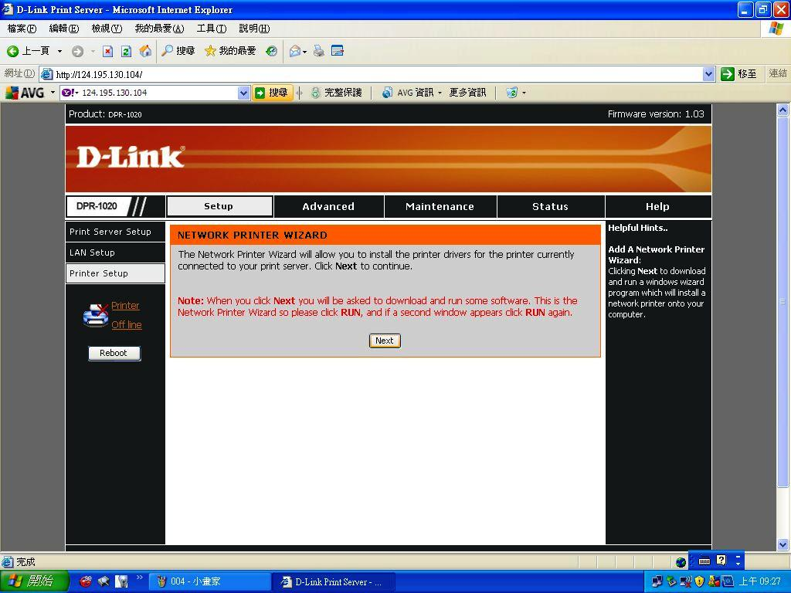
Install the PS-Link
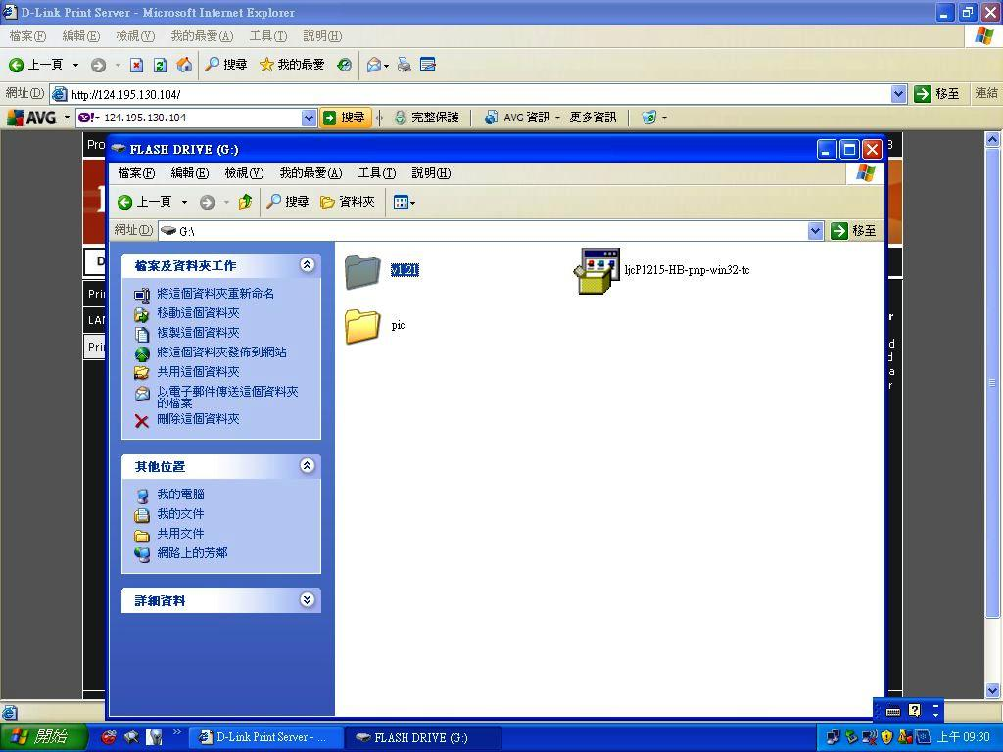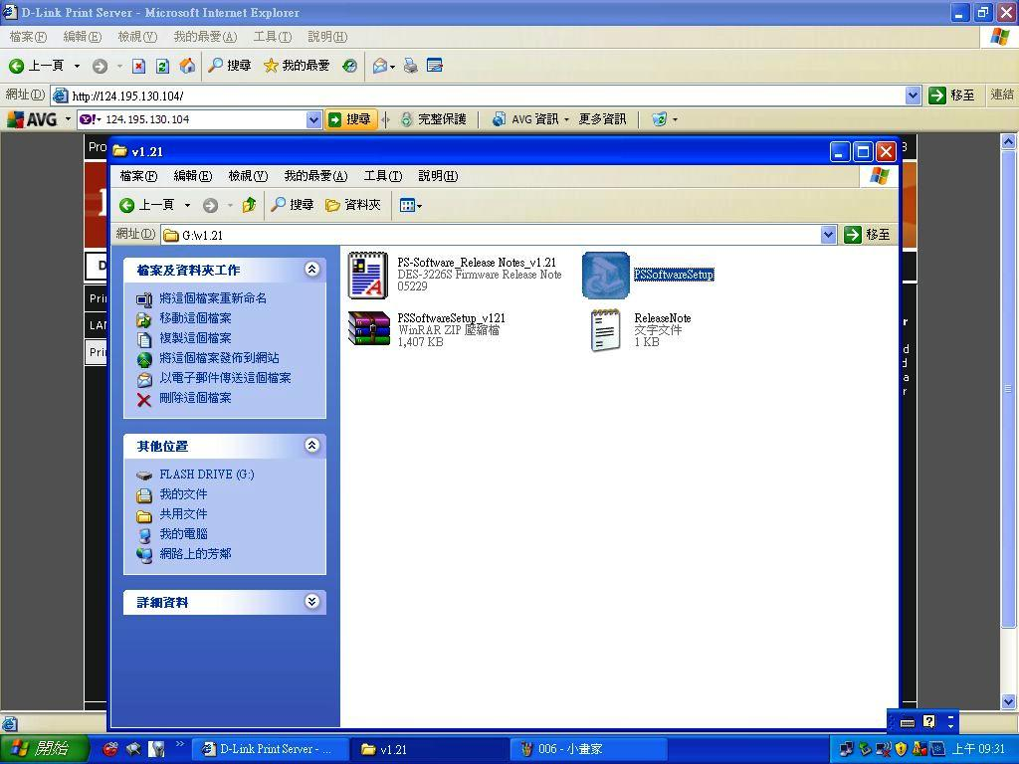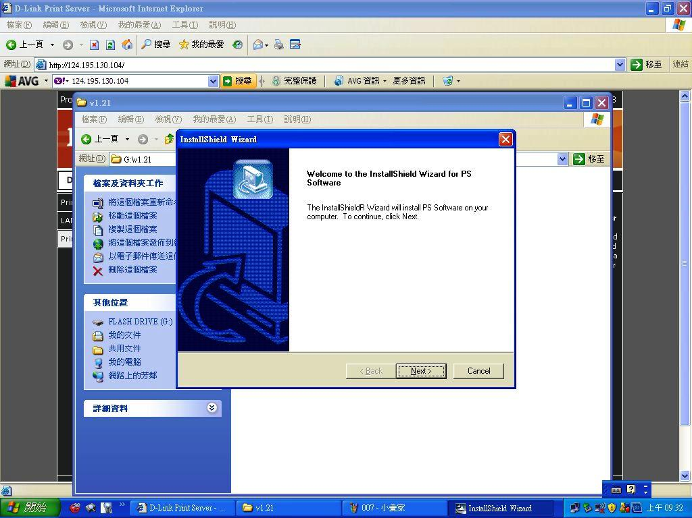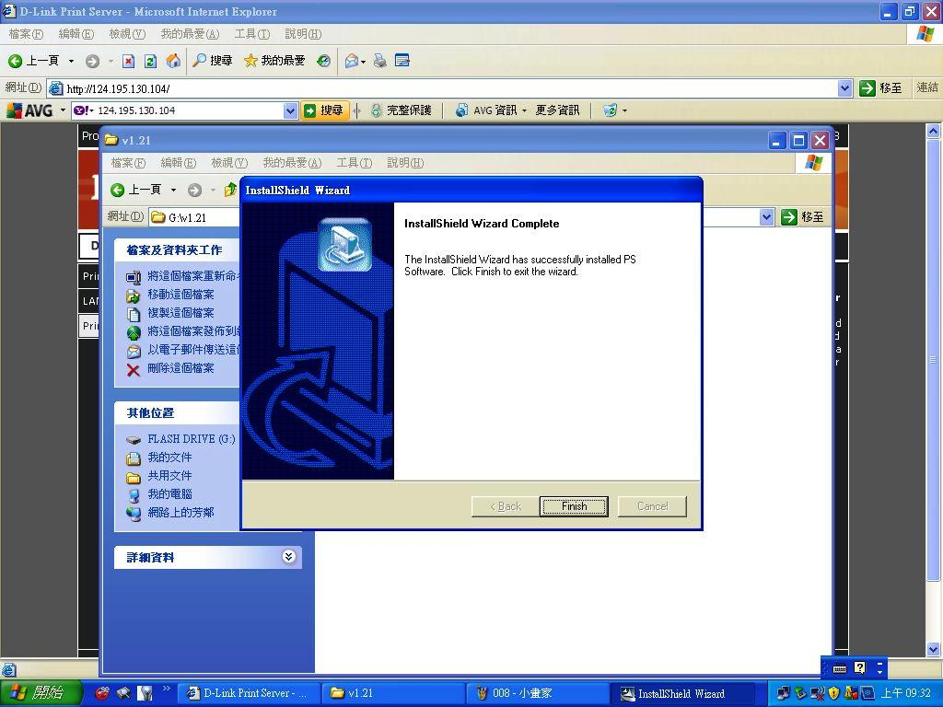
PS-Link has been installed on our NB
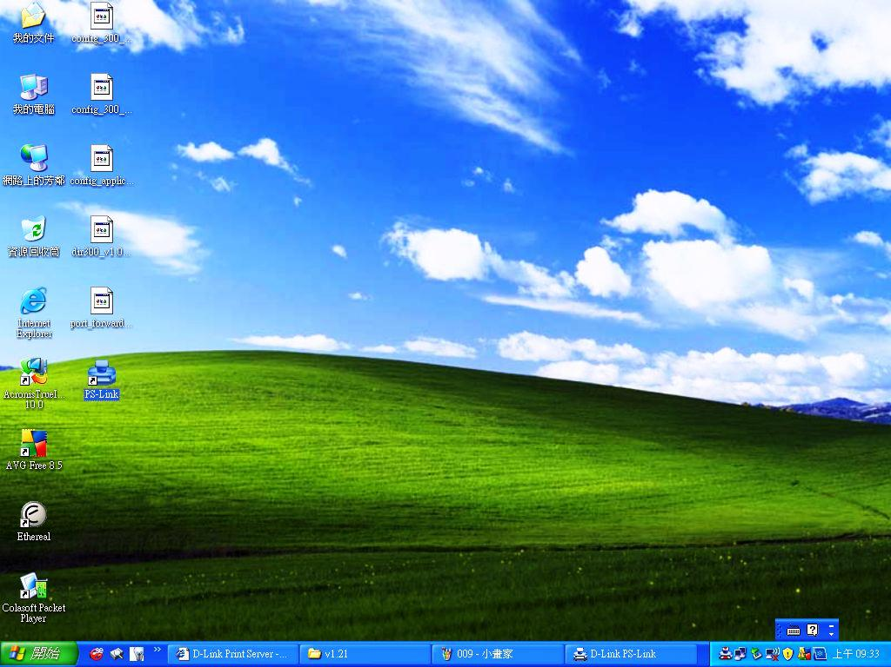
Let’s start to install the driver for HP-1215
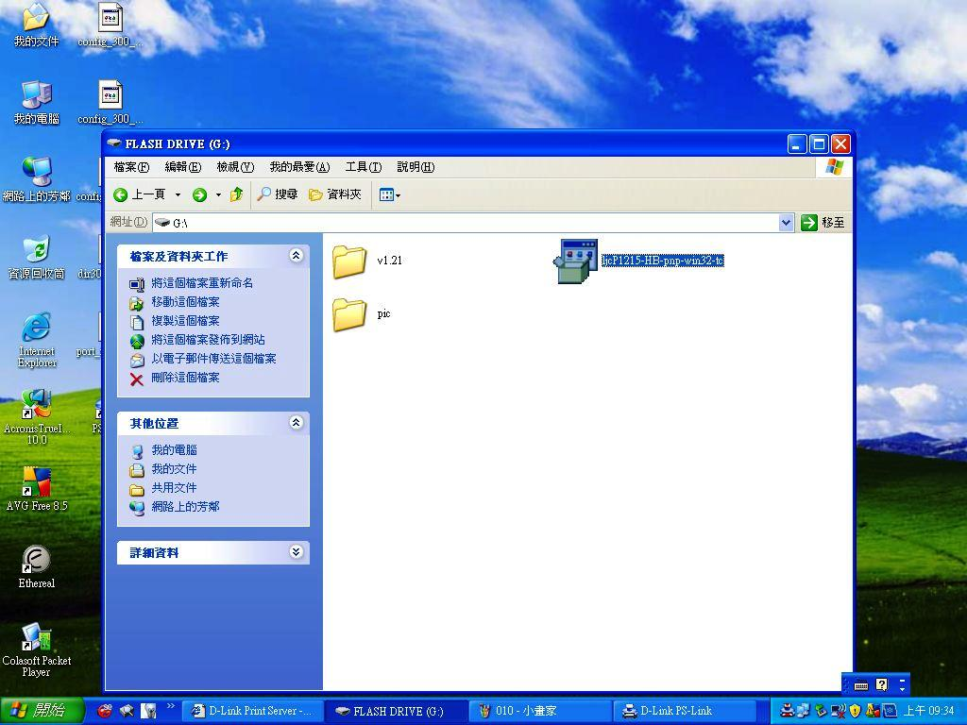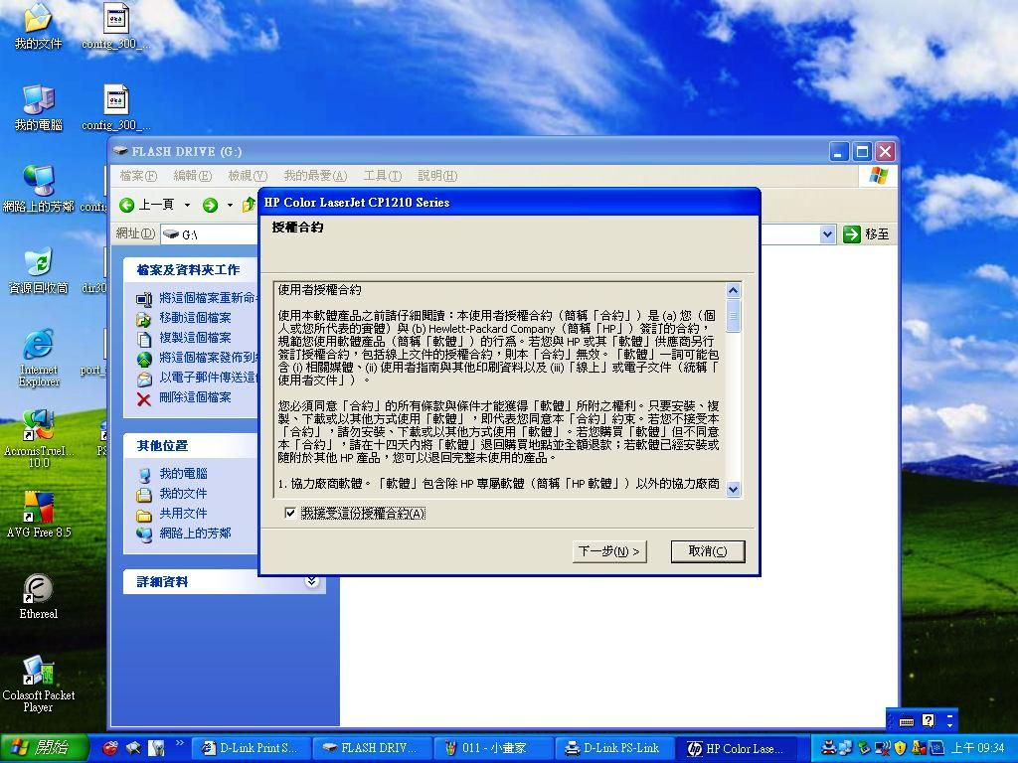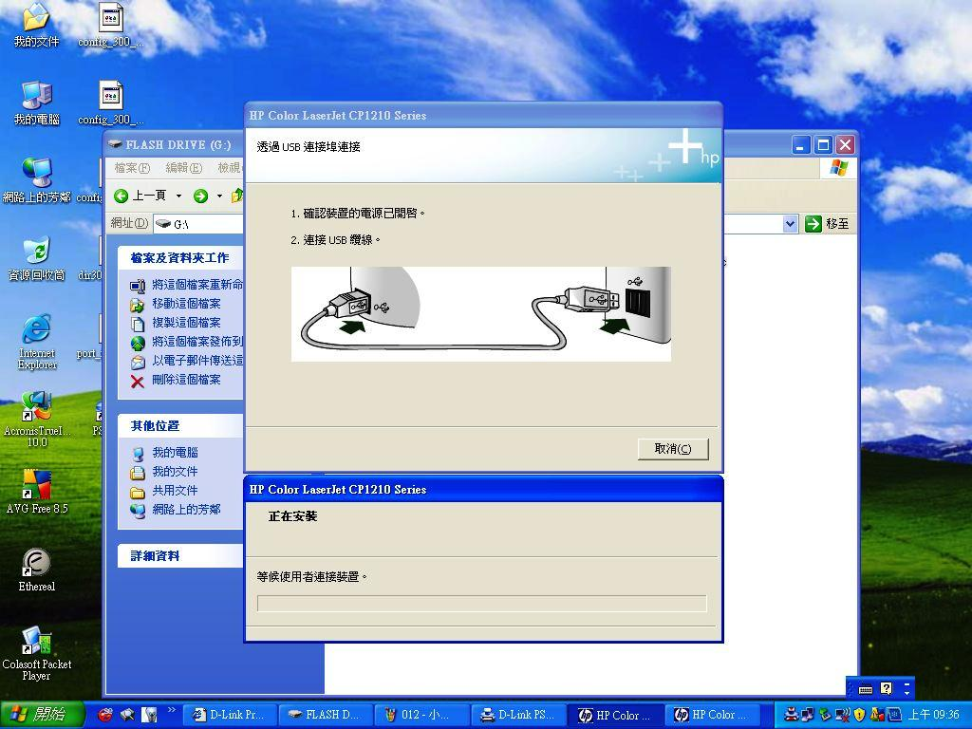It seems to be stop here because the device was not connected.
Please click on the PS-Link on desktop and press “Link”
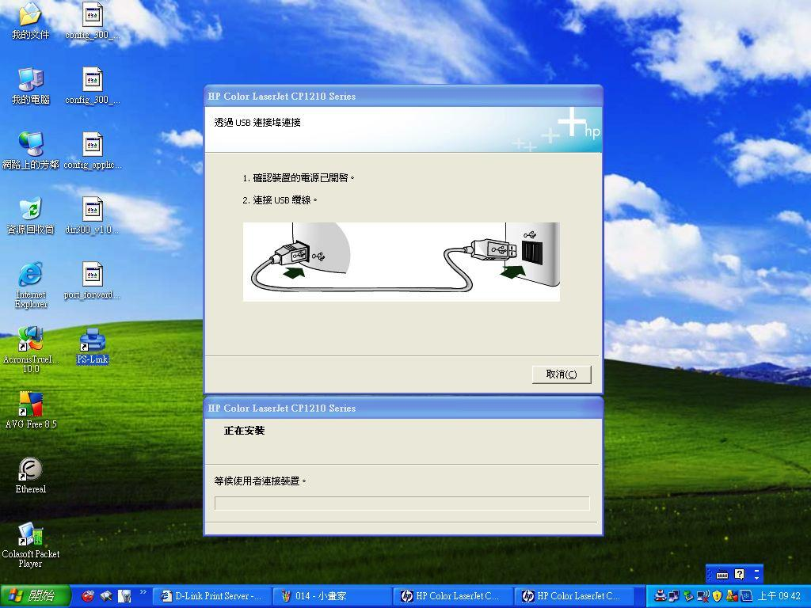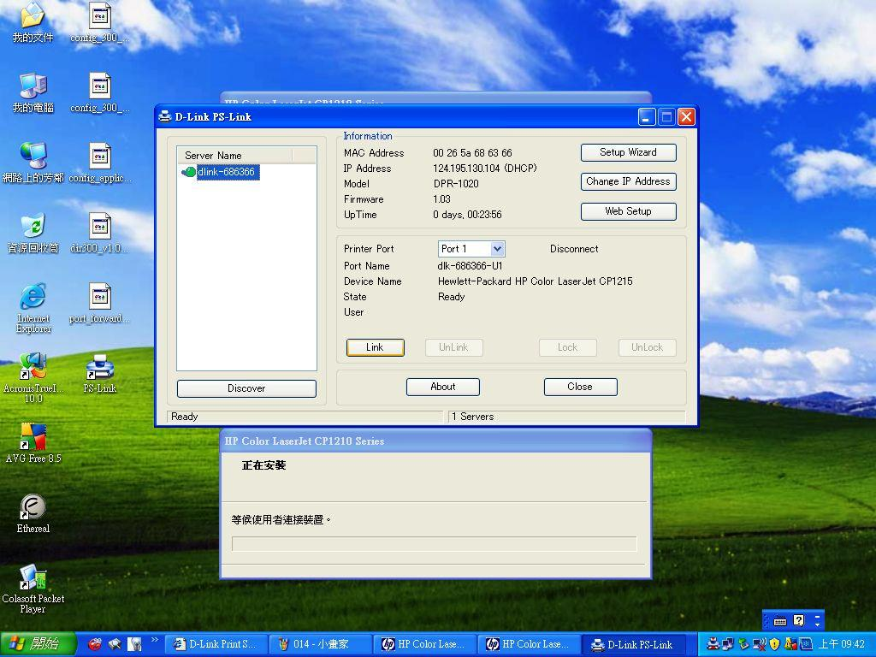The process of driver should continue after press “Link”
