aMule

The ShareCenter’s P2P functionality can be enhanced with the aMule add-on which provides P2P search capabilities. aMule also provides a full featured P2P server/client Web UI that can be launched to work with your ShareCenter P2P functionality.

You can install aMule through the ShareCenter’s Add-On Management page.

Installing and Enabling aMule:

Click on the Applications button, then click Add-On Management.

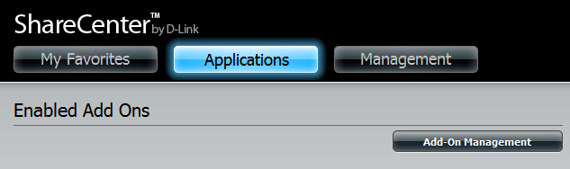

Click Choose File, select the aMule add-on, and then click Apply to install the add-on.

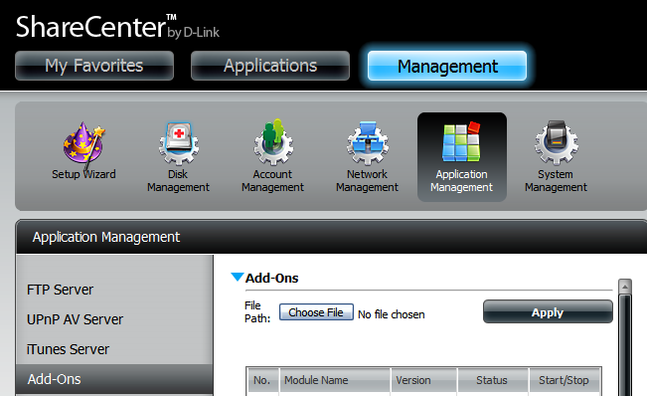

After installing the aMule add-on, click its Start button (shown as a green triangle) to enable the add-on.

A blue checkmark indicates that the aMule add-on is now enabled and ready to use.

Launching aMule
The aMule icon should now be available under the Applications tab of the web UI. Click it to bring up the aMule Launch page.

Click Launch Interface to start using aMule.

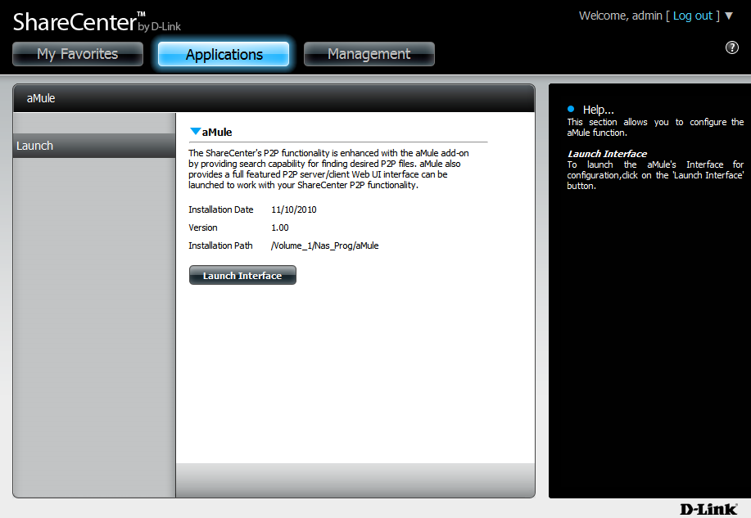

The aMule Interface

After clicking the Launch Interface button, the aMule Web UI will launch where you can then search for P2P files and download them to your ShareCenter through a web interface.

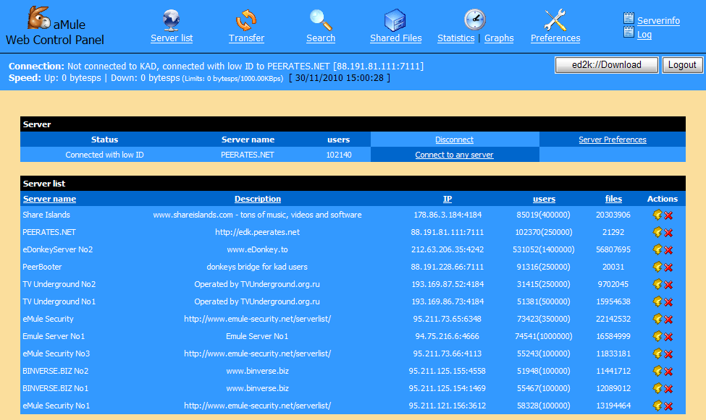

Download a P2P File

Click the “Connect to any server” button to connect to a convenient P2P server in order to search for the P2P files.

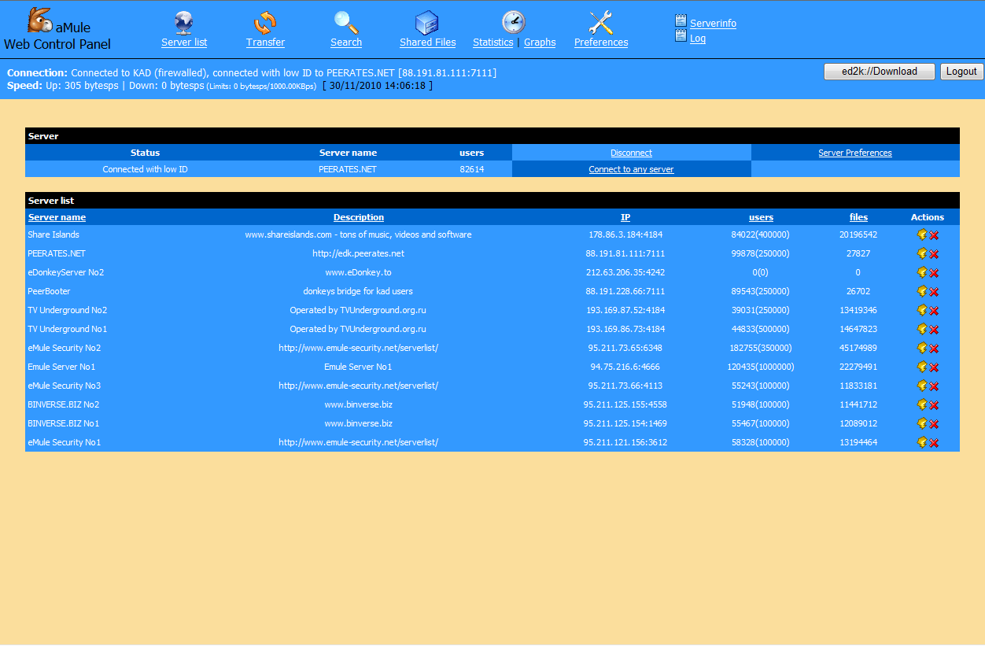

Press the F5 key to update your search if you do not get an immediate connection.

Any search results will appear above the Search where you can then select the desired P2P files by checking the box in the Download column on the right.

When you are finished with your selection(s), click the Download button below the list.

Press the F5 key to update the Search list.

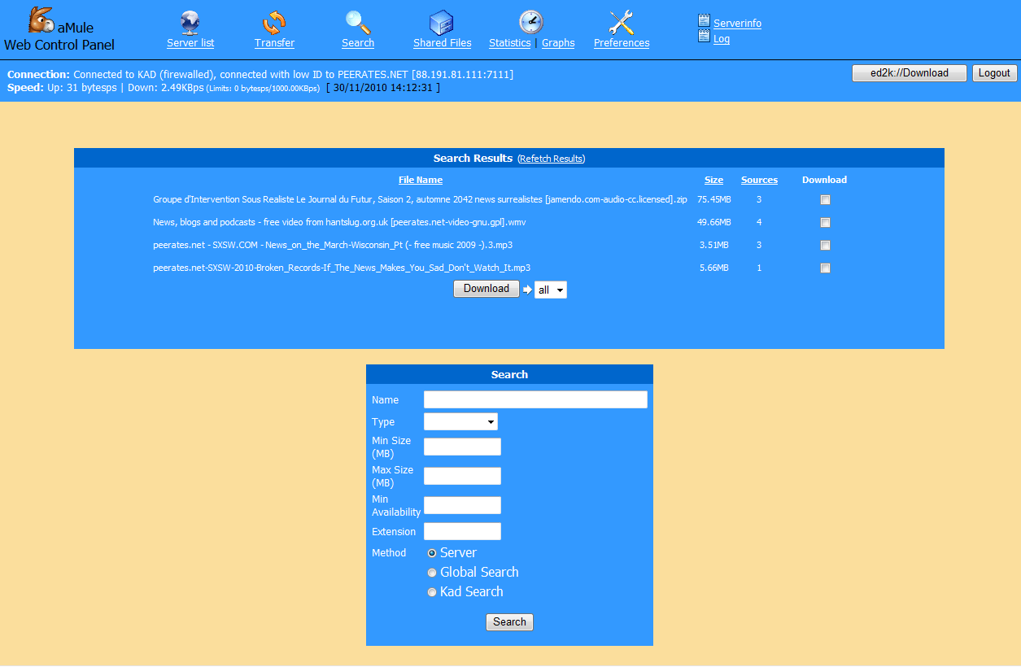

Enter any combination of Search terms to use in Search fields provided.

Select the Server search as follows:

Server - Searches for the file(s) on your local server.
Global Server - Searches for the files on all the servers in your list (takes much longer).
Kad Server - Launches a Kademlia search type.

Click on the Search button to start the search.

You can view the download progress and control/edit your downloads in this table under the Transfer Icon.

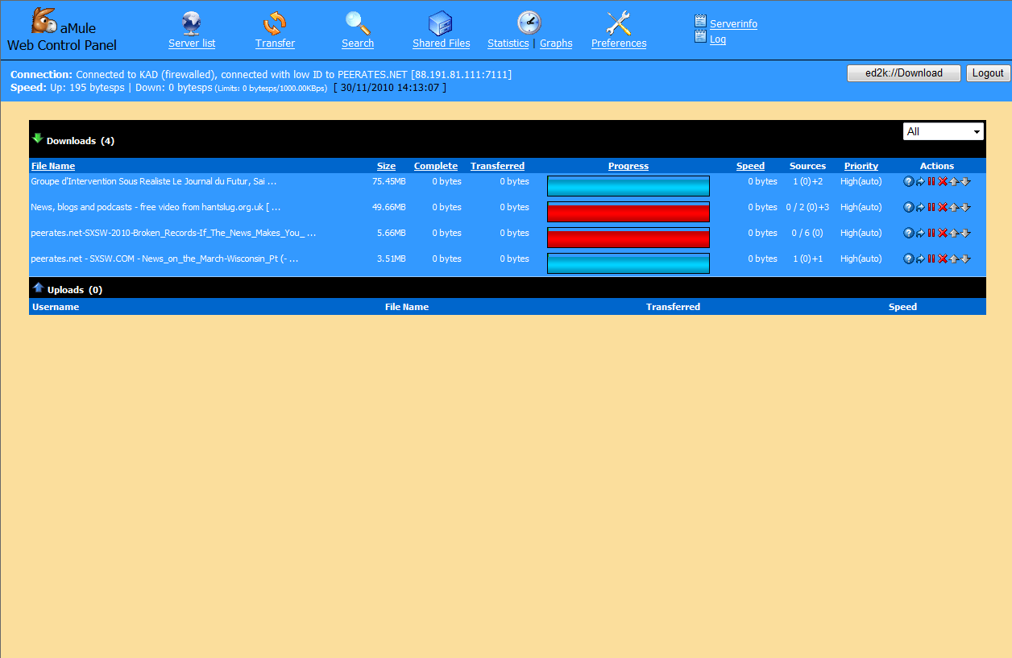

aMule will create a separate volume on your ShareCenter called “aMule”.

Within aMule volume are two folders.

- Incoming – Completed P2P downloaded files will be stored in this folder.

- Temp - P2P files currently being downloaded will be stored in this folder.

Share a P2P File

Add a file to the Incoming folder under the aMule volume. Once the file is in the folder it is automatically placed in the transfer list as an available P2P file for upload.

The file will appear in the list under the Share Files icon as well as in the Transfer icon list.

