Squeeze Center

SqueezeCenter is an add-on that connects to your Logitech SqueezeBox music player(s) to playback music files from your ShareCenter. Since the SqueezeCenter software is installed on your ShareCenter, it avoids any unnecessary usage of any resources if it were installed on a PC.

SqueezeCenter is a ShareCenter add-on developed by D-Link allowing audio to steam to any Logitech media player that is able to connect to the same network the ShareCenter is on. Some of the audio file types that can be played from the ShareCenter include, .MP3, .WAV, .ACC, .FLAC, Ogg Vorbis, and .WMA.

Once the SqueezeCenter add-on and server software is installed, you can double-click it from the Application menu of your ShareCenter. Launch the SqueezeCenter server interface from the menu as shown below.

You can install Squeeze Center through the ShareCenter’s Add-On Management page.

Installing and Enabling Squeeze Center:

Click on the Applications button, then click Add-On Management.

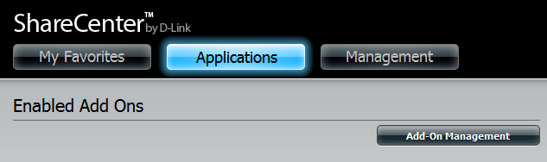

Click Choose File, select the Squeeze Center add-on, and then click Apply to install the add-on.

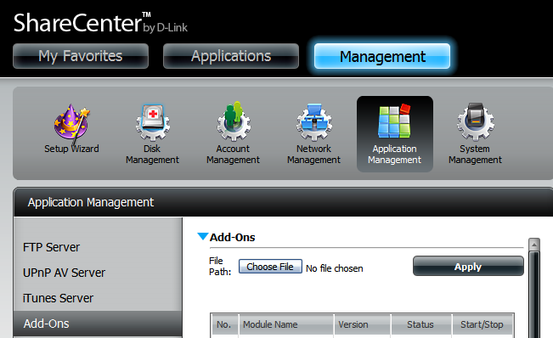

After installing the Squeeze Center add-on, click its Start button (shown as a green triangle) to enable the add-on.

A blue checkmark indicates that the Squeeze Center add-on is now enabled and ready to use.

Launching Squeeze Center
The Squeeze Center icon should now be available under the Applications tab of the web UI. Click it to bring up the Squeeze Center Launch page.

Click Launch Interface to start using Squeeze Center.

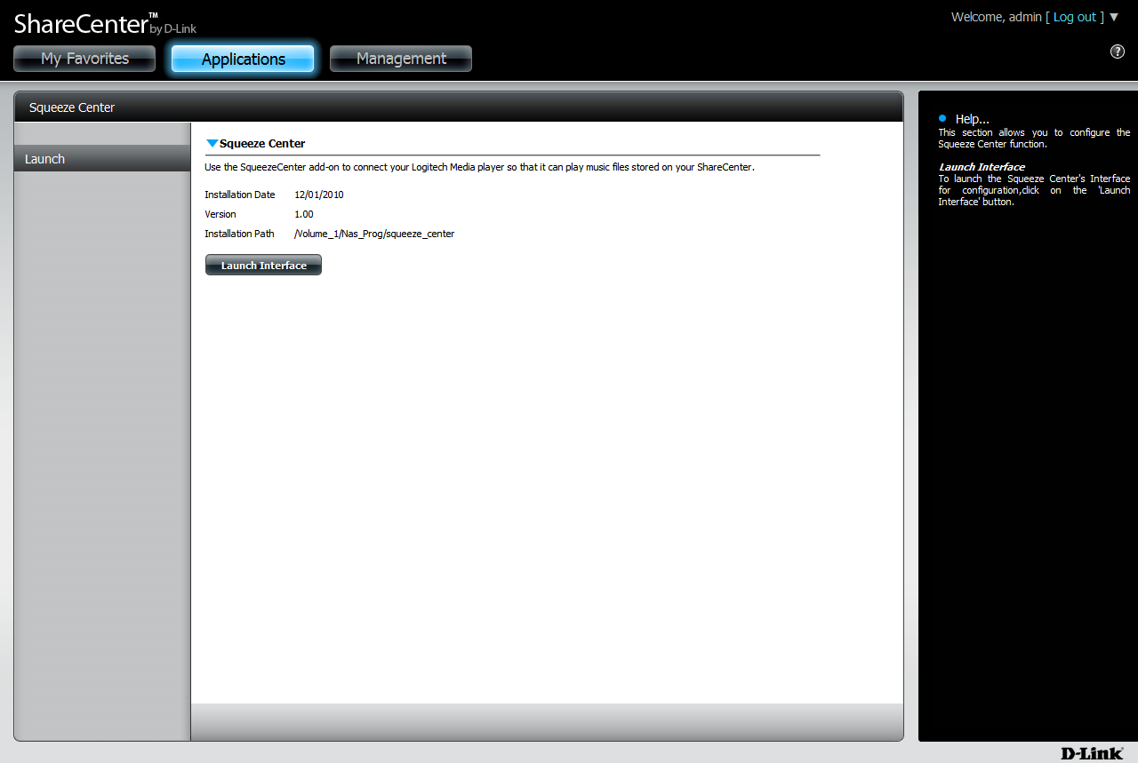

Signing into SqueezeCenter
Enter your SqueezeNetwork account information and click Next. If you do not have a SqueezeNetwork account, click “I need to create a SqueezeNetwork account” and set up an account.

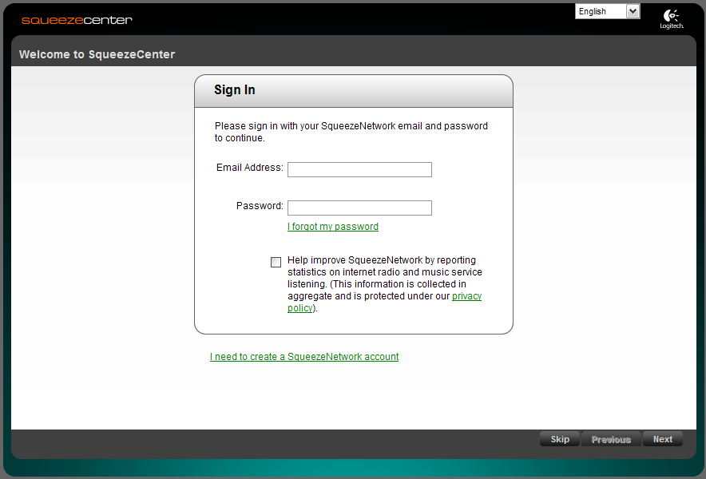

Expand the /mnt/HD folders until you see following folders:

HD_a2 - ShareCenter (Volume 1)
HD_b2 - ShareCenter’s (Volume 2)

(Expand the /mnt/USB/HD_cx for USB Memory)

Then expand folders and select audio files, playlists, and subfolders you wish to playback.

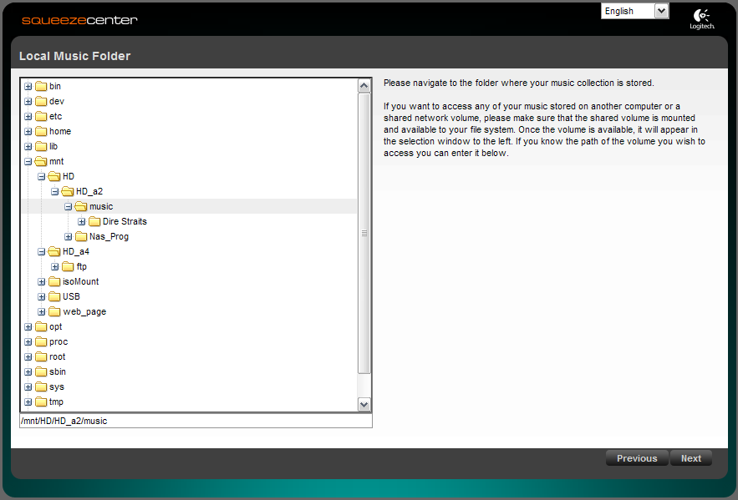

After you finished selecting the location of the files under either:
• /mnt/HD/HD_a2 folder (Vol_1) or
• /mnt/HD/HD_a2 folder (Vol_2) or
• /mnt/ USB/HD_cx (USB Memory) folder

This window will appear confirming your details. Click Previous if you need to make any changes, otherwise click Finish to continue.

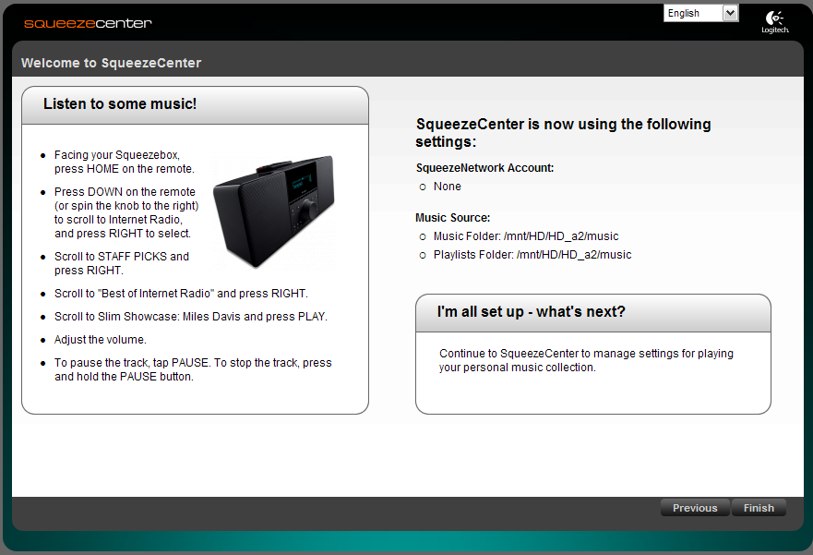

Your ShareCenter’s SqueezeCenter add-on is now ready for use. Click Finish to proceed to SqueezeCenter.

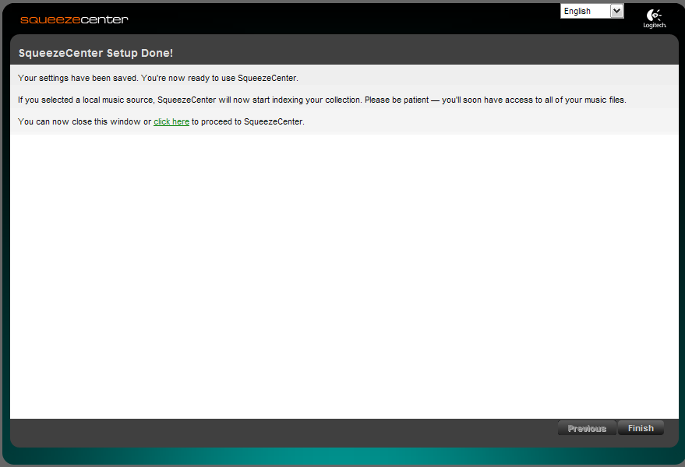

The following screen is where SqueezeCenter manages your audio files on your ShareCenter. You should now be able to connect your Logitech SqueezeBox media player(s) for playback.

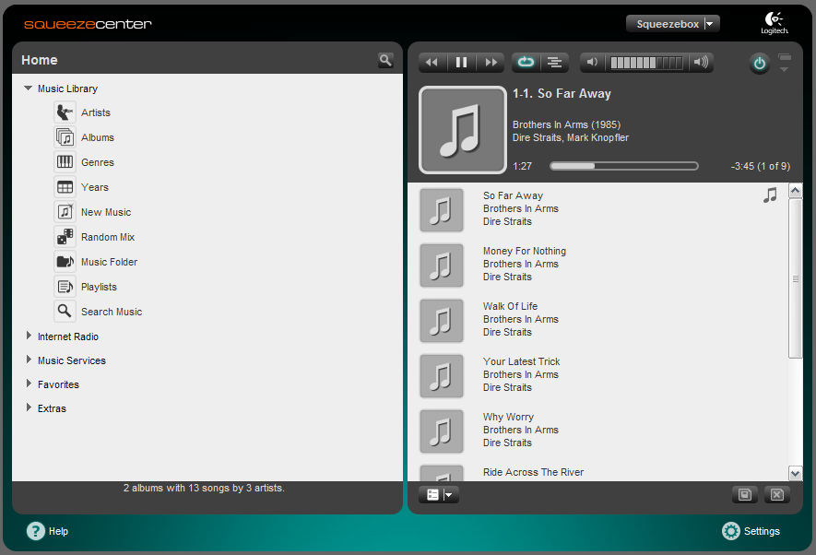

If you need any assistance in managing your SqueezeCenter, you can find tutorial guides by clicking the Help button (Question Mark) located at the bottom left hand corner.

