Photo Center

The Photo Center add-on sets up your ShareCenter to share your photos over the web using the ‘Gallery 2’ software. It provides a convenient interface from which you can create albums from your photos as well as adding descriptions. The albums are then accessible over the web using HTTP so that your family and friends can then view your photos stored on your ShareCenter using any Internet connection.

You can install Photo Center through the ShareCenter’s Add-On Management page.

Installing and Enabling Photo Center:

Click on the Applications button, then click Add-On Management.

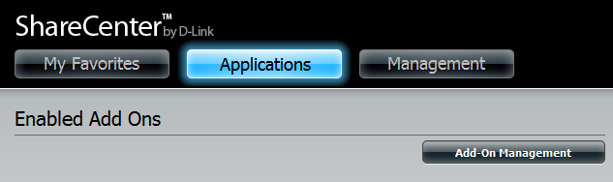

Click Choose File, select the Photo Center add-on, and then click Apply to install the add-on.

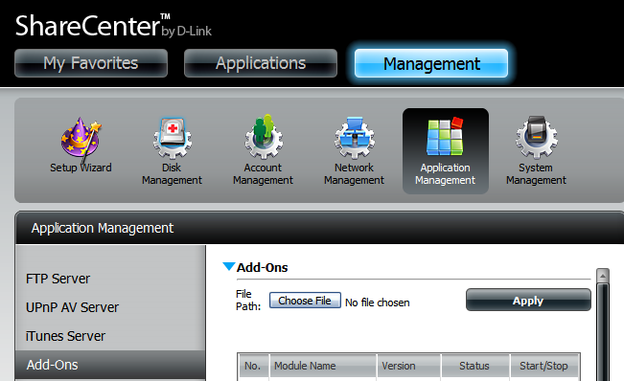

After installing the Photo Center add-on, click its Start button (shown as a green triangle) to enable the add-on.

A blue checkmark indicates that the Photo Center add-on is now enabled and ready to use.

Launching Photo Center
The Photo Center icon should now be available under the Applications tab of the web UI. Click it to bring up the Photo Center Launch page.

Click Launch Interface to start using Photo Center.

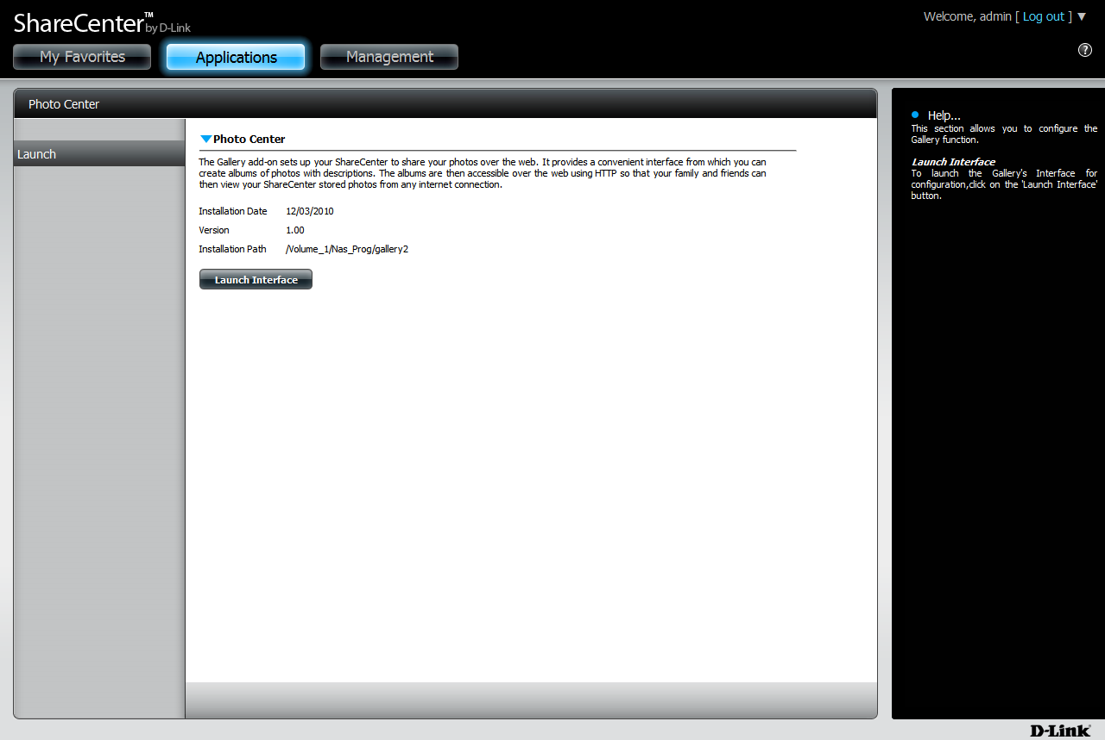

Logging into Photo Center

First you will need to login to Photo Center.
The default username of the Photo Center Web UI is: admin
The password will be the same as the administrator password of the ShareCenter.

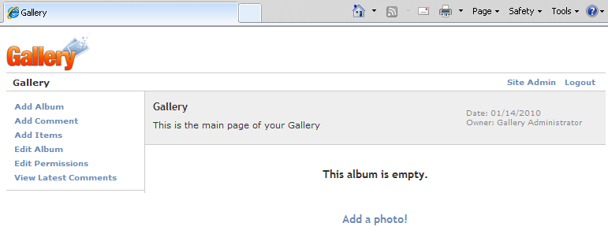

If you need any assistance in creating and maintaining your photo galleries, you can find a complete tutorial in the Help icon (Question Mark) located at the top right hand corner.

