Blog

Create your own ShareCenter based customized blog using the ShareCenter’s Blog add-on (Wordpress), where it can be accessed and commented on from anywhere with an internet connection.

You can install Blog through the ShareCenter’s Add-On Management page.

Installing and Enabling Your Blog:

Click on the Applications button, then click Add-On Management.

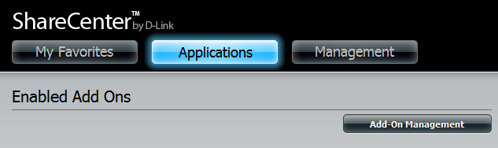

Click Choose File, select the Blog add-on, and then click Apply to install the add-on.

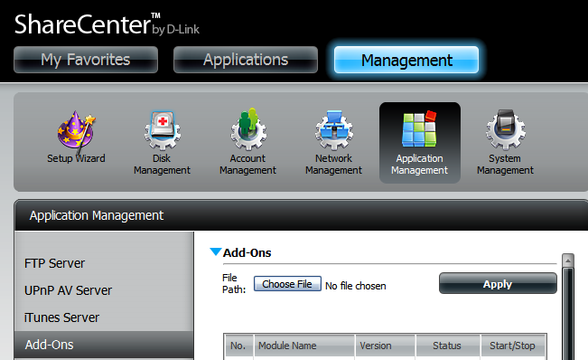

After installing the Blog add-on, click its Start button (shown as a green triangle) to enable the add-on.

A blue checkmark indicates that the Blog add-on is now enabled and ready to use.

Launching Blog
The Blog icon should now be available under the Applications tab of the web UI. Click it to bring up the Blog Launch page.

Click Launch Interface to start using Blog.

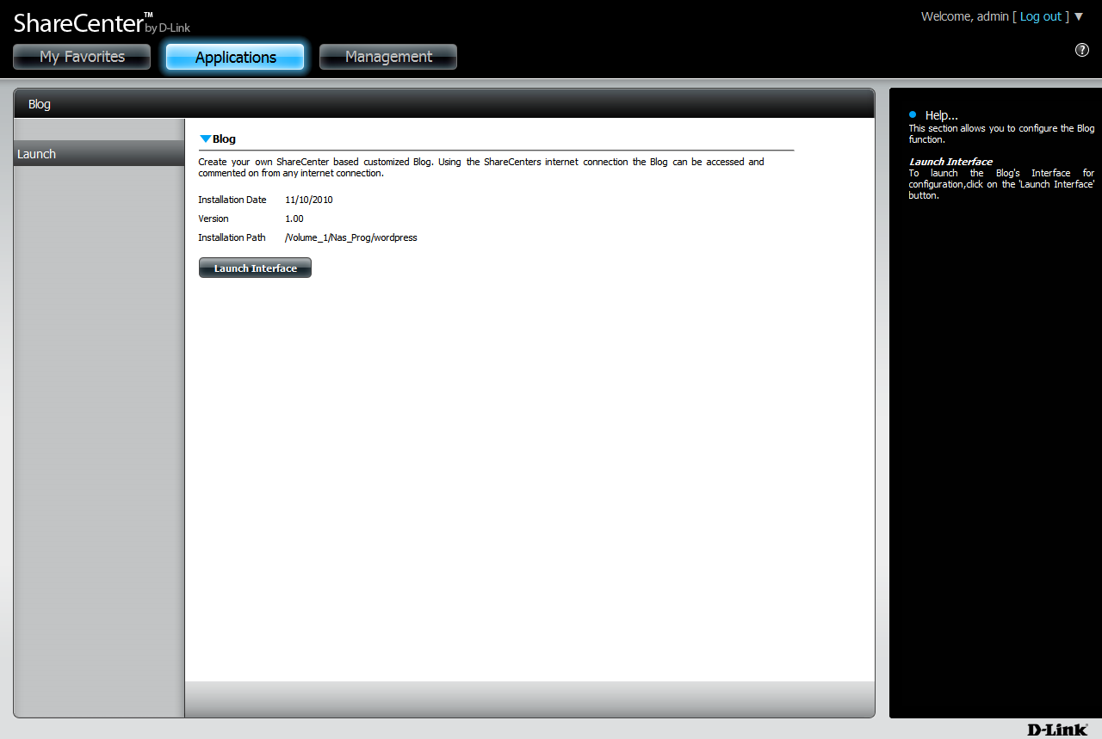

The Blog Interface

Click on the Log in link in the bottom right corner of the page to open the blog administrator login page.

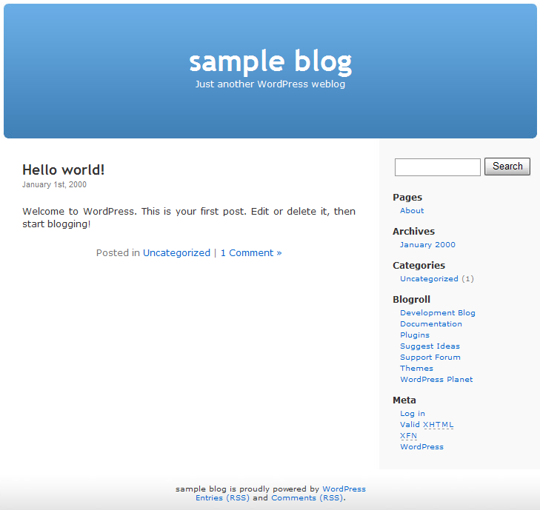

The default administrator login information is:

Username: admin
Password: admin

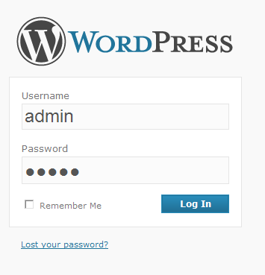
After entering your login information click on the Log In button to proceed.

Note: For security, please change the administrator password after logging in for the first time.

Your blog’s dashboard should appear,allowing you to configure your blog’s settings and create blog posts.

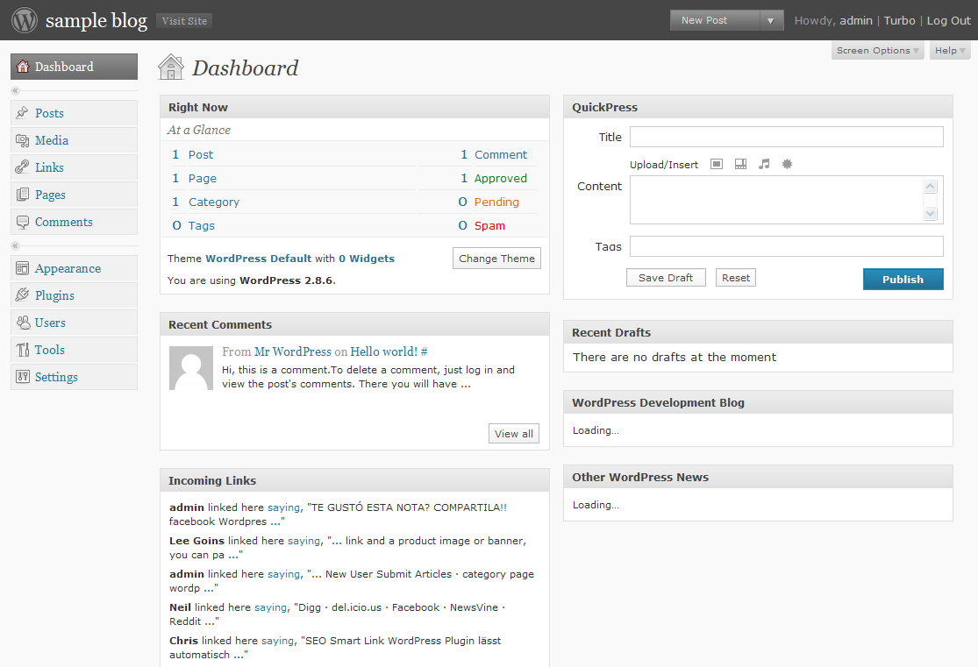

If you need any assistance in creating and maintaining your blog(s), you can find tutorial guides by clicking the Help button located at the top right hand corner.

