Audio Streamer

The Audio Streamer add-on can turn your ShareCenter into an Internet ‘Audio Streamer’ by continuously streaming music. Anyone with access to the Internet through a web browser can then connect to your ShareCenter’s Audio Streamer and listen to the audio files streaming from your ShareCenter.

After you store the audio Files you wish to stream from the ShareCenter, you can then create different playlists according to your selections. These playlists will then continuously stream from your ShareCenter to users across the Internet.

You can install Audio Streamer through the ShareCenter’s Add-On Management page.

Installing and Enabling Audio Streamer:

Click on the Applications button, then click Add-On Management.

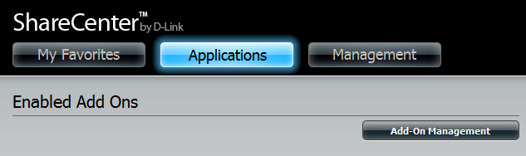

Click Choose File, select the Audio Streamer add-on, and then click Apply to install the add-on.

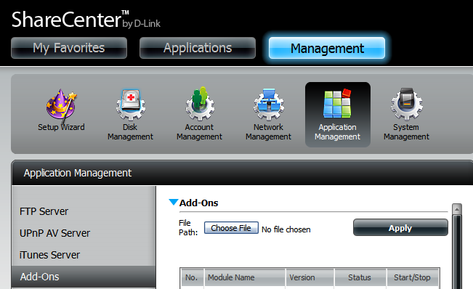

After installing the Audio Streamer add-on, click its Start button (shown as a green triangle) to enable the add-on.

A blue checkmark indicates that the Audio Streamer add-on is now enabled and ready to use.

Launching Audio Streamer
The Audio Streamer icon should now be available under the Applications tab of the web UI. Click it to bring up the Audio Streamer Launch page.

Click Launch Interface to start using Audio Streamer.

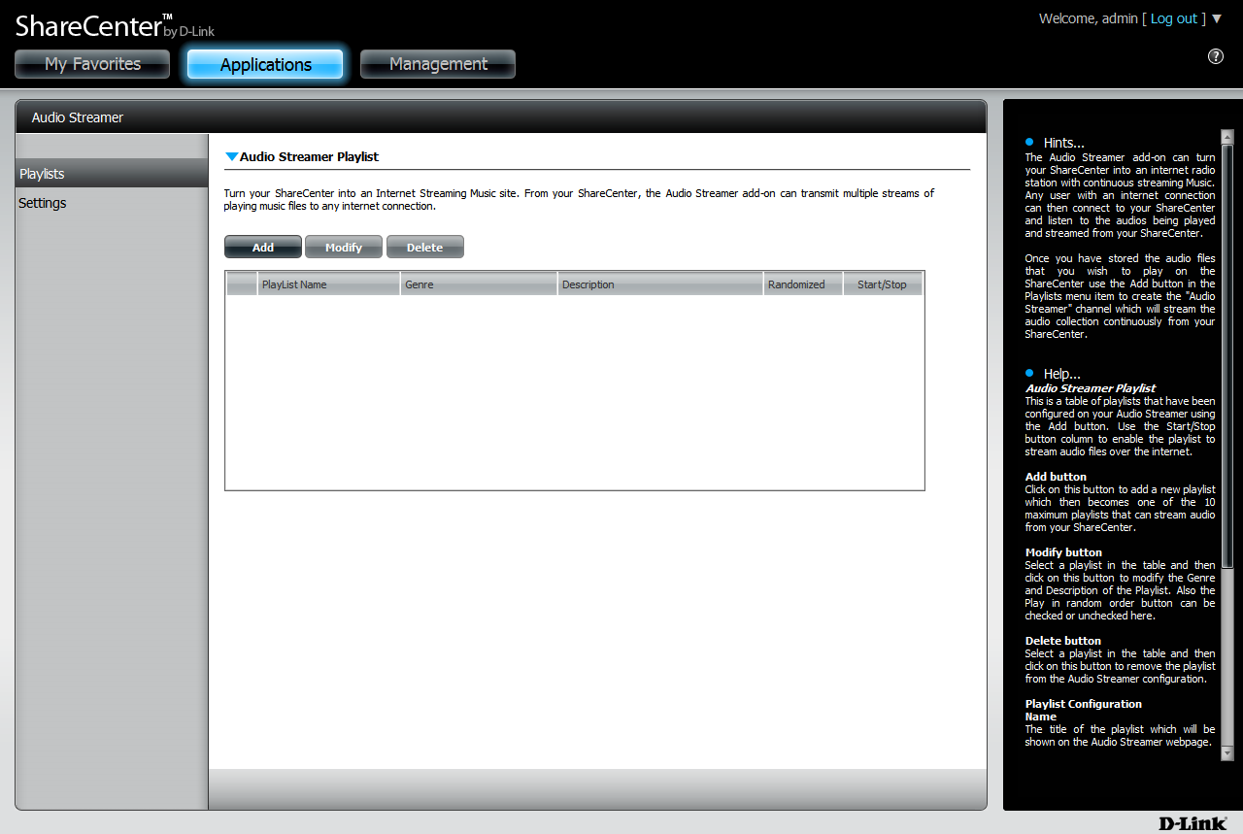

The Audio Streamer Settings
Audio Streamer will use the default port: 8000 to stream music over the Internet. The IPv4 URL linking to your audio stream is the ShareCenter’s network address combined with the port (default 8000) and playlist name. For example:

http://192.168.1.1:8000/Playlist-01.m3u

192.168.1.1 being the ShareCenter’s network address
8000 being the port
Playlist-01.m3u being the name of the playlist selected for streaming

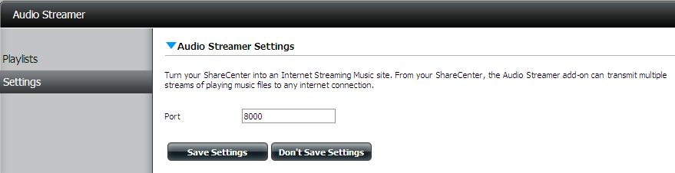

Adding a Playlist
Click the Playlists tab on the left, then click the Add button to create a playlist with audio files you want to stream from your ShareCenter.

First, you will have to give the playlist a name. (Note: Name will become part of stream URL)

Next, you can enter a Genre for the type of music you are selecting(optional).
You can also choose to enter a brief description about your music in the Description field (optional).

Click Next when you are finished.

Expand the volume folder tree and check the boxes next to the audio files and folders you wish to stream.

Click Complete after you have finished selecting your music.

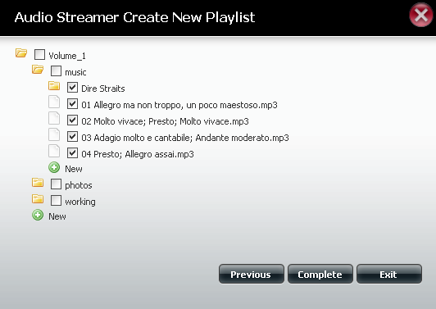

After the playlist is created, it will appear in the playlist table as show below.
Click the Start button (green triangle) to enable and begin streaming.
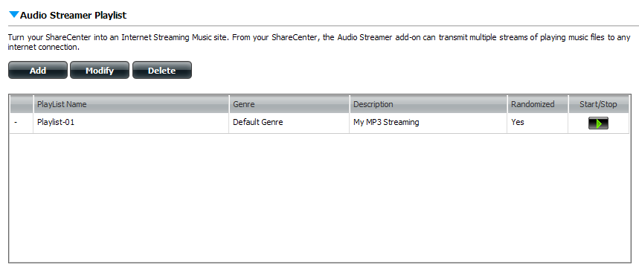

Listening to the Audio Stream
Enter the URL of the playlist into your favorite media player to receive the Audio Stream from your ShareCenter.

Example: http://192.168.1.1:8000/Playlist-01.m3u

