AjaXplorer

AjaXplorer is a file explorer that allows you to use a web browser to remotely (over the Internet) manage files stored in the AjaXplorer folder on your ShareCenter.

You can install AjaXplorer through the ShareCenter’s Add-On Management page. Once installed and enabled, AjaXplorer creates a special folder, /Volume_1/Nas_Prog/ajaxplorer on Volume 1 of your ShareCenter.

Using your web browser, you can access files in this special folder to:
- upload and download files
- directly view photos and videos
- play music and audio files

Installing and Enabling AjaXplorer:

Click on the Applications button, then click Add-On Management.

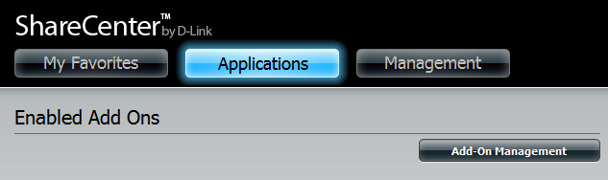

Click Choose File, select the AjaXplorer add-on, and then click Apply to install the add-on.

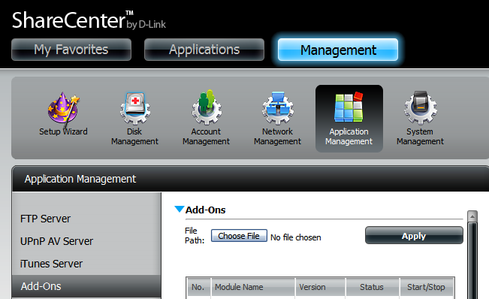

After installing the AjaXplorer add-on, click its Start button (shown as a green triangle) to enable the add-on.

A blue checkmark indicates that the AjaXplorer add-on is now enabled and ready to use.

Launching AjaXplorer
The AjaXplorer icon should now be available under the Applications tab of the web UI. Click it to bring up the AjaXplorer Launch page.

Click Launch Interface to start using AjaXplorer.

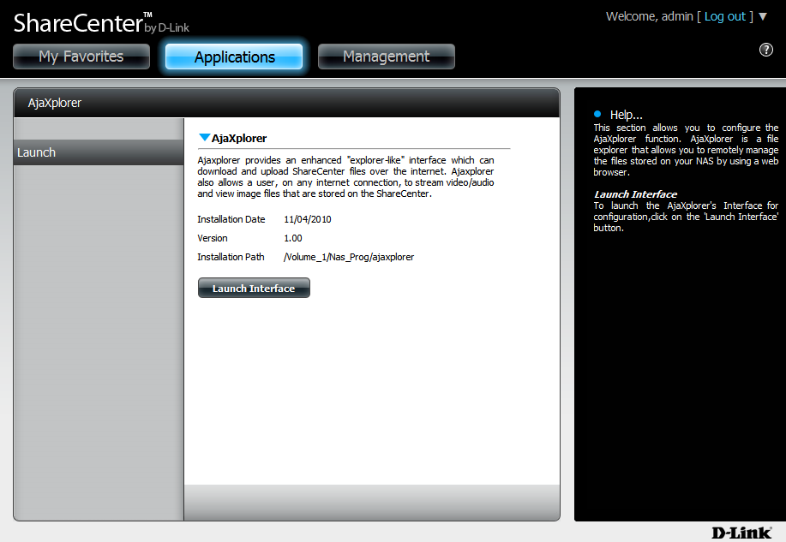

The AjaXplorer Interface

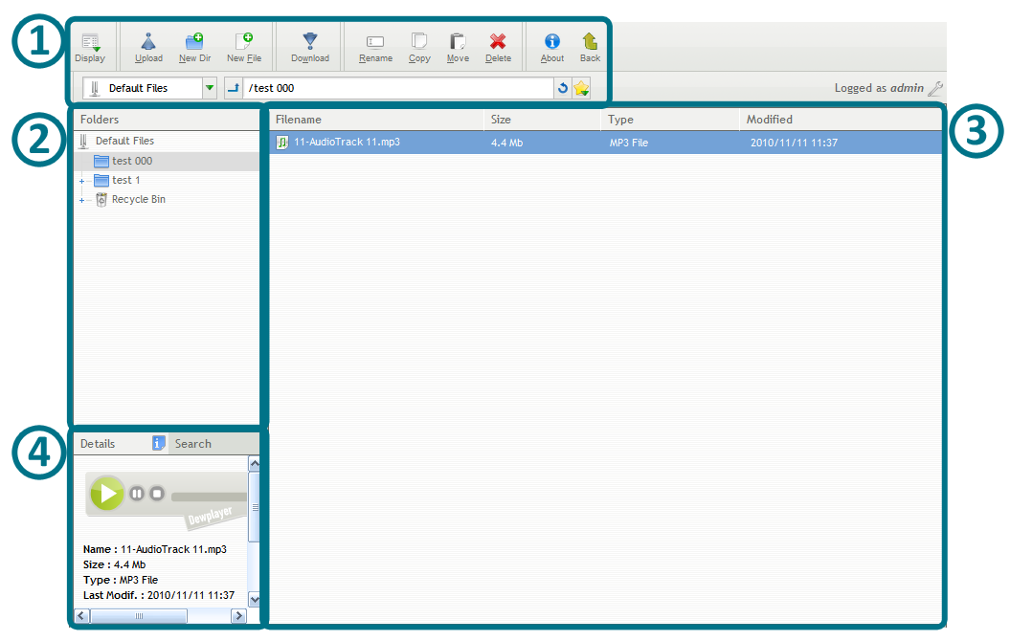

- Buttons Toolbar: Use these buttons to manage your files and folders.
- Folders Pane: Use this panel to browse through the folders inside of the /Ajaxpf/ home folder on your ShareCenter.
- Main Window: This window shows you the files and folders inside of the currently selected folder. You can drag and drop files and folders inside the AjaXplorer interface, or you can right-click a file or folder to bring up a list of things you can do.

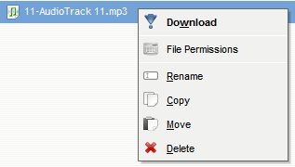

- Details/Search Pane: If you click on the Details tab, you will see extended details about the currently selected file or folder. If an audio or video file is selected, you can preview it by using the playback buttons that appear.

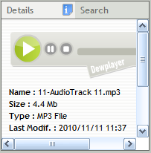

If you click the Search tab, you can search for specific files or folders. Enter the text you want to search for, and then click the search icon next to the text box. AjaXplorer will then search the currently selected folder and its subfolders for the keyword you entered, and will display the results in the box below.

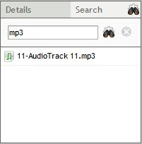

For more information on AjaXplorer, visit their homepage at http://www.ajaxplorer.info

