Win2k3 as PPTP VPN dial-in server, DI-804HV as PPTP dial-up client.
Before the scenario hands-on, we assume that the readers already along with following abilities:
1. The simple routing concept
2. The basic concept of PPTP and VPN.
The scenario also can be applying on DI-824VUP+
Scenario summary:
DI-804HV F/W:V1.44b06
1. Set WAN type to Static PPTP on DI-804 as PPTP client
Windows Server 2003 R2
1. As a PPTP VPN server for testing
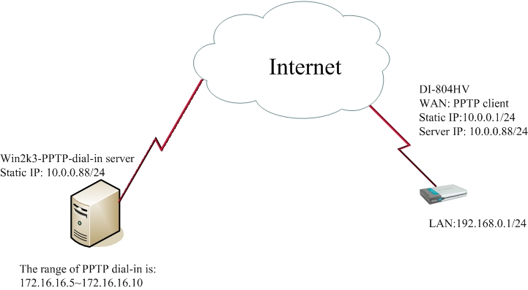
Notice:
1. The DI-8xx series no support the function of MPPE, so the windows 2003 PPTP server must allow no encryption to establish the PPTP tunnel.

Setting for PPTP Client-----DI-804HV
Step 1 Set the WAN type as static PPTP for DI-804
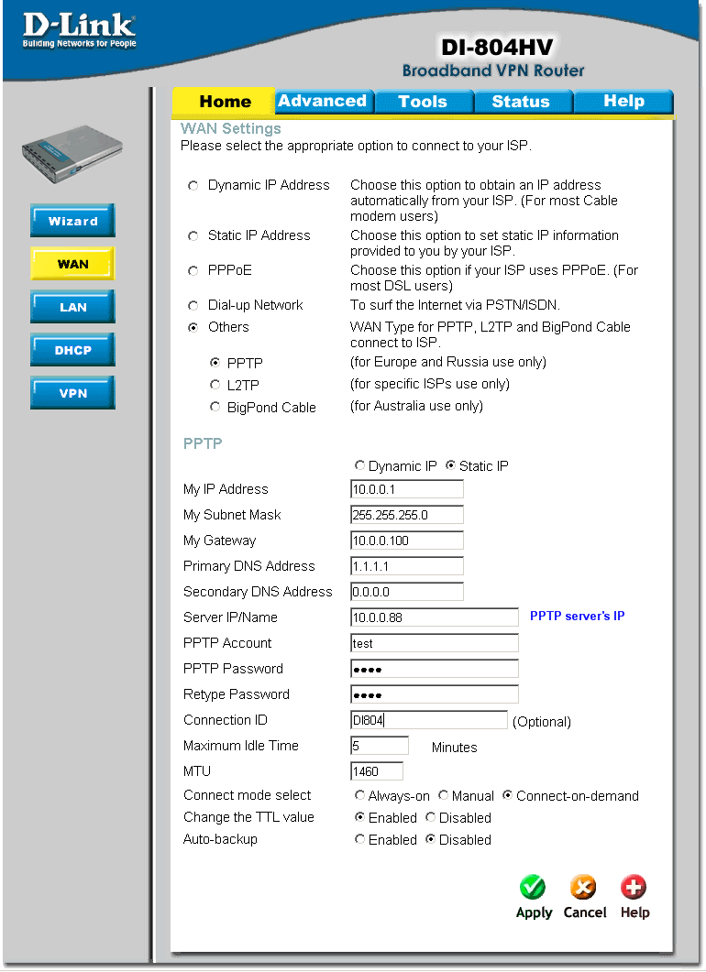
Setting for PPTP Server-----Windows 2003 R2
Step1 Go to Routing and Remote Access service, then press “configure and Enable Routing and Remote Access”
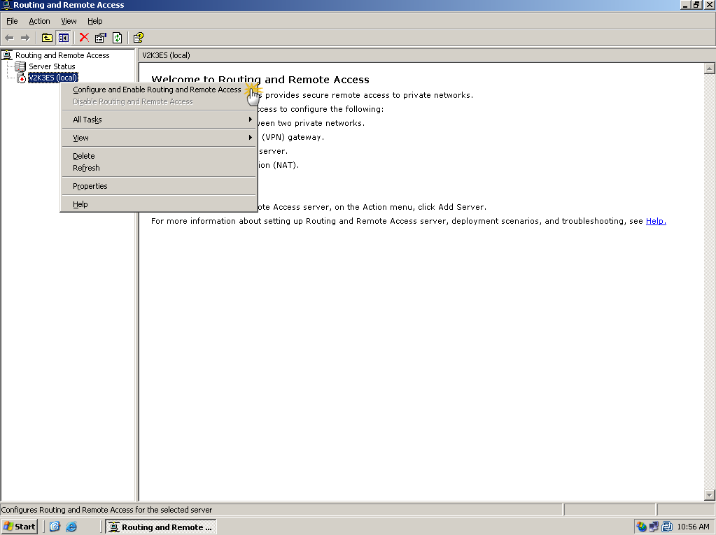
Step2 Popup the Wizard→ click “Next”
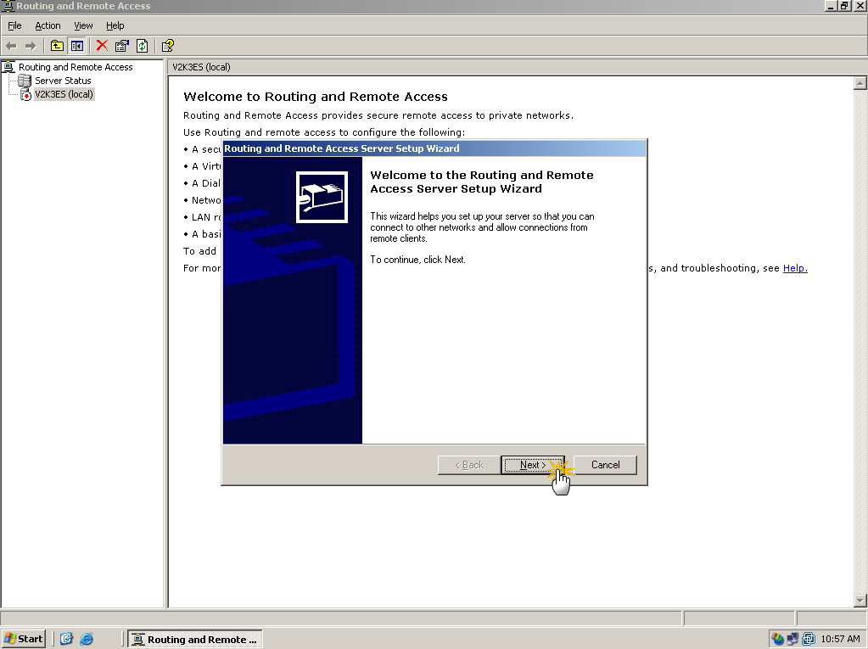
Step3 Choosing “Custom configuration”
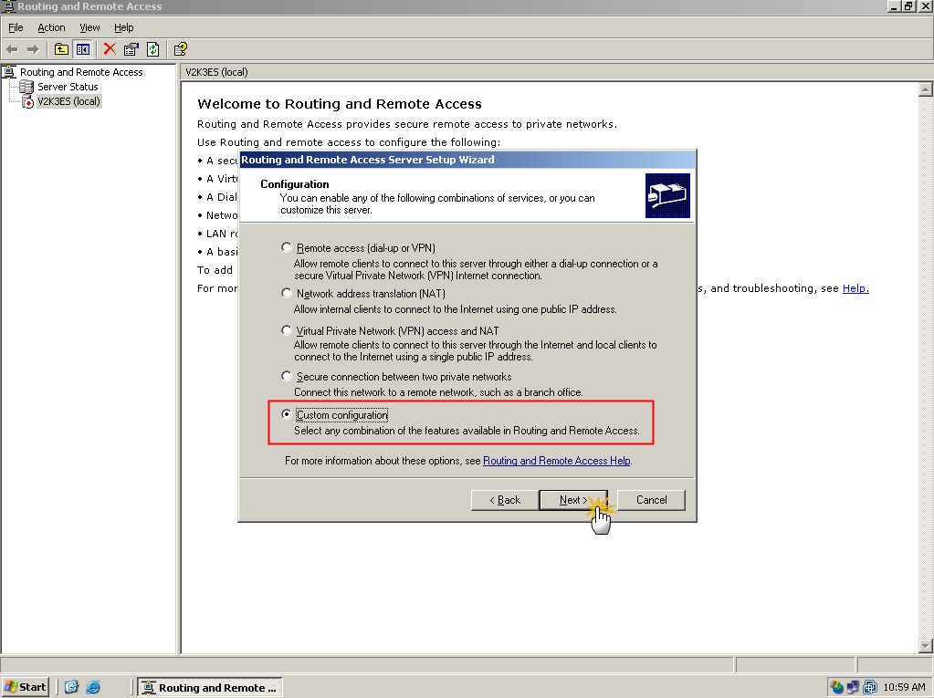
Step4 Choosing the “VPN access”.
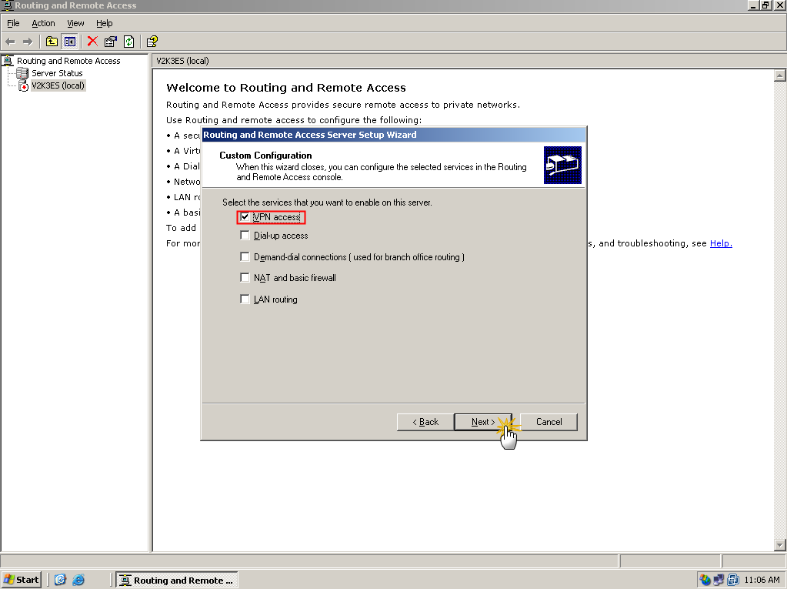
Step5 click the finish, then starting the service.
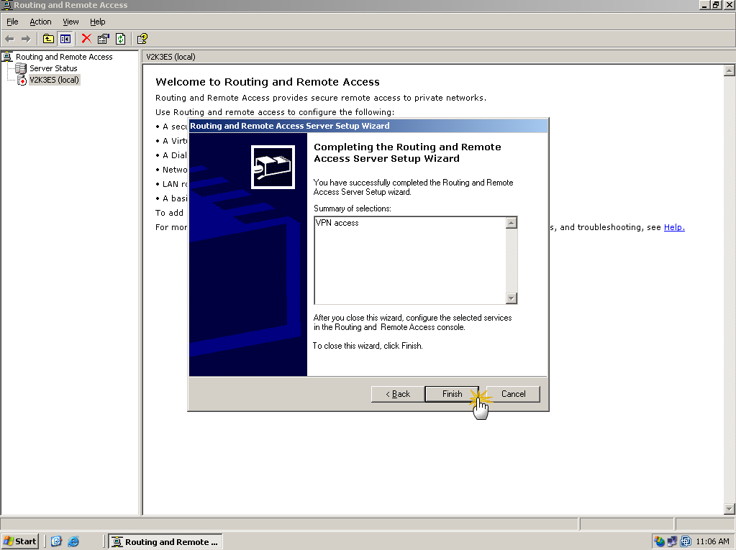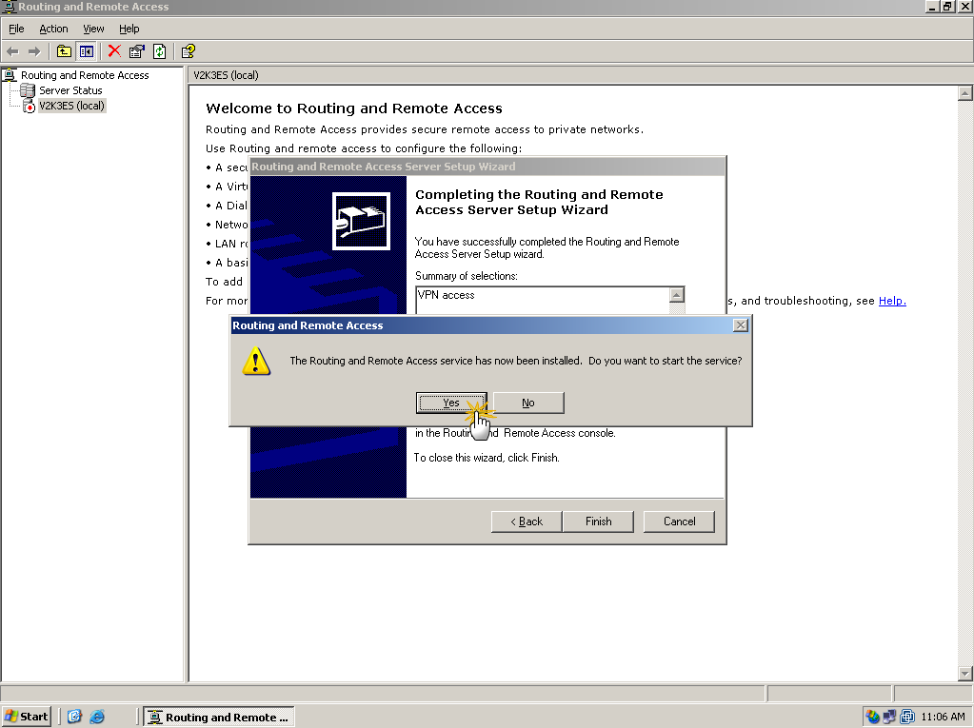
Step6 Check the properties, then following the step as below.


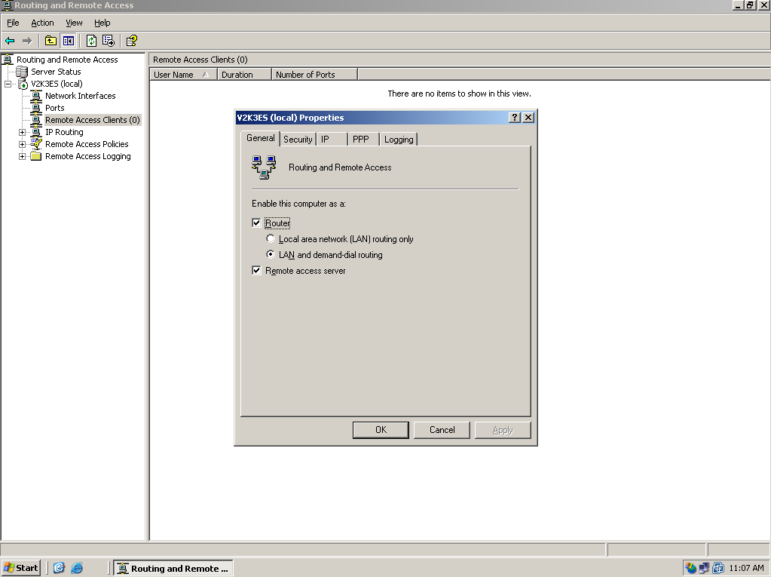
Step7 Choosing the Authentication Method of MS-CHAP, CHAP and PAP, then click ok.

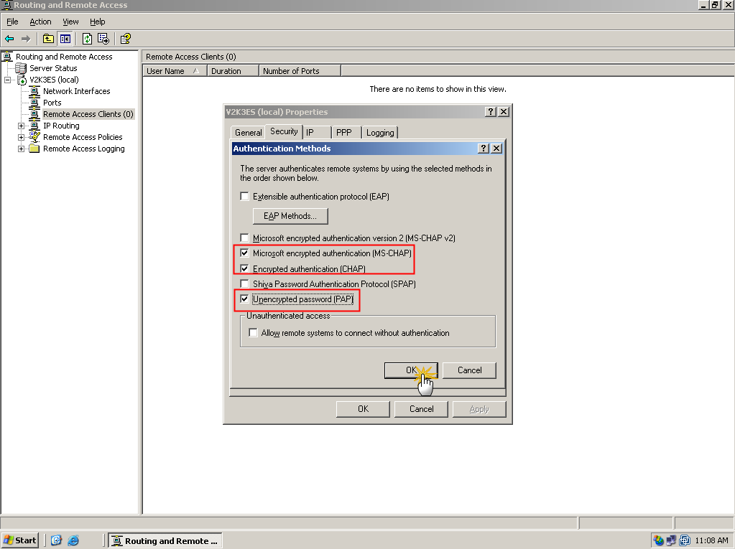

Step8 create an IP range pool for PPTP clients. Within the scenario, we set the range as 172.16.16.5~172.16.16.10
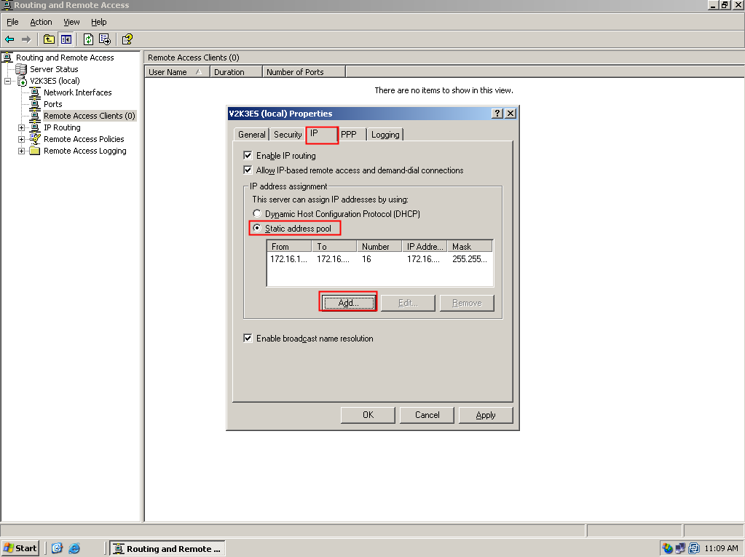
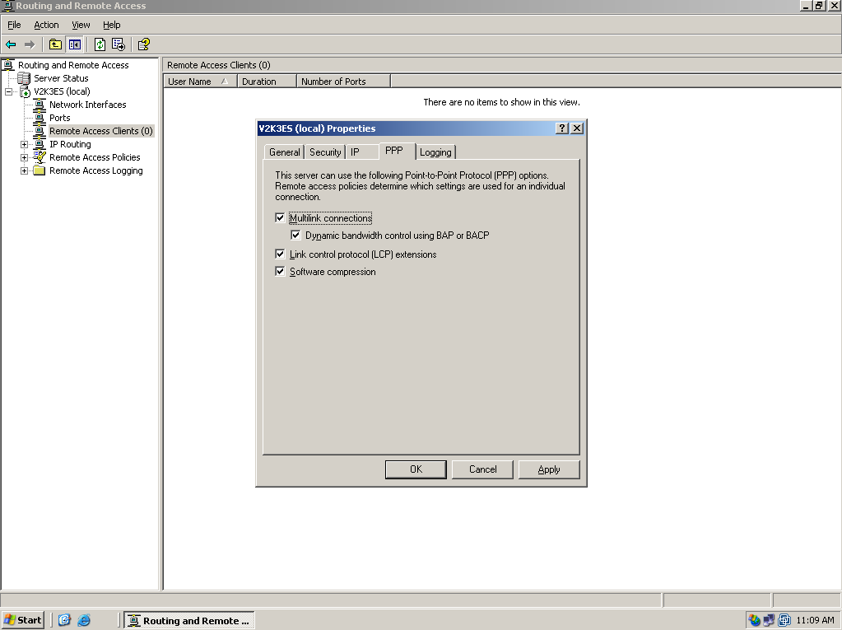
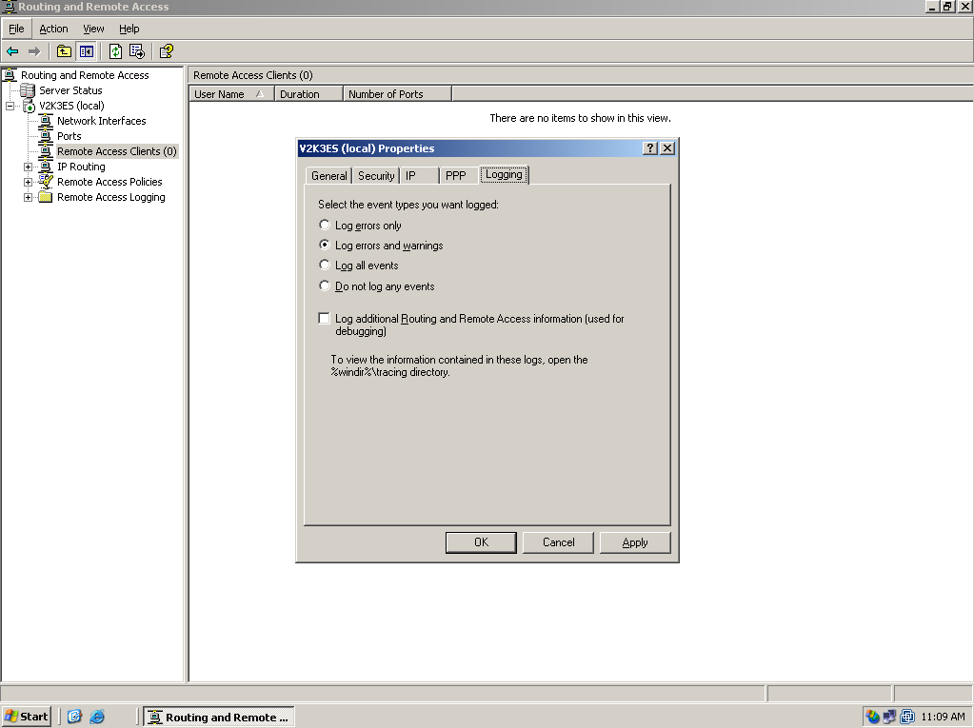
Step9 Add new policy for DI-804HV, and put it on first order.
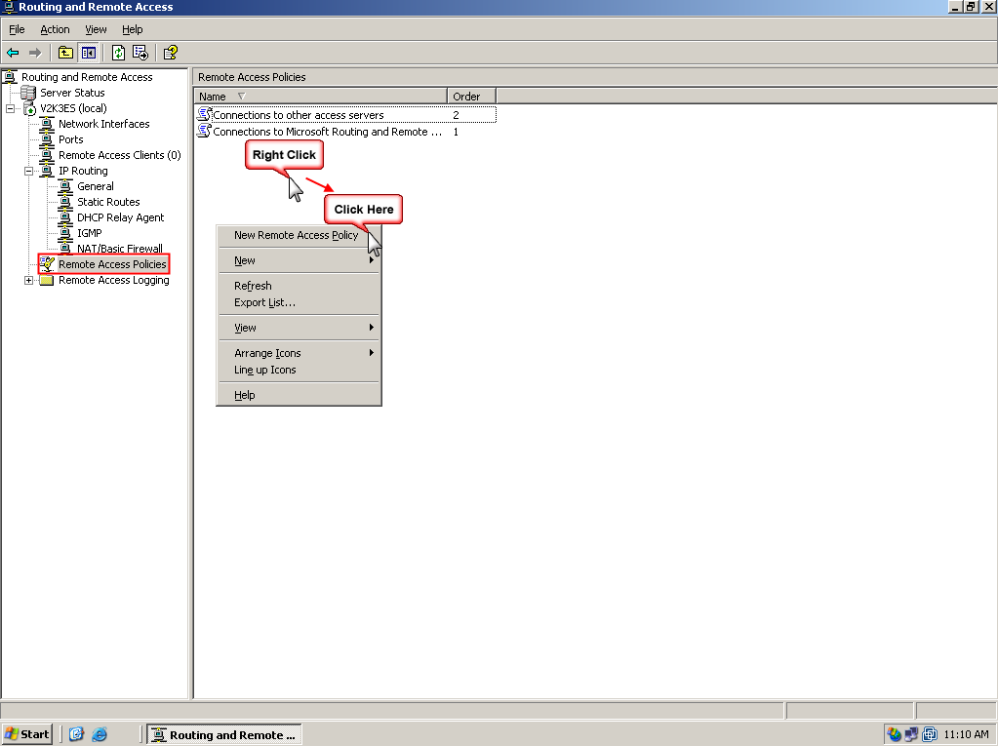
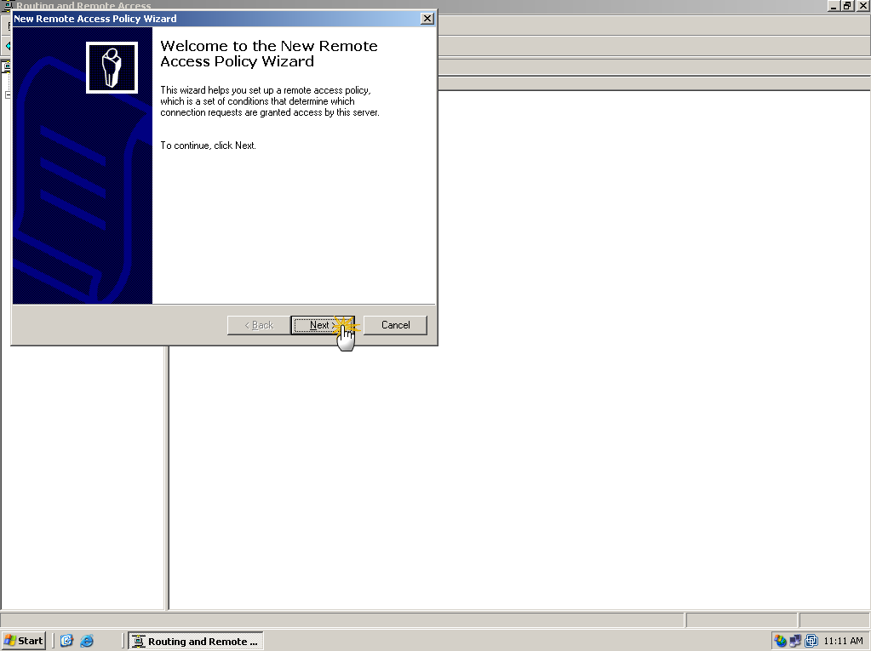
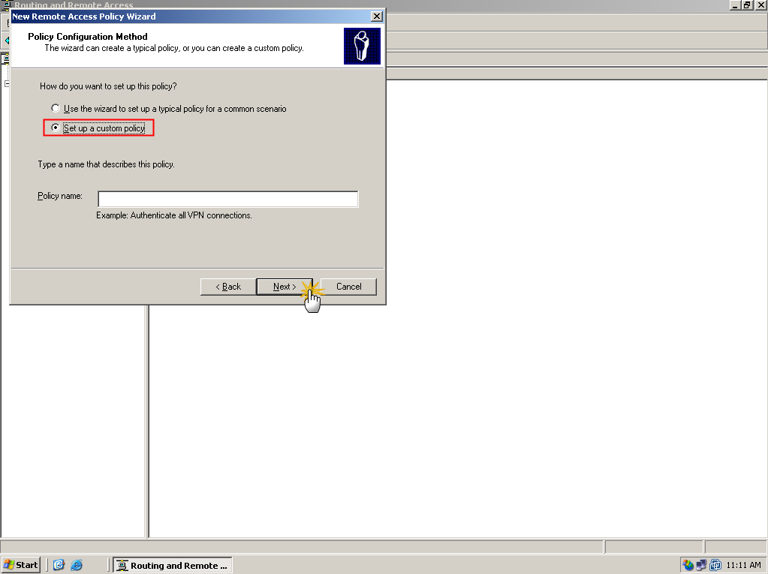
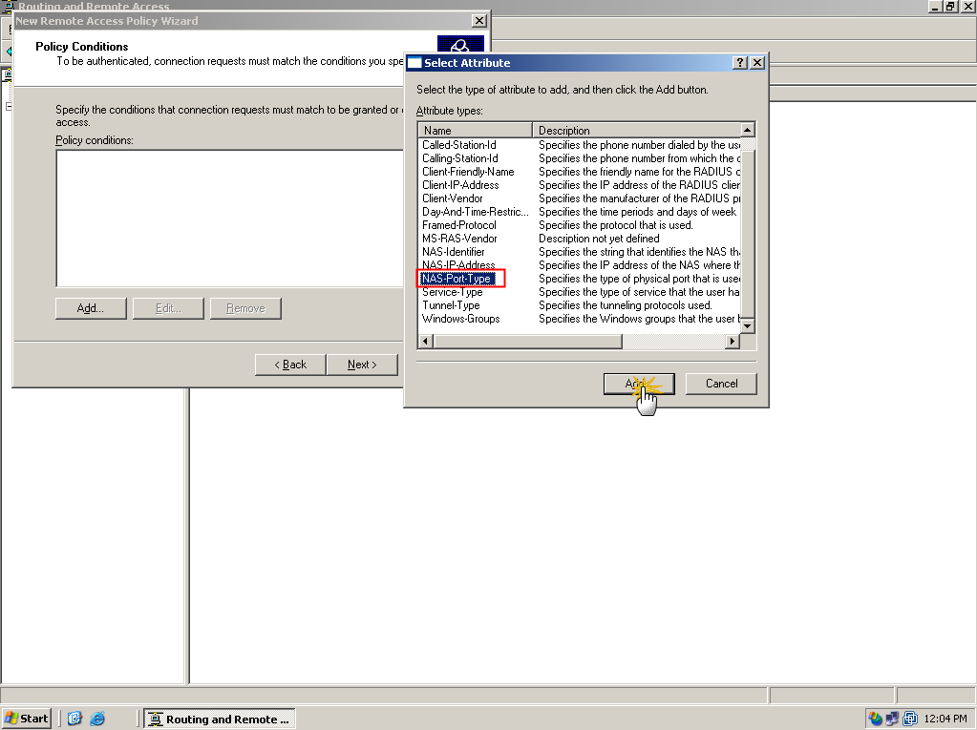
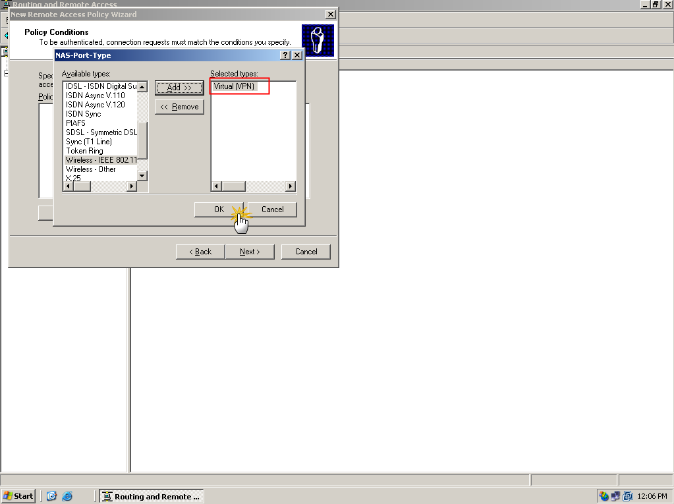
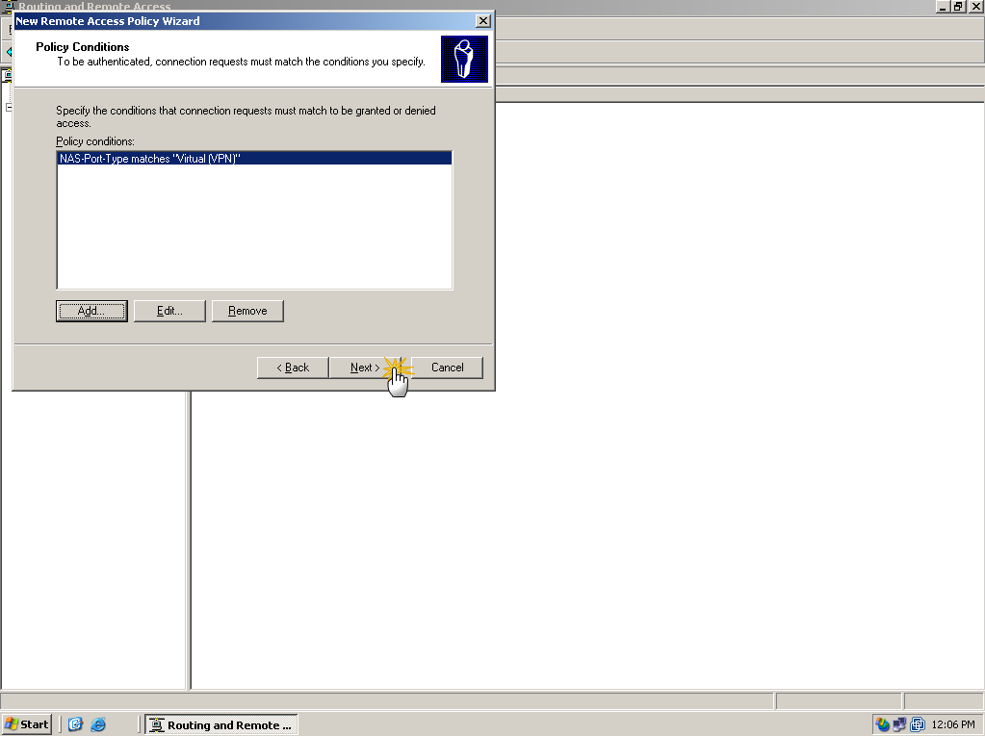
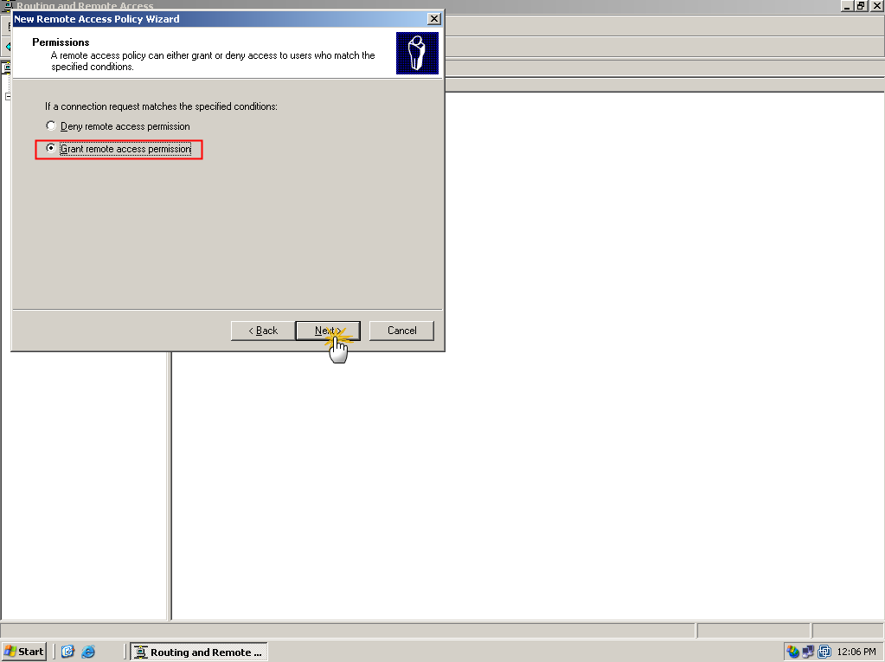
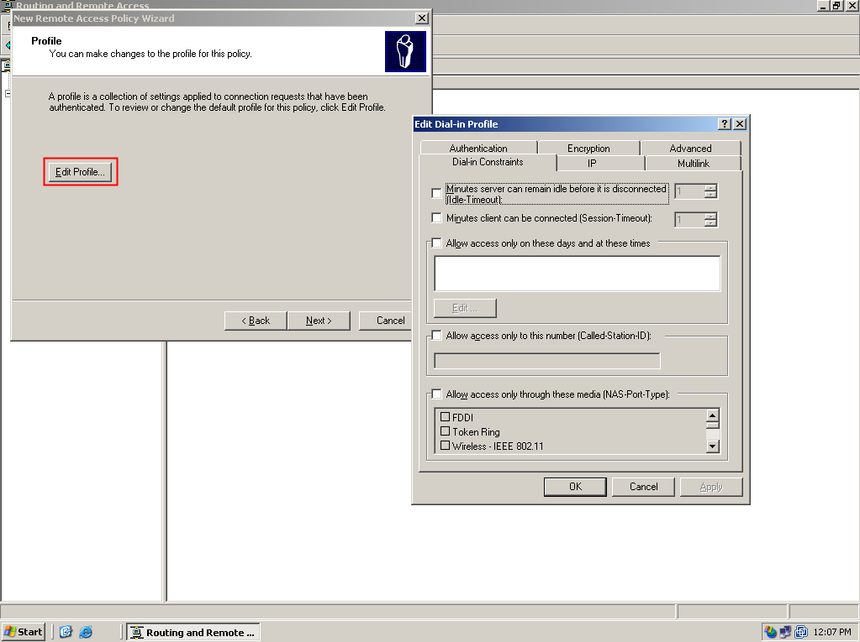
Step10 The DI-804HV no support MPPE, so we enable “No encryption” on PPTP server.
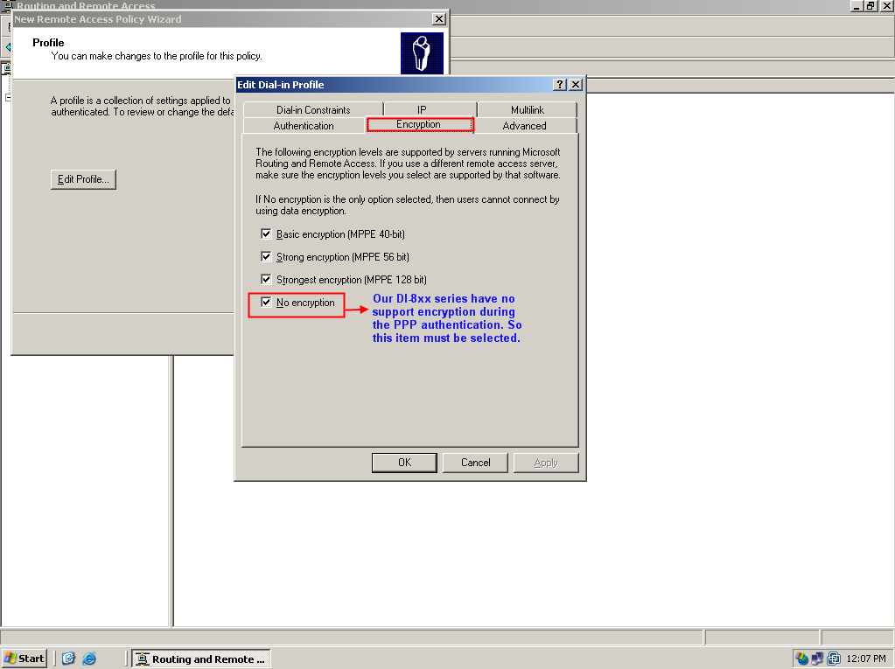
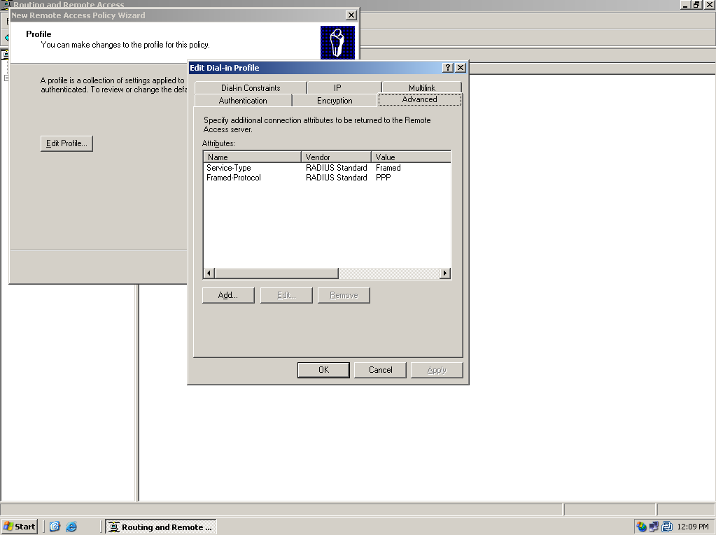
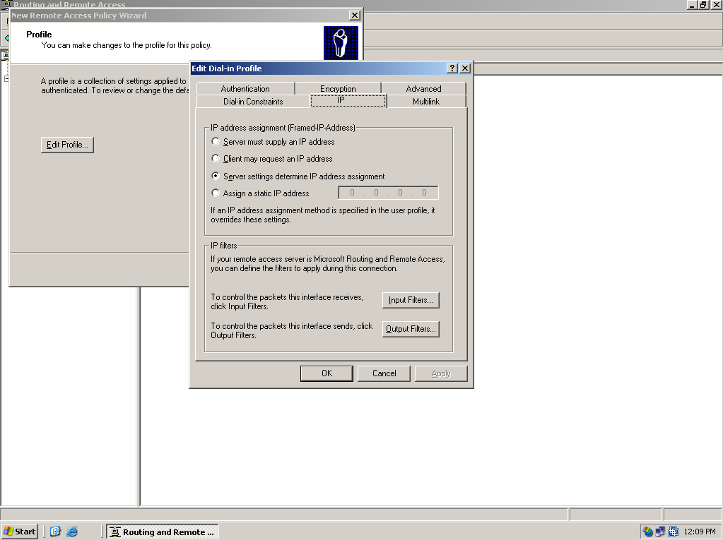
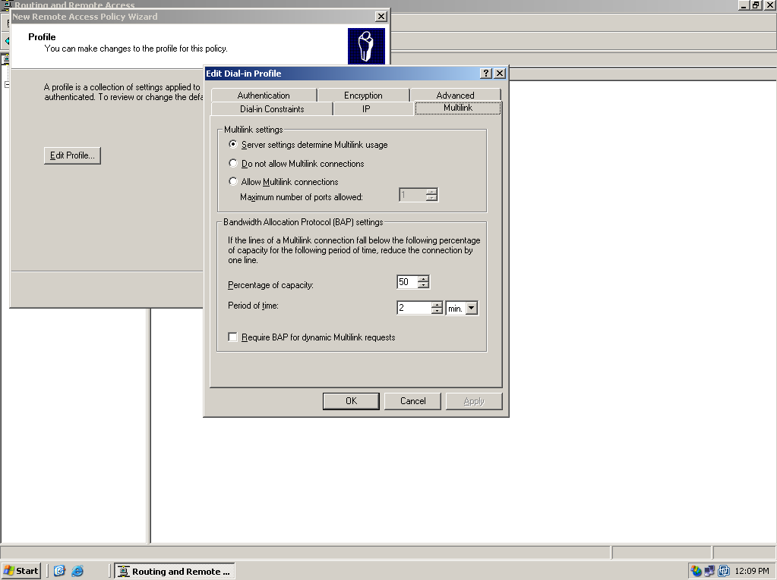
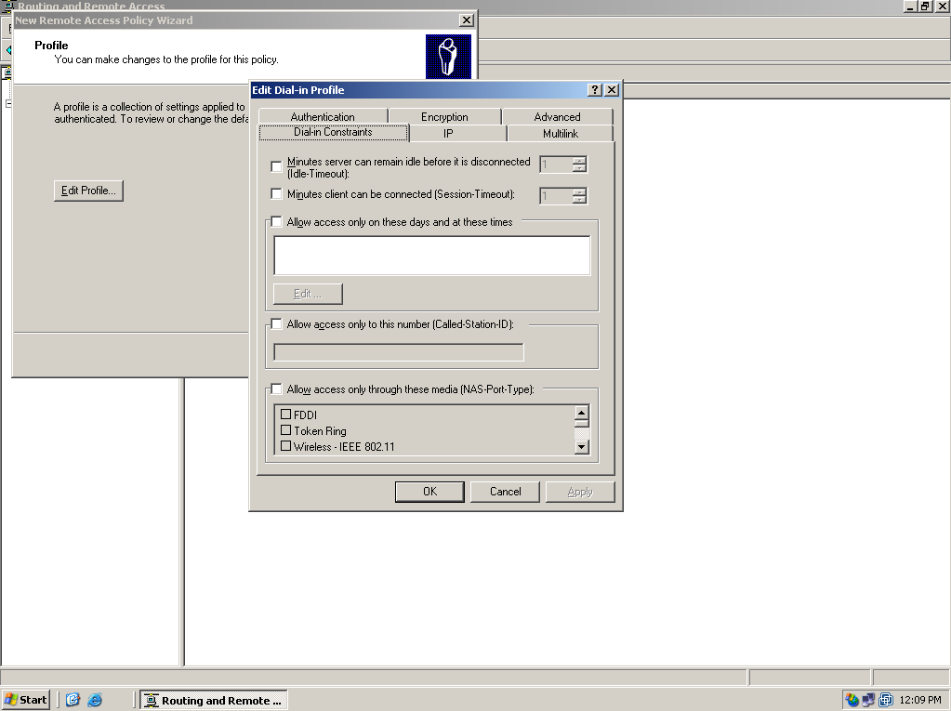
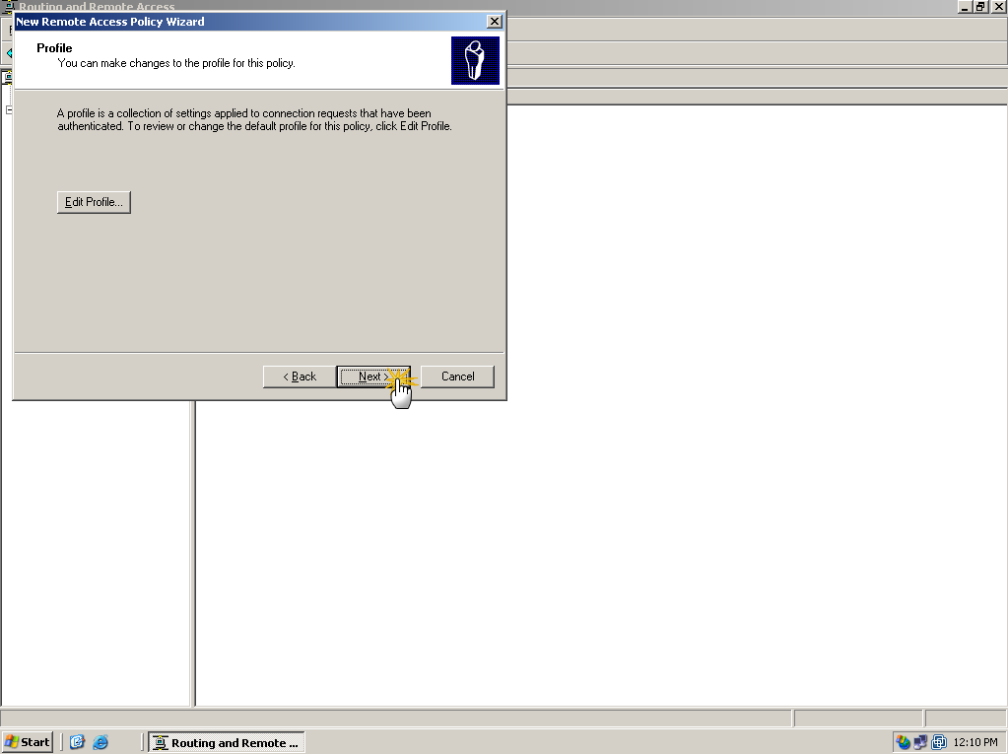
Step Add a user for PPTP authentication. Within the scenario, we add an account as “test” who is allowed to dial into PPTP server.
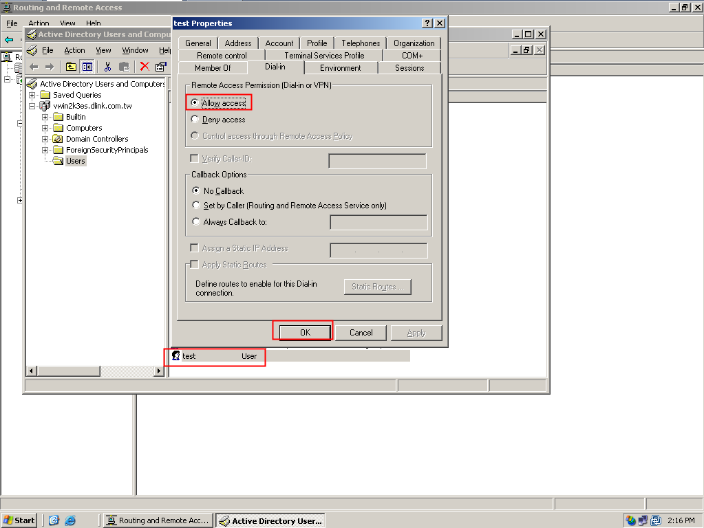

Confirm
DI-804HV dial up to PPTP server
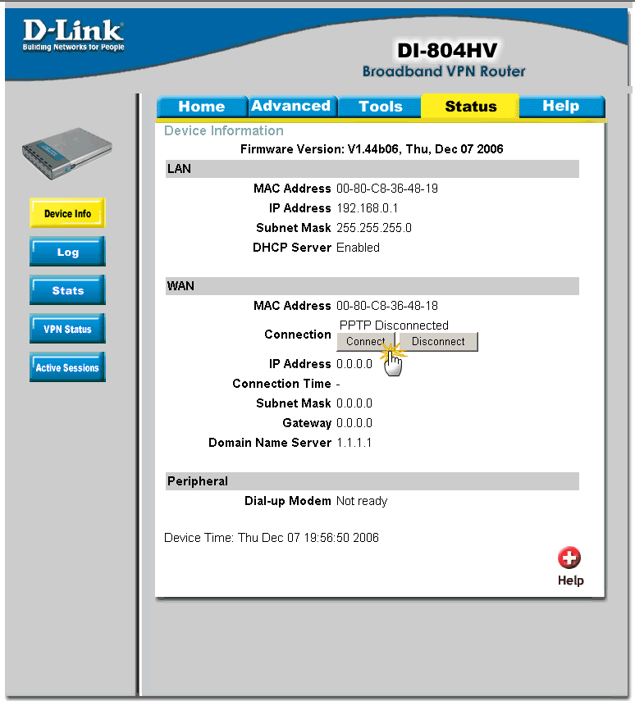

DI-804HV get the IP address from PPTP server.
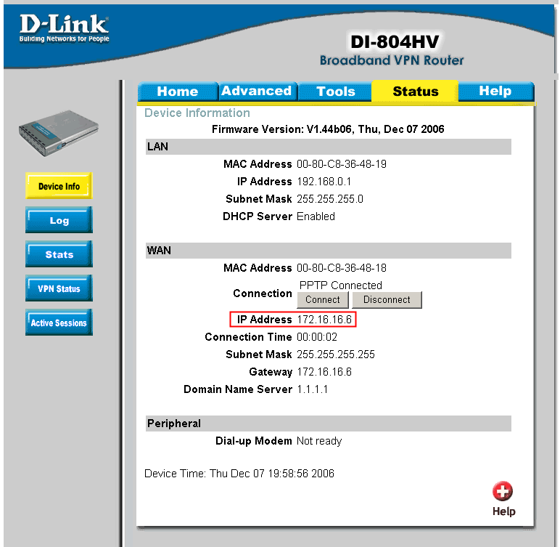

Check status of PPTP server, then we can find the client already connect into PPTP server.
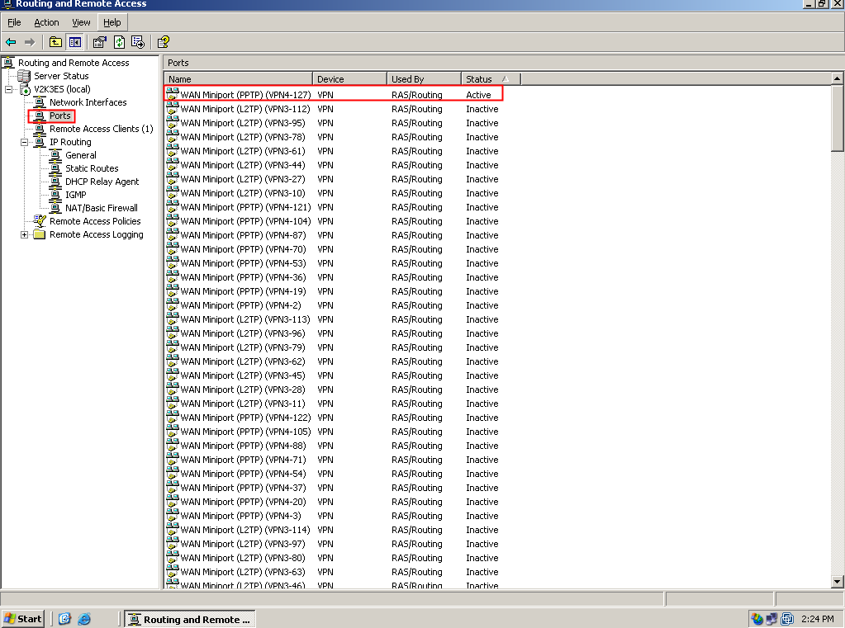
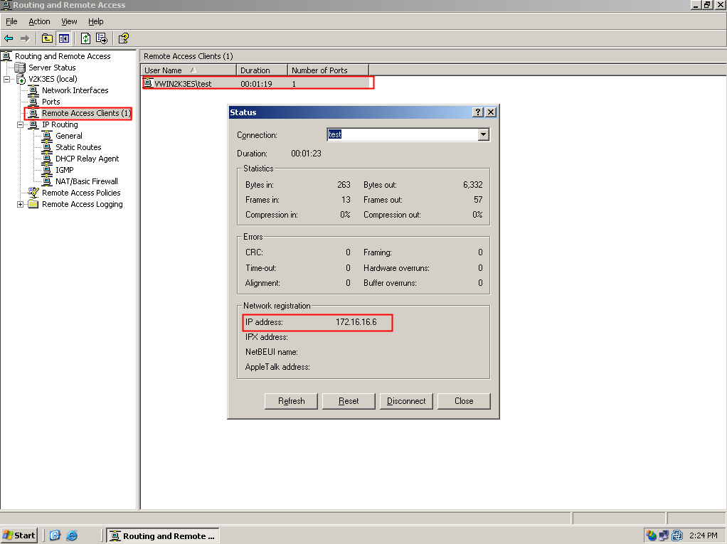

End of document

