DHP-306AV/DHP-307AV firmware upgrade utility guide

System requirements
Windows XP, Windows Vista, or Windows 7 with network support.

Step 1: Install the utility
Follow the wizard’s instructions to install the firmware upgrade utility.
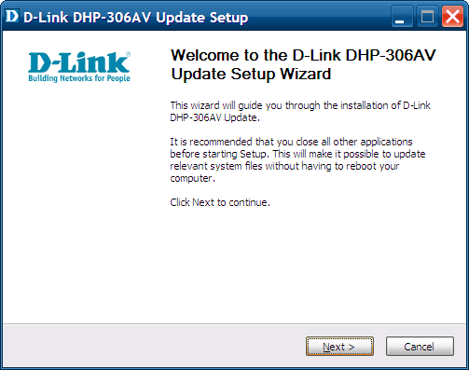

Step 2: Connect to device
Plug the DHP-306AV into an AC wall outlet. Connect one end of the supplied CAT5 Ethernet cable to the Ethernet port of the DHP-306AV and the other end of the cable to the Ethernet port of your computer.

Step 3: Run the utility
Follow these simple steps to upgrade your device. 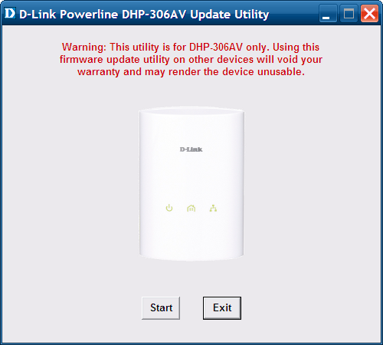
Note: Do not turn off the power and disconnect the Ethernet cable before the process has completed.
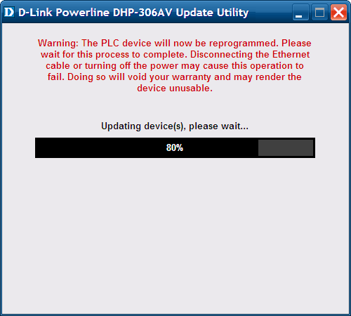

Step 4: Upgrade completed
When the firmware upgrade process has completed, the following screenshot will be displayed. If the update was not successful, please run the utility again.
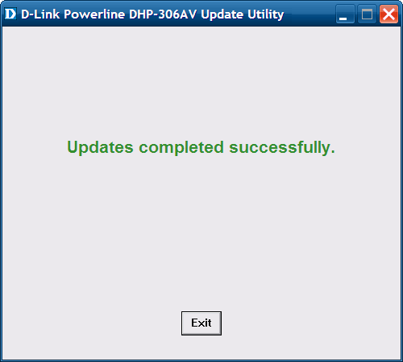
Note: For DHP-307AV users, please connect to another one DHP-306AV first and then go back to Step 2.

