

Firmware Version: | 4.10.B029
Boot Code Version: | 1.00.017
MIB Version: | 4.10.002
D-View Module Version: | 4.0.0.3
Published: | Dec. 26, 2016

These release notes include important information about D-Link switch firmware revisions. Please verify that these release notes are correct for your switch:
- If you are installing a new switch, please check the hardware version on the device label; make sure that your switch meets the system requirement of this firmware version. Please refer to Revision History and System Requirement for detailed firmware and hardware matrix.
- If the switch is powered on, you can check the hardware version by typing “show switch” command via Telnet or by checking the device information page on the web graphic user interface.
- If you plan to upgrade to the new firmware release, please refer to the Upgrade Instructions for the correct firmware upgrade procedure.
For more detailed information regarding our switch products, please refer to Related Documentation.
You can also download the switch firmware, D-View modules and technical documentation from http://tsd.dlink.com.tw.

Content:
Upgrade Instructions: 2
Upgrade using CLI (via Telnet) 2
Upgrade using Web-UI 3
Upgrade using SmartConsole Utility 3
2. Execute SmartConsole Utility 3
New Features: 3
Changes of MIB & D-View Module: 3
Changes of Command Line Interface: 3
Problem Fixed: 3
Known Issues: 3
Related Documentation: 3

Revision History and System Requirement:
Firmware Version | Date | Model | Hardware Version
Runtime: v4.10.B029  Boot: 1.00.017 | 26- Dec.-16 | DGS-1210-28P | C1
Runtime: v4.10.B027  Boot: 1.00.017 | 28- Nov.-16 | DGS-1210-28P | C1
Runtime: v4.10.B026  Boot: 1.00.017 | 16- Nov.-16 | DGS-1210-28P | C1
Runtime: v4.10.B025  Boot: 1.00.017 | 27- Oct.-16 | DGS-1210-28P | C1
Runtime: v4.10.B022  Boot: 1.00.017 | 23- Sep.-16 | DGS-1210-28P | C1
Runtime: v4.10.B021  Boot: 1.00.017 | 29- Aug.-16 | DGS-1210-28P | C1
Runtime: v4.10.B019  Boot: 1.00.017 | 14- Jun.-16 | DGS-1210-28P | C1
Runtime: v4.10.B018  Boot: 1.00.017 | 27- May.-16 | DGS-1210-28P | C1
Runtime: v4.10.B017  Boot: 1.00.017 | 16- May.-16 | DGS-1210-28P | C1
Runtime: v4.10.B013  Boot: 1.00.016 | 16- Mar.-16 | DGS-1210-28P | C1
Runtime: v4.10.B012  Boot: 1.00.016 | 03- Mar.-16 | DGS-1210-28P | C1
Runtime: v4.10.B011  Boot: 1.00.016 | 22- Jan.-16 | DGS-1210-28P | C1
Runtime: v4.10.B008  Boot: 1.00.016 | 07- Jan.-16 | DGS-1210-28P | C1
Runtime: v4.10.B005  Boot: 1.00.016 | 23- Dec.-15 | DGS-1210-28P | C1
Runtime: v4.10.004  Boot: 1.00.016 | 15- Dec.-15 | DGS-1210-28P | C1
Runtime: v4.00.B092  Boot: 1.00.016 | 03- Dec.-15 | DGS-1210-28P | C1
Runtime: v4.00.B087  Boot: 1.00.016 | 23- Nov.-15 | DGS-1210-28P | C1
Runtime: v4.00.B086  Boot: 1.00.016 | 20- Nov.-15 | DGS-1210-28P | C1
Runtime: v4.00.B085  Boot: 1.00.016 | 03- Nov.-15 | DGS-1210-28P | C1
Runtime: v4.00.B084  Boot: 1.00.016 | 16- Oct.-15 | DGS-1210-28P | C1
Runtime: v4.00.B083  Boot: 1.00.016 | 13- Oct.-15 | DGS-1210-28P | C1
Runtime: v4.00.B082  Boot: 1.00.016 | 30- Sep.-15 | DGS-1210-28P | C1
Runtime: v4.00.B081  Boot: 1.00.016 | 18- Sep.-15 | DGS-1210-28P | C1
Runtime: v4.00.B078  Boot: 1.00.016 | 03- Sep.-15 | DGS-1210-28P | C1
Runtime: v4.00.B077  Boot: 1.00.016 | 27- Aug.-15 | DGS-1210-28P | C1
Runtime: v4.00.B076  Boot: 1.00.016 | 19- Aug.-15 | DGS-1210-28P | C1
Runtime: v4.00.B074  Boot: 1.00.016 | 03- Aug.-15 | DGS-1210-28P | C1
Runtime: v4.00.B072  Boot: 1.00.016 | 11- May.-15 | DGS-1210-28P | C1
Runtime: v4.00.0J66B  Boot: 1.00.016 | 20- Apr.-15 | DGS-1210-28P | C1
Runtime: v4.00.064  Boot: 1.00.016 | 02- Feb.-15 | DGS-1210-28P | C1
Runtime: v4.00.B055  Boot: 1.00.012 | 04- Sep.-14 | DGS-1210-28P | C1
Runtime: v4.00.B053  Boot: 1.00.012 | 19- Aug.-14 | DGS-1210-28P | C1
Runtime: v4.00.B052  Boot: 1.00.012 | 13- Aug.-14 | DGS-1210-28P | C1
Runtime: v4.00.B049  Boot: 1.00.012 | 29- July.-14 | DGS-1210-28P | C1
Runtime: v4.00.B046  Boot: 1.00.012 | 18- June.-14 | DGS-1210-28P | C1
Runtime: v4.00.B045  Boot: 1.00.012 | 08- May.-14 | DGS-1210-28P | C1
Runtime: v4.00.043  Boot: 1.00.012 | 17- Mar.-14 | DGS-1210-28P | C1
Runtime: v4.00.B042  Boot: 1.00.010 | 13- Mar.-14 | DGS-1210-28P | C1
Runtime: v4.00.B039  Boot: 1.00.010 | 06- Feb.-14 | DGS-1210-28P | C1
Runtime: v4.00.024  Boot: 1.00.010 | 05- Nov.-13 | DGS-1210-28P | C1

Upgrade Instructions:
D-Link Smart Switches support firmware upgrade via TFTP server. You can download the firmware from D-Link web site http://tsd.dlink.com.tw, and copy the downloaded firmware to the TFTP server folder. Please make sure that the TFTP server is accessible from the switch via networks.

Upgrade using CLI (via Telnet)
1. Make sure the network connection between the switch and PC is active.
2. Use software that supports telnet, for example, HyperTerminal or Telnet command in Microsoft Windows, to connect to the switch. If you are using Telnet command, type the command followed by the switch IP address, eg. telnet 10.90.90.90.
3. The logon prompt will appear.

The switch will prompt the user to enter his/her username and password. It should be noted that upon the initial connection, both the default user name and password are admin.
To upgrade the switch firmware, execute the following command:

Command | Function
download{firmware_fromTFTP tftp://ip-address/filename | cfg_fromTFTP tftp://ip-address/filename} | Download firmware file from the TFTP server to the switch.

When completing firmware upgrade, the following messages will pop up.
Device will reboot after firmware upgraded successfully
Image upgraded successfully

4. Execute the following command to check the firmware version and switch’s information.
Command | Function
show switch | Display the information of current firmware and boot version.

Example:

- DGS-1210-28P:
Command: download firmware_fromTFTP tftp://10.90.90.91 DGS-1210-28P-C1-4-00-024hex
Device will reboot after firmware upgraded successfully
Image upgraded successfully

- DGS-1210-28P:
Command: show switch
DGS-1210-28P> show switch
System name :
System Contact :
System Location :
System up time : 0 days, 0 hrs, 36 min, 56 secs
System Time : 01/01/2013 01:01:55
System hardware version : C1
System firmware version : 4.00.024
System boot version : 1.00.010
System serial number : 1MB1733K0000A
MAC Address : 00-87-87-AB-88-77

Upgrade using Web-UI
- Connect a workstation installed with java SE runtime environment to any switch port of the device.
- Open the web browser from the workstation and enter the IP address of the switch. The switch’s default IP address is 10.90.90.90.
- Enter administrator’s password when prompted. The password is admin by default.
- To update switch's firmware or configuration file, select Tools > Firmware Backup & Upgrade from the banner.
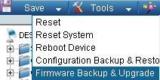v

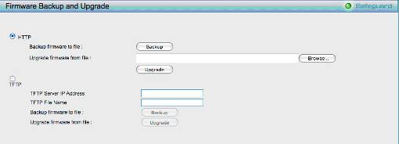
- Two methods can be selected : HTTP or TFTP

- Select HTTP to upgrade the firmware to or from your local drive of PC.
- Click Browse to browse your inventories for a saved firmware file
- Click Upgrade after selecting the firmware file you want to restore
- Click OK to continue with firmware upgrade
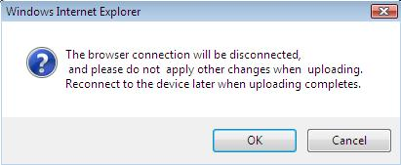

- Click OK to continue with firmware upgrade
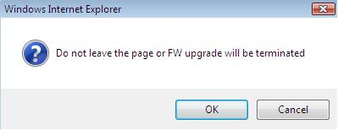

- Wait until the “Firmware Upgrade Successful” message pops up and login again after device boots up.
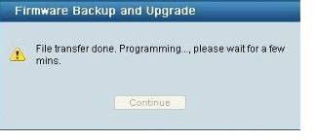

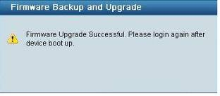

- Select TFTP to upgrade the firmware to or from a remote TFTP server.
- Enter the name of the firmware file located on the TFTP server
- Click Upgrade after selecting the firmware file you want to restore
- Click OK to continue with firmware upgrade

- Wait until the firmware upgrade ends and login again after device boots up.

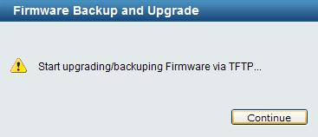

Upgrade using D-Link Network Assistant
1. Connect a workstation installed with java SE runtime environment to any switch port of the device

2. Execute D-Link Network Assistant
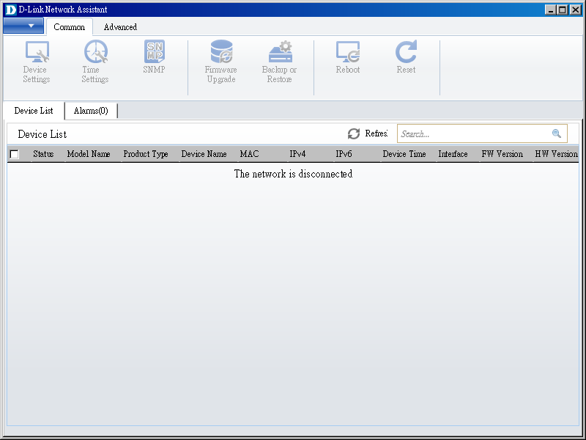

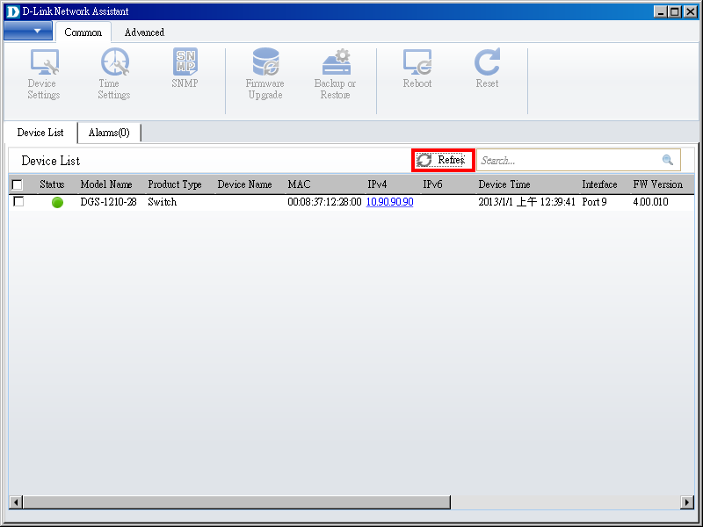
3. Click Refresh button to search target switch

4. Single click the icon of the column to choose the target switch
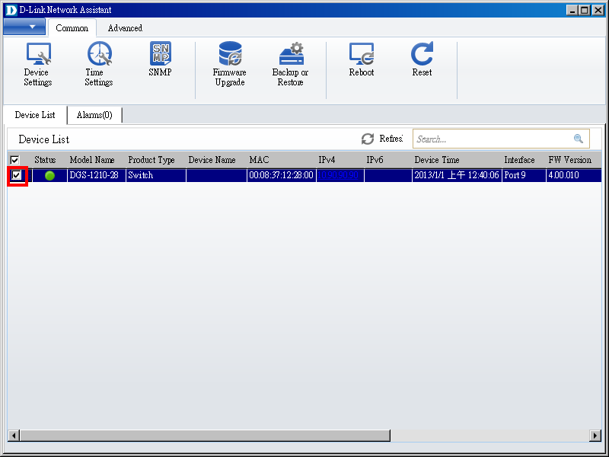

5. Click Firmware Upgrade button
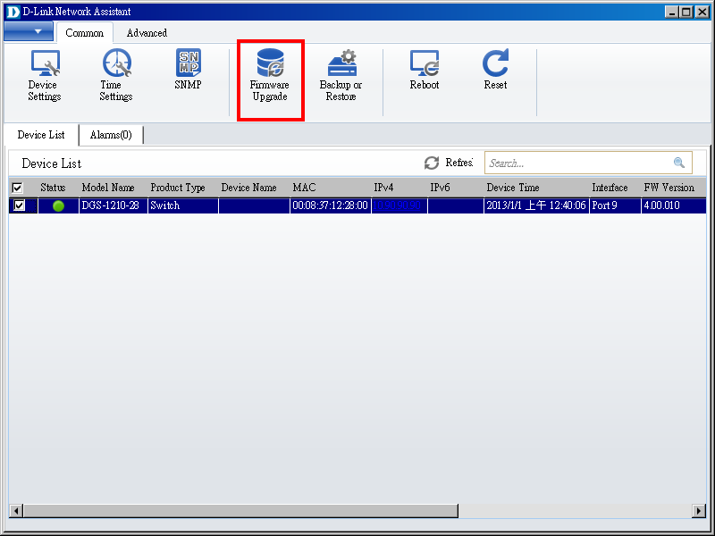

6. Select PC IP address is used to connect the target switch, then click Browse button and select the firmware file (Model name_HW ver._FW ver. .hex) on your local hard drive.
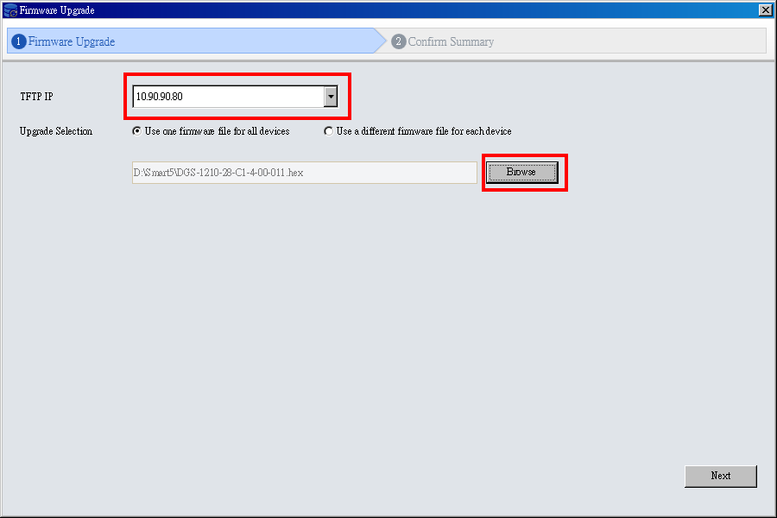

7. Click the checkbox and click “Submit” button to start firmware upgrade.
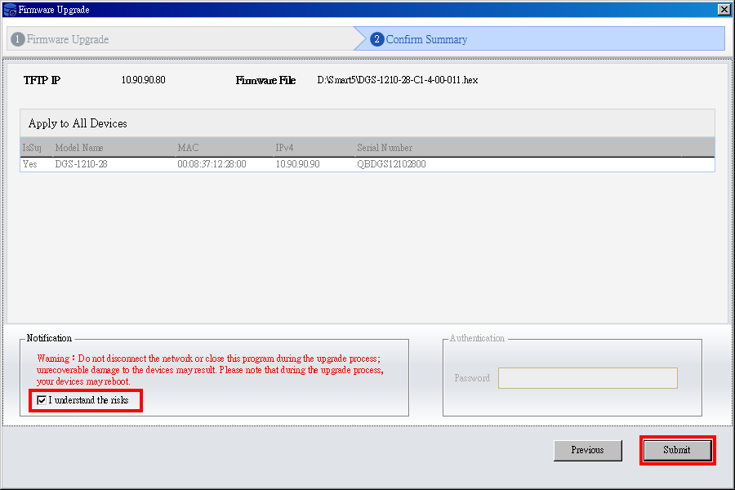

8. Once the message changed to success, click “Close” button to complete and exit the firmware upgrade
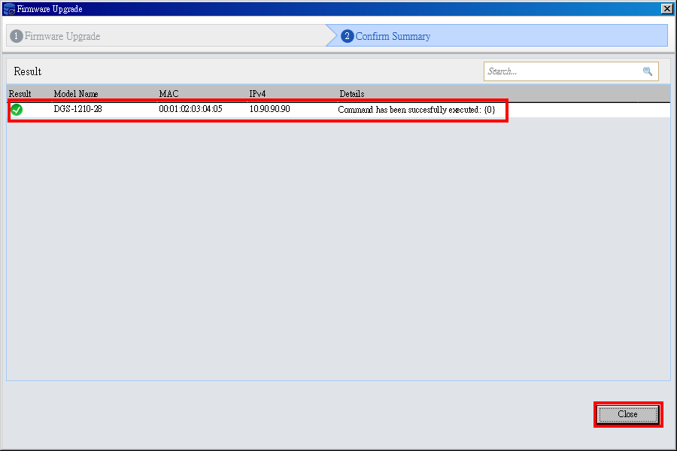

New Features:

Firmware Version | New Features
V4.10.B029 | N/A
V4.10.B027 | N/A
V4.10.B026 | N/A
V4.10.B025 | N/A
V4.10.B022 | N/A
V4.10.B021 | N/A
V4.10.B019 | N/A
V4.10.B018 | N/A
V4.10.B017 | N/A
V4.10.B013 | N/A
V4.10.B012 | N/A
V4.10.B011 | N/A
V4.10.B008 | N/A
V4.10.B005 | N/A
V4.10.004 | - Change default of EEE to disable.  - Port Auto Downgrade.  - Legacy PD.
V4.00.B092 | N/A
V4.00.B087 | N/A
V4.00.B086 | N/A
V4.00.B085 | N/A
V4.00.B084 | N/A
V4.00.B083 | N/A
V4.00.B082 | N/A
V4.00.B081 | N/A
V4.00.B078 | N/A
V4.00.B077 | N/A
V4.00.B076 | N/A
V4.00.B074 | N/A
V4.00.B072 | N/A
V4.00.J066B | N/A
V4.00.064 | N/A
V4.00.B055 | N/A
V4.00.B053 | N/A
V4.00.B052 | N/A
V4.00.B049 | N/A
V4.00.B046 | N/A
V4.00.B045 | N/A
V4.00.043 | N/A
V4.00.B042 | N/A
V4.00.B039 | N/A
V4.00.024 | First Release

Changes of MIB & D-View Module:
The new features of MIB file are also included in the corresponding D-View module. Please download the D-View module from http://tsd.dlink.com.tw. For detailed changes of MIB content, please refer to the modification history in each MIB file.
Firmware Version | MIB File | New Features
V4.10.B029 | DGS-1210-28P-CX-4-10-002.mib | N/A
V4.10.B027 | DGS-1210-28P-CX-4-10-002.mib | N/A
V4.10.B026 | DGS-1210-28P-CX-4-10-002.mib | N/A
V4.10.B025 | DGS-1210-28P-CX-4-10-002.mib | N/A
V4.10.B022 | DGS-1210-28P-CX-4-10-002.mib | N/A
V4.10.B021 | DGS-1210-28P-CX-4-10-002.mib | N/A
V4.10.B019 | DGS-1210-28P-CX-4-10-002.mib | N/A
V4.10.B018 | DGS-1210-28P-CX-4-10-002.mib | N/A
V4.10.B017 | DGS-1210-28P-CX-4-10-002.mib | N/A
V4.10.B013 | DGS-1210-28P-CX-4-10-002.mib | N/A
V4.10.B012 | DGS-1210-28P-CX-4-10-002.mib | N/A
V4.10.B011 | DGS-1210-28P-CX-4-10-002.mib | N/A
V4.10.B008 | DGS-1210-28P-CX-4-10-002.mib | N/A
V4.10.B005 | DGS-1210-28P-CX-4-10-002.mib | N/A
V4.10.004 | DGS-1210-28P-CX-4-10-002.mib | - Port Auto Downgrade.  - Legacy PD.
V4.00.B092 | DGS-1210-28P-CX-4-00-B017.mib | N/A
V4.00.B087 | DGS-1210-28P-CX-4-00-B017.mib | N/A
V4.00.B086 | DGS-1210-28P-CX-4-00-B017.mib | N/A
V4.00.B085 | DGS-1210-28P-CX-4-00-B017.mib | N/A
V4.00.B084 | DGS-1210-28P-CX-4-00-B017.mib | N/A
V4.00.B083 | DGS-1210-28P-CX-4-00-B017.mib | N/A
V4.00.B082 | DGS-1210-28P-CX-4-00-B017.mib | Add DHCPRetryTimes object.
V4.00.B081 | DGS-1210-28P-CX-4-00-B016.mib | N/A
V4.00.B078 | DGS-1210-28P-CX-4-00-B014.mib | N/A
V4.00.B077 | DGS-1210-28P-CX-4-00-B014.mib | N/A
V4.00.B076 | DGS-1210-28P-CX-4-00-B014.mib | N/A
V4.00.B074 | DGS-1210-28P-CX-4-00-B014.mib | N/A
V4.00.B072 | DGS-1210-28P-CX-4-00-B014.mib | N/A
V4.00.J066B | DGS-1210-28P-CX-4-00-B014.mib | N/A
V4.00.064 | DGS-1210-28P-CX-4-00-B014.mib | N/A
V4.00.B055 | DGS-1210-28P-CX-4-00-B014.mib | N/A
V4.00.B053 | DGS-1210-28P-CX-4-00-B014.mib | N/A
V4.00.B052 | DGS-1210-28P-CX-4-00-B014.mib | N/A
V4.00.B049 | DGS-1210-28P-CX-4-00-B014.mib | 1. Add poePortLegacyPDDetect object on DGS-1210-28P.
V4.00.B046 | DGS-1210-28P-CX-4-00-013.mib | N/A
V4.00.B045 | DGS-1210-28P-CX-4-00-013.mib | N/A
V4.00.043 | DGS-1210-28P-CX-4-00-013.mib | N/A
V4.00.B042 | DGS-1210-28P-CX-4-00-B012.mib | Add poePortDelayPowerDetect object for 59111 IOT issue with HIKVision Camera on DGS-1210-28P.
V4.00.B039 | DGS-1210-28P-CX-4-00-010.mib | N/A
V4.00.024 | DGS-1210-28P-CX-4-00-010.mib | First Release

Firmware Version | D-View Module File | New Features
V4.10.B029 | DView_DGS-1210-28PC1_4.0.0.5_setup.exe | N/A
V4.10.B027 | DView_DGS-1210-28PC1_4.0.0.5_setup.exe | N/A
V4.10.B026 | DView_DGS-1210-28PC1_4.0.0.5_setup.exe | N/A
V4.10.B025 | DView_DGS-1210-28PC1_4.0.0.5_setup.exe | N/A
V4.10.B022 | DView_DGS-1210-28PC1_4.0.0.5_setup.exe | N/A
V4.10.B021 | DView_DGS-1210-28PC1_4.0.0.5_setup.exe | N/A
V4.10.B019 | DView_DGS-1210-28PC1_4.0.0.5_setup.exe | N/A
V4.10.B018 | DView_DGS-1210-28PC1_4.0.0.5_setup.exe | N/A
V4.10.B017 | DView_DGS-1210-28PC1_4.0.0.5_setup.exe | N/A
V4.10.B013 | DView_DGS-1210-28PC1_4.0.0.5_setup.exe | N/A
V4.10.B012 | DView_DGS-1210-28PC1_4.0.0.5_setup.exe | N/A
V4.10.B011 | DView_DGS-1210-28PC1_4.0.0.5_setup.exe | N/A
V4.10.B008 | DView_DGS-1210-28PC1_4.0.0.5_setup.exe | N/A
V4.10.B005 | DView_DGS-1210-28PC1_4.0.0.5_setup.exe | N/A
V4.10.004 | DView_DGS-1210-28PC1_4.0.0.5_setup.exe | Update the Digital Signature.
V4.00.B092 | DV_DGS-1210-28P_V4.0.0.3_FW_v4.00.024.exe | N/A
V4.00.B087 | DV_DGS-1210-28P_V4.0.0.3_FW_v4.00.024.exe | N/A
V4.00.B086 | DV_DGS-1210-28P_V4.0.0.3_FW_v4.00.024.exe | N/A
V4.00.B085 | DV_DGS-1210-28P_V4.0.0.3_FW_v4.00.024.exe | N/A
V4.00.B084 | DV_DGS-1210-28P_V4.0.0.3_FW_v4.00.024.exe | N/A
V4.00.B083 | DV_DGS-1210-28P_V4.0.0.3_FW_v4.00.024.exe | N/A
V4.00.B082 | DV_DGS-1210-28P_V4.0.0.3_FW_v4.00.024.exe | N/A
V4.00.B081 | DV_DGS-1210-28P_V4.0.0.3_FW_v4.00.024.exe | N/A
V4.00.B078 | DV_DGS-1210-28P_V4.0.0.3_FW_v4.00.024.exe | N/A
V4.00.B077 | DV_DGS-1210-28P_V4.0.0.3_FW_v4.00.024.exe | N/A
V4.00.B076 | DV_DGS-1210-28P_V4.0.0.3_FW_v4.00.024.exe | N/A
V4.00.B074 | DV_DGS-1210-28P_V4.0.0.3_FW_v4.00.024.exe | N/A
V4.00.B072 | DV_DGS-1210-28P_V4.0.0.3_FW_v4.00.024.exe | N/A
V4.00.J066B | DV_DGS-1210-28P_V4.0.0.3_FW_v4.00.024.exe | N/A
V4.00.064 | DV_DGS-1210-28P_V4.0.0.3_FW_v4.00.024.exe | N/A
V4.00.B055 | DV_DGS-1210-28P_V4.0.0.3_FW_v4.00.024.exe | N/A
V4.00.B053 | DV_DGS-1210-28P_V4.0.0.3_FW_v4.00.024.exe | N/A
V4.00.B052 | DV_DGS-1210-28P_V4.0.0.3_FW_v4.00.024.exe | N/A
V4.00.B049 | DV_DGS-1210-28P_V4.0.0.3_FW_v4.00.024.exe | N/A
V4.00.B046 | DV_DGS-1210-28P_V4.0.0.3_FW_v4.00.024.exe | N/A
V4.00.B045 | DV_DGS-1210-28P_V4.0.0.3_FW_v4.00.024.exe | N/A
V4.00.043 | DV_DGS-1210-28P_V4.0.0.3_FW_v4.00.024.exe | N/A
V4.00.B042 | DV_DGS-1210-28P_V4.0.0.3_FW_v4.00.024.exe | N/A
V4.00.B039 | DV_DGS-1210-28P_V4.0.0.3_FW_v4.00.024.exe | N/A
V4.00.024 | DV_DGS-1210-28P_V4.0.0.3_FW_v4.00.024.exe | First Release

Changes of Command Line Interface:
The section below only shows command line changes that may bring backward compatibility issues with configuration settings for previous version of firmware.
Any new feature commands that do not have backward compatibility issues are not included in the below section.

Firmware Version | Changes
V4.10.B029 | N/A
V4.10.B027 | N/A
V4.10.B026 | N/A
V4.10.B025 | N/A
V4.10.B022 | N/A
V4.10.B021 | N/A
V4.10.B019 | N/A
V4.10.B018 | N/A
V4.10.B017 | N/A
V4.10.B013 | N/A
V4.10.B012 | N/A
V4.10.B011 | N/A
V4.10.B008 | N/A
V4.10.B005 | N/A
V4.10.004 | N/A
V4.00.B092 | N/A
V4.00.B087 | N/A
V4.00.B086 | N/A
V4.00.B085 | N/A
V4.00.B084 | N/A
V4.00.B083 | N/A
V4.00.B082 | N/A
V4.00.B081 | N/A
V4.00.B078 | N/A
V4.00.B077 | N/A
V4.00.B076 | N/A
V4.00.B074 | N/A
V4.00.B072 | N/A
V4.00.J066B | N/A
V4.00.064 | N/A
V4.00.B055 | N/A
V4.00.B053 | N/A
V4.00.B052 | N/A
V4.00.B049 | N/A
V4.00.B046 | N/A
V4.00.B045 | N/A
V4.00.043 | N/A
V4.00.B042 | N/A
V4.00.B039 | N/A
V4.00.024 | First Release

Problem Fixed:

Firmware Version | Problems Fixed
V4.10.B029 | - DES-1210 rev.C1 accepts incompatible firmware[DRU20161207000001-Russia]  - DGS-1210 connection is unstable[DGC20161103000001-Taiwan]  - DGS-1210 issue with multicast packets[DRU20161208000005-Russia]  - filter ISIS packets[DGC20161222000002-Taiwan]  - DES-1210-28P issue with device management 2[DRU20161025000001-Russia].
V4.10.B027 | - [DRU20161110000001] STP port cost on aggregation lacp link.
V4.10.B026 | - Issue loading web interface in Mac OS 10.12[DUSA20161108000001-Canada].
V4.10.B025 | - Unable to delete snmp group settings [DI20161011000001-Japan]
V4.10.B022 | - DGS-1210 rev.C1 DoS prevention blocks NTP [DRU20160823000001-Russia]  - PoE port state setting is not kept after rebooting the switch[DI20160907000002-Japan]
V4.10.B021 | - SNMP Community Name needs to support special characters “!”.  - DGS-1210: Manual / Sync Time Settings with TimeZone settings [DUSA20160730000002-USA].  - DGS-1210-52P issue with link aggregation.[DRU20160811000004-Russia]  - DGS-1210 rev.C1 can't configure DOS attack prevention [DRU20160819000001-Russia].
V4.10.B019 | - The same poe issue with case:DGC20160406000001[DGC20160523000002-Taiwan].
V4.10.B018 | - VLAN ID can’t save [DEUR20160510000007-Eastern Europe].
V4.10.B017 | - PORT DESCRIPTION IS NOT PROPAGATED[DEUR20160420000006-Eastern Europe].
V4.10.B013 | - DGS-1210-52 issue with CARP entries [DRU20160216000002-Russia].
V4.10.B012 | - Fix Switch Web Server issue, WebUI blocked by Kaspersky antivirus [DRU20160125000007-Russia].  - DGS-1210-28 DNA and host IP address [DEUR20160204000002-Central Europe].
V4.10.B011 | - Remove web login timeout to improve user-experience.  - Fix browser auto save website account and password incorrect issue.
V4.10.B008 | - Fix change password with special characters, cannot login issue.  - WebGUI will login timeout after we enter "Port Statistics".
V4.10.B005 | - DGS-1210 DHCP Enhancement for Whitesky.  - DGS-1210-28 save configuration failed！[DGC20151217000003-China]  - Increase security with web login.
V4.10.004 | - For formal release.
V4.00.B092 | - [DEUR20151120000003-Eastern Europe]Test Case that Port mirror does not mirror outgoing traffic.  - Please see the Bug Tracking System. (WS5 Series).
V4.00.B087 | - Make sure the issue of user can download configuration file with any authentication will be fixed.  - Configuration backup button not work.
V4.00.B086 | - Change the password field in the html file to replace with “check” or other suitable field.  - To remove the concern, we suggest to run hash on the client side, too. In other words, please change the java script to make sure client will send out new password which is been hashed and send to switch. Then switch need to run hash with its original password and compare these two string are the same.  - Gamebit value should be hashed. It will help to make sure to randomize gamebit value from user point of view.  - Make sure the issue of user can download configuration file with any authentication will be fixed.  - Fix [DEUR20150529000006]DGS-1210-28 – VoiceVLAN
V4.00.B085 | - Fix Samsung SENS RC420 cannot ping correctly when EEE enabled. (D-track DI20151015000004-Korea).  - Change external PHY as master preferred mode (DEUR20151012000003).  - Enable IEEE802.3az EEE Fast Ethernet connection failed.(DGC20151019000003-China).  - Change default of EEE to disable.
V4.00.B084 | - Change default of EEE to disable.
V4.00.B083 | - DGS-1210 WebSmart wrong stp cost on lacp links [DRU20150907000006-Russia].  - DGS-1210 rev.B1 reboots[DRU20150907000005-Russia].
V4.00.B082 | - HQ20150921000011: ACL question[DGC20150921000002-Taiwan]  - Add DHCP retry time for [DUSA20150721000002]DGS-1210 DHCP client mode stops similar to case DUSA20131128000001  - HQ20150820000009: LACP Issue with Windows Server 2012R2[DEUR20150819000004-UKI].
V4.00.B081 | - [DRU20150729000002]DES-1210 dos prevention blocks ip phones traffic.  - [DRU20150903000003-Russia]DES-1210-28P issue with adding port to vlan.  - [DUSA20150820000002]DHCP for management on DGS-1210-28 C1 for VLAN 1 affecting VLAN 2.
V4.00.B078 | - Power budget assignment per port with LLDP[DI20150602000006-Japan.  - LLDP/LLDP-MED default disabled.
V4.00.B077 | - Fix issue: DGS-1210 DHCP client mode stops similar to case DUSA20131128000001[DUSA20150721000002-USA].  - Fix issue:[HQ20150707000001]DGS-1210-28 Lease renewal DNS and nslookup issue - DHCP option 12[DUSA20150707000001-USA]  - Fix the filter unregistered multicast feature doesn't work issue.
V4.00.B076 | - Fix [HQ20150814000010]DGS-1210-10P the Admin password can be changed by everybody without knowing the Admin password. [DEUR20150813000005-Central Europe]  - PoE AT port add 2-Event Physical Layer classification in default.
V4.00.B074 | 1. OpenSSL issue: CVE-2015-1789 (OpenSSL before 0.9.8zg)  https://web.nvd.nist.gov/view/vuln/detail?vulnId=CVE-2015-1789  2. [DGC20150626000004-Taiwan]MAC ACL function problem.  3. [DEUR20150722000006-Central Europe]DGS-1210 - VLAN LBD issue.
V4.00.B072 | - [DEUR20150420000001-Eastern Europe]IGMP Leave is sent with wrong Source IP.
V4.00.J066B | - DGS-1210 C1 Factory setting for EEE function[DI20150226000004]
V4.00.064 | - Fix Multilanguage DE issue.  - Fix config backup page issue.  - Fix config backup page at DE language issue.  - Fix IPv6 TFTP Fw backup fail.
V4.00.B055 | 1. Fix incorrect model on SSL certificate.
V4.00.B053 | 1. [DGC20140801000004-Taiwan] DGS-1210-28 can't show the specific igmp group.
V4.00.B052 | 1. OpenSSL before 0.9.8za, which allows man-in-the-middle attack, and consequently hijack sessions or obtain sensitive information.
V4.00.B049 | 1. Add Enable / Disable Legacy PD detection for POE feature.
V4.00.B046 | 1. [DUSA20140530000002-Canada] DGS 1210-28P will not forward LLDP multicast mac address.
V4.00.B045 | - Modify STP edge default value to "True".  - long ping response time.
V4.00.043 | - Updated version to 4.00.043.
V4.00.B042 | 1. 59111 IOT issue with HIKVision Camera, Please be noted, first time PoE mcu upgrade will cause initialize time delay about 6-7 minutes.
V4.00.B039 | 1. Add New default MAC (B0C5540 ~ B0C5547) for ASV.  2. [DBG13120389] There are some packet loss when sends IPV6_CTRL1.str and IPV6_CTRL2.str.
V4.00.024 | First Release

* D-Link tracking number is enclosed in ()

Known Issues:
Firmware Version | Issues | Workaround
V4.10.B029 | N/A | None
V4.10.B027 | N/A | None
V4.10.B026 | N/A | None
V4.10.B025 | N/A | None
V4.10.B022 | N/A | None
V4.10.B021 | N/A | None
V4.10.B019 | N/A | None
V4.10.B018 | N/A | None
V4.10.B017 | N/A | None
V4.10.B013 | N/A | None
V4.10.B012 | N/A | None
V4.10.B011 | N/A | None
V4.10.B008 | N/A | None
V4.10.B005 | N/A | None
V4.10.004 | N/A | None
V4.00.B092 | N/A | None
V4.00.B087 | N/A | None
V4.00.B086 | N/A | None
V4.00.B085 | N/A | None
V4.00.B084 | N/A | None
V4.00.B083 | N/A | None
V4.00.B082 | N/A | None
V4.00.B081 | N/A | None
V4.00.B078 | N/A | None
V4.00.B077 | N/A | None
V4.00.B076 | N/A | None
V4.00.B074 | N/A | None
V4.00.B072 | N/A | None
V4.00.J066B | N/A | None
V4.00.064 | N/A | None
V4.00.B055 | N/A | None
V4.00.B053 | N/A | None
V4.00.B052 | N/A | None
V4.00.B049 | N/A | None
V4.00.B046 | N/A | None
V4.00.B045 | N/A | None
V4.00.043 | N/A | None
V4.00.B042 | N/A | None
V4.00.B039 | N/A | None
V4.00.024 | - When use D-View Module and Private MIB to set interface MDI/MDIX, the DUT console display settings fail info.(Web Browser settings does not exist this issue)  Wait about 10 mins, the DUT will no reply.  Broadcom 1000M Full does not  support MDI/MDIX.  - Follow D-Link test plan, the DUT default settings ping respond need to <= 1 ms, but our DUT cannot fit this request. (Limitation)  - The DUT DHCP Relay function cannot support two device DHCP relay application.  - The DUTVoice VLAN and ASV dynamic member ingress rule still follow original VLAN member rule not Voice or ASV VLAN. (Limitation)  - The DUT Auto Sureillance VLAN default OUI does not fit D-Link ASV Spec 1.3.  D-Link Surveillance Device range should support 28-10-7B-00-00-00 ~ 28-10-7B-2F-FF-FF, but test result 28-10-7B-30-00-00 still can join to dynamic member. (Limitation)  - The DUT Mirror Function Target Port always get packets with Tag info from Source port TX even all ports belong to Untag and forward Untag packets to test.  (PS: Mirror RX 􀙛unction does not exist this issue)  (Limitation)  - The DUT VLAN Based Loopback detection will cause DUT cannot respond when uplink loop topology.  Test Step:  1. Create VLAN ID 256.  2. Control PC connect to 256 VLAN member.  3. Enable LBD VLAN mode support VID 1~255 and enable all ports LBD function.  4. Use port1 (include VID 1~255) uplink to loop topology.  5. The DUT no respond, we must remove loop topology, the DUT just can reply normally. (Limitation)  - The DUT LBD cannot block all ports loop interface after uplink all ports loop after about 10 mins.  Port1 connect to port2, port3 connect to port4...  Port23 connect to control PC, Port24 connect to  DHCPv4/v6 server.  The DUT will loop after about 10 mins, the DUT console interface will display error message and loop packets is ICMPv6 (RA) Multicast packets.(Limitation)  - The DUT Static MAC auto learning disable interface still can forward packets to other interface even does not create static MAC. (via ASV default OUI MAC address)  After confirm with D-Link Shan, he agree this behavior when forward fit OUI packets to disable auto learning interface at currect state, but still need note to D-Lab Bug System and test report. (Limitation)  - Sometimes the DUT STP P2P Function fast change port state does not valid after uplug and plug interface.(know issue)  - The DUT ACL Protocol Source/destination port mask check error settings function does not valid. The DUT still can accept incorrect port mask settings.  - Enable syslog log function,When the control PC connect to the DUT,syslog can get "PoE power off" message. (Limitation)  - PoE interface dispaly slower than other interface about 3 sec. (Limitation)  - When test DUT All port, it will be link down-> link up. (Limitation)  - When 802.1Q vlan mode change Asymmetric vlan mode Enabled,The DUT ping respond will become to hight in 802.1Q entry max. (Limitation)  - Enable EEE function and link with ASUS K52F (JMicron PCI Express Gigabit Ethernet Adapter)and A43S(Atheros AR8151), the speed down to 100 Full duplex mode.(base on win 8) (Limitation)  - When add white list via D-view, find the white list Web UI display does not fit with D-view.  - The DUT Static MAC auto learning disable interface still can forward packets to other interface even does not create static MAC. (via ASV default OUI MAC address)(know issue) | None

Related Documentation:
- DGS-1210-28P Series User Manual
- DGS-1210-28P Series Getting Started Guide

