[Step]

1.You can add the IP4 group(named DMZ_LAN) which contains lannet and dmznet on Address Book.
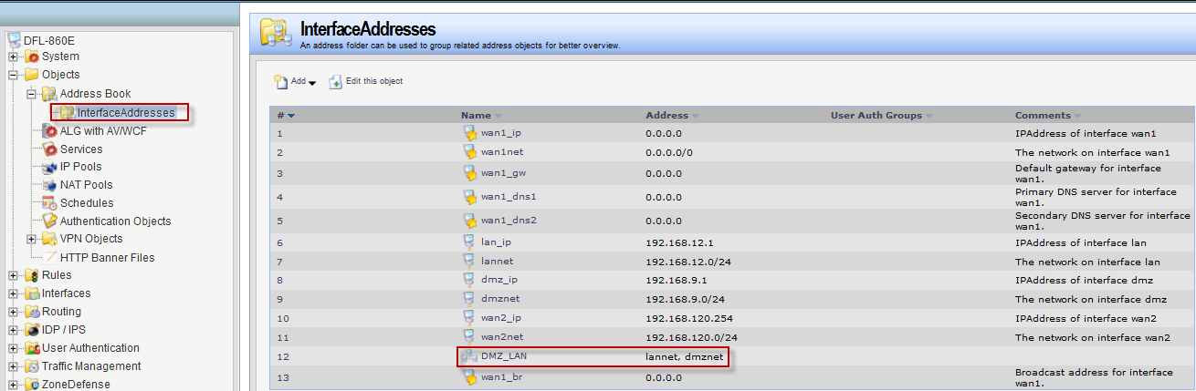

2. And then add the interface group (named DMZ_LAN) which contains LAN port and DMZ port on Interfaces.
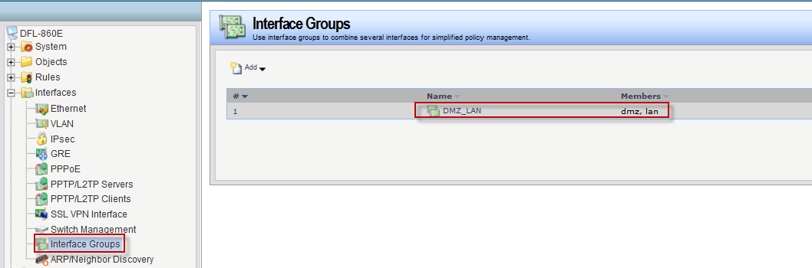

3. Finally, the IP Rules has changed.

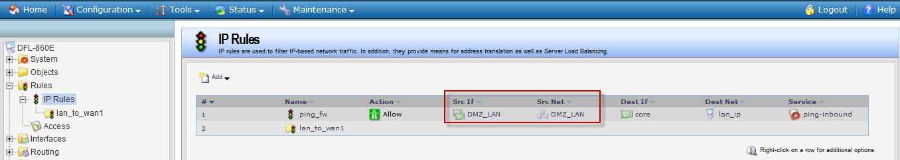
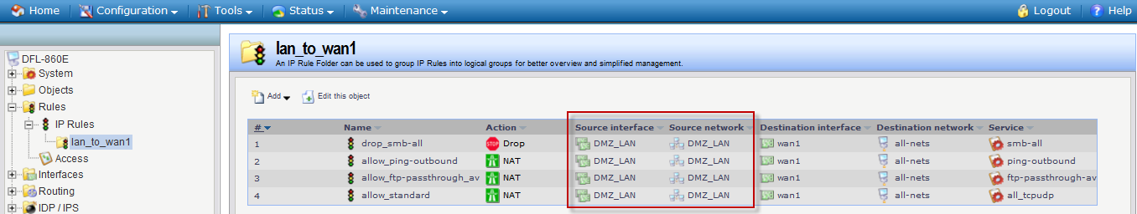

(DFL-860E firmware is 2.40.00.10-16817)
