Transparent Mode and Wan Failover

IP: 192.168.20.10/24

IP: 192.168.20.1/24
IP: 1.1.1.2/24 IP: 2.2.2.2/24

WAN1 IP: 1.1.1.1/24 WAN2 IP: 2.2.2.1/24
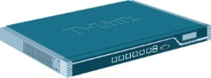
LAN1 IP: 1.1.1.1/24

LAN1 LAN2 LAN3
IP: 1.1.1.100/24 IP: 192.168.2.10/24 IP: 192.168.3.10/24
GW: 1.1.1.2 GW: 192.168.2.1 GW: 192.168.3.1

- Go to “interface groups” and add three interface groups.
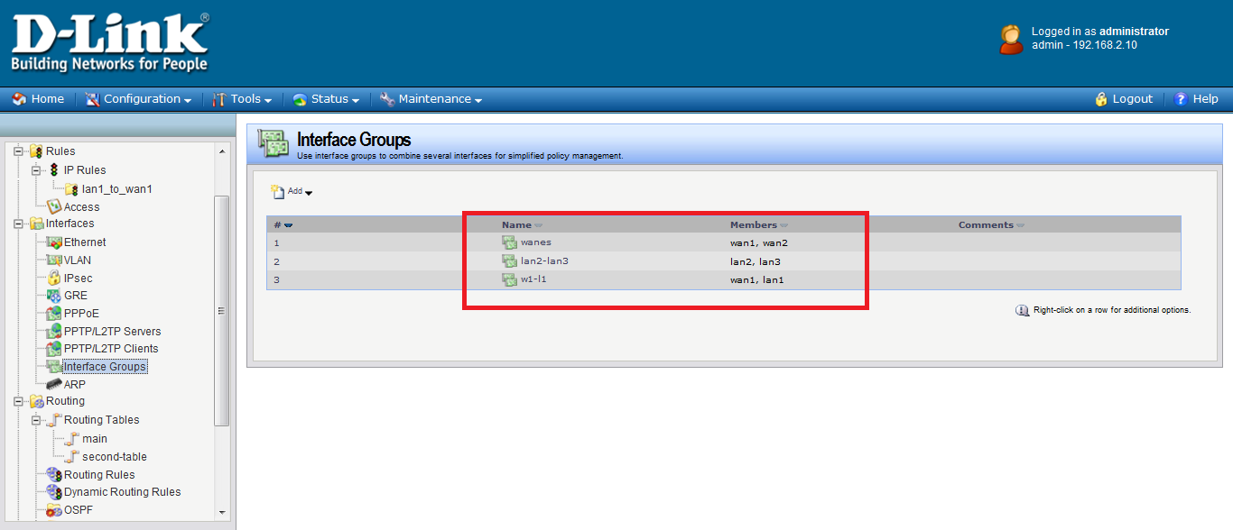
- Change your IP address to correct IP address.
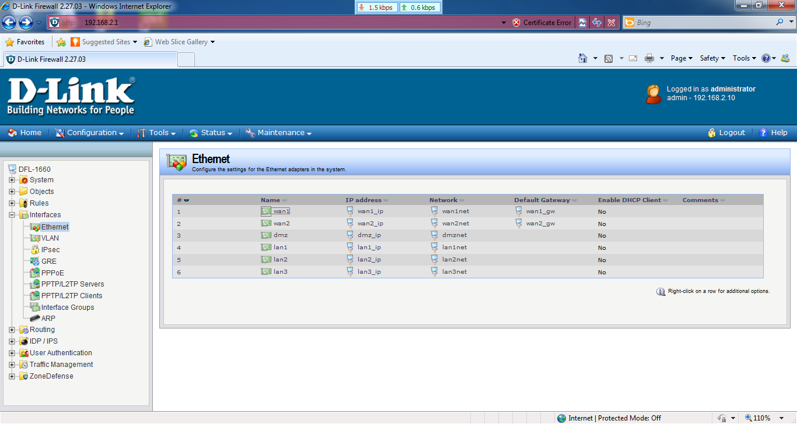

- Do not choose these two items on WAN1, WAN2 and LAN1.
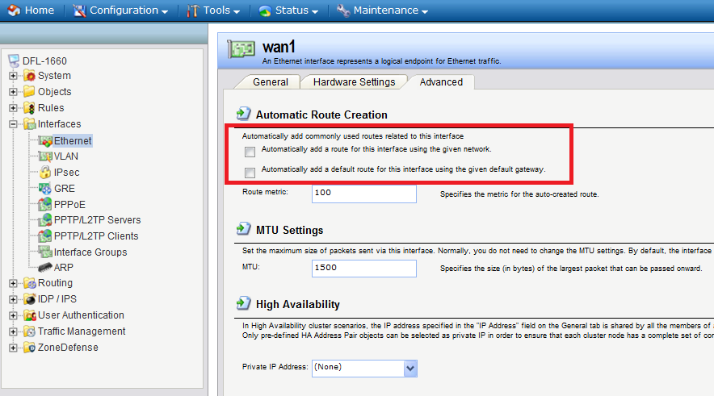

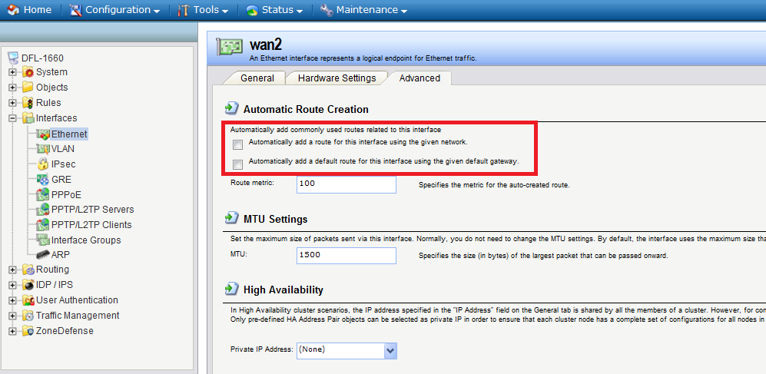

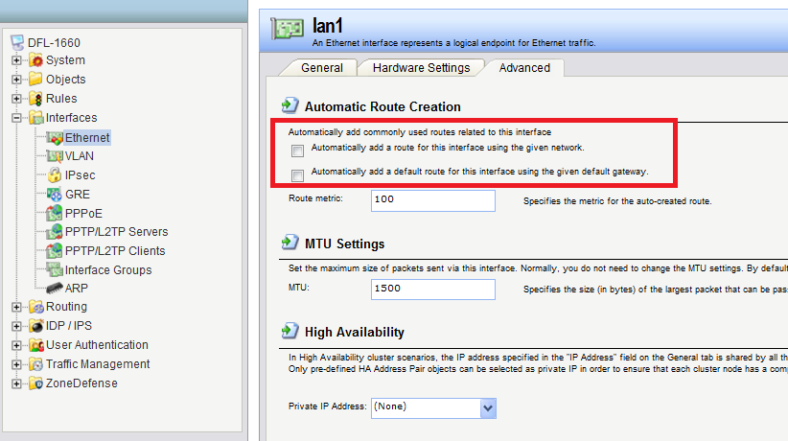

- Create two “switch route” in the main table.
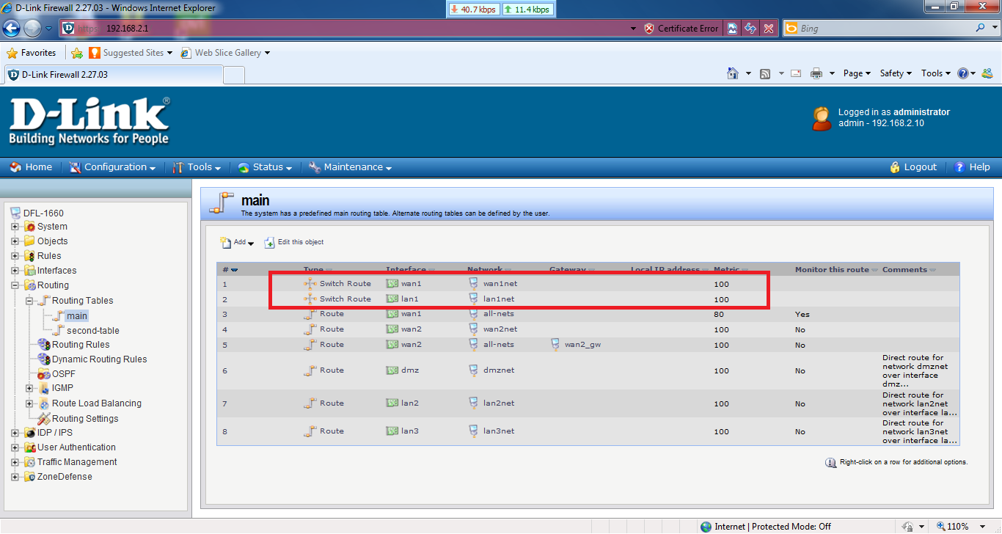

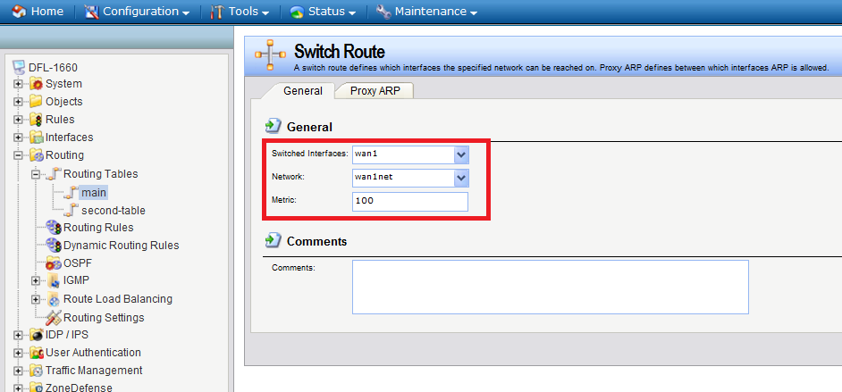

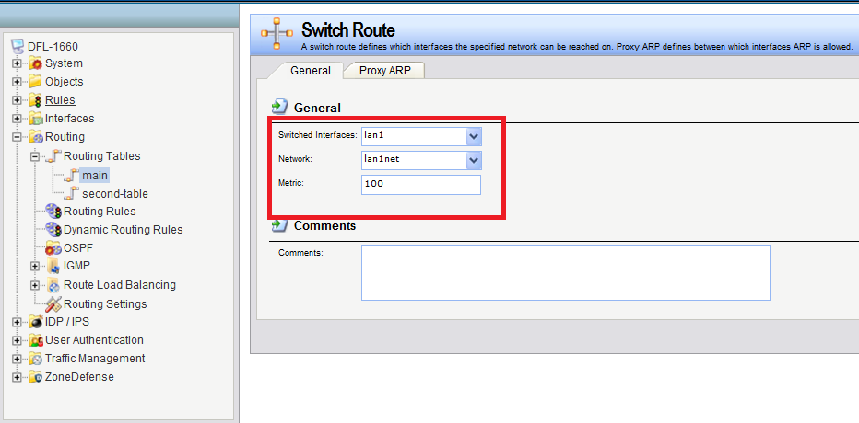
- Create three routes in the “main table”.
Wan1 route need gateway address “1.1.1.2” .
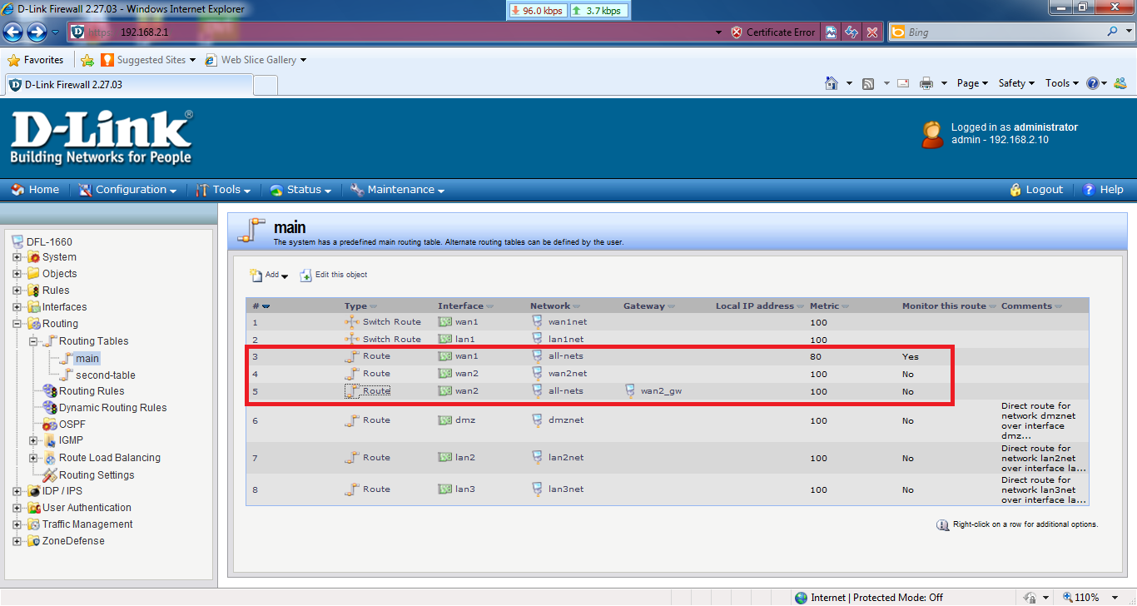
- Enable “Monitor for Route Failover” in the WAN1 route.
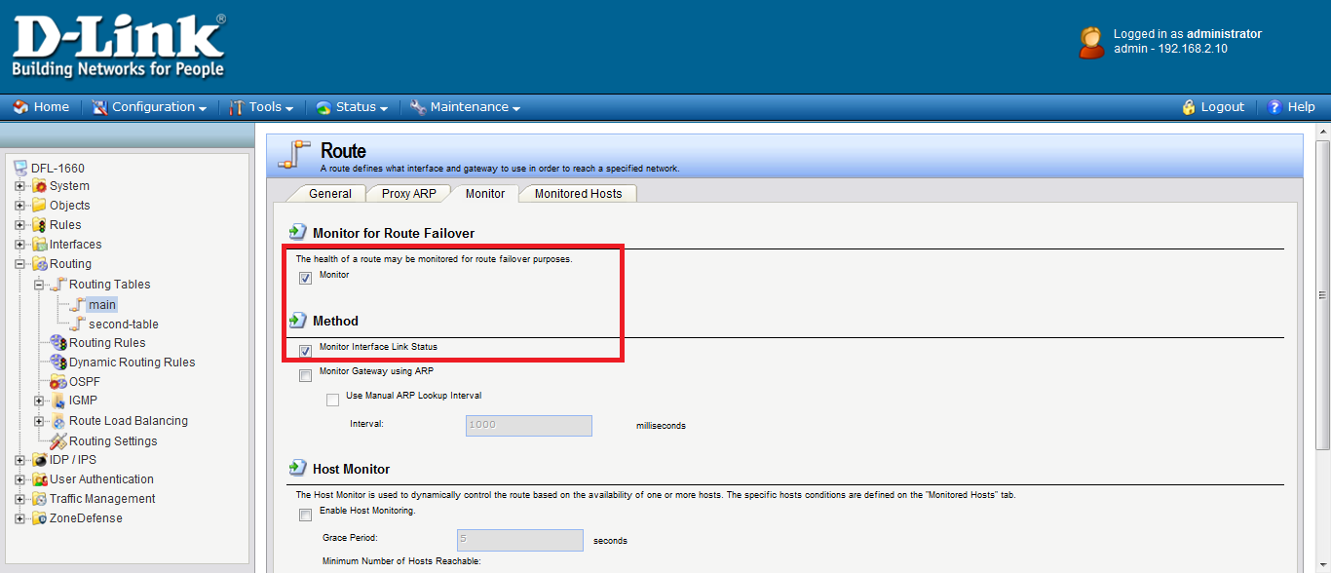
- Add a new “second-table” in the routing table.
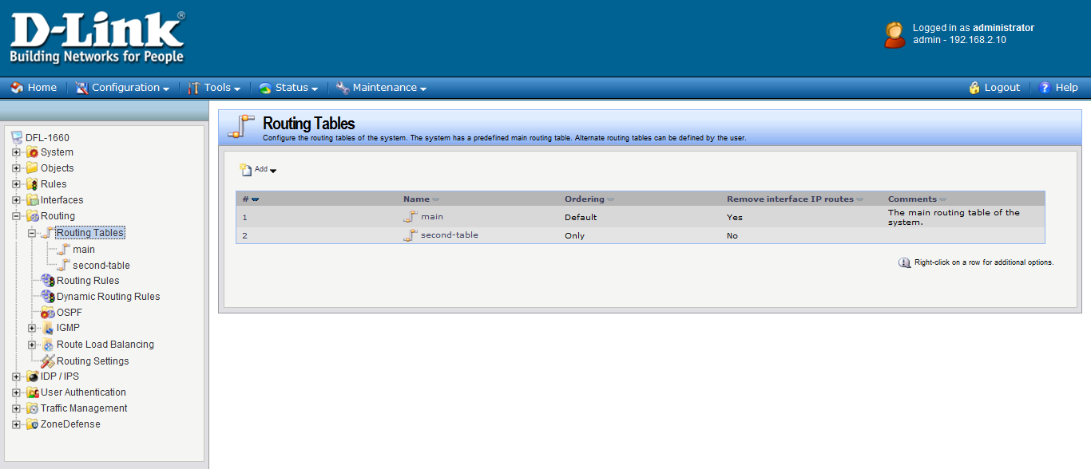

- Add four new routes in the “second-table”.
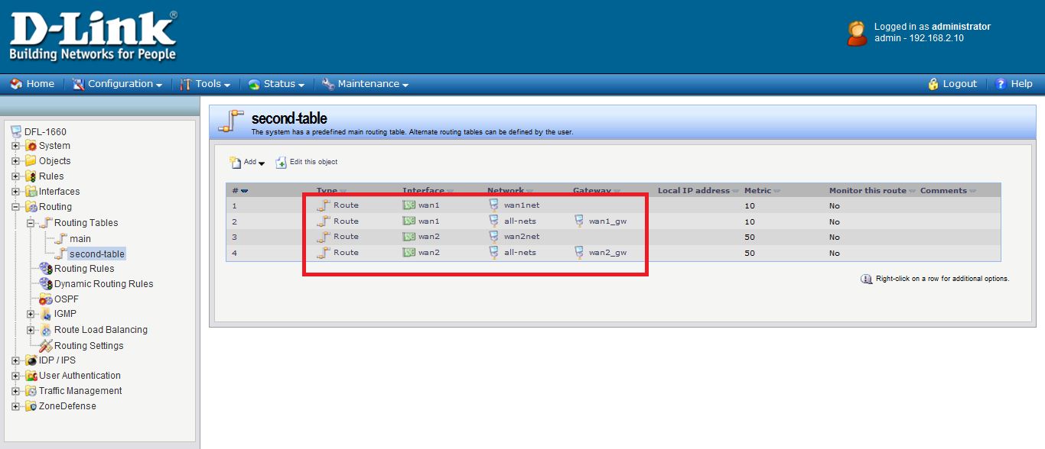

- Go to “routing rules” and add a new routing rule.
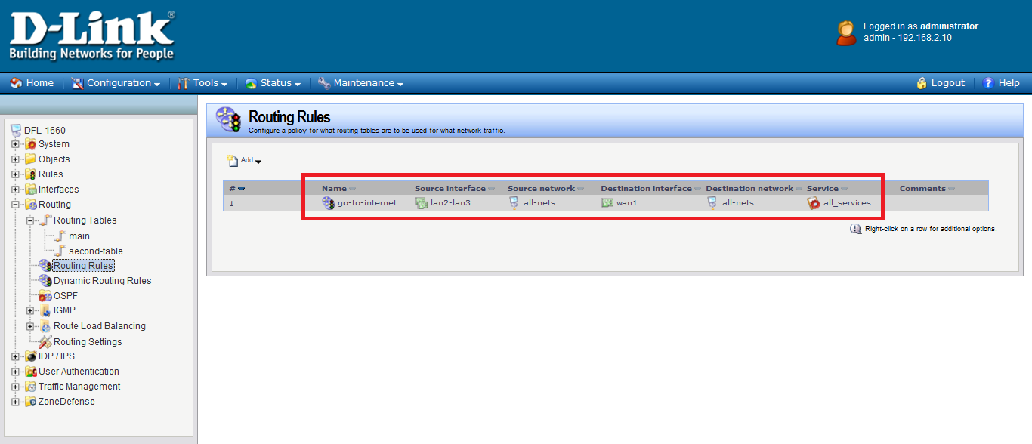

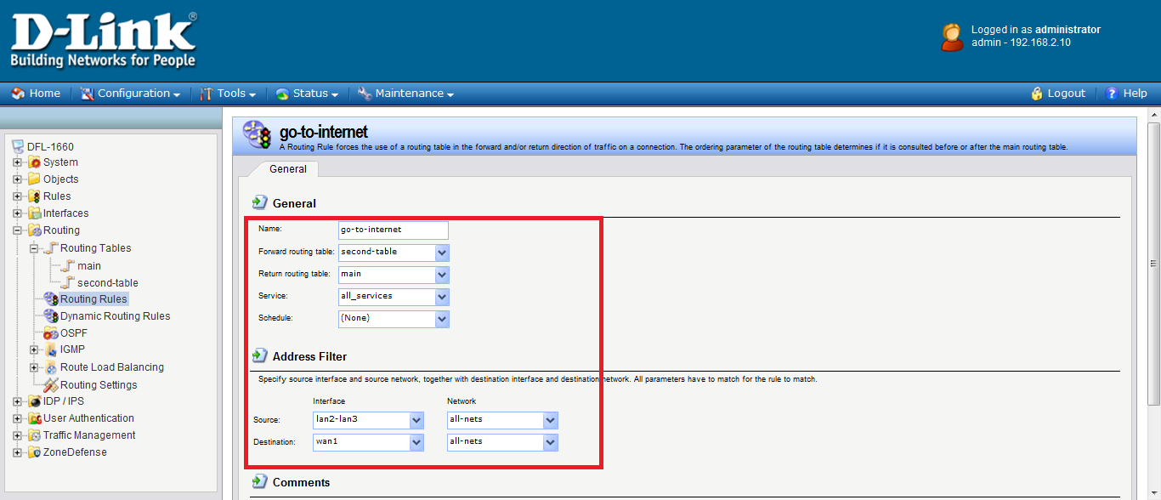

- Go to “IP rules” and add two new IP rules.
