How to setup port forward to PPTP server under LAN using DFL
Problem description: Customer wants to setup a PPTP server under DFL’s LAN network, and needs to configure DFL so it maps the PPTP negotiation with the PPTP server under LAN.
[Topology]
DSR-500N (WAN) ---- (LAN) DFL-860E (WAN) -----Internet----PPTP client (Windows PC)
Device: DFL-860E, DSR-500N
Firmware: DFL: 10.21, DSR: 2.02B501C

[Configuration Procedure]:
Configuration on DSR:
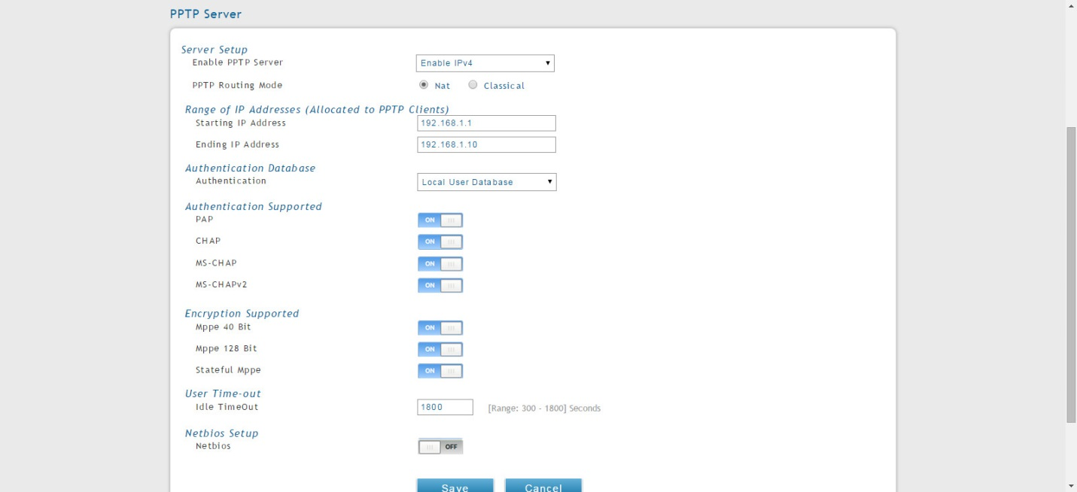
Setup the PPTP server on DSR.
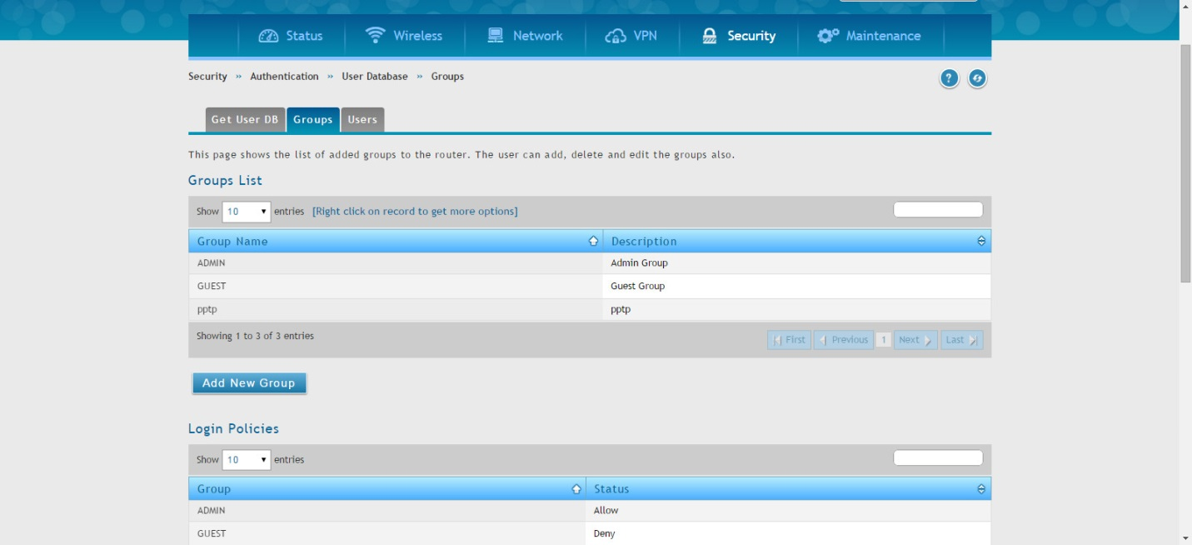
Create a group for PPTP users, we use local user database for authentication.
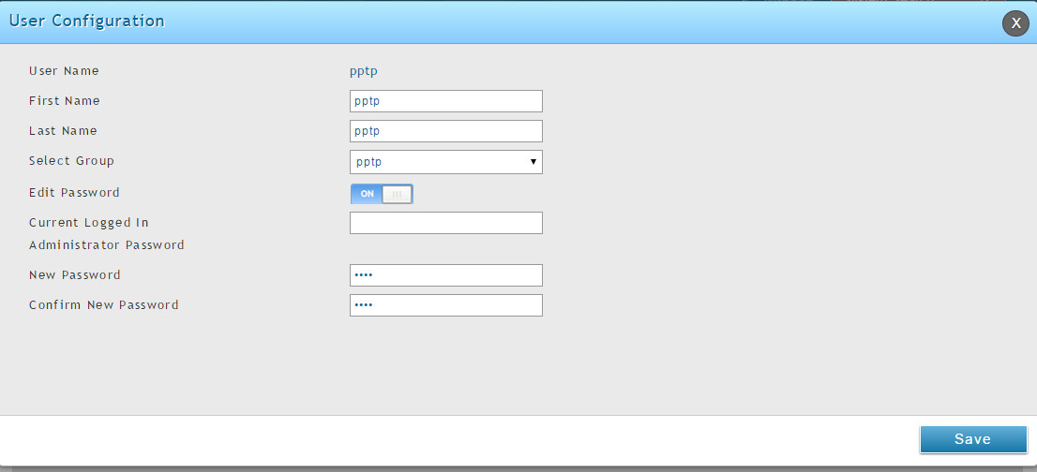
Add a user and select the PPTP group created earlier.
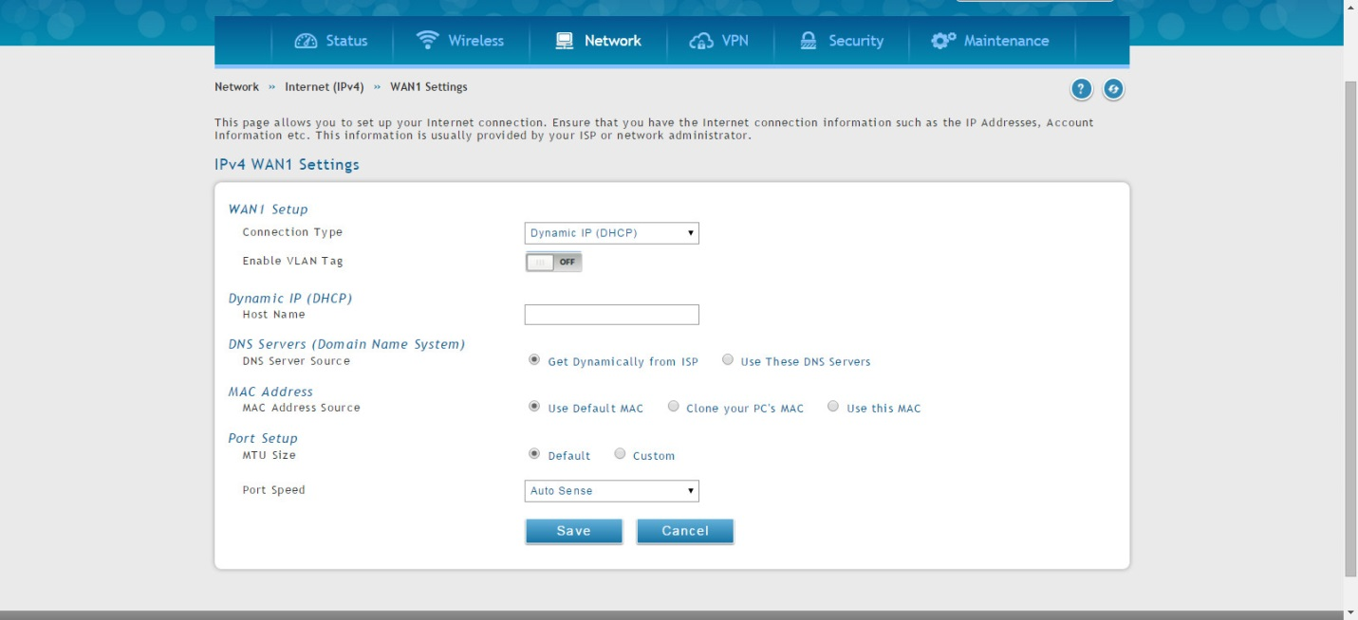
Set connection type as DHCP for WAN1.
Configuration on DFL:
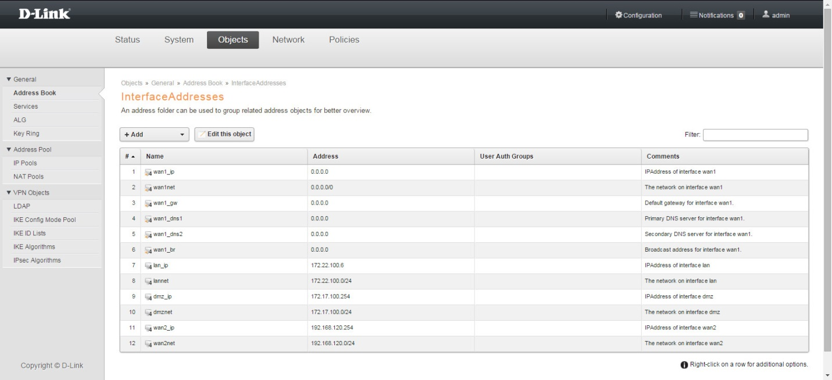
Set the LAN interface IP and LAN network different from DSR’s LAN network
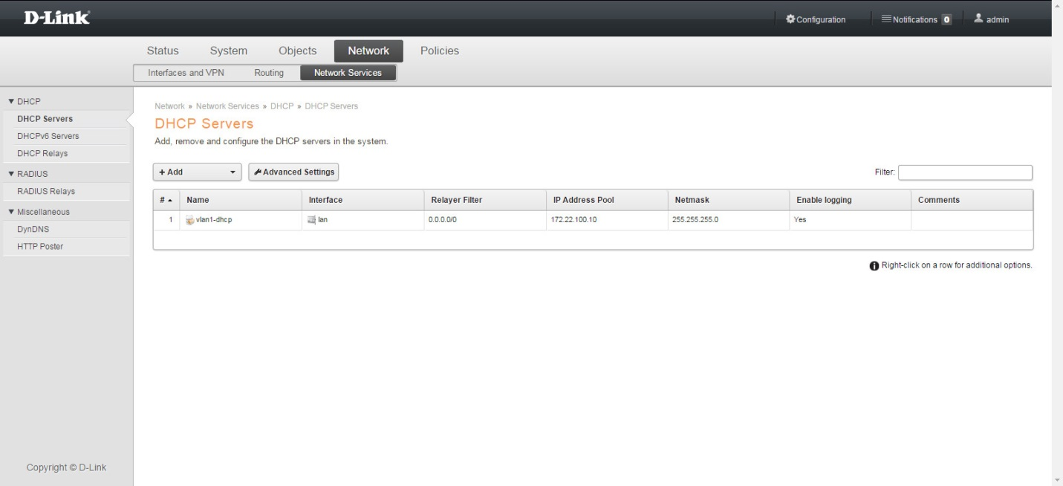
Setup a DHCP server with only 1 IP in the IP pool, this is for configuration simplicity, you can also set static IP for DSR’s WANIP also.

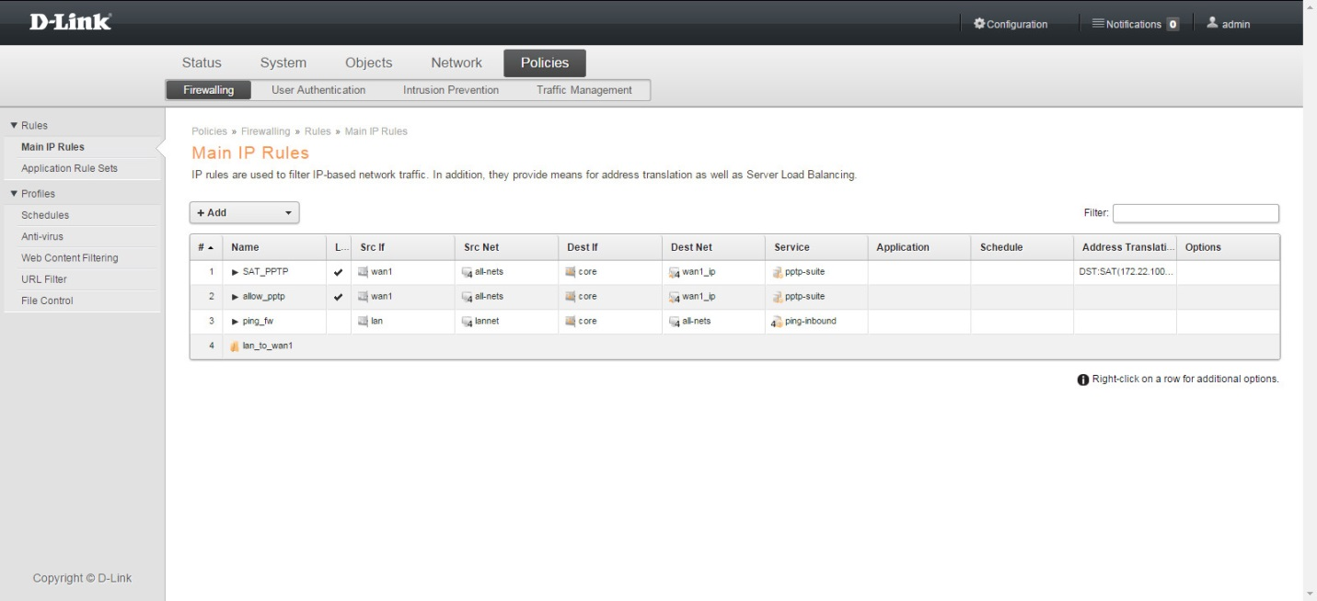
Setup two IP rules for the SAT for PPTP server
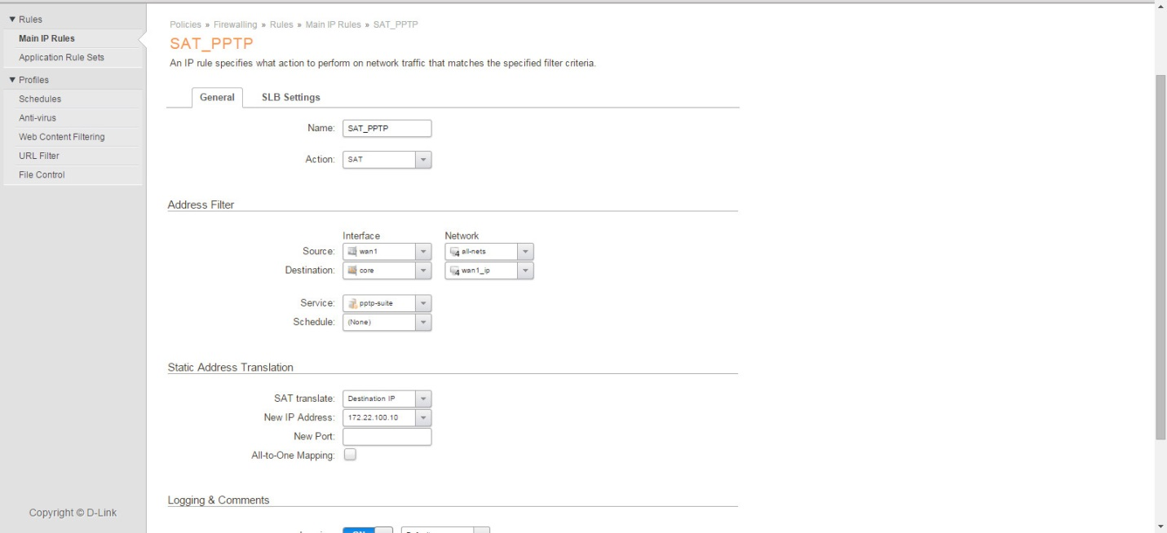
The first rule is SAT, for the static address translation we type in the DSR’s WANIP as new IP address
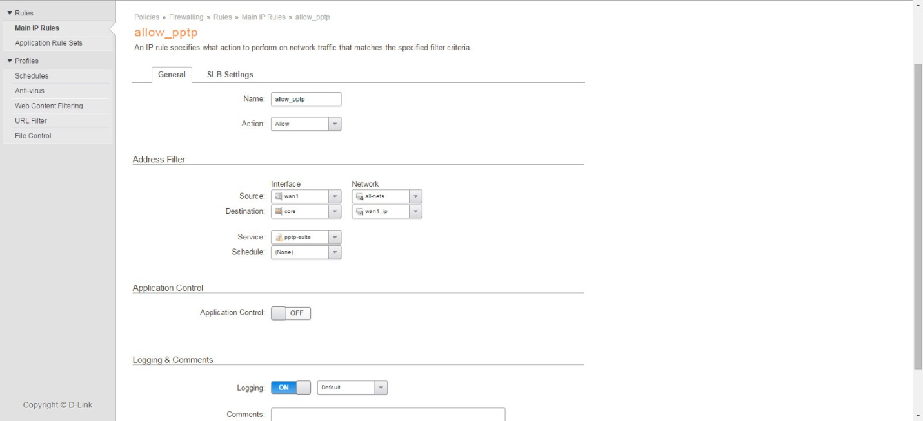
Second rule is the ALLOW for the first SAT traffic.

Test results:
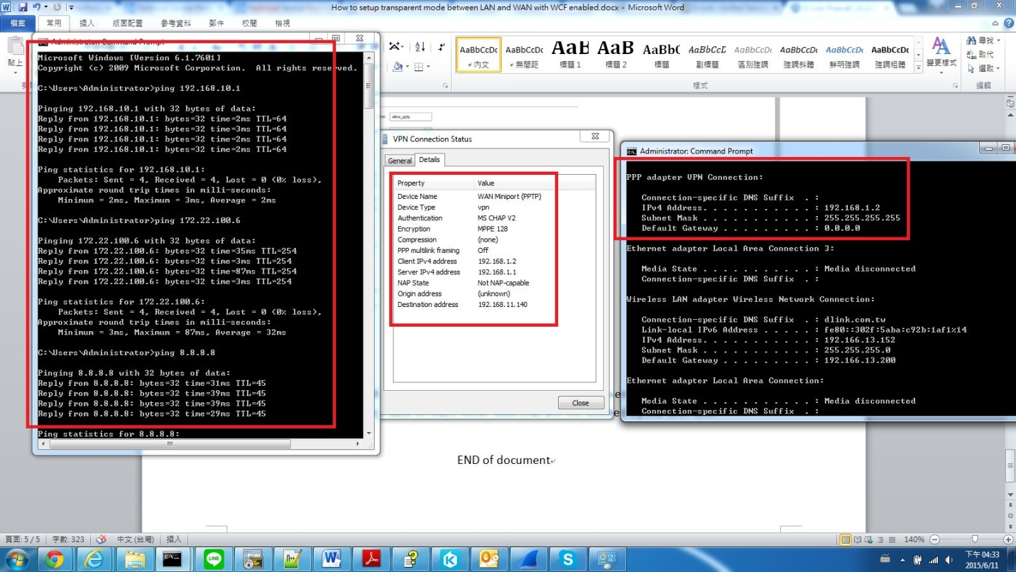
After successful connection, we will get a PPTP IP from the address pool set on DSR’s PPTP server.
END of document

