How to setup SIP ALG

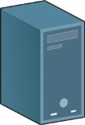 SIP Server: Public IP

Internet

WAN IP: PPPoE
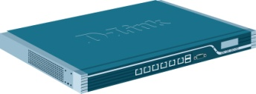DFL-800

SIP Phone: X-Lite 4.0 SIP Phone: X-Lite 4.0

This topology is reference “NetDefendOS_2.27.03_Firewall_UserManual” P.273 scenario 1. You can study chapter 6.2.8. “The SIP ALG”. It can make you understand SIP ALG more detail.

- Add a new SIP ALG.
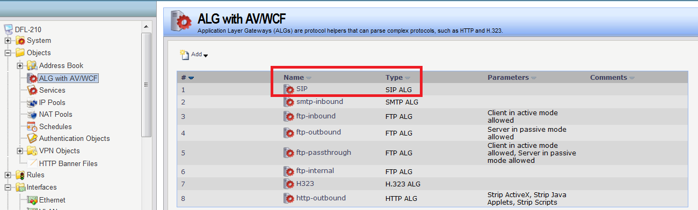

- Add a new SIP-UDP service.
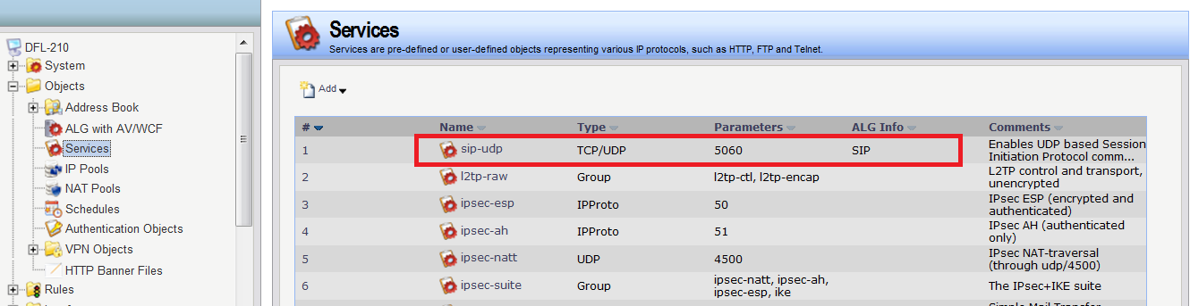

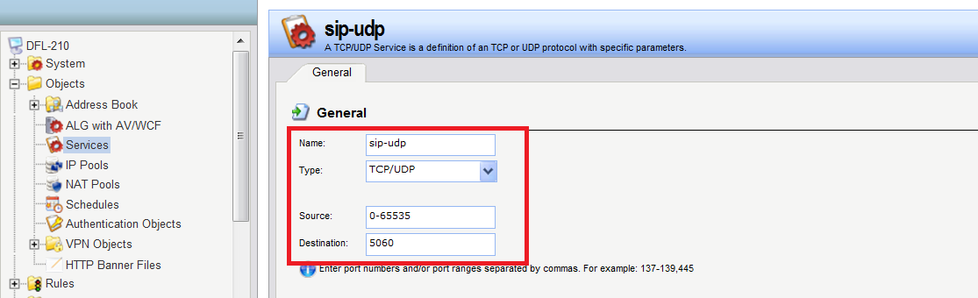

- Add two new IP rules “SIP” and “SIP-IN”.

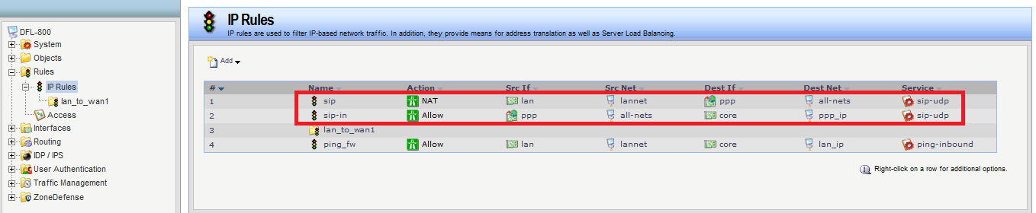

- Change timeout settings.
