How to setup HA on the DFL-1660

This example provides a step-by-step guide for setting up an HA cluster.

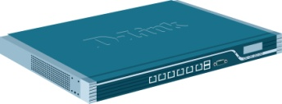Master firewall

Sync Interface

Slave firewall

Setup master DFL-firewall
- Disable “DHCP client” function.
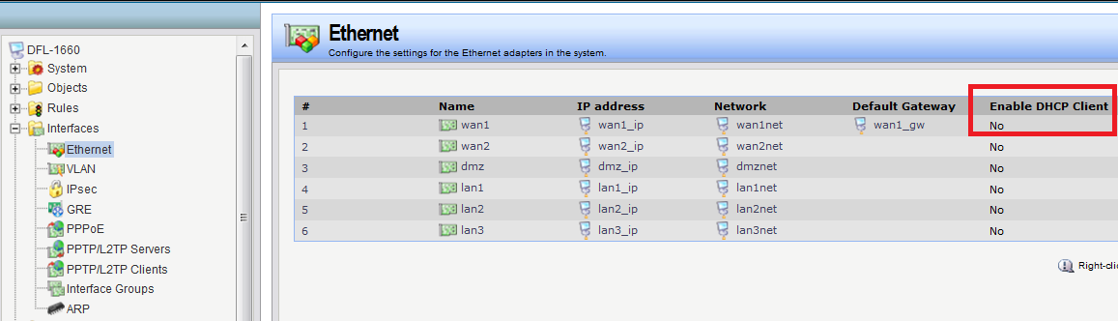

(2) Create new HA interface. You need to type master and slave HA IP address.
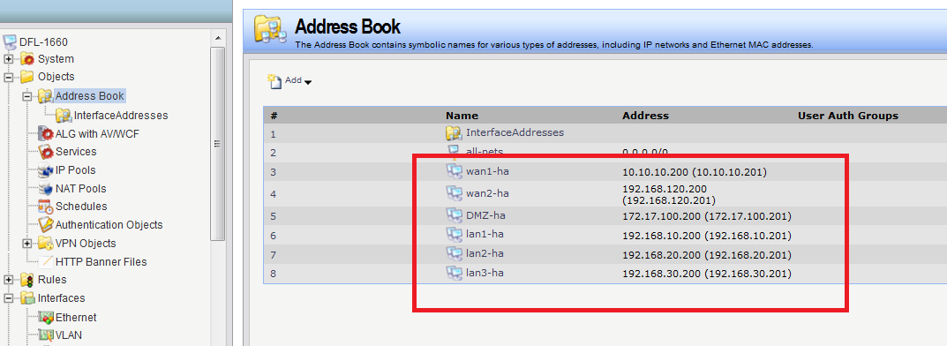
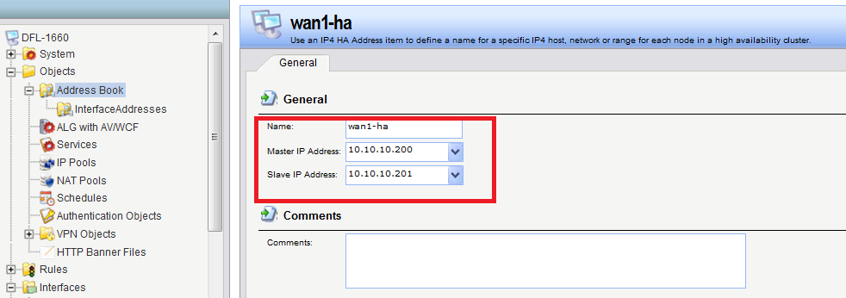

(3) I choose LAN3 to do a “Sync interface”.
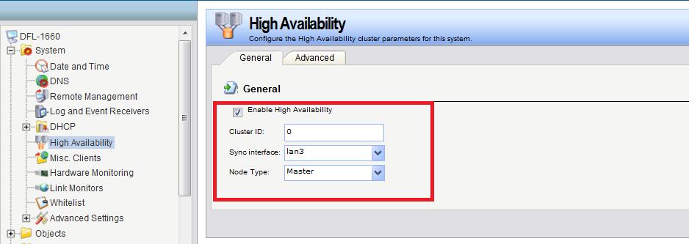
(4) Go to Interface > Ethernet > Advanced. For each interface and set the “High Availability”, “Private IP Address” field to be the name of the “IP4 HA Address” object created previously for the interface.

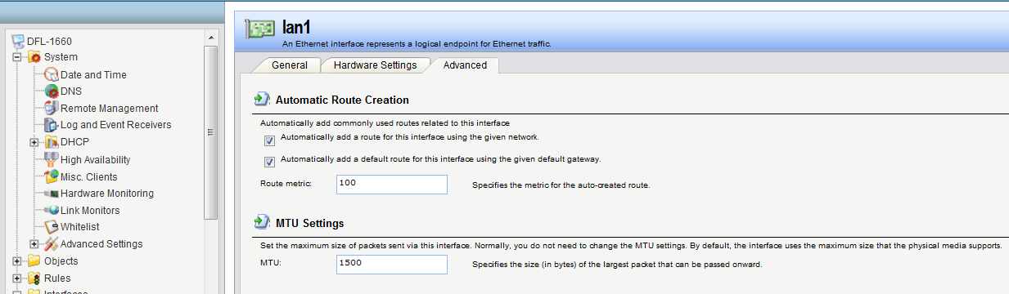

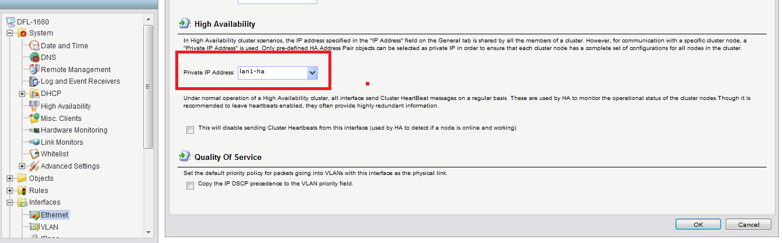

Setup slave DFL-firewall

- Disable “DHCP client” function.
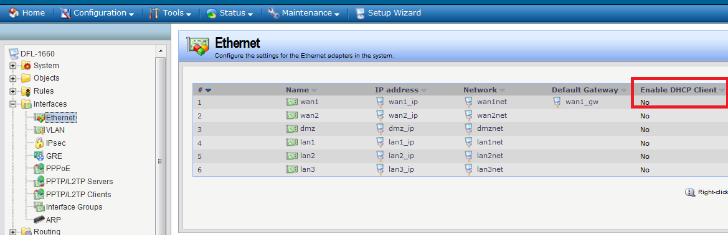

(2) Create new HA interface. You need to type master and slave HA IP address.
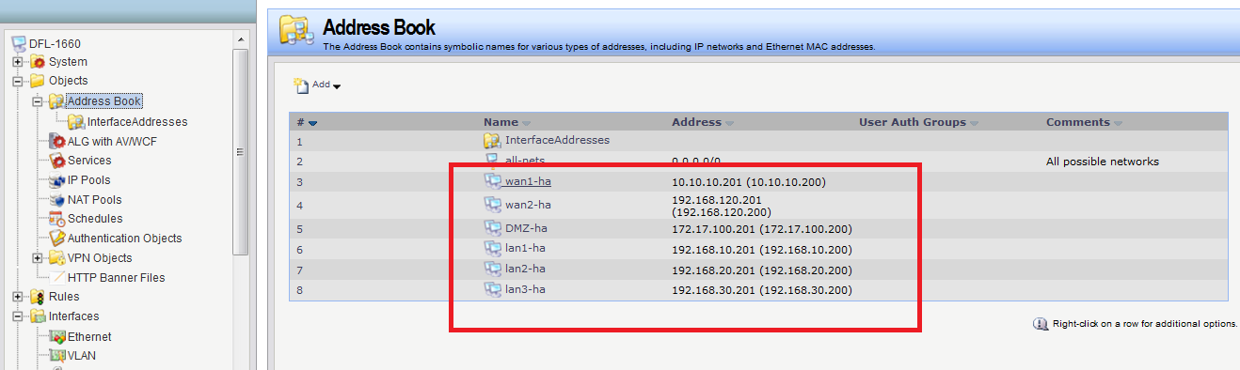
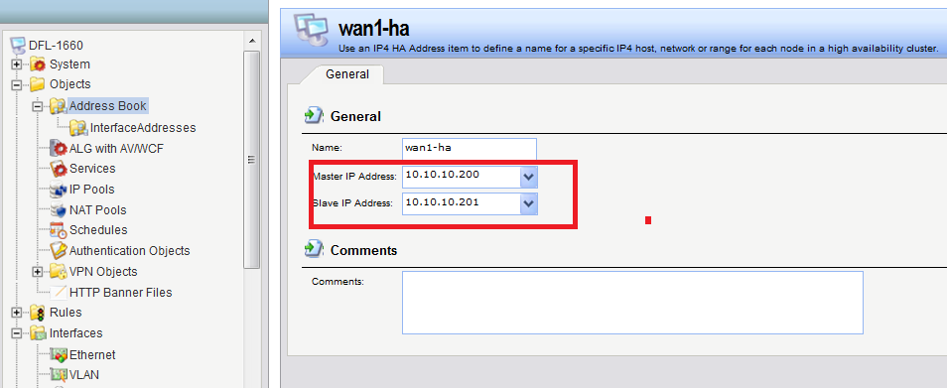

(3) I choose LAN3 to do a “Sync interface”.

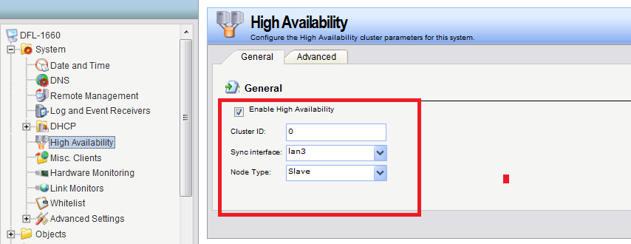

(4) Go to Interface > Ethernet > Advanced. For each interface and set the “High Availability”, “Private IP Address” field to be the name of the “IP4 HA Address” object created previously for the interface.

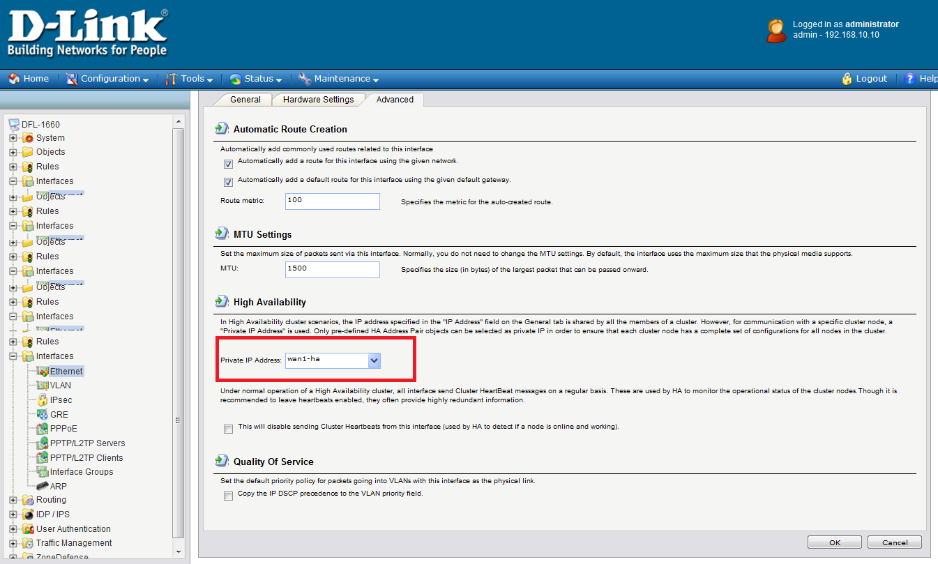

End of document.

