How to manage AP on DWS-3160 over IPsec?
Step 1. Set up DWS-6600 IP to be 192.168.10.2/24

Step 2. Set up DWR-250A IP configuration
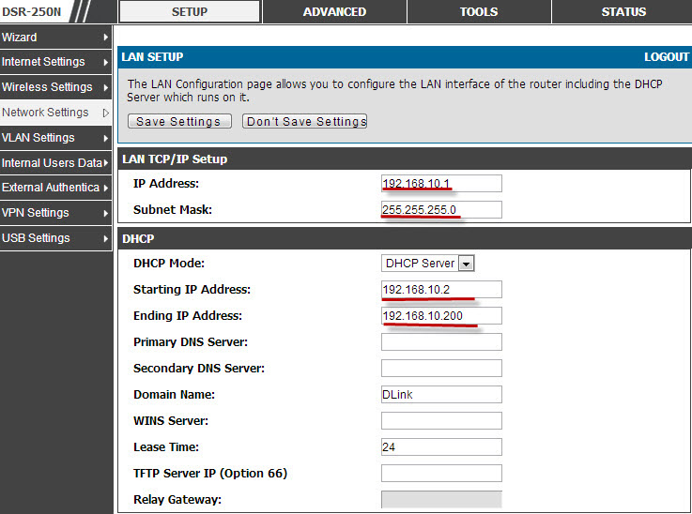

Step 3. Go to DWS-205A VPN Setting->IPset->IPsec policies.
Set up DWR-250A IPsec configuration.
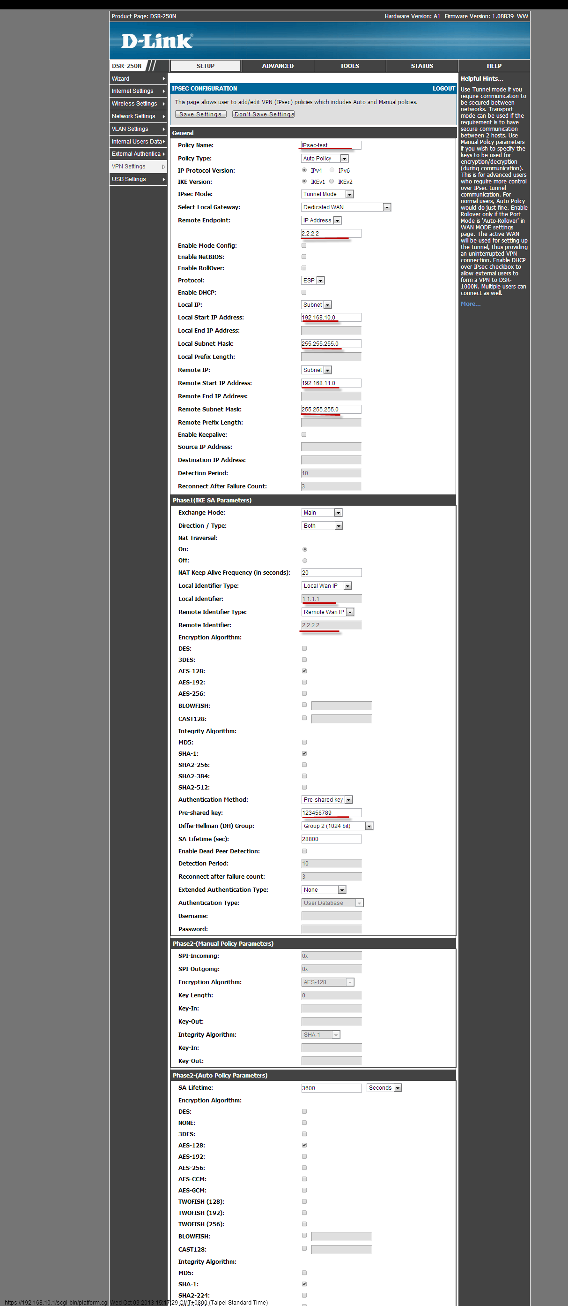
Step 4. Set up DWR-250B IP configuration
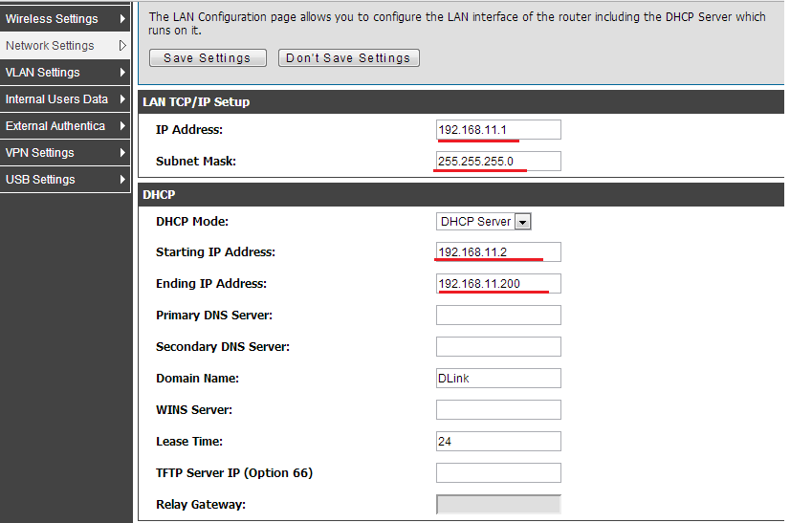

Step 5. Go to DWS-205B VPN Setting->IPsec->IPsec policies.
Set up DWR-250B IPsec configuration.
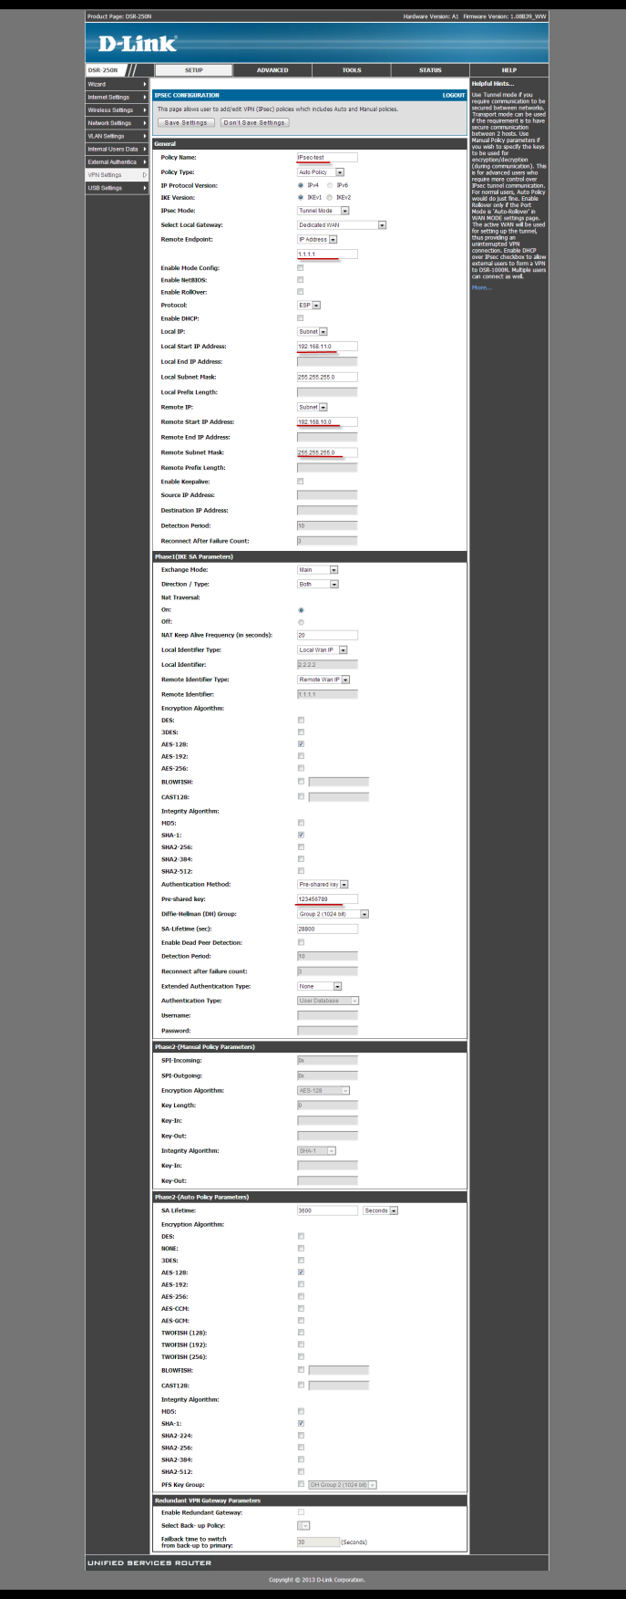
Step 6. Set up DWS-4026 L3 Interface.
For Port 13.
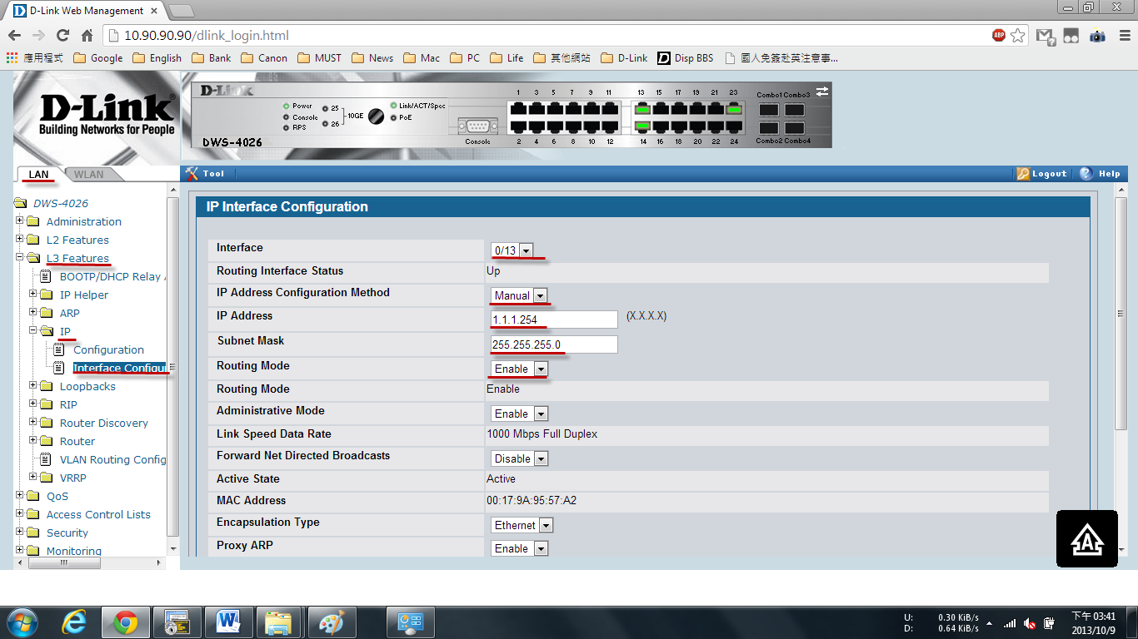
For Port 14.
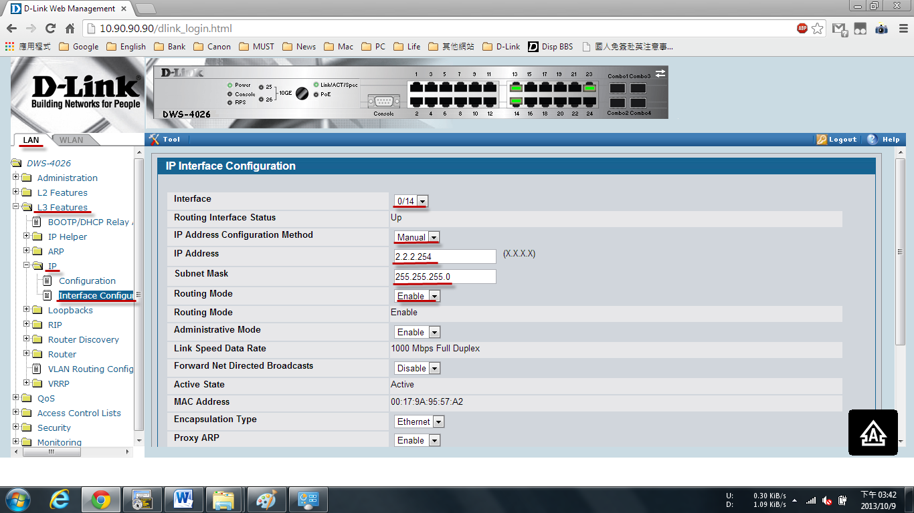

Step 7. Establish IPsec connection between DSR-A and DSR-B
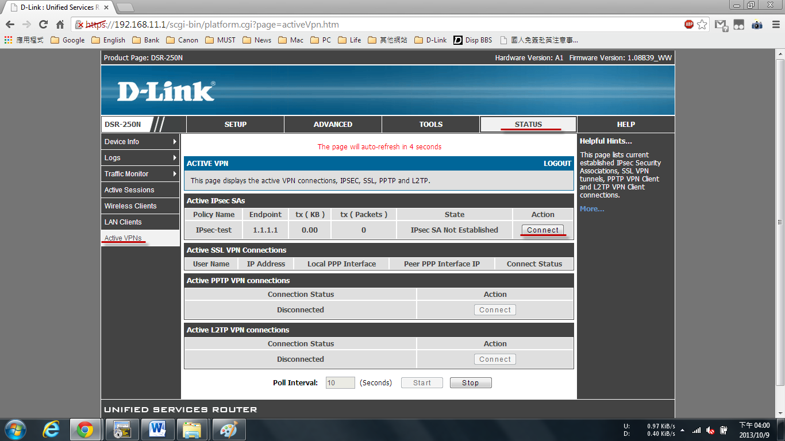
Check Link status
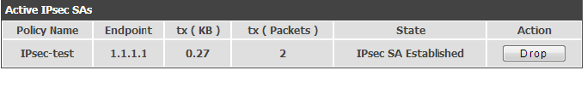
Step 8. Set up DWS-3160 IP configuration
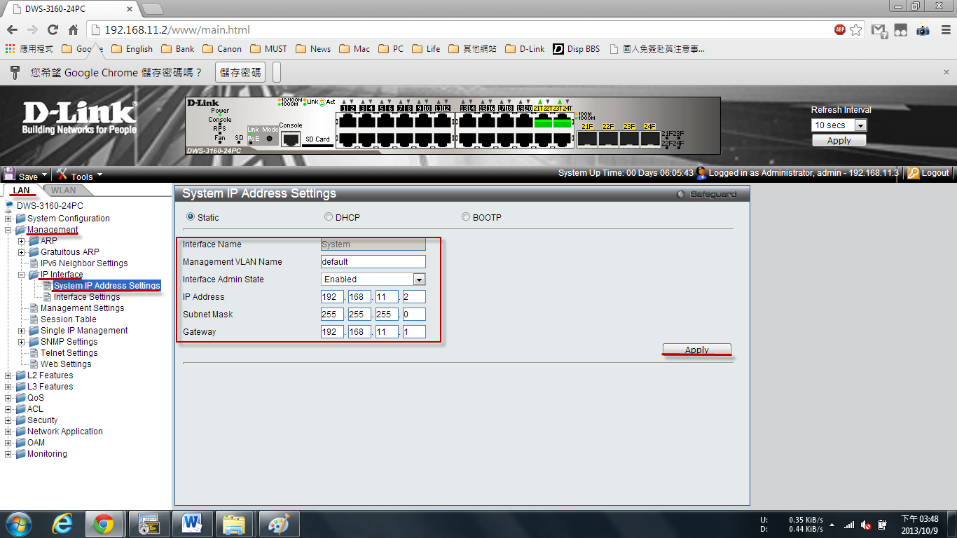
Step 9. Enable L3/IP Discovery and add AP’s IP address 192.168.10.2.
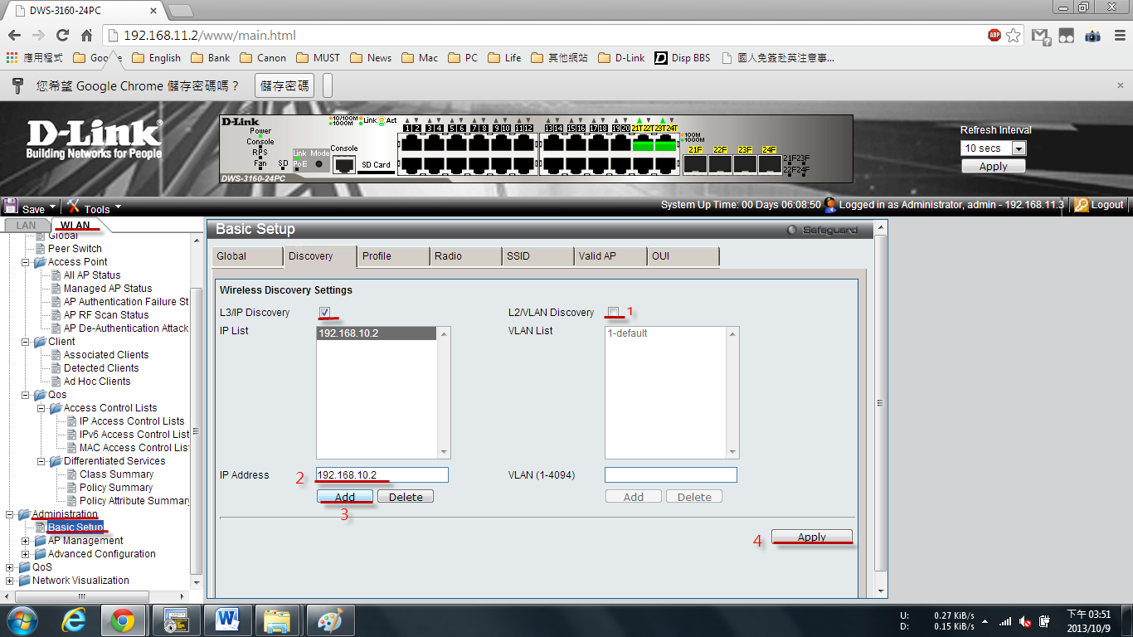
Step 10. Go to mentoring->Access Point->All AP status and then manage AP
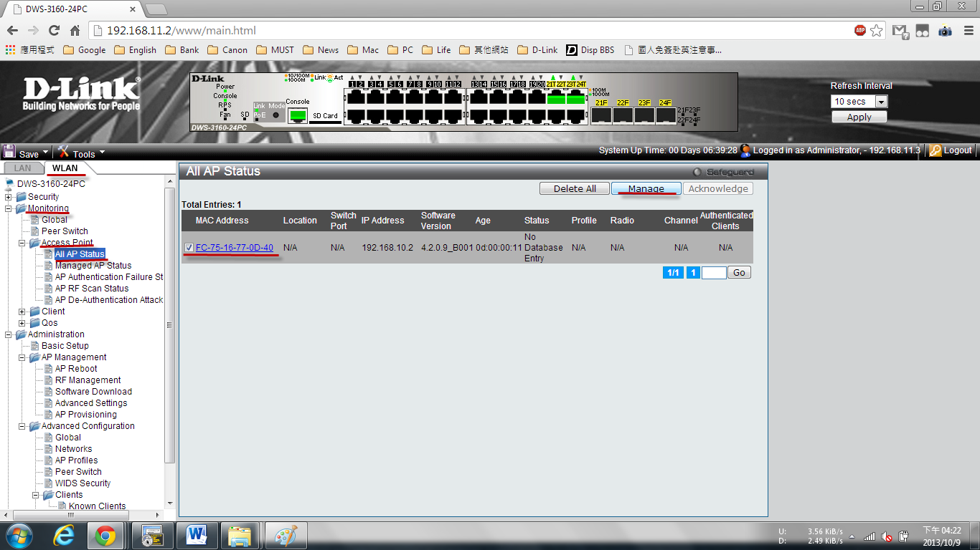

Result：

