Enable traffic to a web server on an internal network

Topology:

WAN
LAN

IP address: 192.168.10.200

The example we have decided to use is that of a web server with a private address located on an internal network. From a security standpoint, this approach is wrong, as web servers are very vulnerable to attack and should therefore be located in a DMZ. However, due to its simplicity, we have chosen to use this model in our example.

- Needs to create three IP rules.
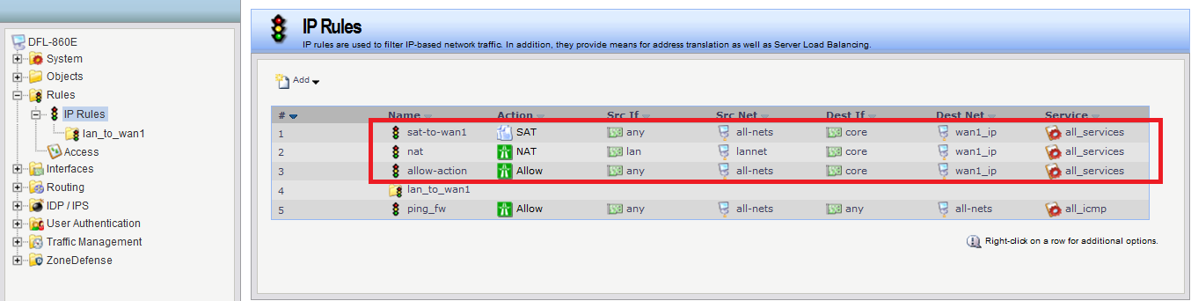

- In order for external users to access the web server, they must be able to contact it using a public address.
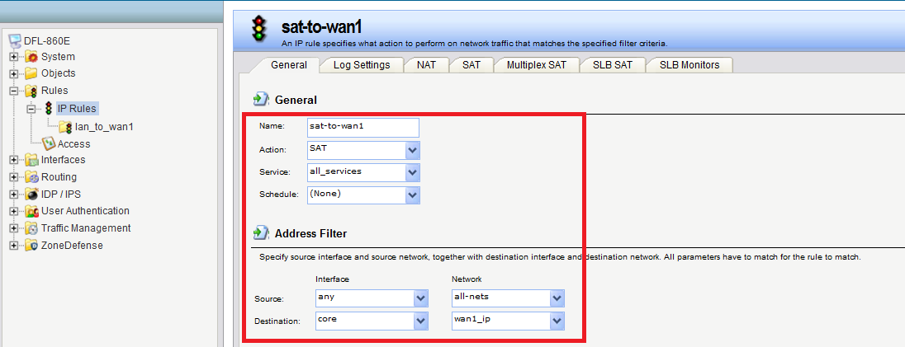

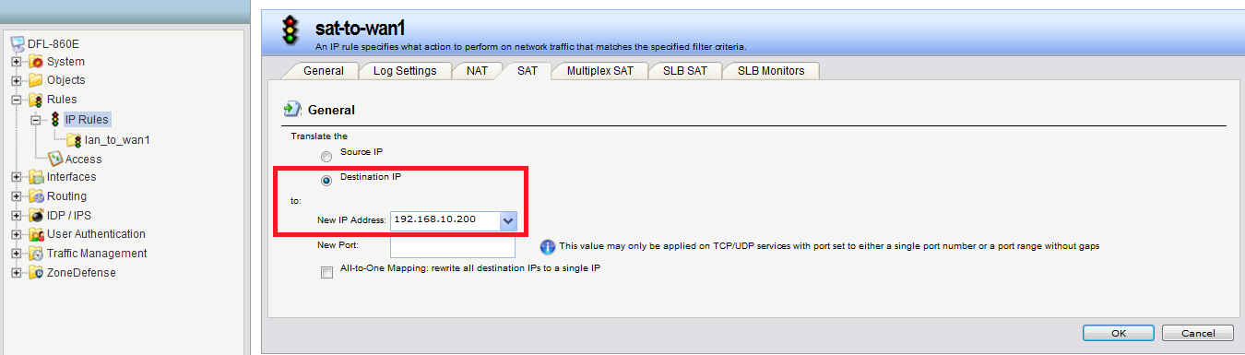

- We also need a rule that allows internal machines to be dynamically address translated to the Internet.
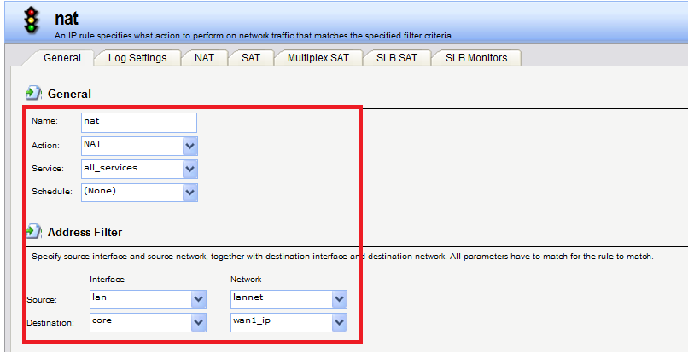

- SAT rule states that address translation can take place if the connection has been permitted, and “allow” rule permits the connection.
