How to setup IPSec NAT traversal on DFL-860

Topology:

IP address: 192.168.10.100/24

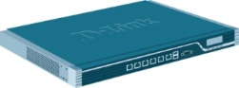 DFL-260E
WAN IP address: 190.41.99.177/29

WAN1 IP address: 190.41.99.178/29
DFL-860
LAN IP address: 10.1.1.1/24

WAN IP address: 10.1.1.2/24
DFL-210

IP address: 192.168.2.100/24

- We need to add a new service “TCP-UDP-ICMP-IPSEC”.
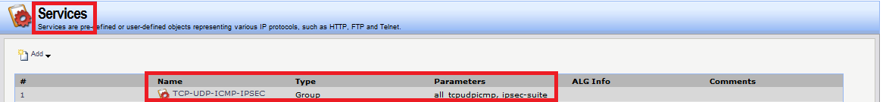

- Choose “all_tcpudpicmp” and “ipsec-suite”. “ipsec-suite” has IP protocol 50, 51 and UDP port 500 and 4500.
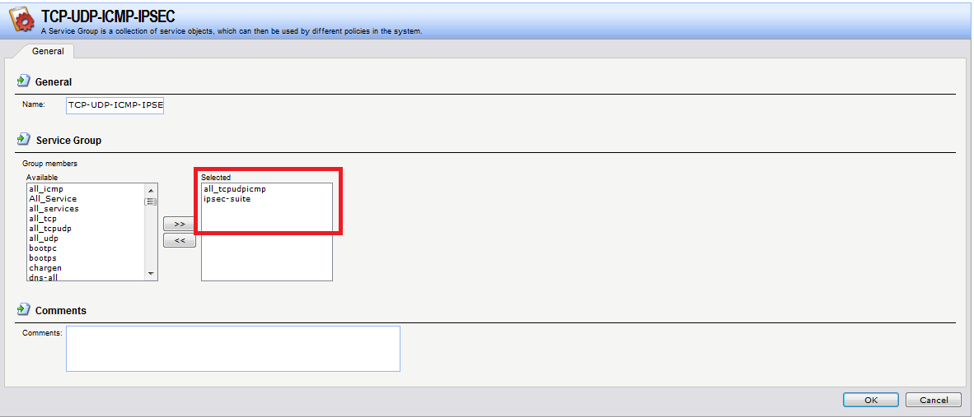

- Because IPSec traffic is bidirectional. We need use new service “TCP-UDP-ICMP-IPSEC” for LAN to WAN rules and WAN to LAN rules.
Because DFL-860 just do IPSec NAT traversal therefore we need to use SAT+ALLOW rule make IPSec traffic transmit to DFL-210.

DFL-260E IPSec remote endpoint is IP address 190.41.99.178.
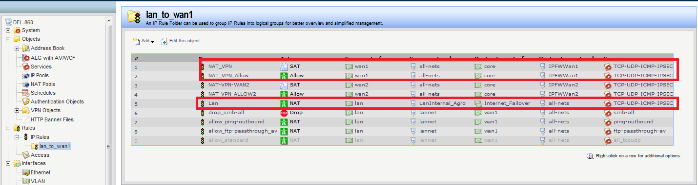

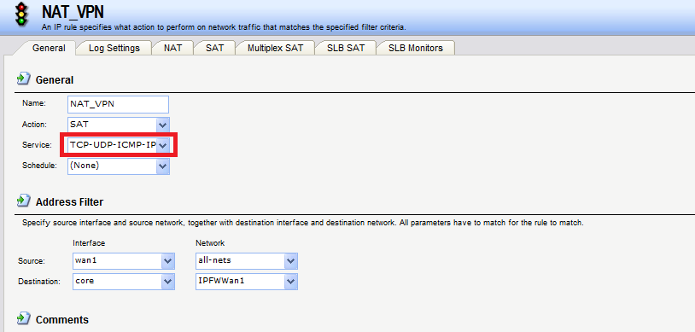
- IsaServer = IP address 10.1.1.2/24
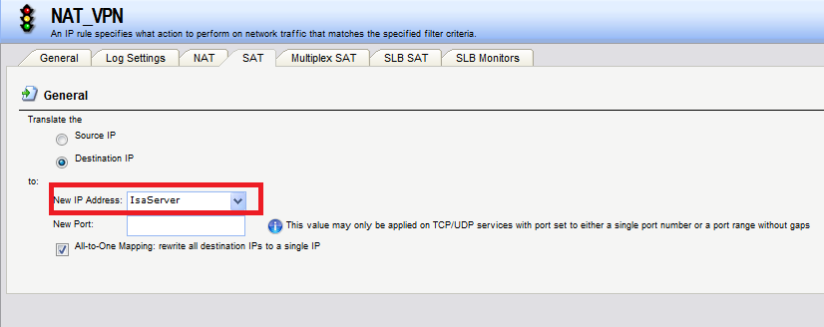

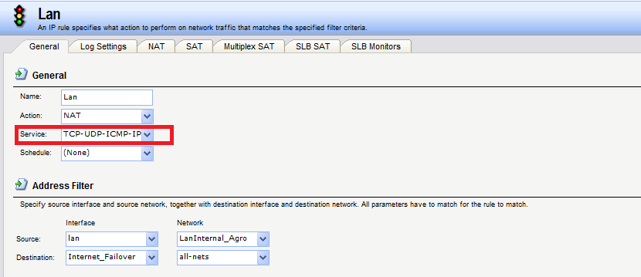

- Go to advanced settings. Disable “IPSec before rule”.

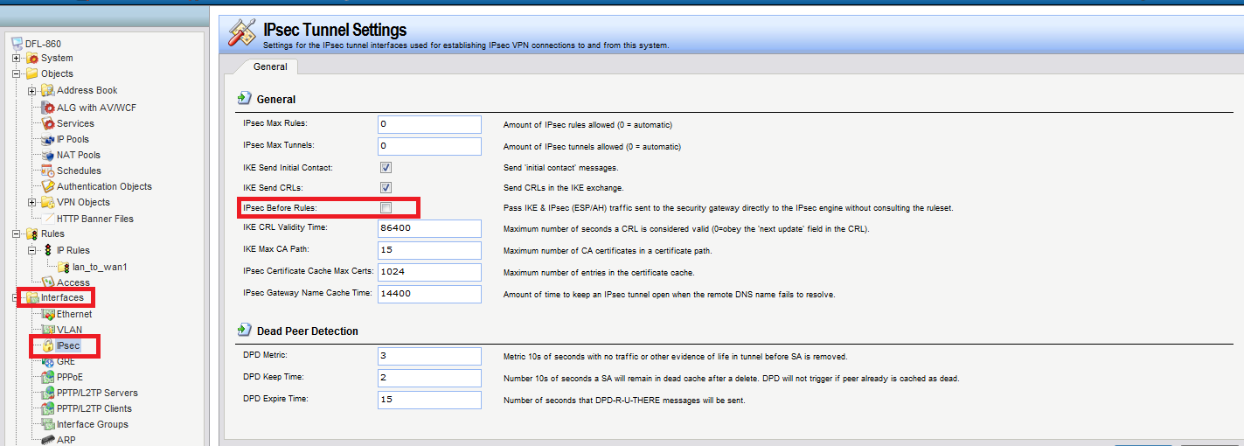

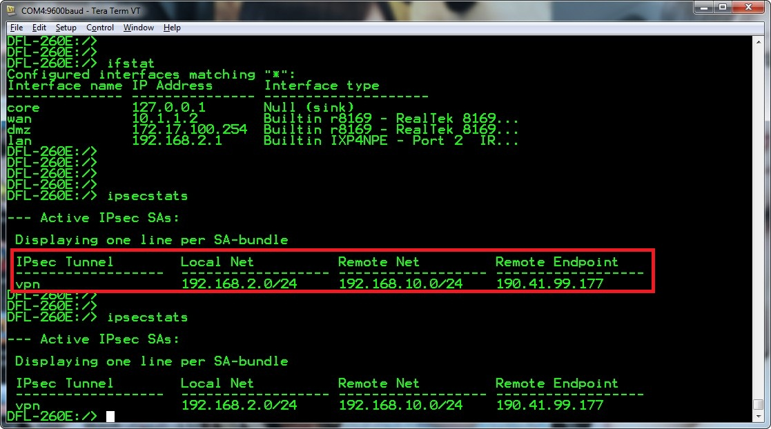

END

