The FW version later 2.40.00.10 support IPv6 Function.
In this KM, we will know how to enable IPv6 Router Advertisement function on DFL.

- Go to System/Advanced Settings/IP Settings, click “Enable IPv6”.
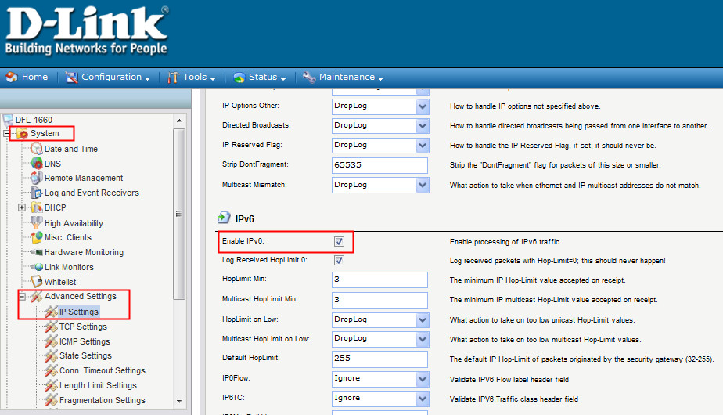
- And then enable the IPv6 on the interface.
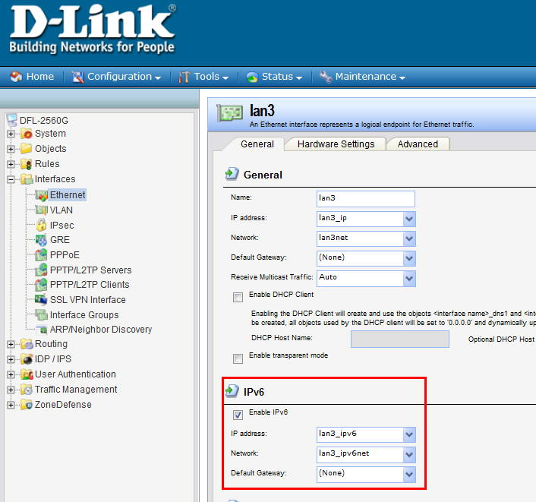

- On page “Advanced”, enable the router advertisement function.
