IP Telephony in IEEE 802.1x-Enabled MAC Based Network deployment and Configuration Guide(DGS-3420)
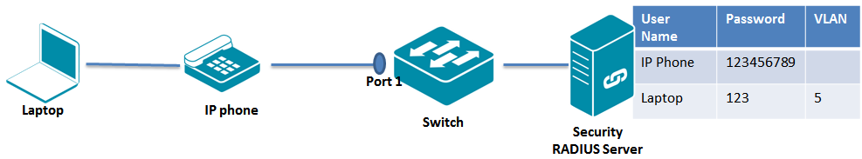
Scenario:
Based on our current design, if the device is authenticated via “dynamic VLAN assigmen by RADIUS server” on specific port, the specific port will be added into untagged member of “dynamic VLAN assigmen by RADIUS server””.
In order for the port that the authenticated IP Phone is connected to to be added into tagged member of Voice Domain, user should do the following pre-setting
- manually configure the specifc port(such as port 1) as tagged member port of Voice Domain(VLAN 4) and PVID value of the specific port should be the vid of Voice Domain via issuing “config port_vlan 1 pvid 4” command
- For the RDIUS server, it should not dynamically assign VLAN to the IP Phone.
- After IP phone is authenticated and Radius server doesn’t assign any VLAN to IP Phone, the authenticated IP Phone will belong to the original VLAN which means the same as PVID.

When the IP Phone authenticates successfully, it is given access to the voice domain with VLAN 4 and is only allowed access to the voice domain with VLAN 4.
When the laptop behind the phone authenticates successfully, it is given access to the data domain with VLAN 5. The port will be added into untagged member of VLAN 5 and the Laptop is only allowed access to the data domain with VLAN 5.

For IP Phone and Laptop Configuration
Enable IP phone and Laptop for IEEE802.1x.
Here is the athentication information of IP phone and Laptop.
IP Phone :
User Name is “IP Phone” and password is “123456789”
Configure IP Phone’s VLAN to VLAN 4 Domain.
Laptop:
User Name is “Laptop” and password is “123”.

For Switch Configuration
/*************************************************************************** VLAN 4 is used for Voice Domain and add port 1 as tagged member of VLAN 4.
* VLAN 5 is used for Data Domain.
* Set Port 1’s PVID as 4
*********************************************************************/
#VLAN
createvlan v4 tag 4
configvlan v4 add tagged 1/*In order to make sure IP Phone can receive tagged Voice VLAN 4 traffic */
createvlan v5 tag 5
configvlan v5 advertisement disable
configport_vlan 1 pvid 4/*In order to make sure IP Phone can be authenticatedon VLAN 4*/
/**************************************************************************enable 802.1x MAC Based on port 1
*********************************************************************/
#802.1x
enable 802.1x
config 802.1x capability ports 1 authenticator
config radius add 1 10.90.90.201 key 123456 default
config 802.1x mac_based ports 1
Verification
Note :
Laptop’s MAC is 00-23-5A-58-B6-9C
IP Phone’s MAC is F0-DE-F1-93-2D-E2
