How to trace route from PPTP client to DFL LAN user

Topology:

PPTP client DFL LAN user
IP: 172.31.1.10
Gateway: 172.31.1.2

In the default setting, The DFL unit can’t be traced from PPTP client to LAN user, when we trace routing path of remote host with tracert command in Windows OS.

- Allow DFL unit can be traced.
Step1. Go System > Advanced Settings > IP Settings > TTL on Low: change its value to Log.

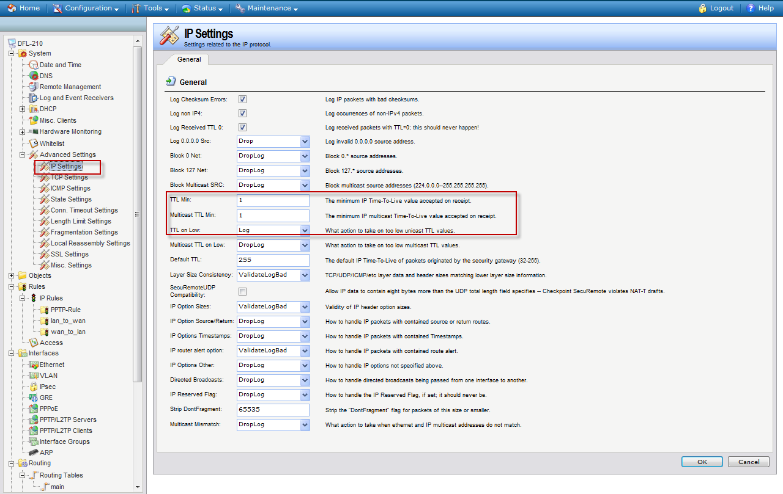

Step2. Go to PPTP rule folder and add a new IP rule from PPTP interface to LAN interface. And service must be choose “all-icmp”, Destination network choose “ALL-NETS”, because you have many LAN networks.

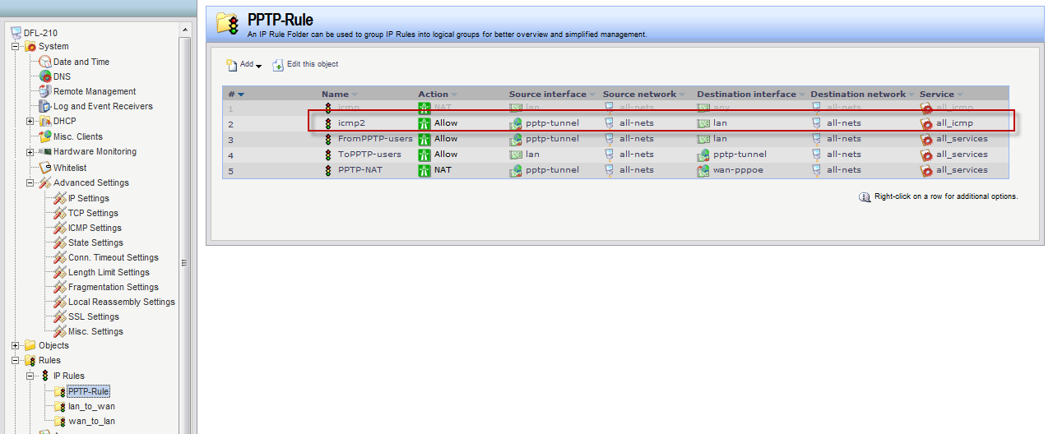

The PTP client can be traced.

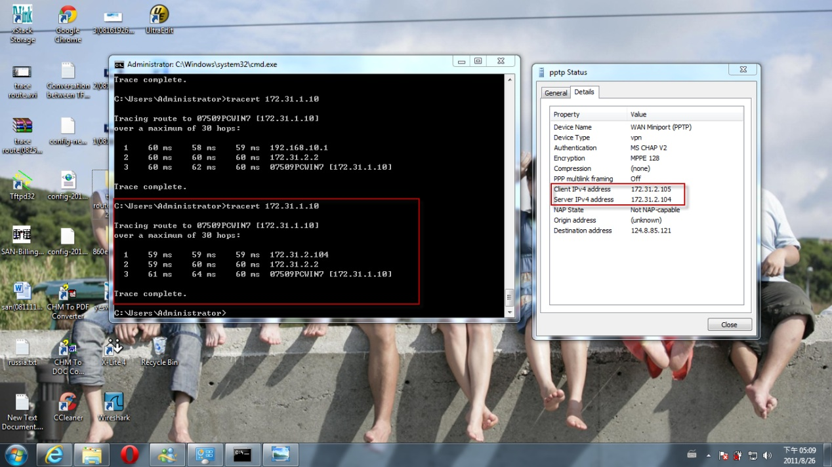

END

