How to setup SAT and IPSec VPN on wan2

IP:192.168.10.10/24

WAN:10.10.10.2/24

IP:10.10.10.1/24
IP:103.10.10.2/24
WAN1:DHCP WAN2:103.10.10.1/24
DFL-800

IP:192.168.1.3/24 IP:192.168.1.200/24
HTTP server FTP server

(1)Go to “Ethernet” to change IP address.
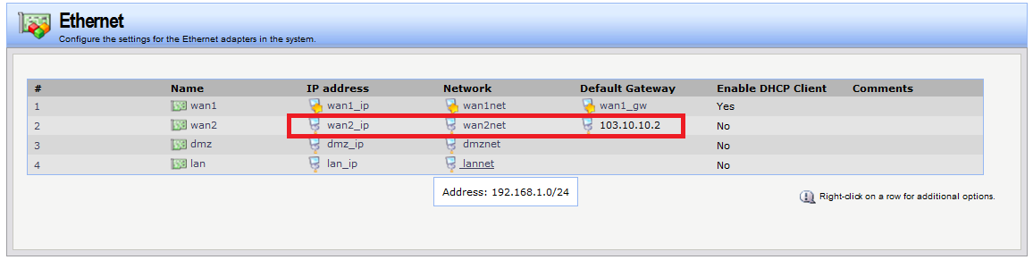

(2)Go to “Object” -> “Authentication objects”.Add a new pre-share key.
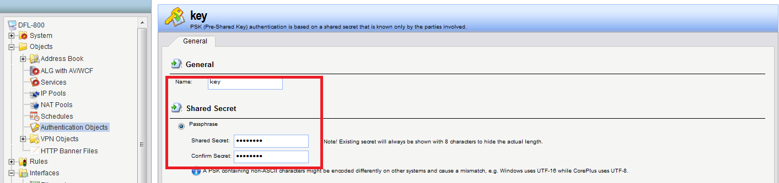

(3)Go to “Interface” -> “IPSec”. Add a new IPSec tunnel.
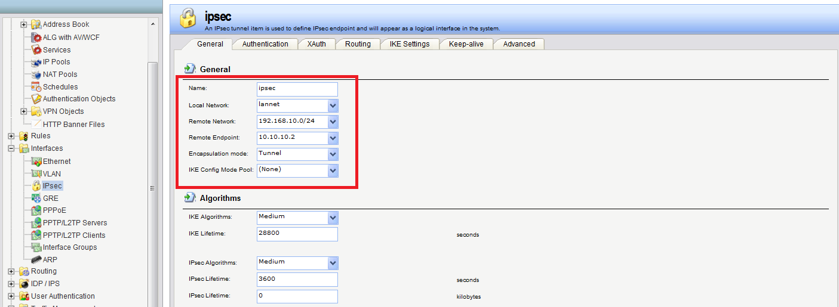

(4)Go to “main table”. Add a new route. Please be carefully “network” and “gateway”.
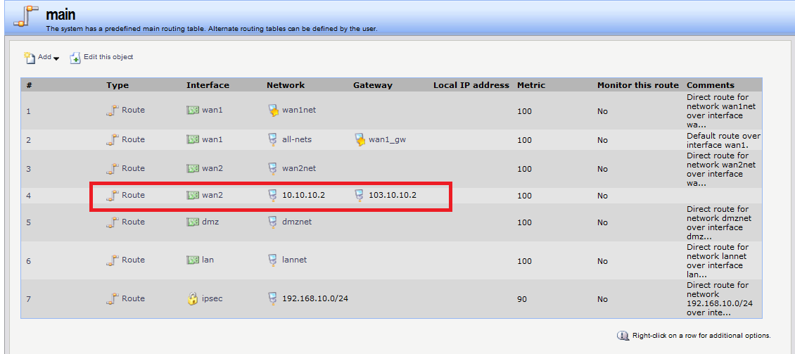

(5)Go to “Rule” -> “Access”. Add a new accept rule for wan2.
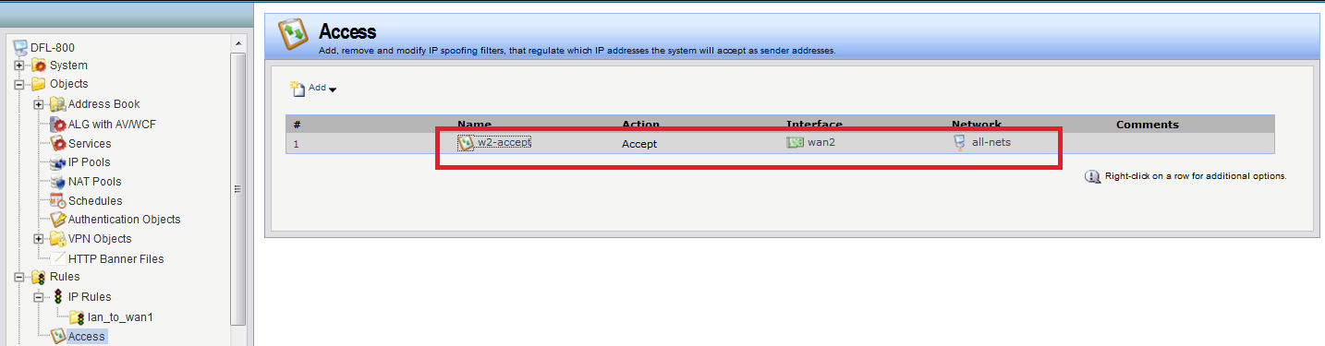

(6)Go to “Rule” -> “IP Rules”. Add two new rules for VPN.
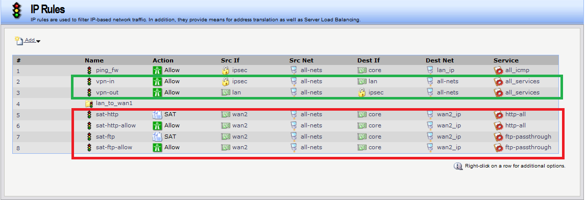
(7)Go to “routing”. Add a new PBR table.
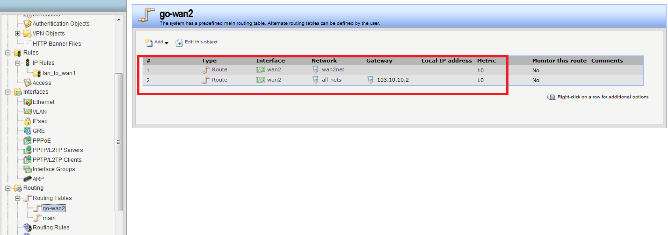

(8)Go to “routing” -> “routing rules”. Add a new rule for PBR table.
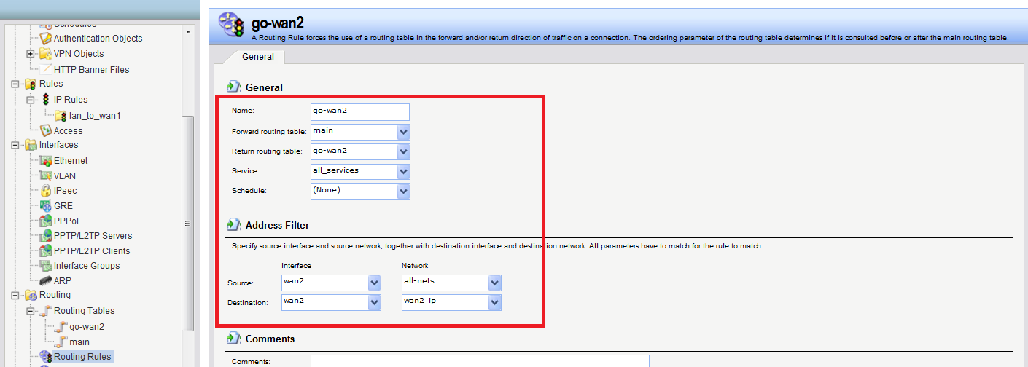

(9)Go to “Rule” -> “IP Rules”. Add four new rules for SAT.

