How to setup PPTP ALG

Topology:

IP: 192.168.1.10/24

LAN: 192.168.1.1/24
DFL-860E: PPTP server
WAN1: static ip

WAN: PPPoE
DFL-260E: PPTP ALG
LAN:192.168.10.1/24

IP: 192.168.10.10/24
PPTP client

You can study “NetDefendOS_2.27.03_Firewall_UserManual” P.269 chapter 6.2.7. “The PPTP ALG”. It can make you understand PPTP ALG more detail.

DFL-260E
(1)Go to “ALG with AV/WCF”. Add a new ALG “PPTP-ALG”.

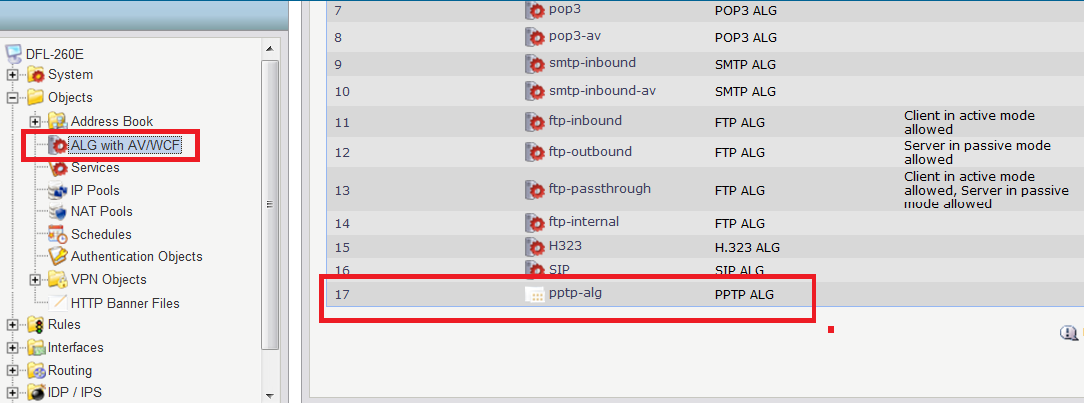
(2) Go to “Service”. Add a new “PPTP-service”.
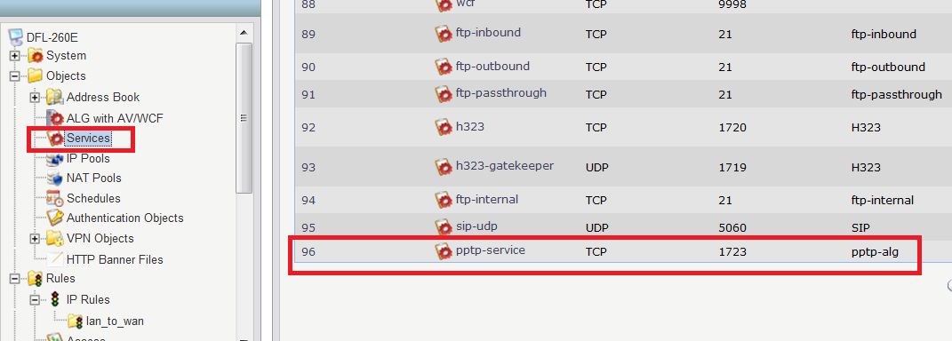
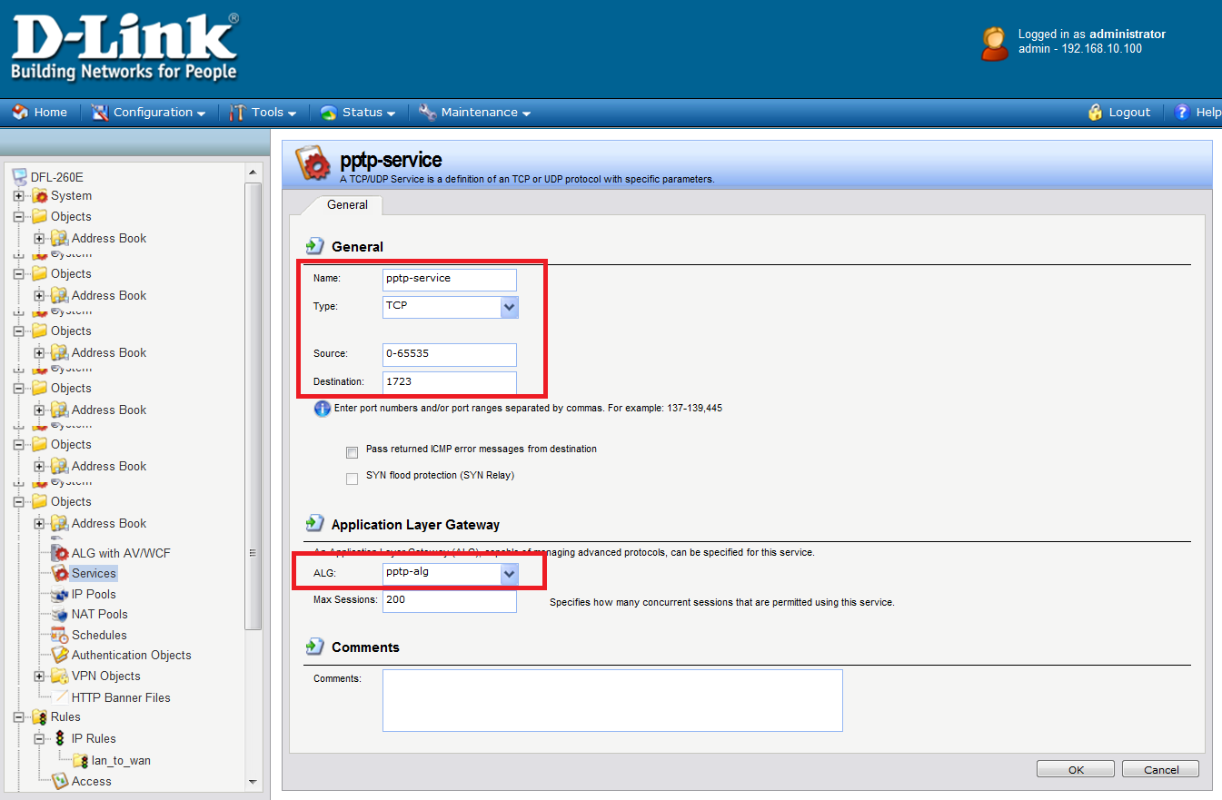
(3)Go to “IP Rules”. Add a new “PPTP” rule.
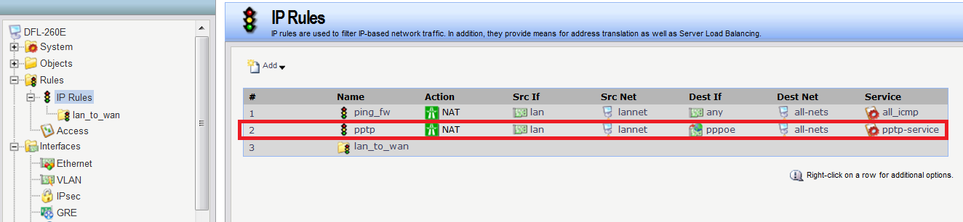

(4)
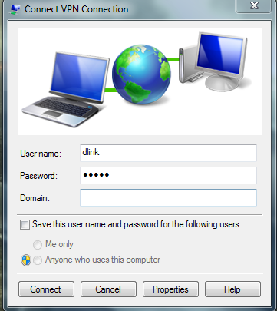

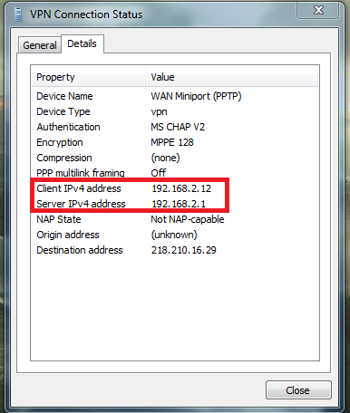

DFL-860E

(1) Go to “Address book”. Add two new IP objects.
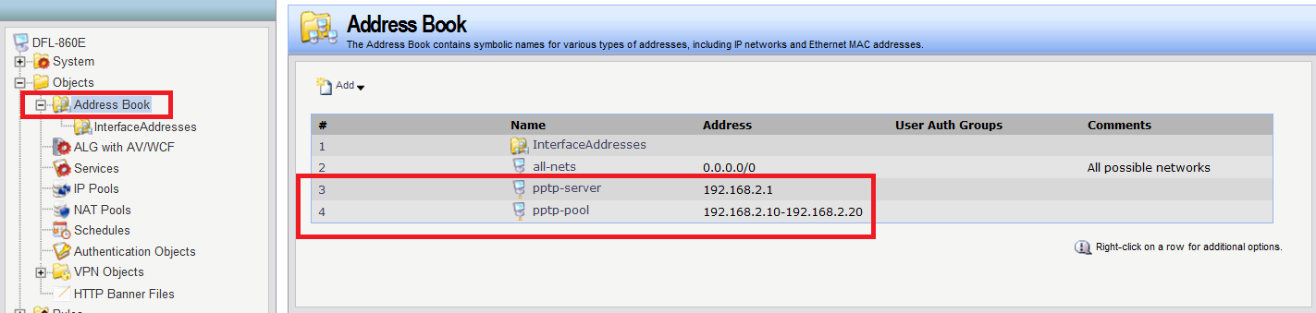

(2) Go to “PPTP server”.
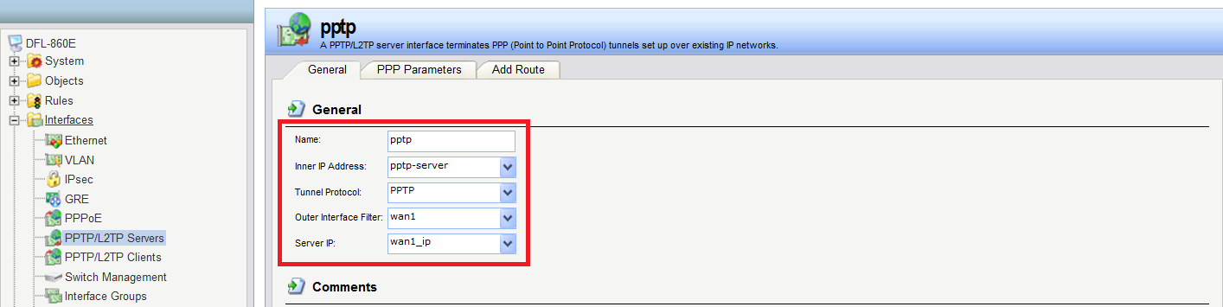

(3) Go to “AdminUsers”. Add a new user “dlink”.
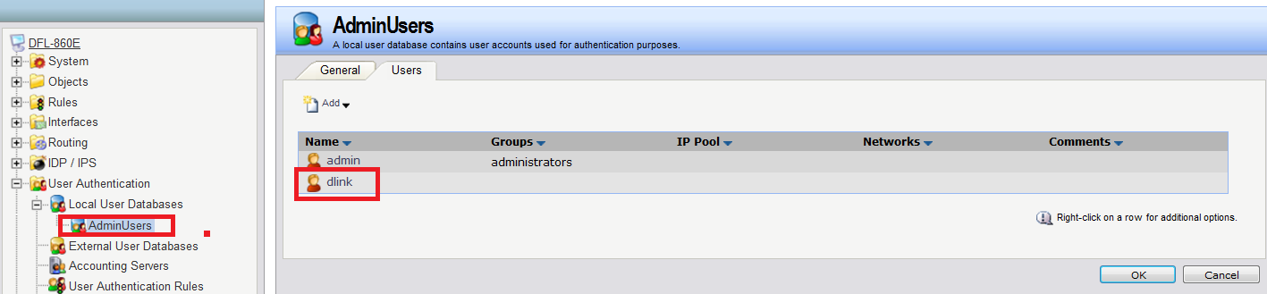
(4) Go to “User Authentication Rules”. Add a new rule “PPTP”.
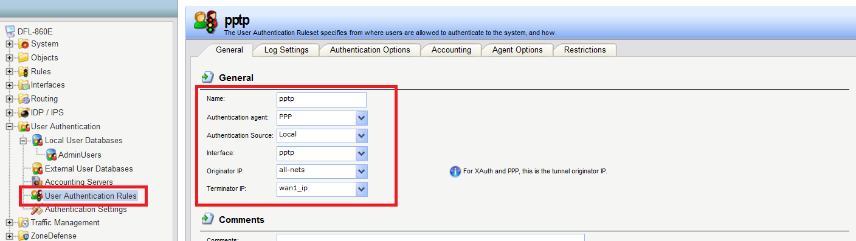

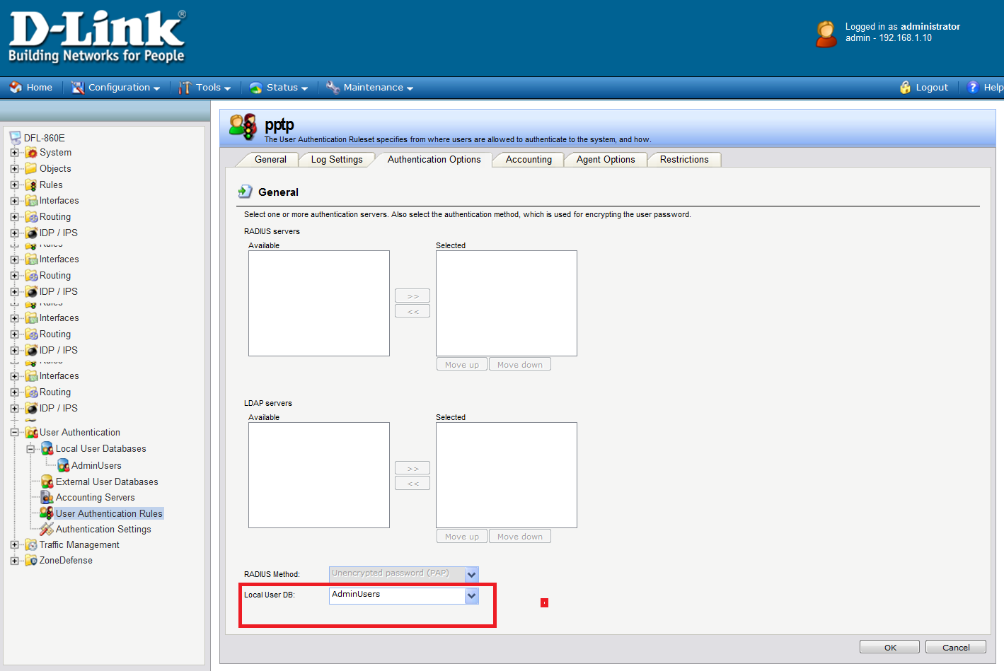

(5)Go to “IP Rules”. Add a new “PPTP” rule.
