The Version of Ubuntu in this KM is Ubuntu-11.04-desktop-i386
The DFL FW is v2.40.00.10

[Test Topology]
PC1(192.168.1.100)------(L1:192.168.1.1/24)DFL-2560(W1:PPPoE)------Internet
PC2(192.168.1.66)-------/
PC1 is the Radius server; PC2 is the End User
The MAC address of PC2 is 00-21-70-b5-ee-92

The settings of DFL-2560
Setup DFL-Firewall RADIUS Server, the shared secret is “dlink”
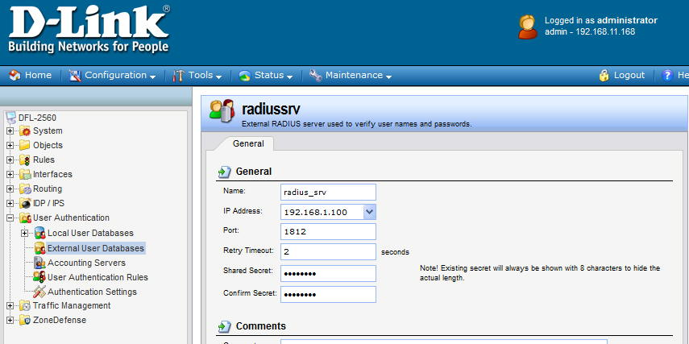

Setup the WebUI before rule and change the http port to 8080
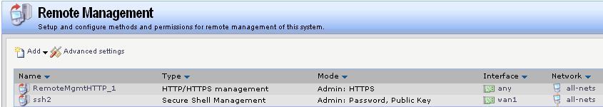
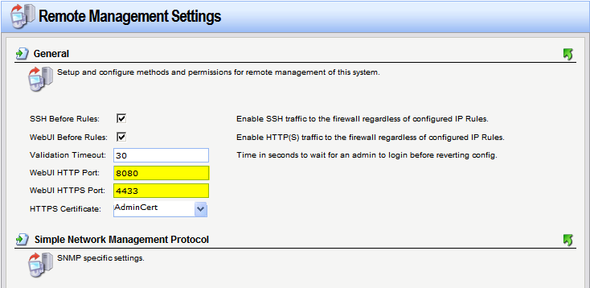

Setup DFL Firewall User Authentication Rule
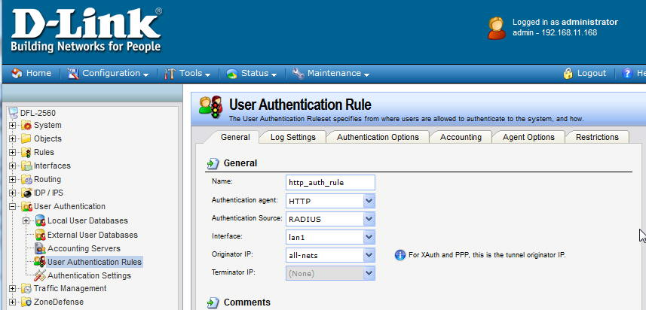
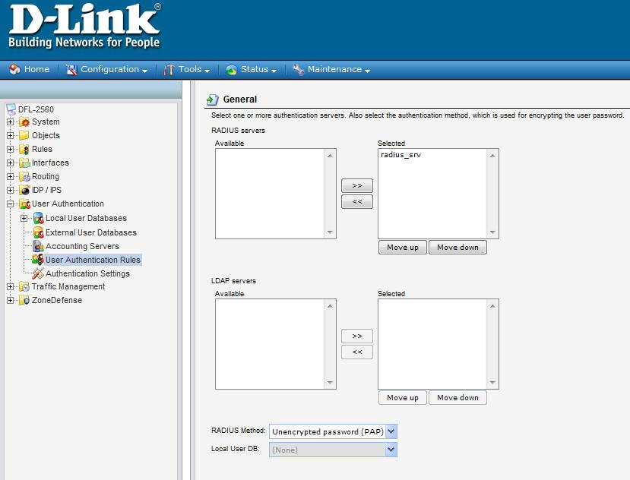

Select “MAC authentication” as the Login Type
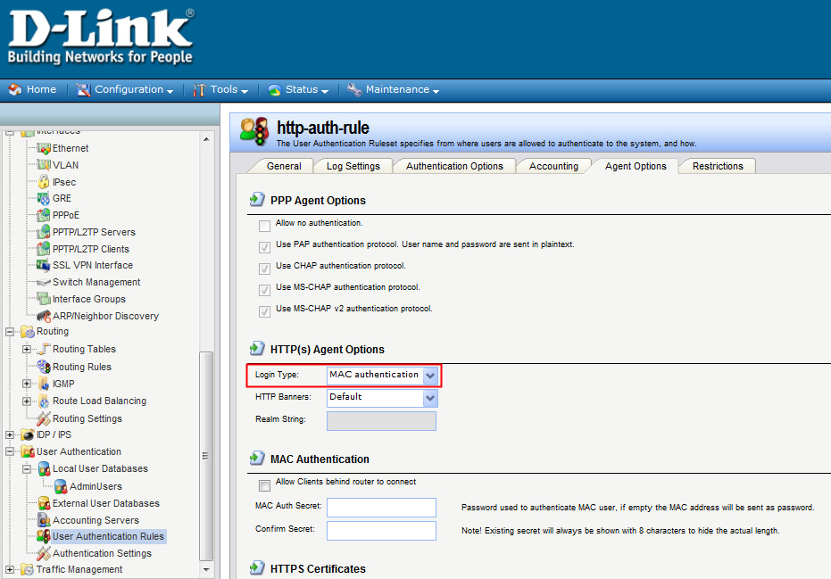

Add an IPv4 address object for authenticated users
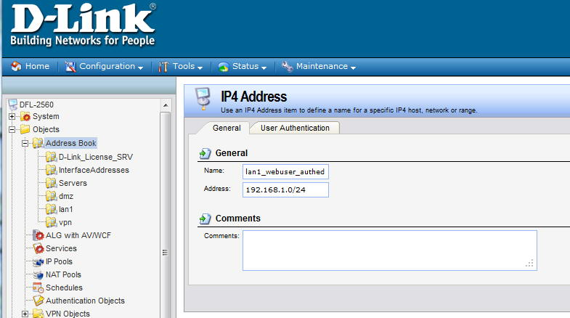

The authed user is “00-21-70-b5-ee-92”, or the authed group is “webauthedgroup”.
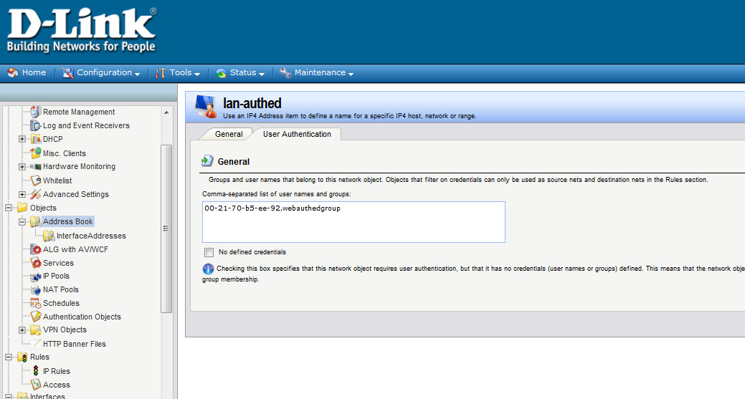

Setup the required IP Rules
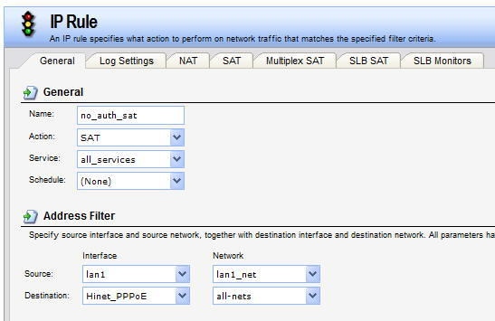
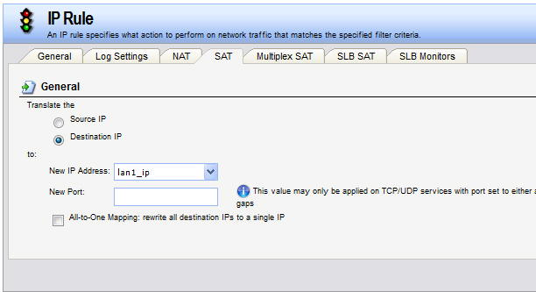
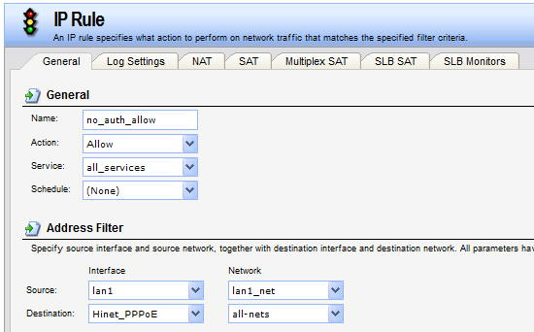

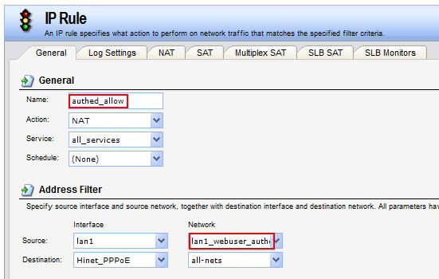

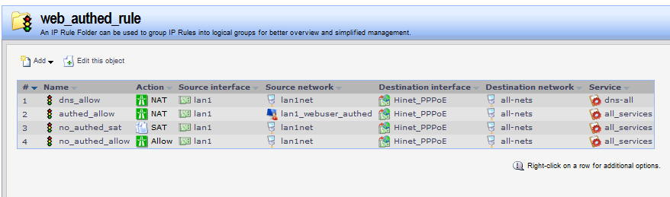

The settings of the Radius Server
Install the freeradius
#apt-get install freeradius

Setup the information of radius client(DFL-2560)
#vi /etc/freeradius/clients.conf
client 192.168.1.1 {
secret = dlink
shortname = private-network-test

Setup the group information
#vi /usr/share/freeradius/dictionary.dlink
##########################
VENDOR D-Link 5089
ATTRIBUTE D-Link-User-Group 1 string D-Link
##########################

#vi /usr/share/freeradius/dictionary
$INCLUDE dictionary.dlink

Setup the user account and password
/etc/freeradius/users
00-21-70-b5-ee-92 Cleartext-Password := " 00-21-70-b5-ee-92"
D-Link-User-Group = "webauthedgroup"
Note : the user name and password is PC2’s MAC address.

#/etc/init.d/freeradius stop
#/etc/init.d/freeradius start
#/etc/init.d/freeradius restart
or
#freeradius -X -i [ip address] -p 1812

End of this document

