How to configure the DFL-series, to use the group and user created in AD windows 2003, for filters WCF in DFL-firewall.

Topology:

WAN
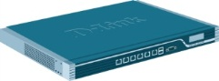LAN

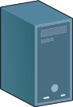
PC_A PC_B Server 2003
IP: 192.168.1.10 IP: 192.168.1.20 IP: 192.168.1.100
User: test1 User: test2
Group: room1 Group: room2
WCF: Gambling WCF: Shopping

In this example, we have two groups “room1” and “room2”. You have different WCF function, if you use different user account and password to login.

- Add a new “external user database”.
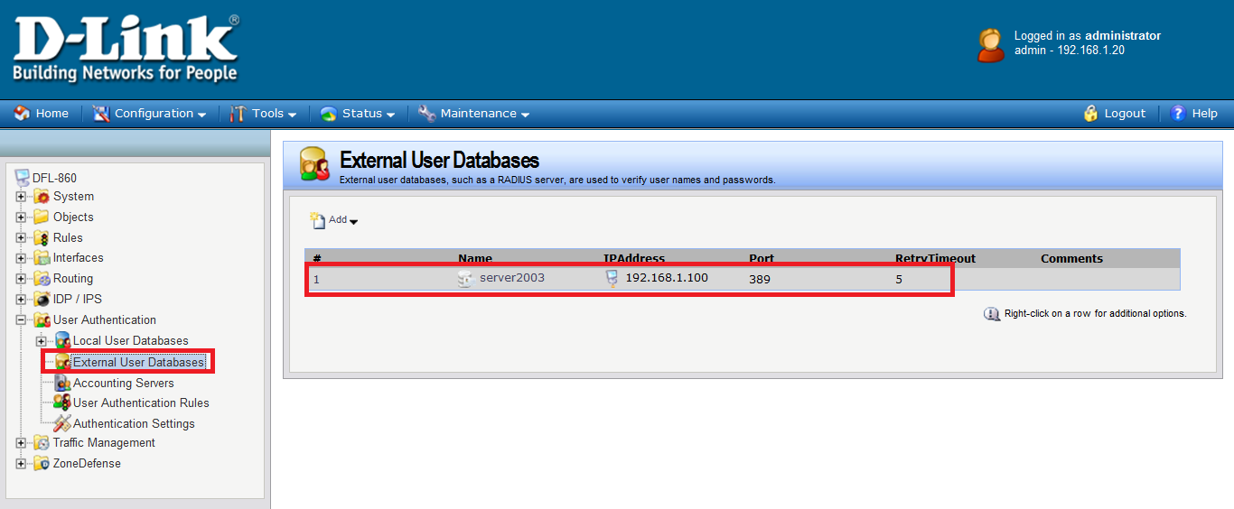

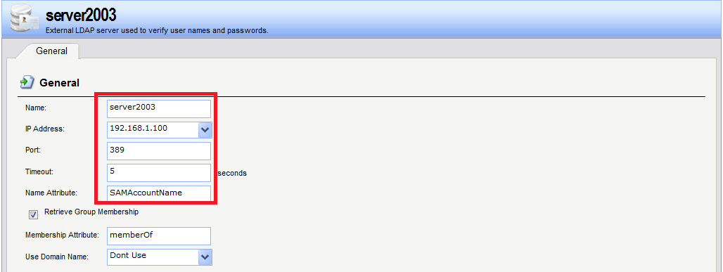

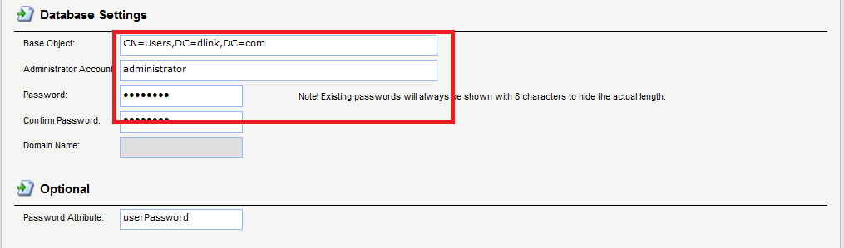

- Add a new “user authentication riles”.
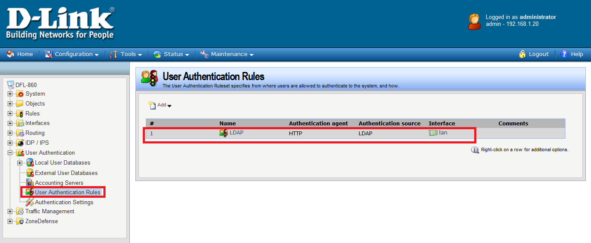

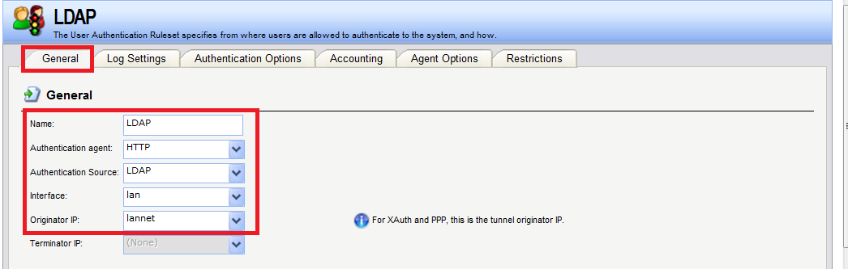
- Choose “LDAP servers”.
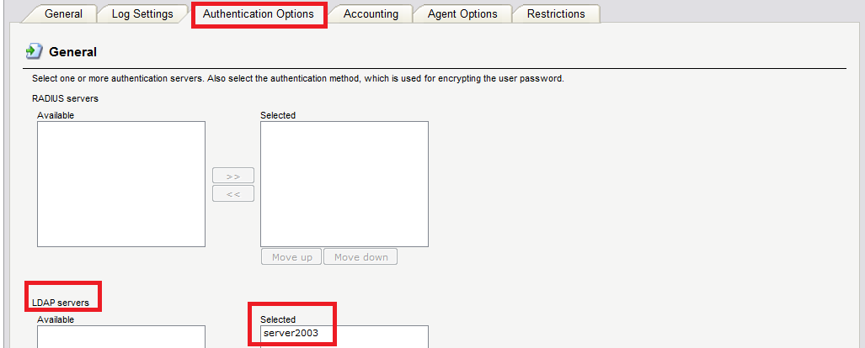

- Add two new authentication addresses.
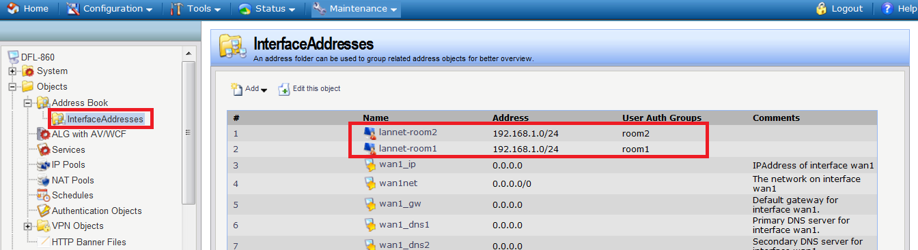
- Authentication group names must be the same with LDAP server.
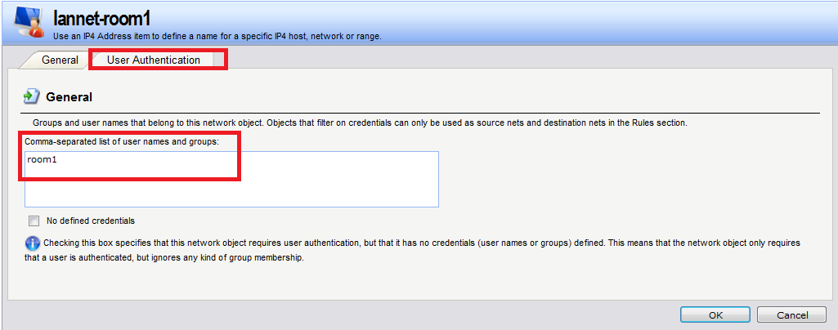

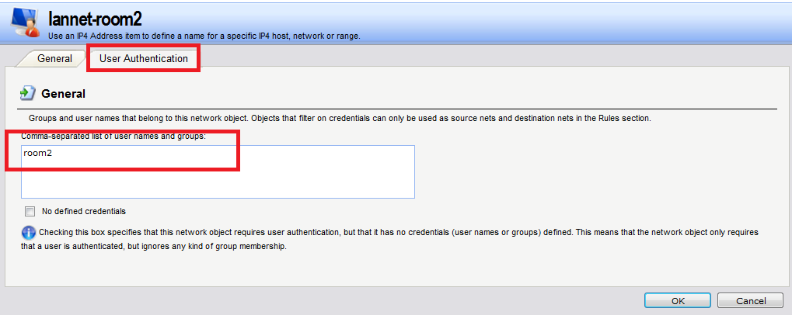

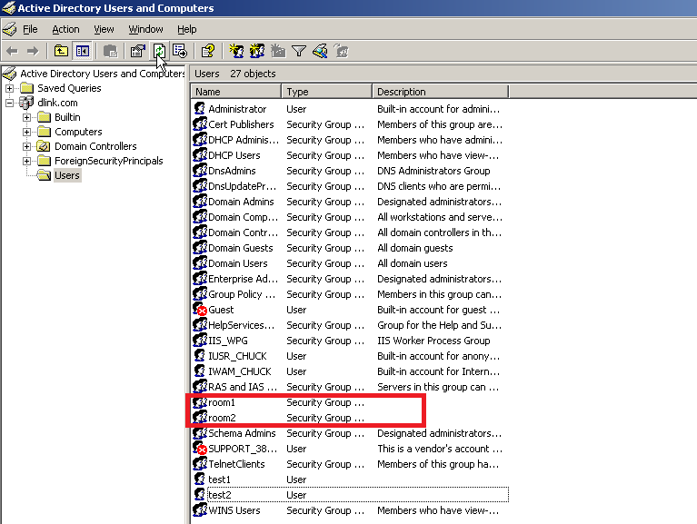
- Add a new “HTTP” ALG.
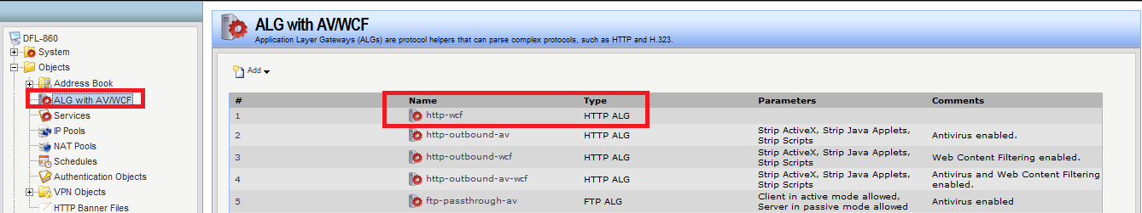
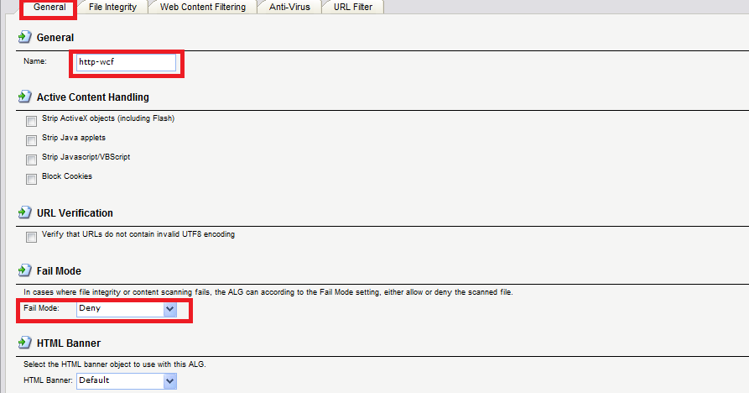

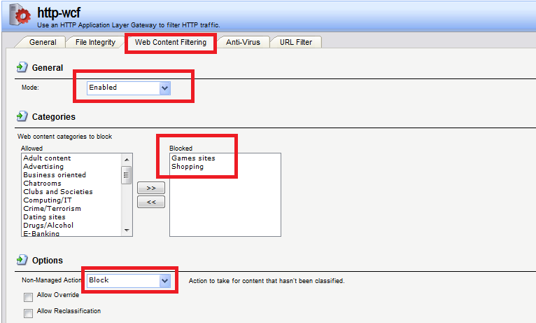

- Add two new services “HTTP-WCF-shopping” and “HTTP-WCF-gambling”.
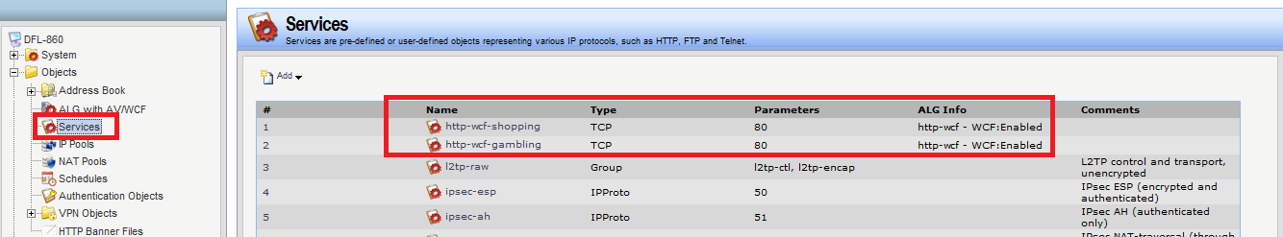

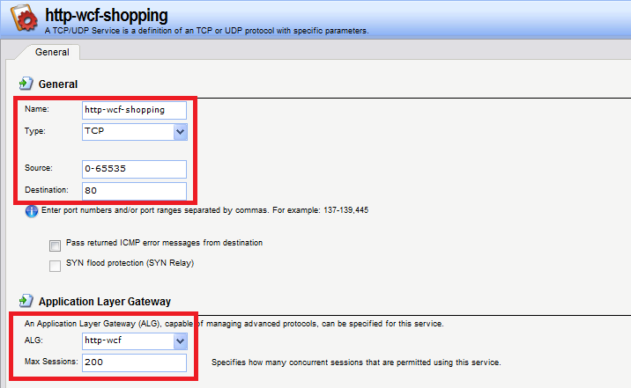

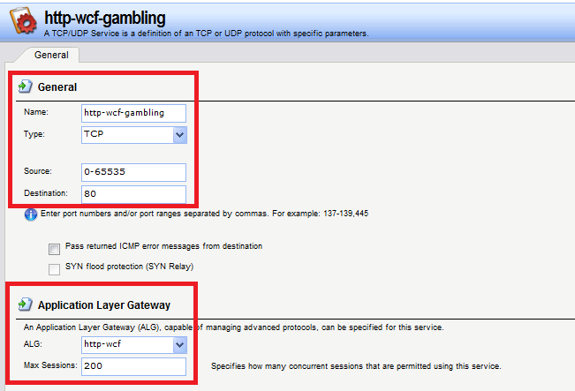

- Add five IP rules. These are for authentications.
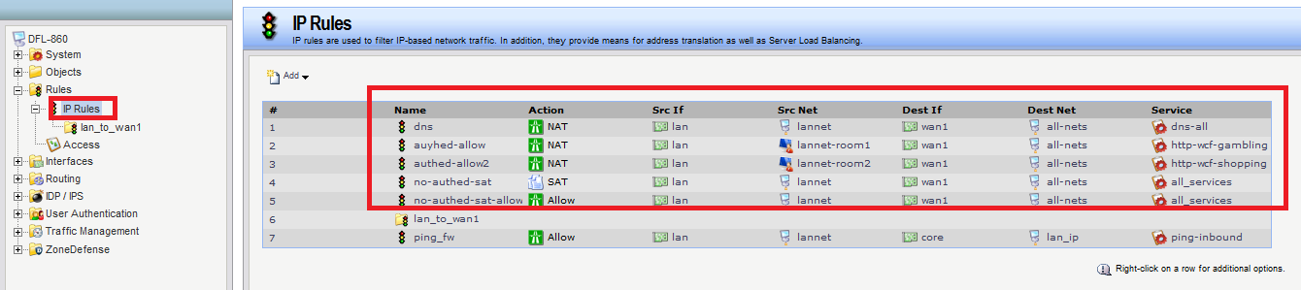
- New IP address have to choose “LAN_IP”.
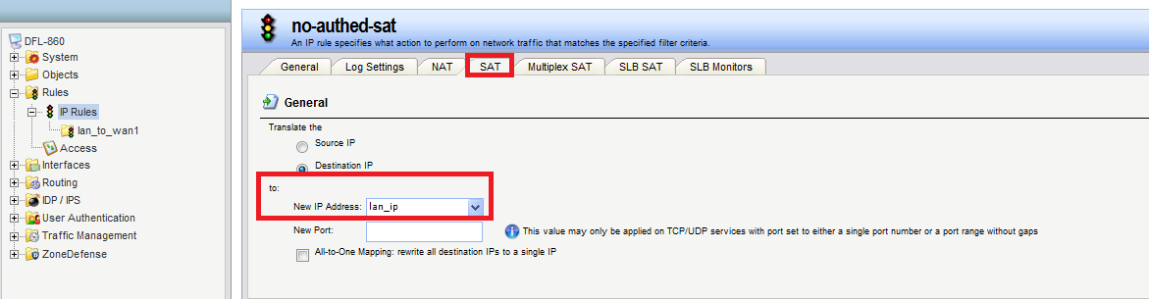

- You can see the status, if you authentication successfully.
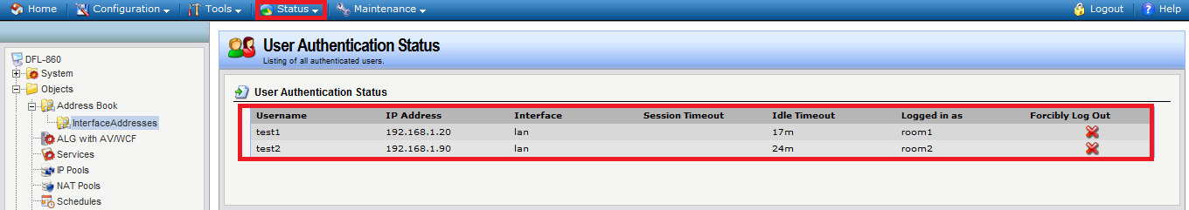
- This is forbidden successfully.
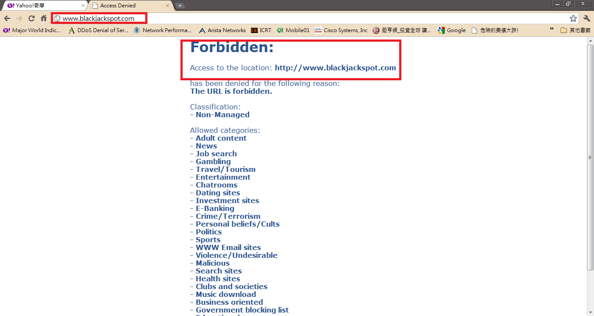

END

