IKE Configuration mode
IKE Configuration Mode is an extension to IKE that allows NetDefendOS to provide LAN configuration information to remote VPN clients. It is used to dynamically configure IPSec clients with IP address and corresponding subnet, and to exchange other types of information associated with DHCP. The IP address provide to a client can be either be based on a range of predefined static IP address defined for Config mode or it can come from DHCP servers associated with IP Pool object.

Test Topology.

VPN client PPPoE
IPSec software: TheGreenBow

WAN: Public IP
DFL-260E
LAN: 192.168.10.1/24

IP: 192.168.10.10/24

- Go to “address book”. Add a new IP address pool. This address subnet is the same with LAN subnet.
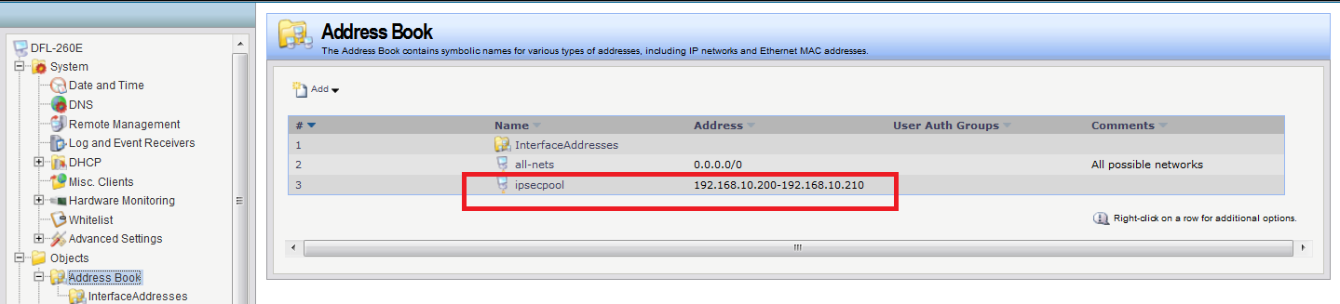

- Go to “VPN object” > “IKE Config Mode Pool”. Add a new IKE Config Mode Pool object.
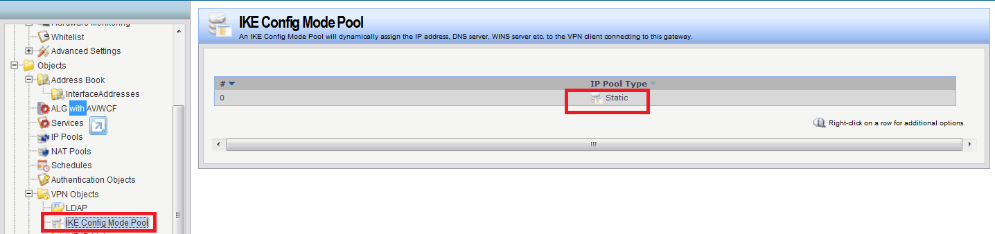

- Choose the “Use a Static IP Pool”. IP Pool: ipsecpool Network: class C
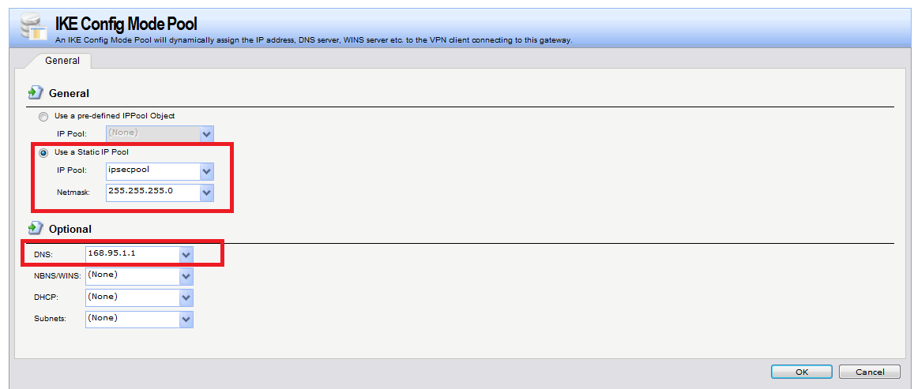
- Co to “Interface” > “ipsec”. Select the pool in the “IKE Config Mode Pool” drop down list.
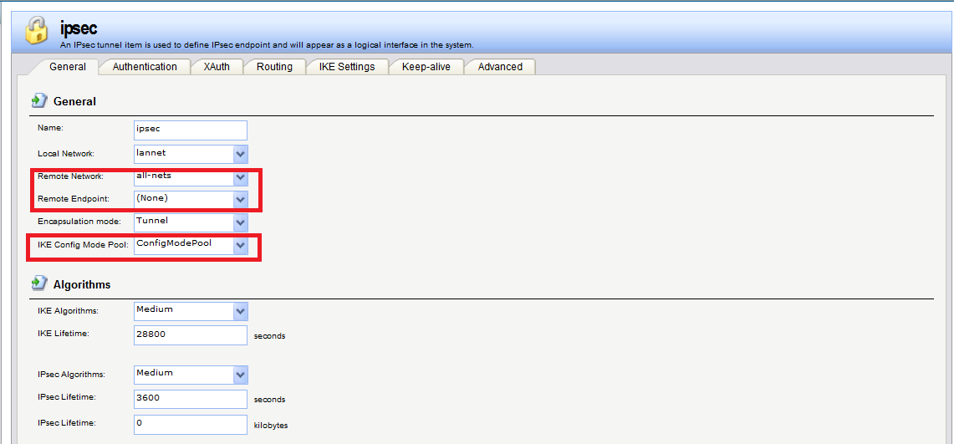

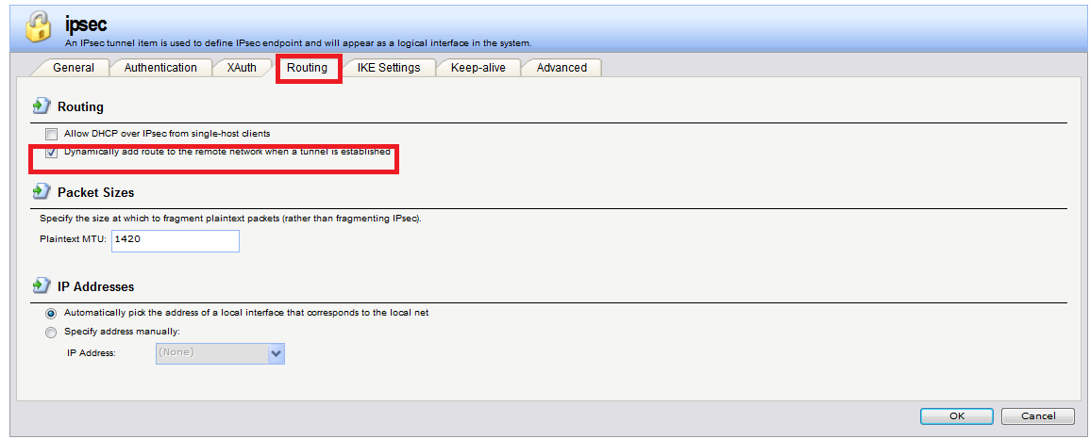

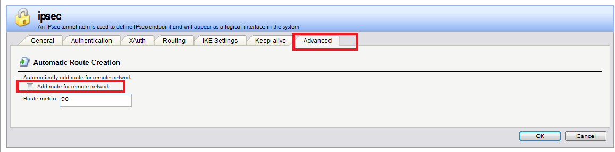

- Create 2 IP rules for VPN.
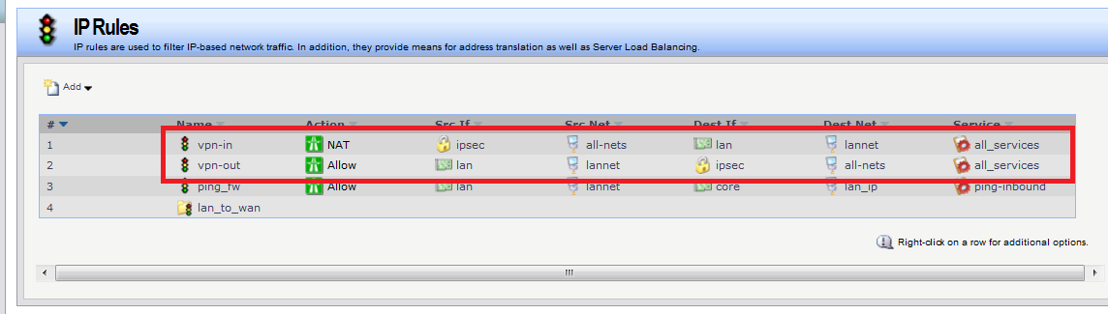

- If IPSec create successful, you can use “routes” to verify the IPSec interface.
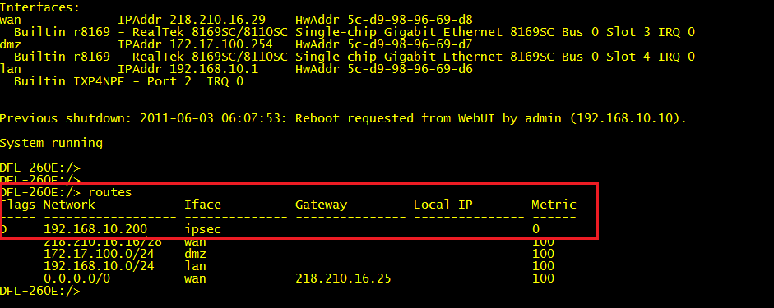

END

