How to use IDP to block YAHOO and MSN messenger

WAN1
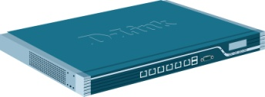DFL-860
LAN

Client
MSN: MSN messenger 2011
YAHOO: MSN messenger 11.0.0.1751

- Go to http://security.dlink.com.tw -> NetDefend Live ->
NetDefend IPS.
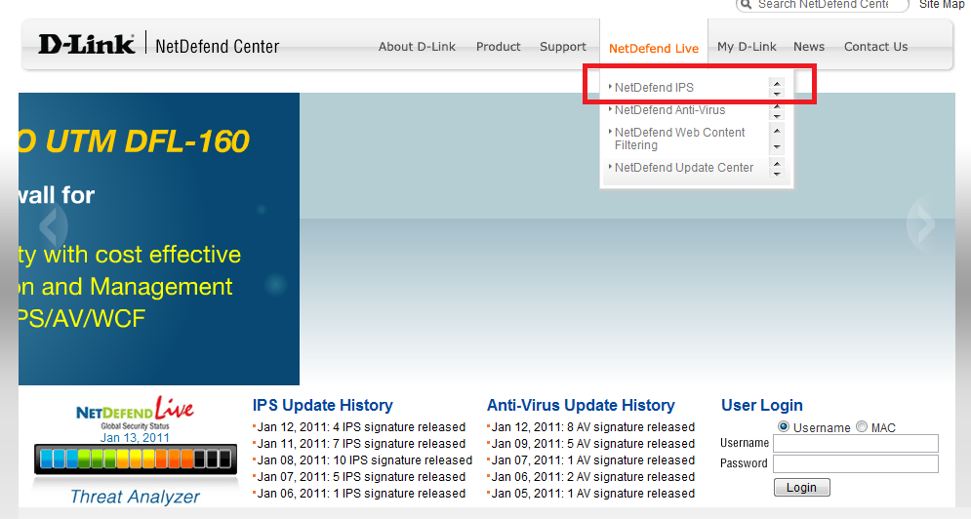
(2)You can use search to find which function do you want.
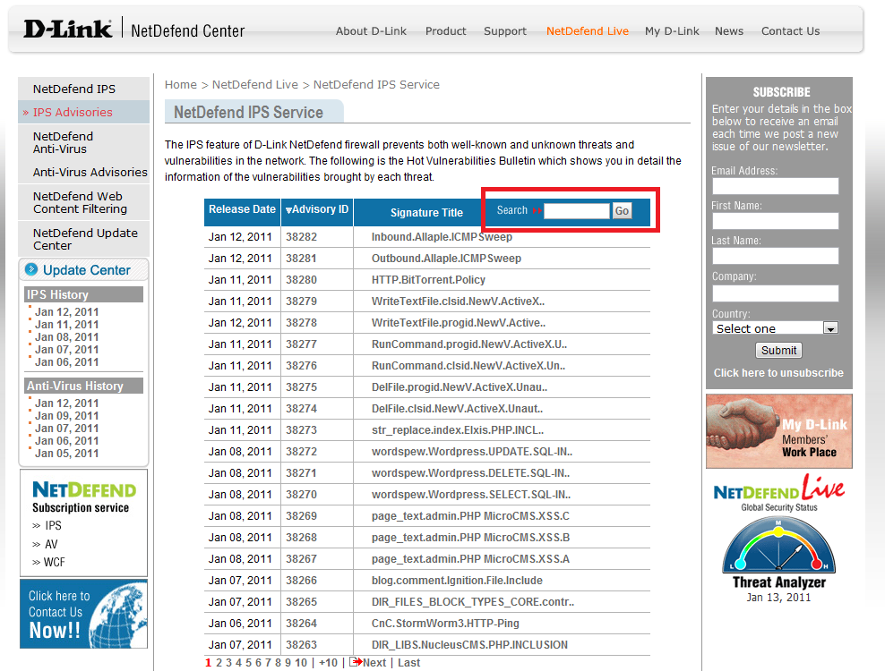

(3)Go to IDP/IPS -> IDP signatures. Find which group do you want.
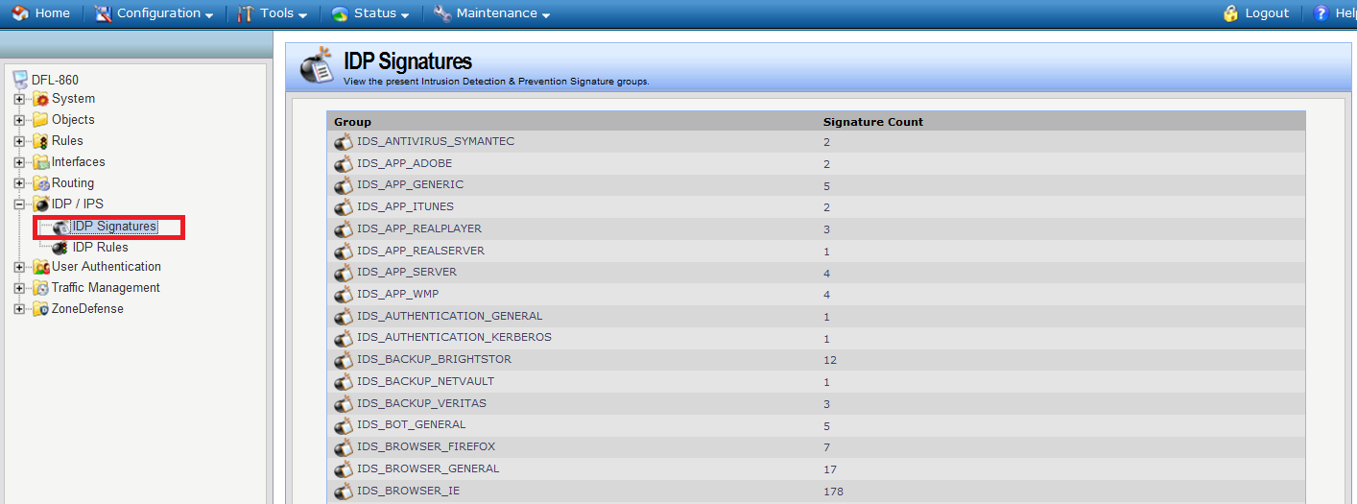

(4) Go to IDP/IPS -> IDP rules. Add two new IDP rule “msn” and
“yahoo”.
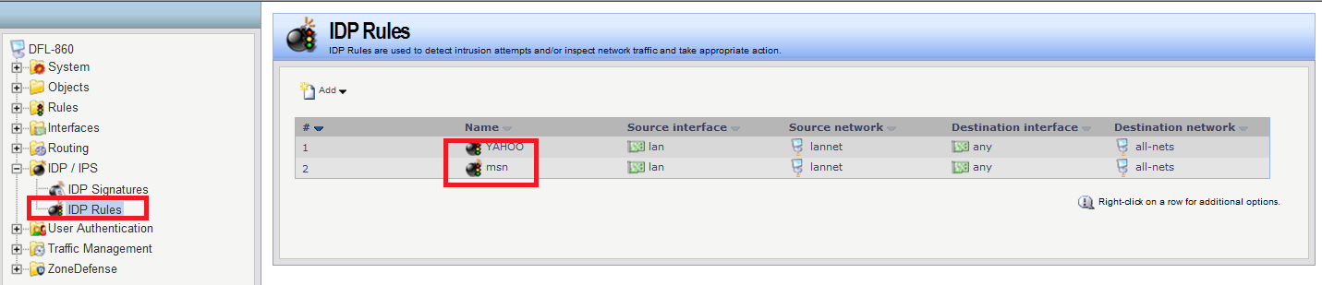

(5)Go into “yahoo”.
Be careful to address filter and service.
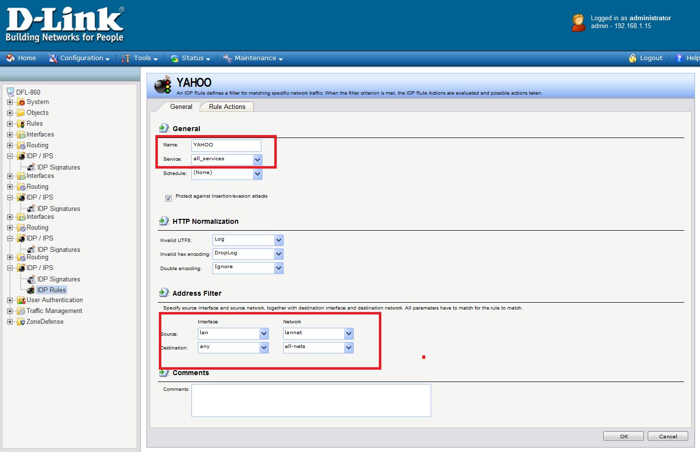

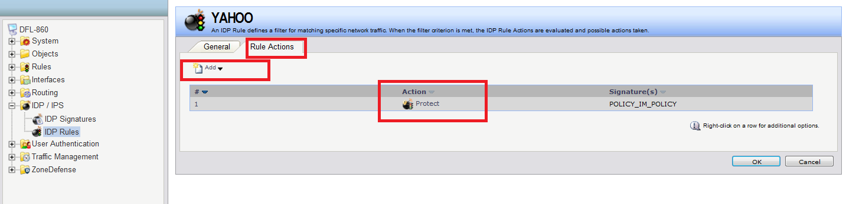

Choose action:protect. Signature:POLICY_IM_POLICY
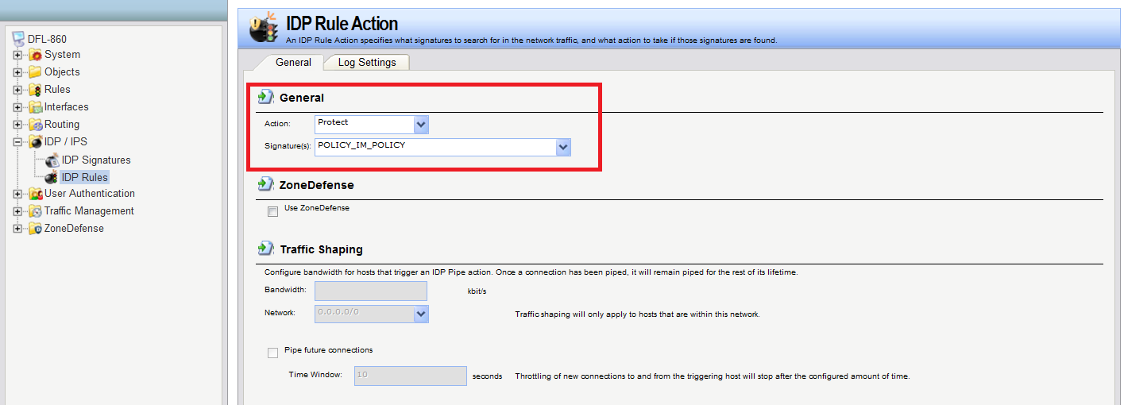
(6)Go into “MSN”.
Be careful to address filter and service.
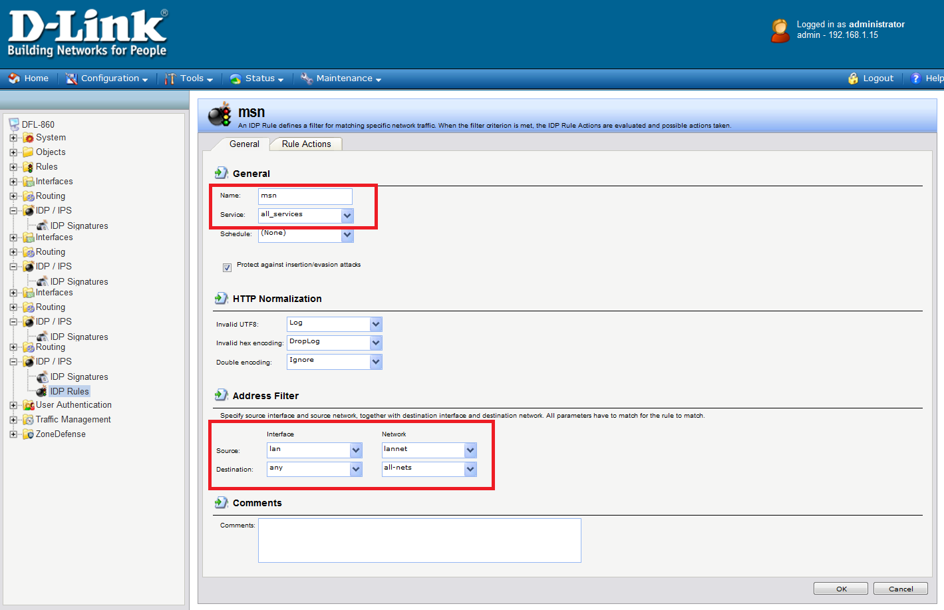

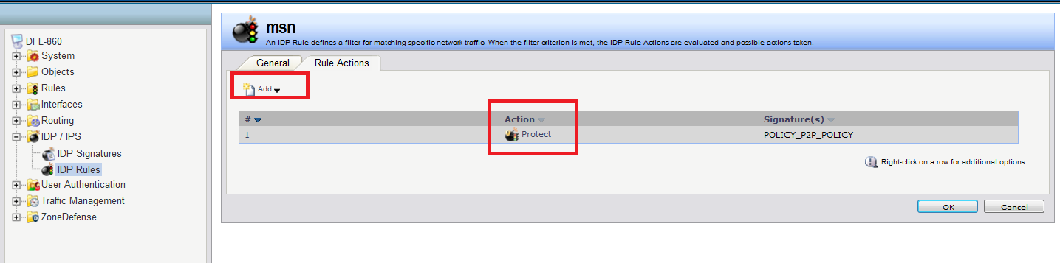
Choose action: protect. Signature: POLICY_P2P_POLICY.
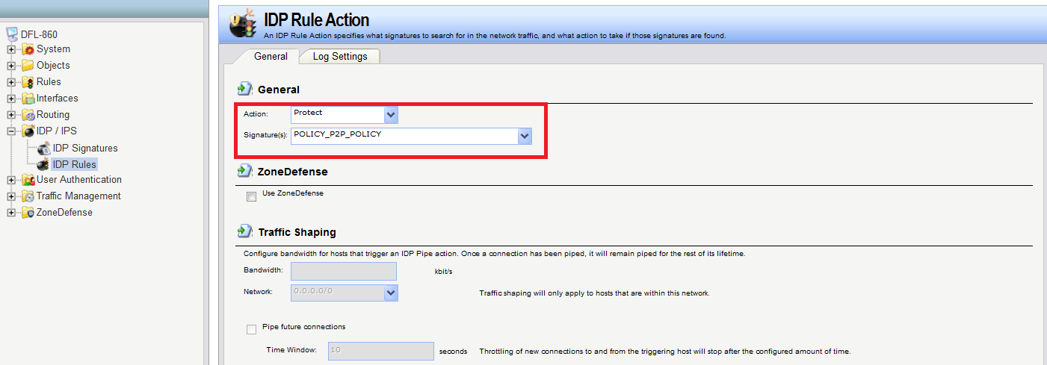
Go to status->logging.
