How to setup static content filtering

Through the HTTP ALG, NetDefendOS can block or permit certain web pages based on configured lists of URLs which called blacklists and whitelists. This type of filtering is also known as Static Content Filtering. The main benefit with Static Content Filtering is that it is an excellent tool to target specific web sites, and make the decision as to whether they should be blocked or allowed.

- Adding an HTTP ALG in order to filter HTTP traffic.
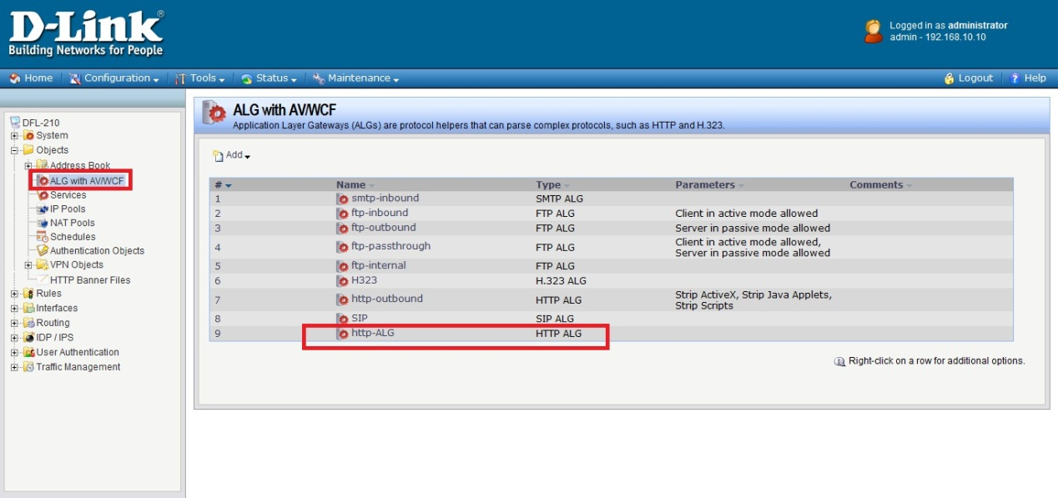

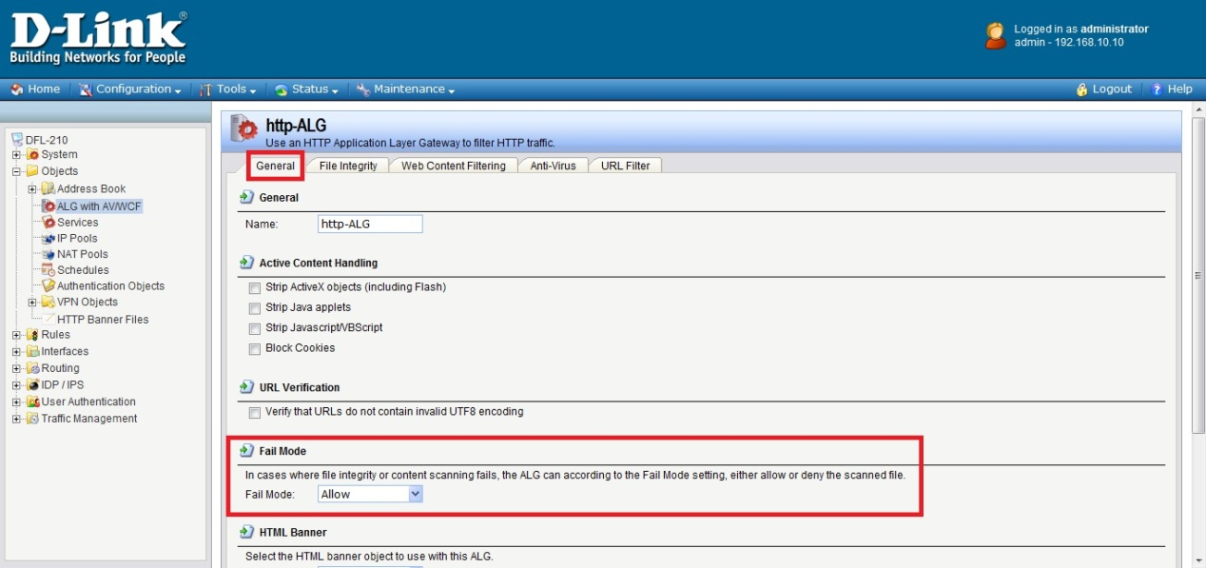

- Click the “URL Filter” tab. Now click “Add” and select “HTTP ALG URL” from the menu. Select “Blacklist” as the “Action”. Enter www.google.com.tw/* in the URL textbox.
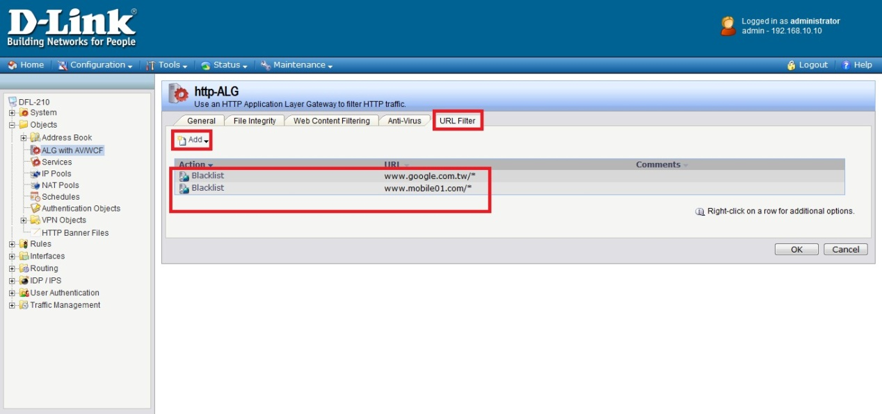

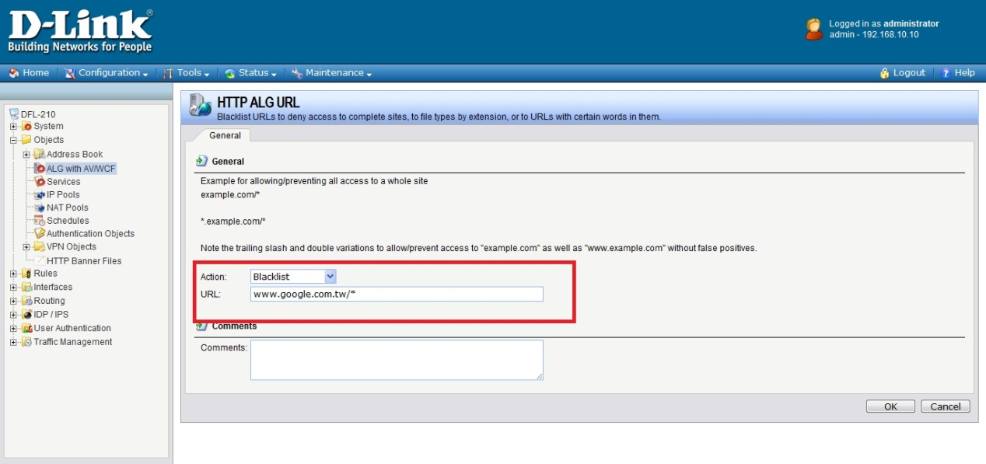

- Adding an “HTTP ALG service” in order to filter HTTP traffic.
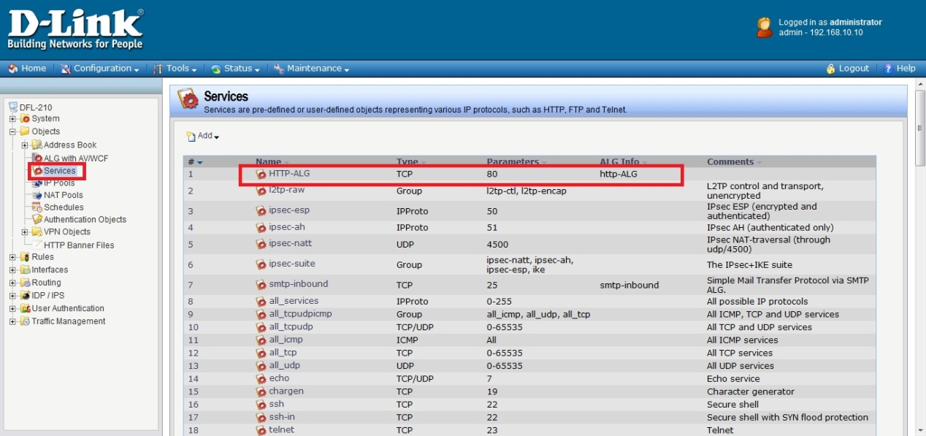

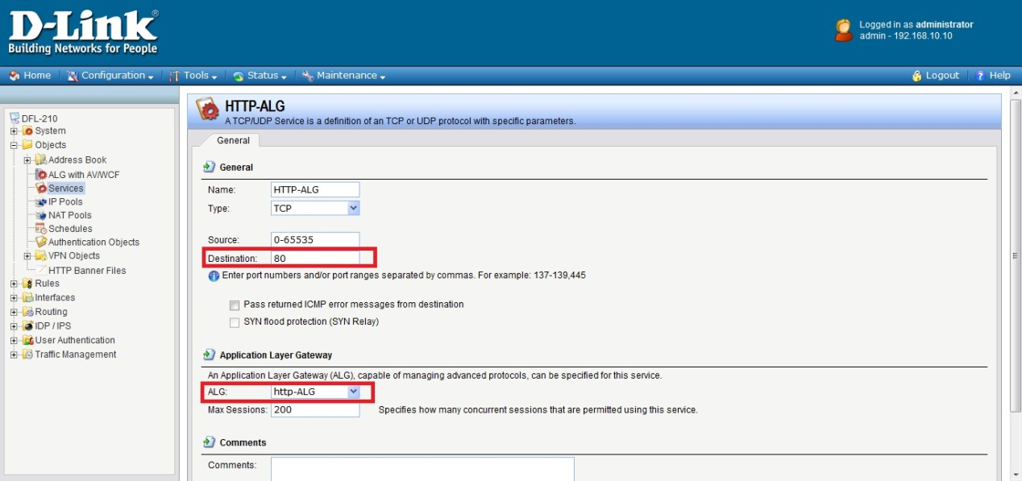

- Adding an “HTTP-test” IP rule in order to new “HTTP-ALG” service.
