How to setup one to one SAT

WAN IP: 218.210.16.29

FTP server server HTTP server
IP: 192.168.1.10 IP: 192.168.1.30 IP: 192.168.1.20

Public IP: 218.210.16.27 to 192.168.1.10
Public IP: 218.210.16.28 to 192.168.1.20
Public IP: 218.210.16.29 to 192.168.1.30

- Create two routes in the main table. Because these two IP address is not on your interface.

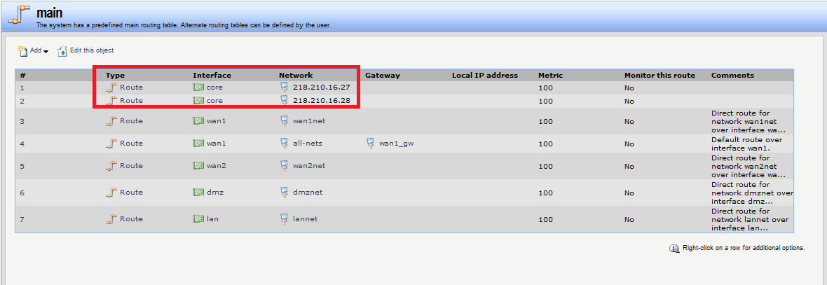
- Create two ARP publish. Because these two IP address is not on your interface.
You have to use WAN1 to
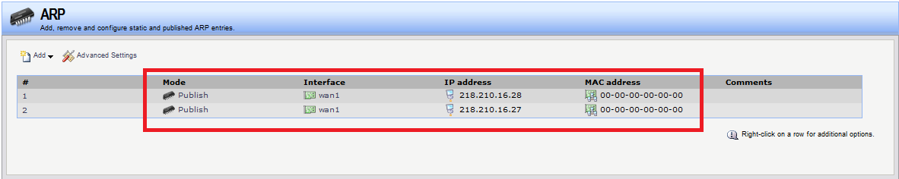
- Create SAT IP rules.
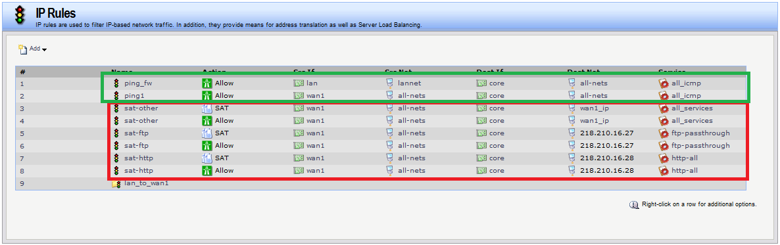

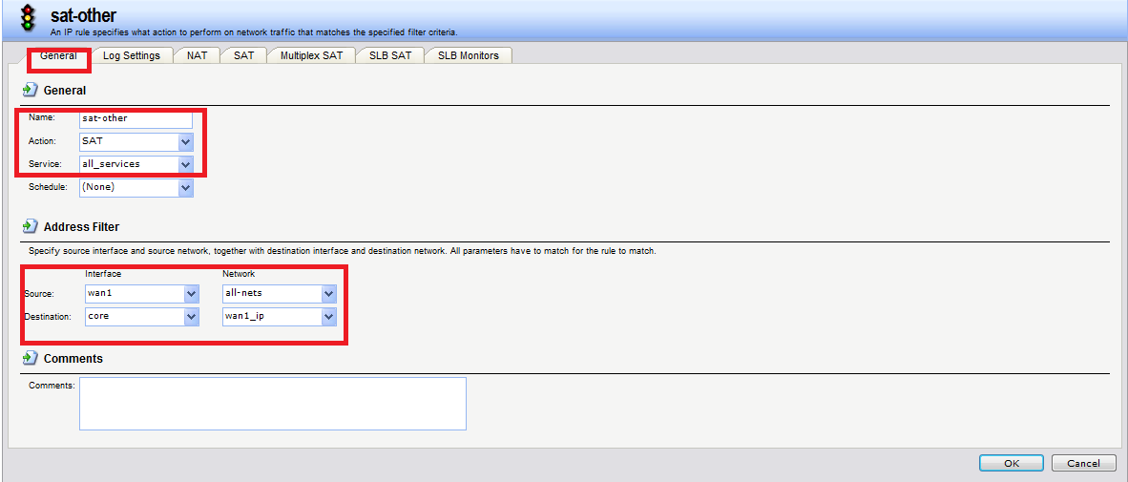

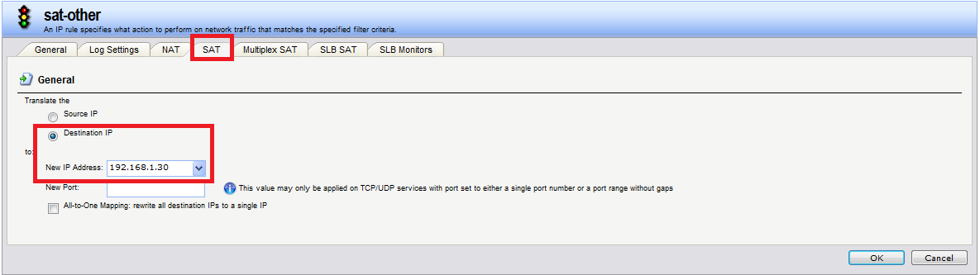

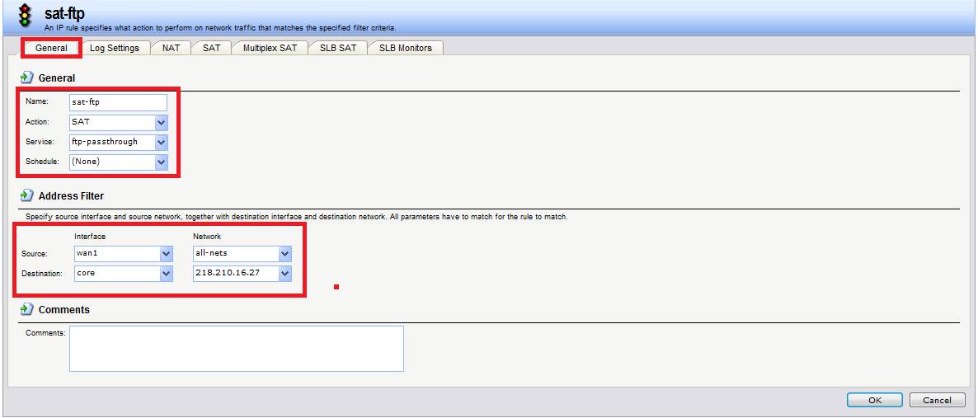

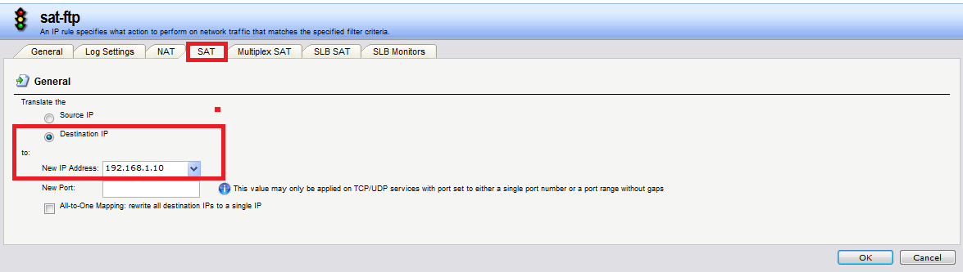

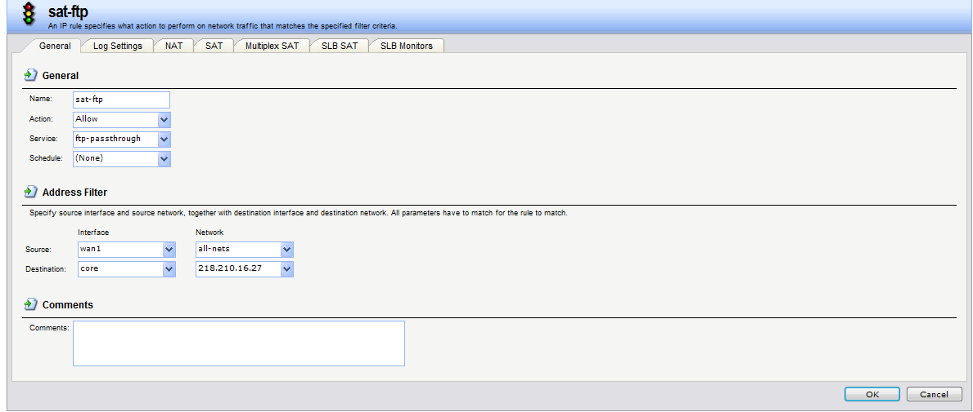

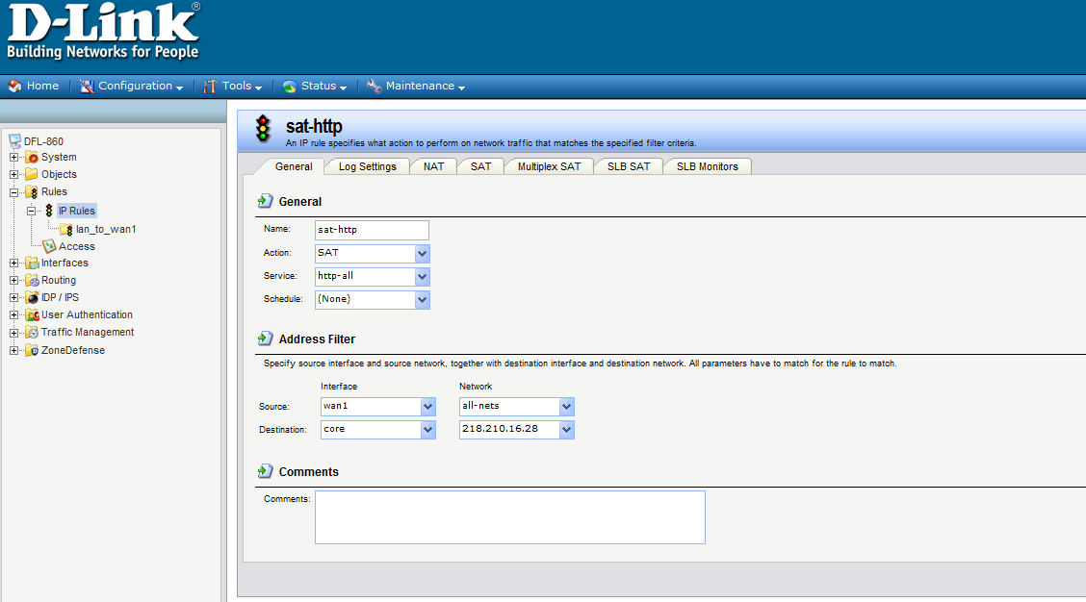

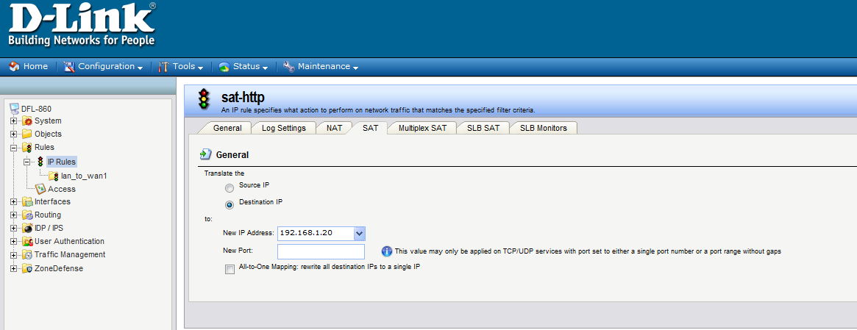

END

