How to setup dynamic WCF
This example shows how to setup a dynamic content filtering policy for HTTP traffic from LAN to all-nets.

- Add a new HTTP ALG and choose which categories would you want to blocked.
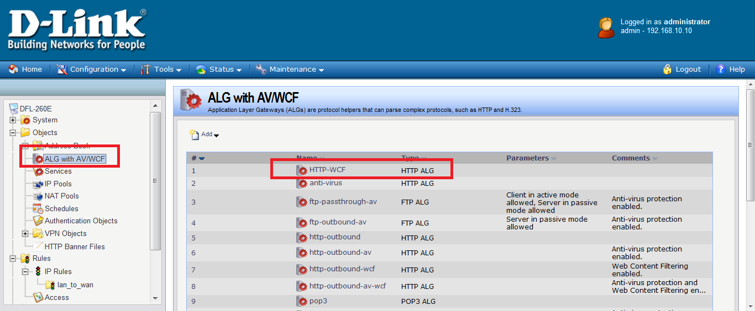

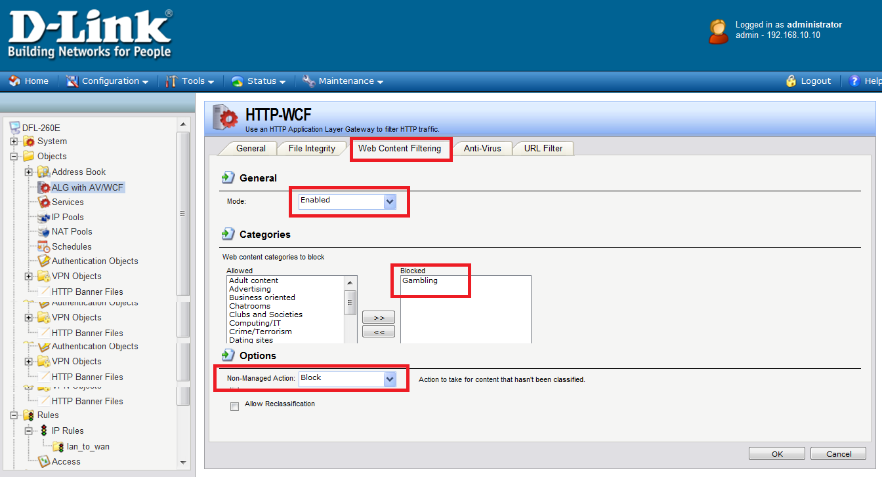

(2)Add a new TCP service.
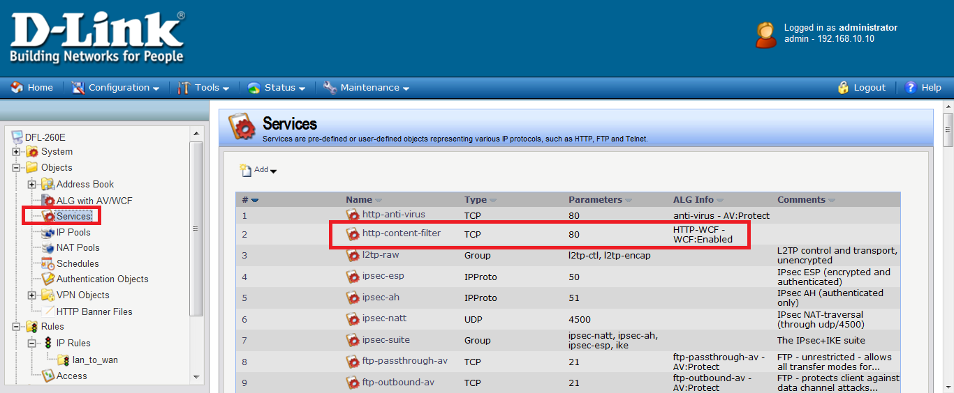

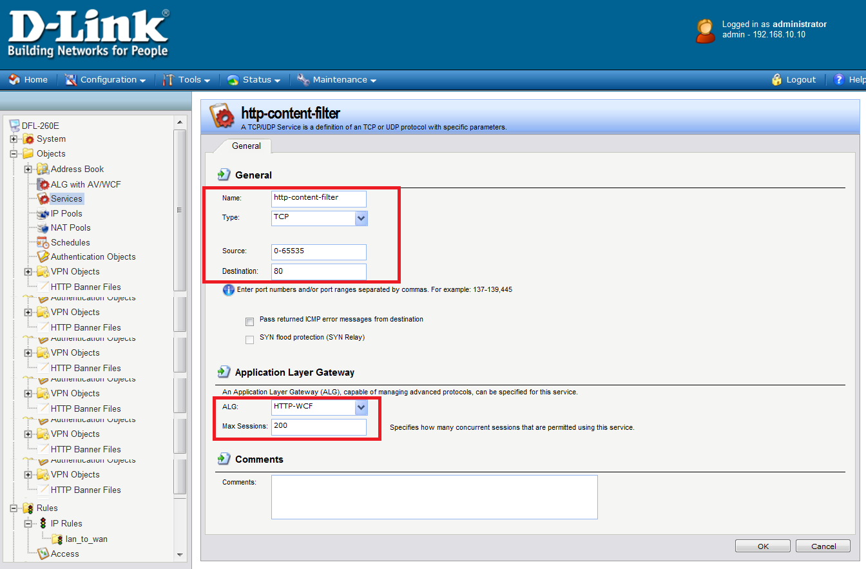

(3)Add a new IP rule.
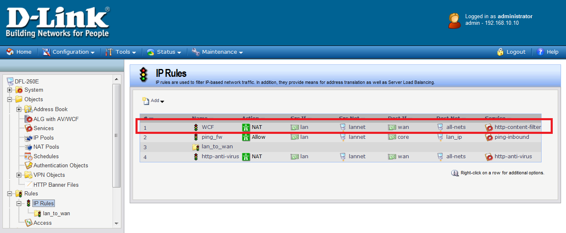

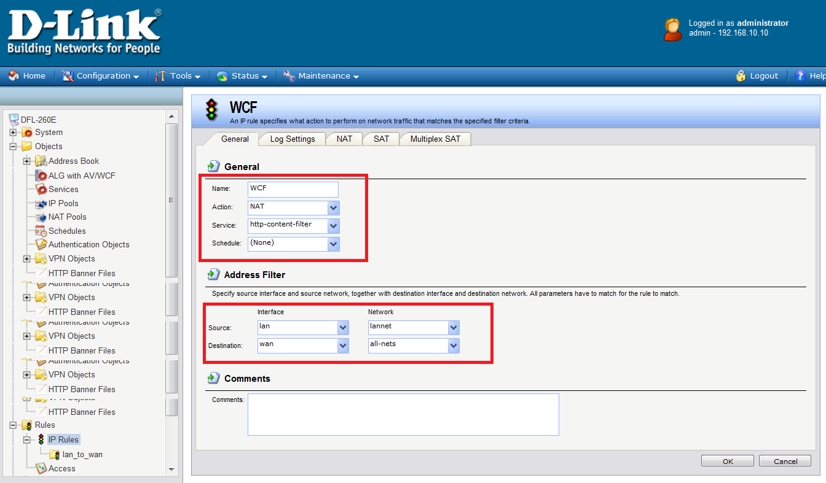

Dynamic content filtering is now activated for all web traffic from LAN to all-nets.

