How to setup SSL VPN on DFL

Topology:

PC 1 -------------------------- DFL (PPPoE) -------------Internet------------SSL client

Setup:
- Check firmware. You need to use 2.30.01.06.
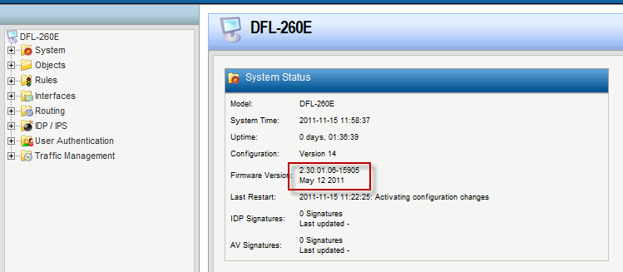
- Add a new PPPoE interface.
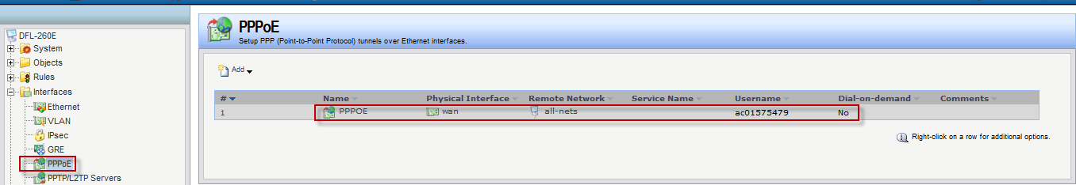

- Add a new SSL VPN interface. Inter IP and IP address pool must be in the same subnet.
Outer interface: PPPoE
Server IP: pppoe_ip

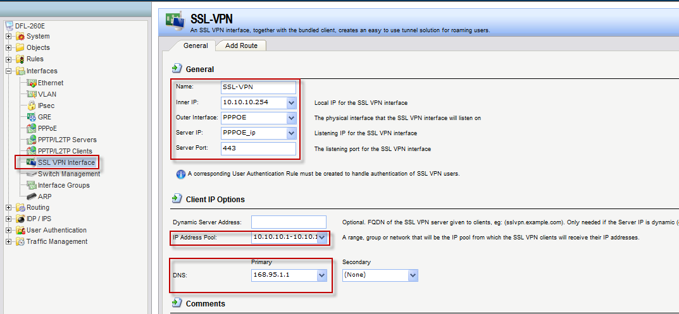

Note:
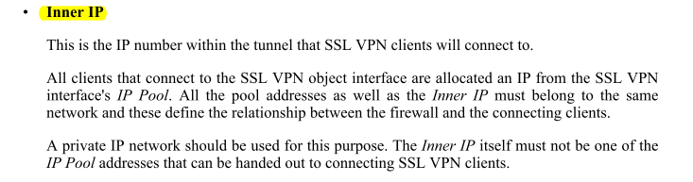
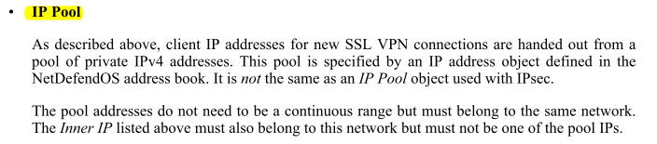

About more SSL VPN information, please read “NetDefendOS_2.40.00_Firewall_UserManual”.

- Add a new SSL VPN user “dlink”.
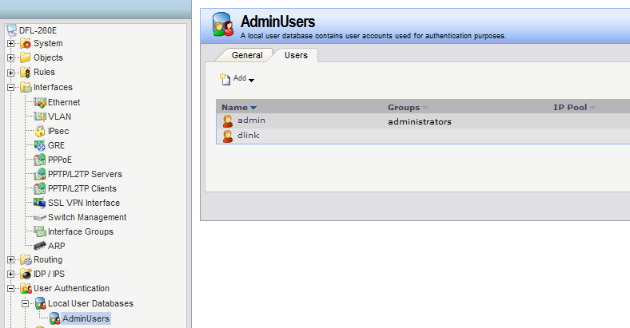

- Go to “User Authentication rules”.
Interface: SSL-VPN
Originator IP: all-nets
Terminator IP: PPPOE_ip
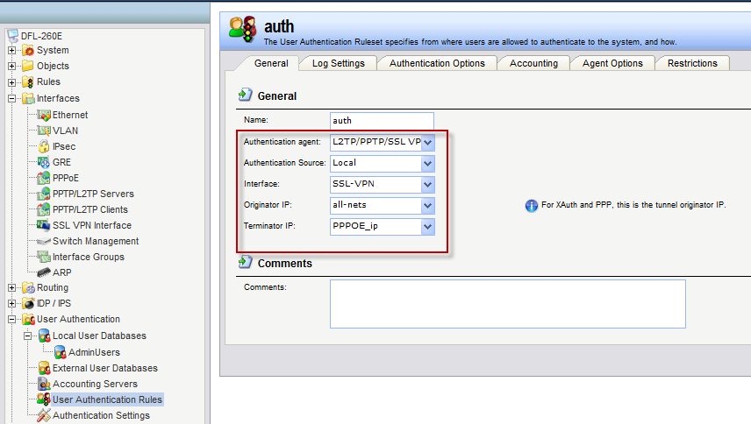

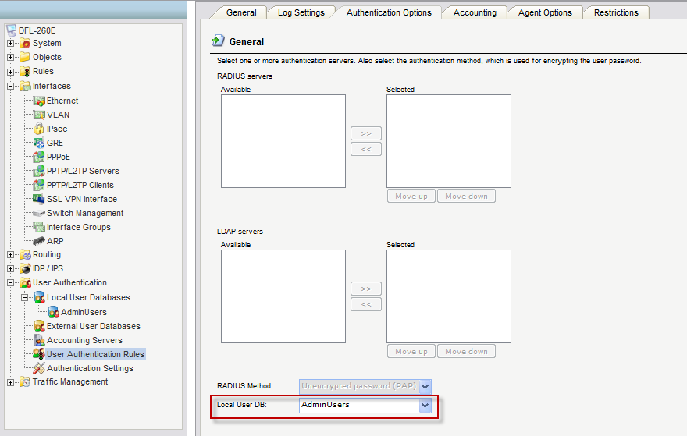

- Add 2 IP rules for SSL VPN user.
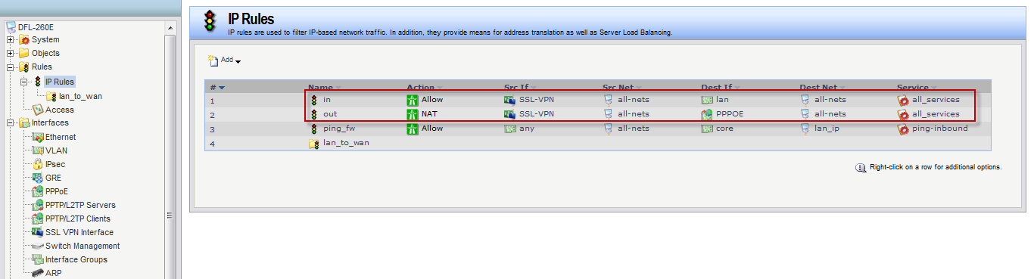

- You can use SSL VPN client to connect DFL.

END

