How to setup L2TP over IPsec on the DFL-series

Topology:

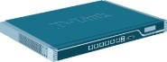
L2TP over IPsec Server L2TP over IPsec user

- Add 2 address object “l2tp-server” and “l2tp-pool”.

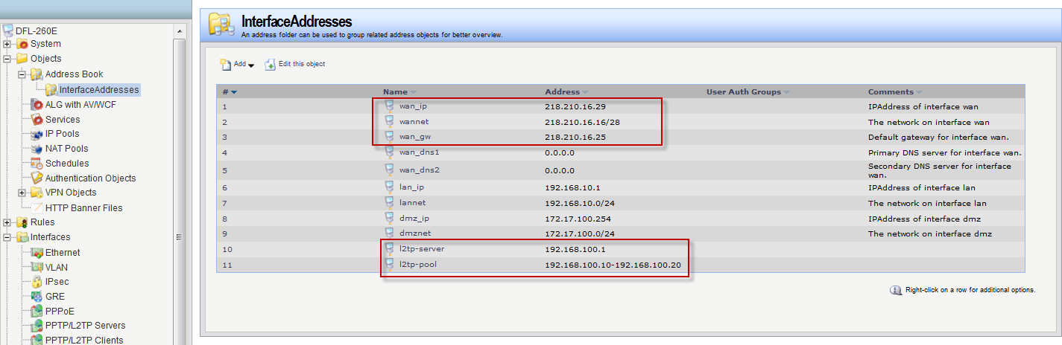
- Add a new pre-share key.
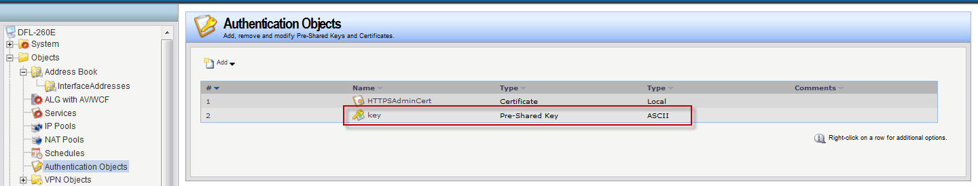
- Add a new IPsec interface.
Local network “wan-IP”
Remote network “all-nets”
Mode “transport”

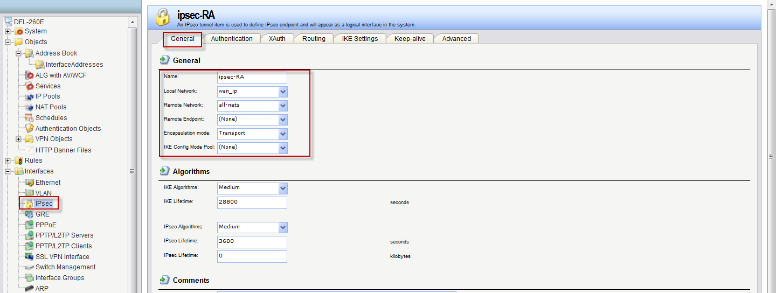

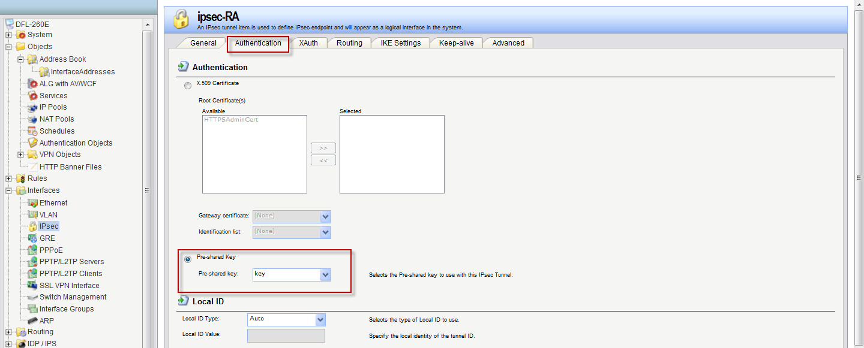
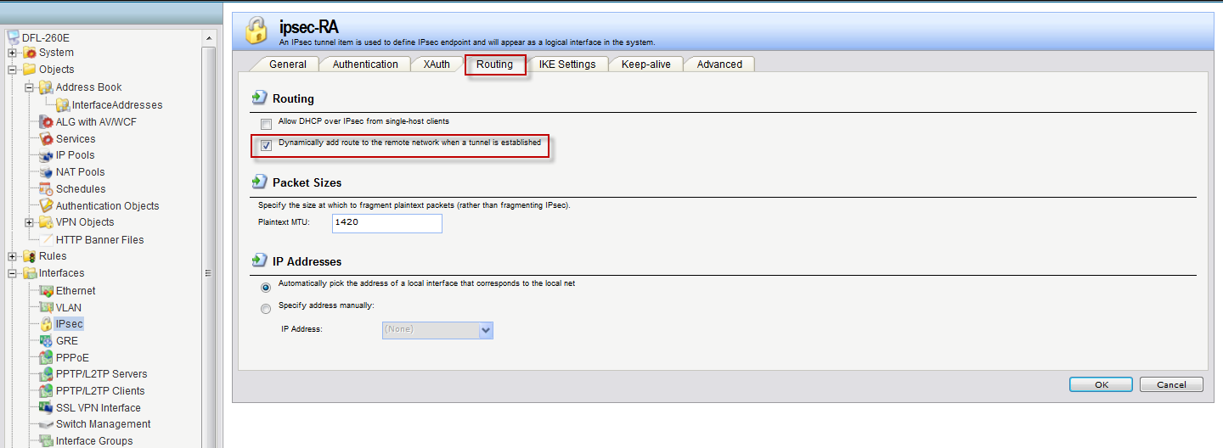
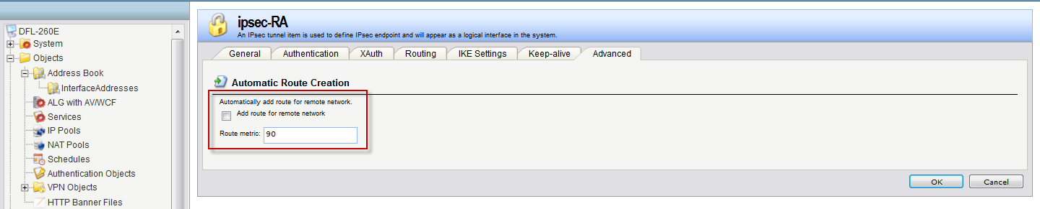

- Add a new LTP server interface.
Inner IP address: “L2TP-server”
Tunnel protocol: “L2TP”
Outer interface: “IPsec-RA”
Server IP: “WAN_IP”
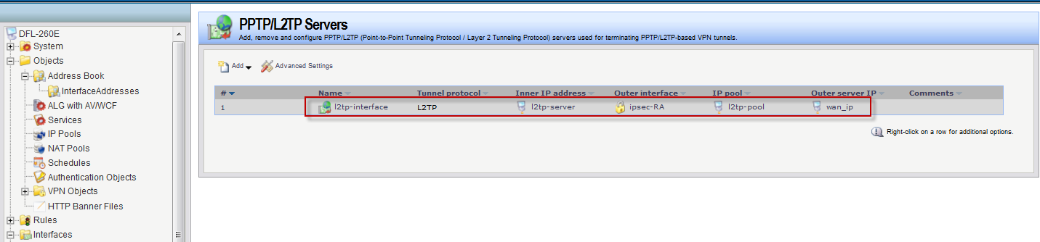
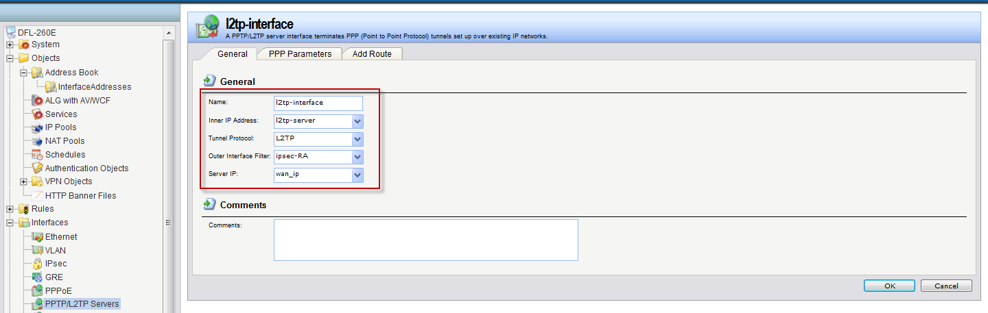
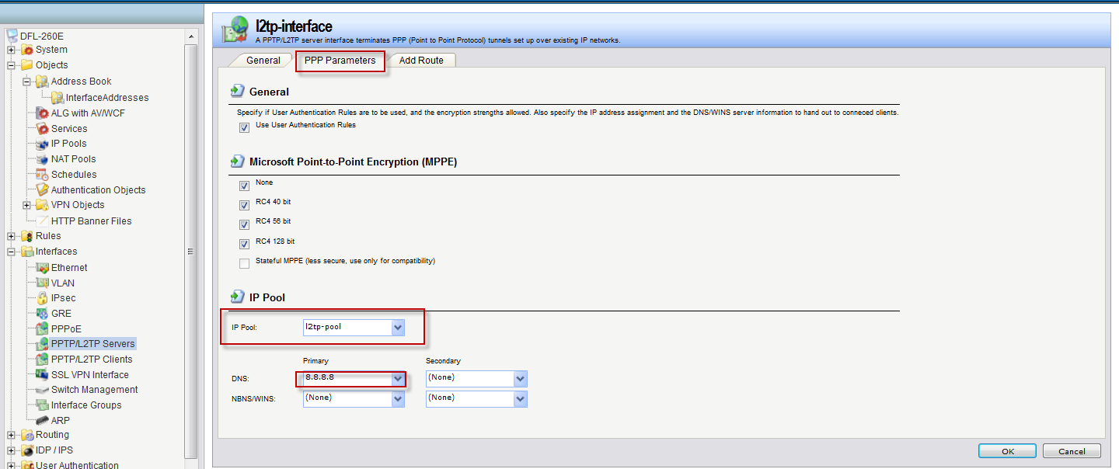
(5)
Add a new interface group for “L2TP-interface” and “LAN”.
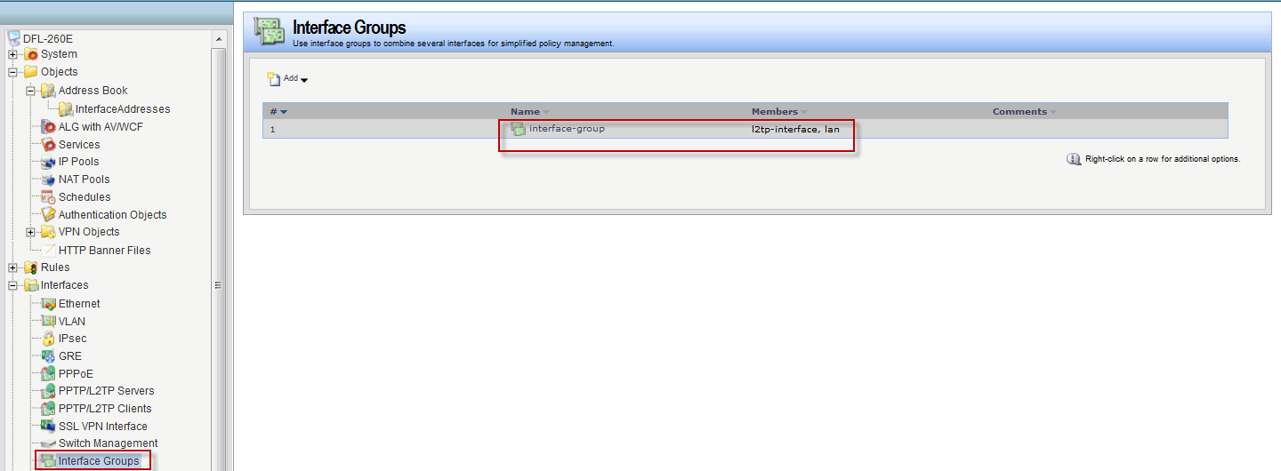

- Add a new IP rule for L2TP user.
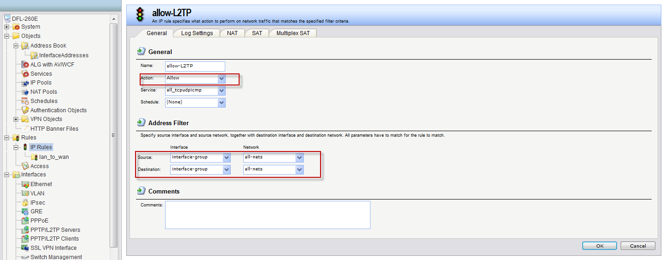

- Add new L2TP user account.
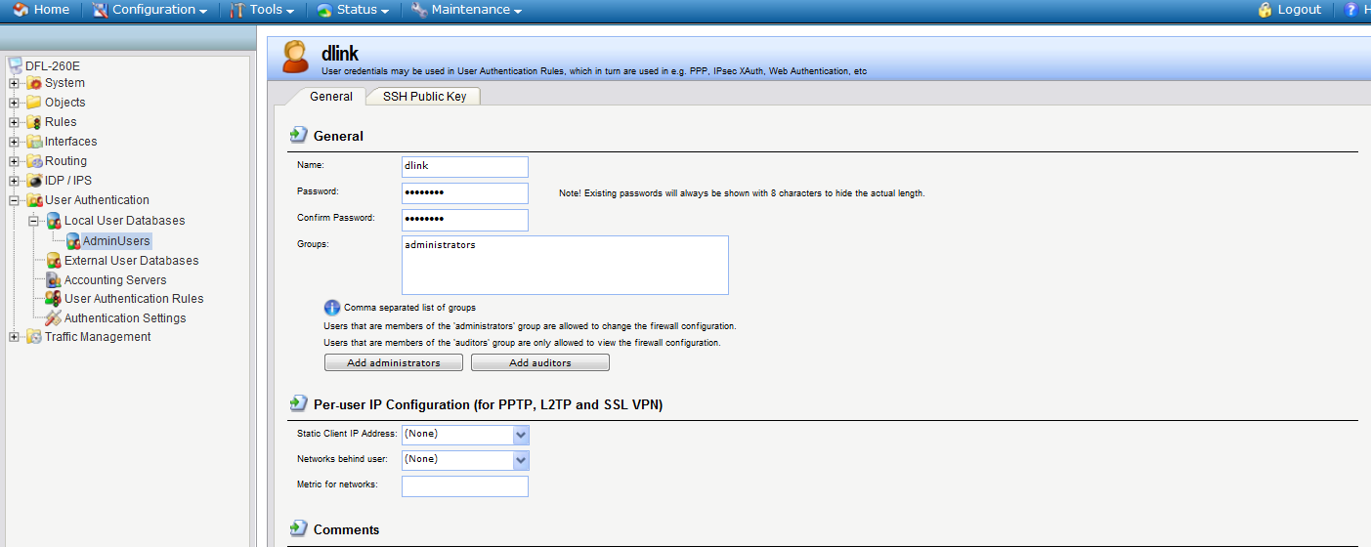
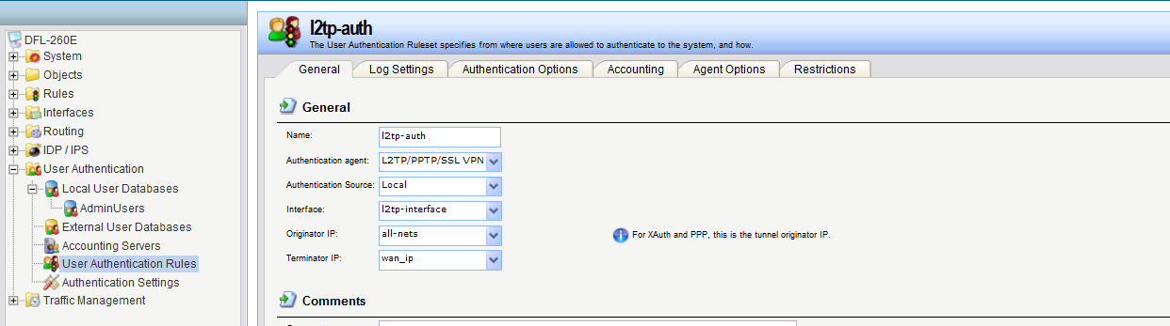
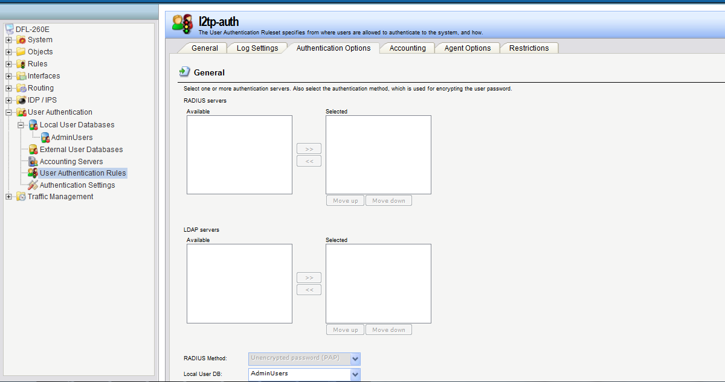

END

