How to setup Anti-Virus Scanning
This example shows how to setup an Anti-Virus scanning policy for HTTP traffic from “LAN” to “all-nets”. We will assume there is already a NAT rule defined in the IP rule set to NAT this traffic.

- Create an HTTP ALG Object “HTTP-ALG-AV”.
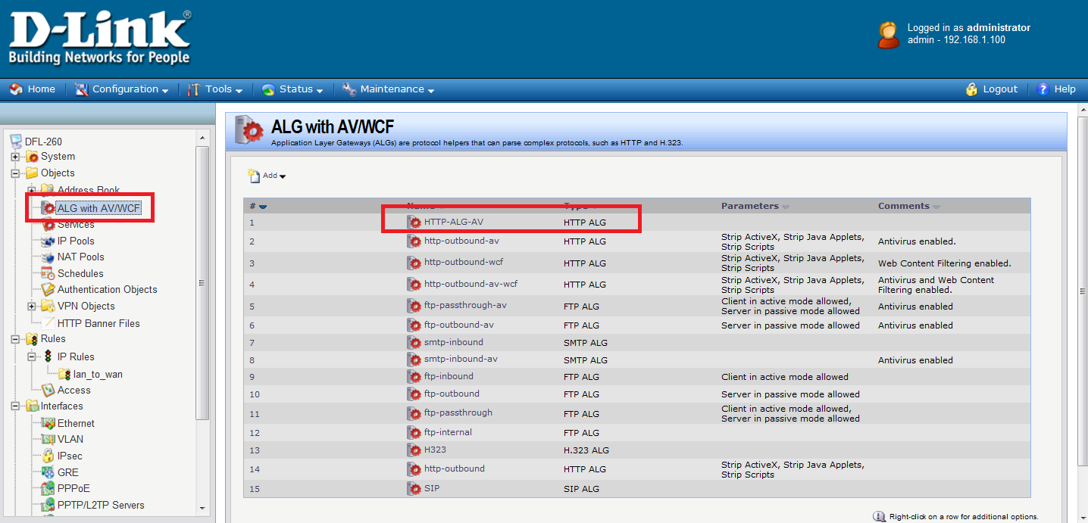
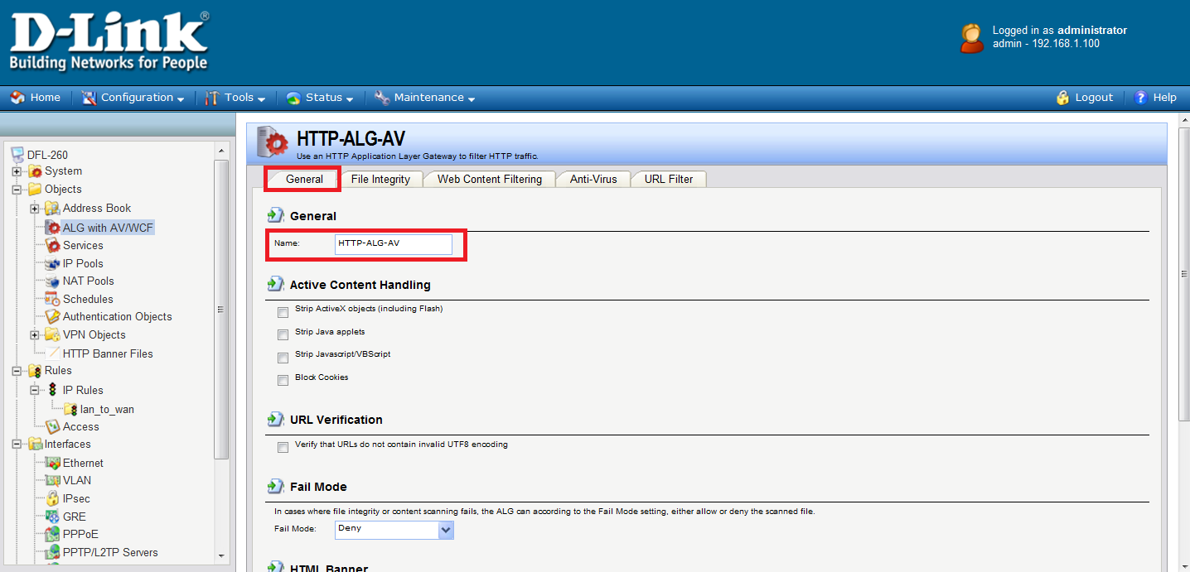

- Select “Protect” in the “Mode” dropdown list.
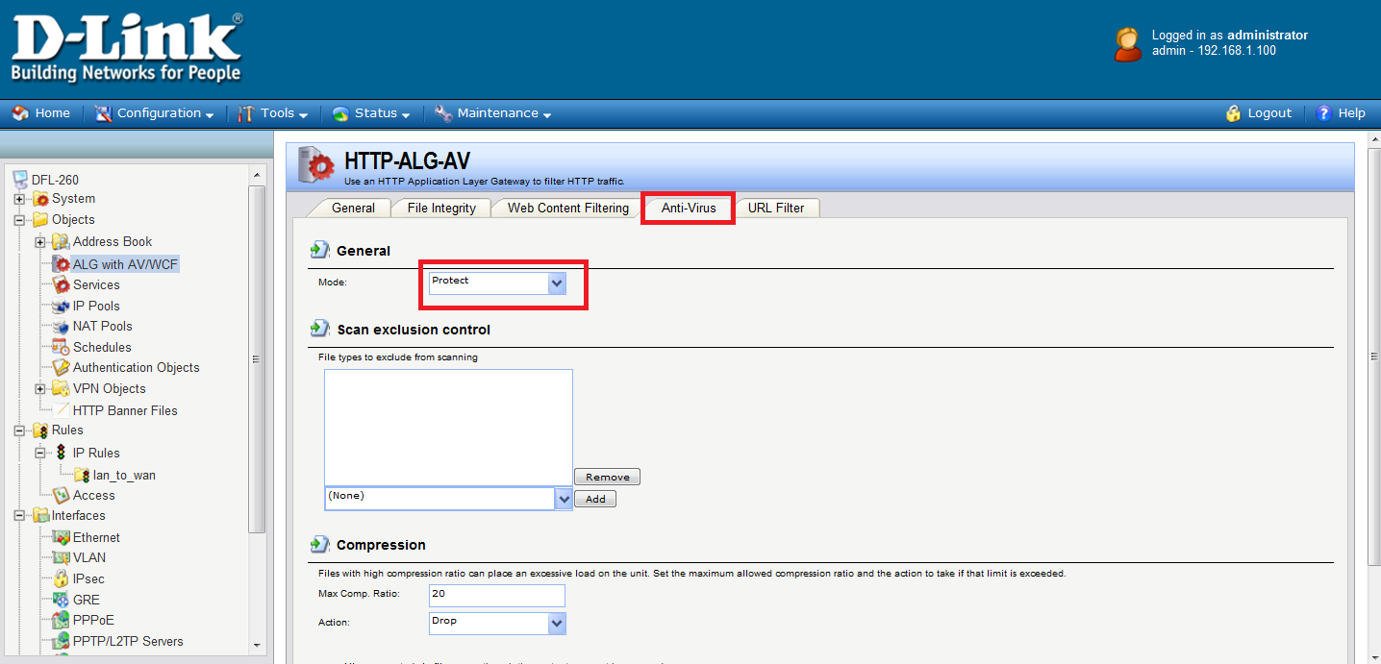
- Then, create a “Service object” using the new “HTTP ALG”.
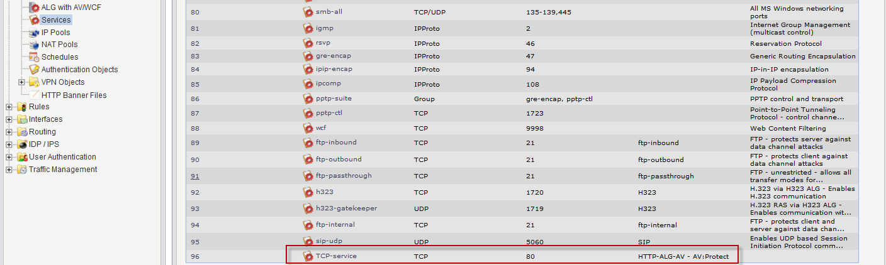

- Select the “TCP” in the “Type” dropdown list. Enter 80 in the “Destination Port” textbox. Select the “HTTP-ALG-AV” just created in the ALG dropdown list.
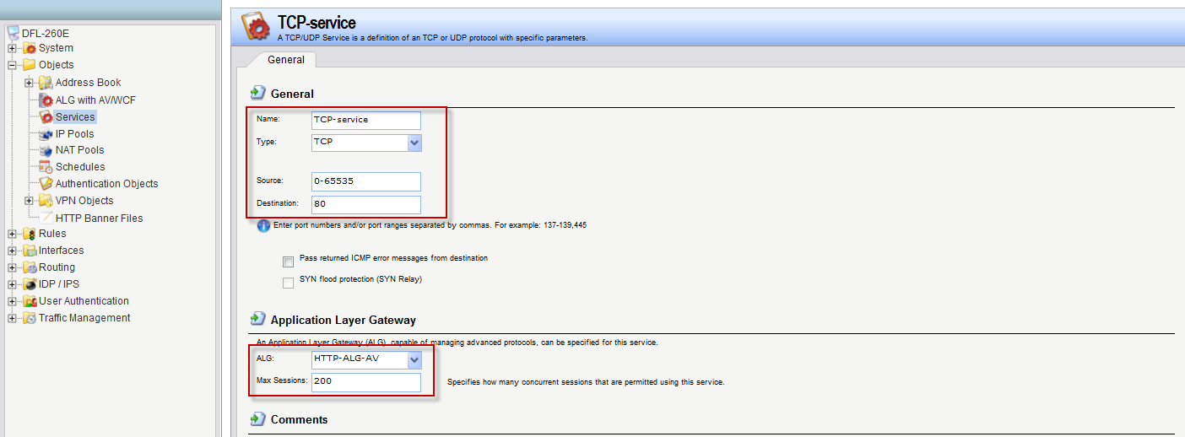
- Create a new IP Rule. Select the new service, “TCP-services”, in the “Service” dropdown list. Anti-Virus scanning is now activated for all web traffic from “lannet” to “all-nets”.
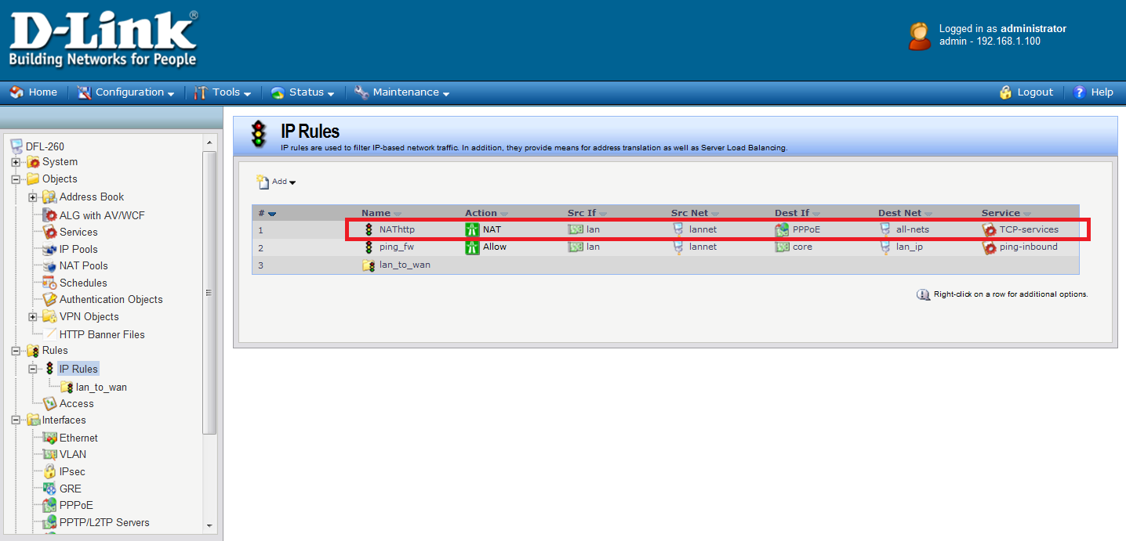
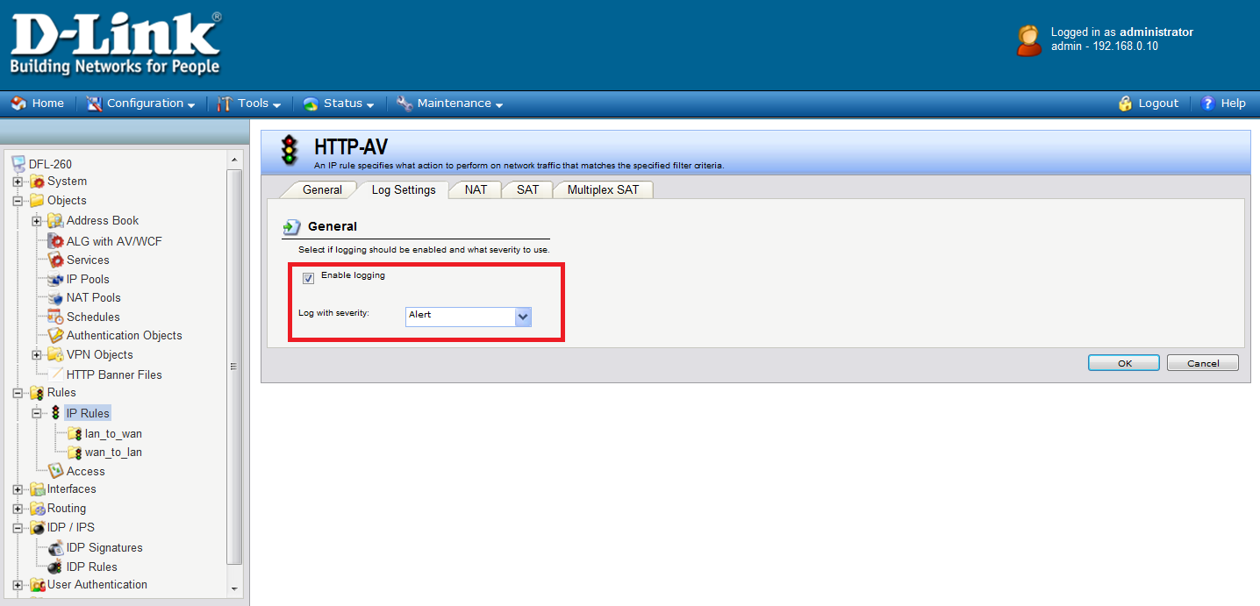

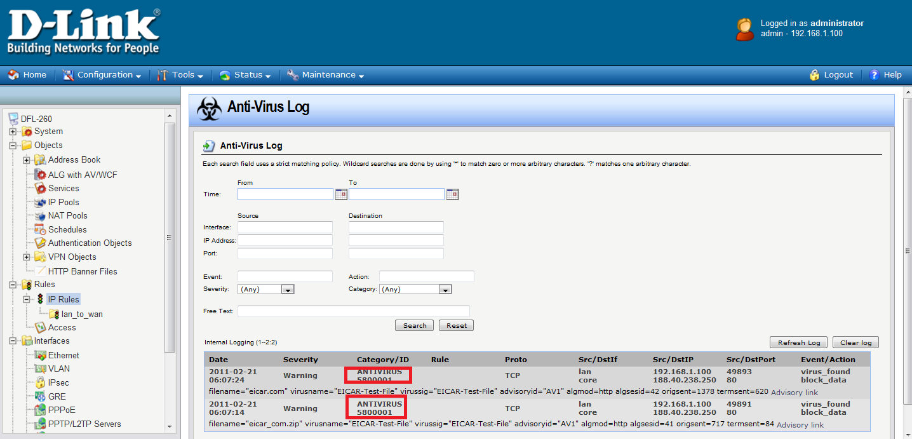

Anti-Virus scanning is now activated for all web traffic from “lannet” to
“all-nets”.

