DNS-325/DNS-345 User Shares Setup
This setup document is an example with 5 users and 3 groups.

How to logon to the DNS-325/345
- Logon to the DNS-325/345 via the IP address.( Please note the DNS-325/345 will get an IP address from the DHCP server if an DHCP server is available, if not the default IP address should be 192.168.0.32)
Example: 192.168.100.59
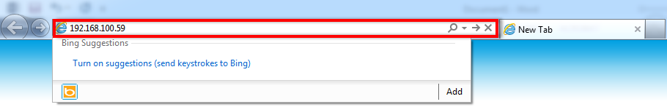
The default username and password is:
Username: System Administrator (admin)
Password: (keep Blank)
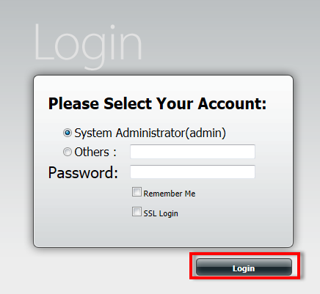
How to add a user
- Please select “Management ”
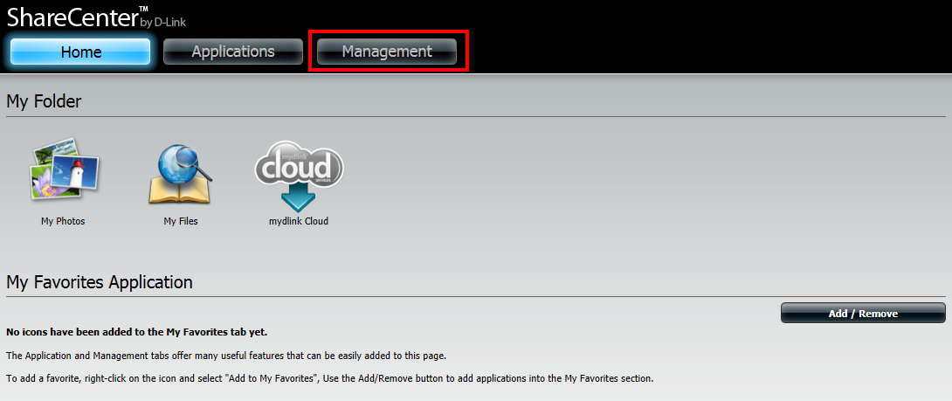
- Please select “Account Management”
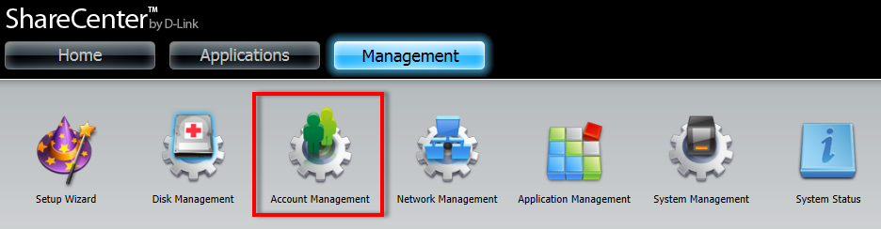
- Please select 1”Users/Groups”, under User settings Select 2”Create” to start the wizard.
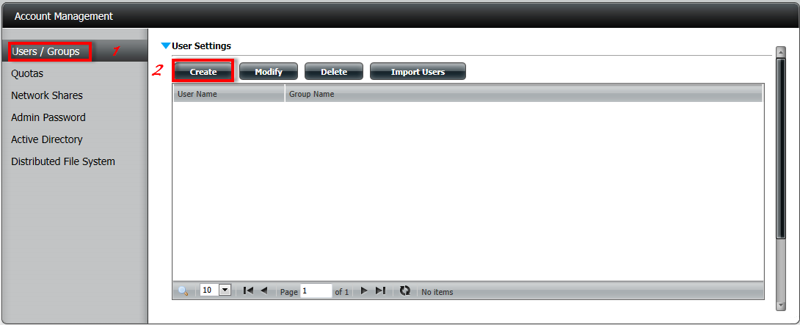

- At the first page select “Next”
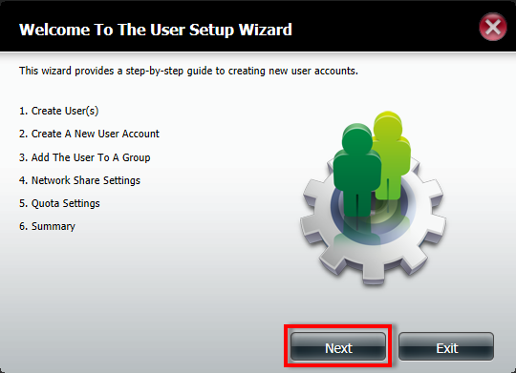
- Select “Create A Single User” and select “Next”
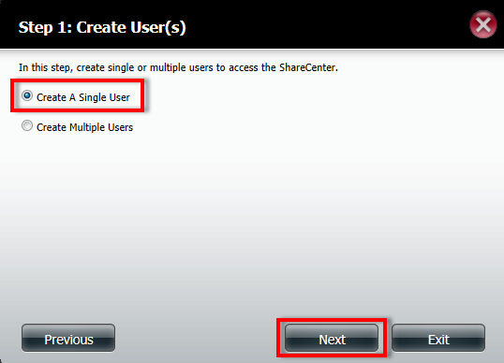
- Give the user a username and Password and select “next”
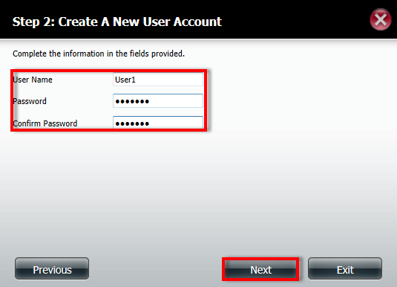
- As no Groups are created yet, please select “Next”
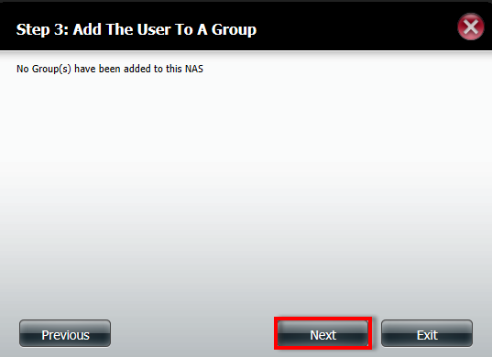
- Select which “Volumes” the user is allowed to see and select “Next”
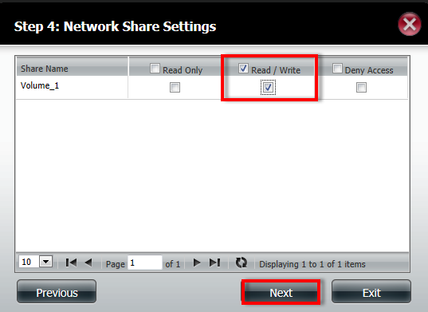
- Select which services you would like the user to have and select “Next”
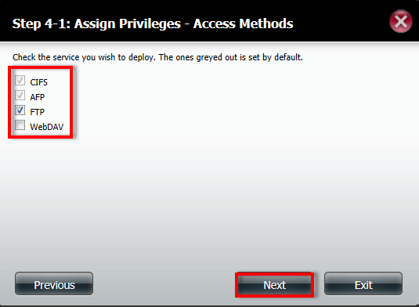
- Select what the User Quota is on which Volume
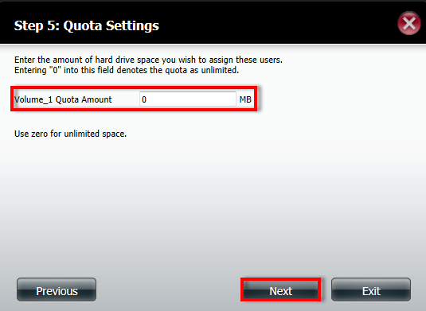
- Verify the User settings and select “Finish”
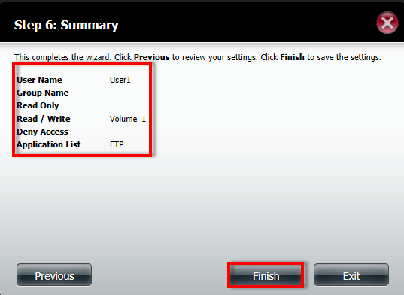
How to create a group:
- Under Group settings Select “New”
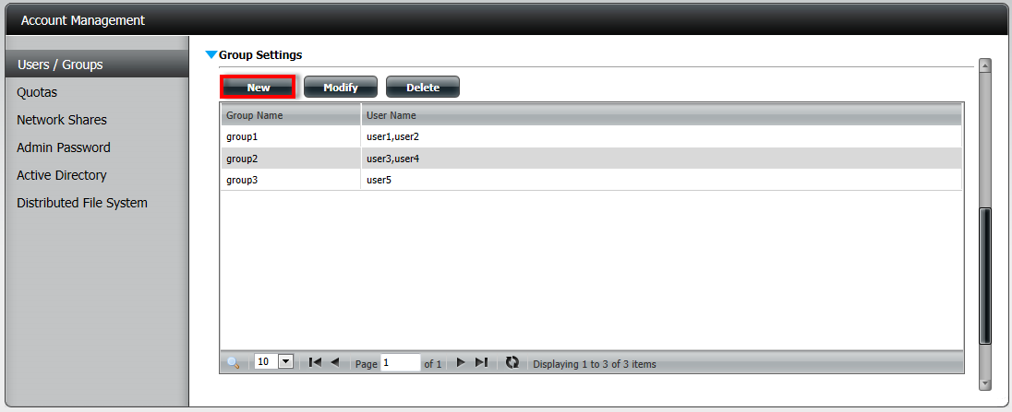
- At the first page select “Next”
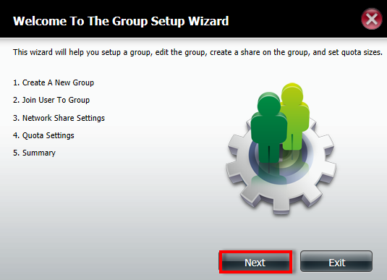

- Give the Group a name and select “Next”
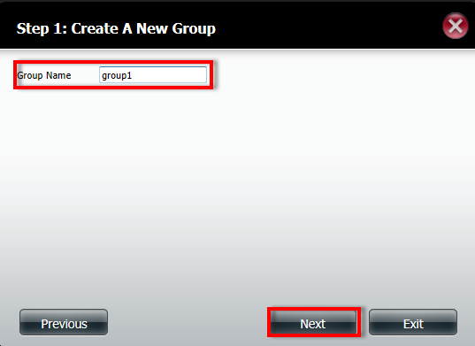
- Select which user you want as part of the group and select “Next”
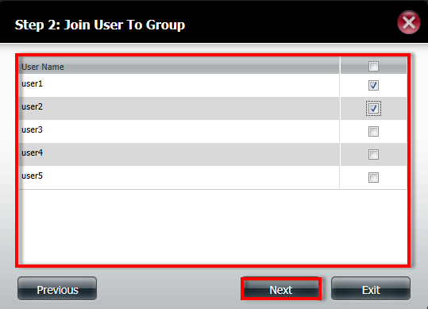
- Select which Volume the group is allowed to see and select “Next”
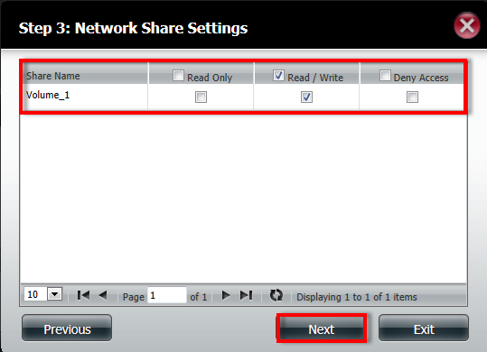
- Select which services the group is allowed to use and select “Next”
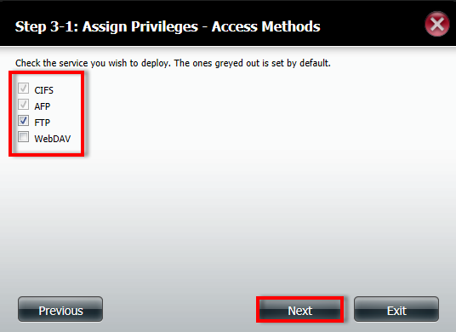

- Select the Quota for the group and select “Next”
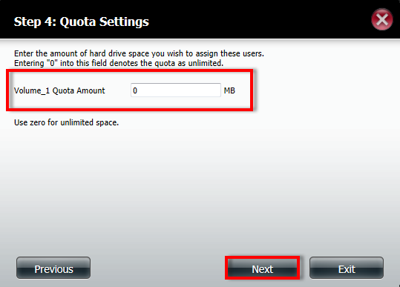
- Verify the setting of the group and select “Finish”
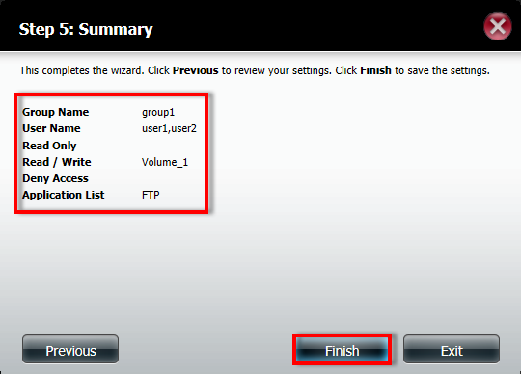
How to create Network Shares for Users:
- Select “Network Shares” under “Account Management”
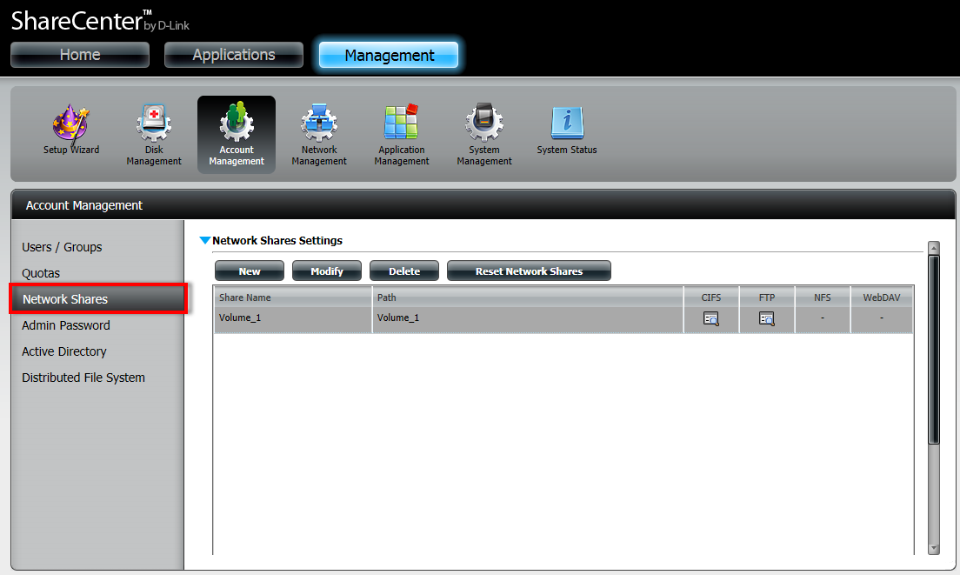
- Select the Volume Name and select “Delete” (please note, this will not delete the volume, it only makes sure that anyone who does not have the correct permissions will not be able to access the volume)
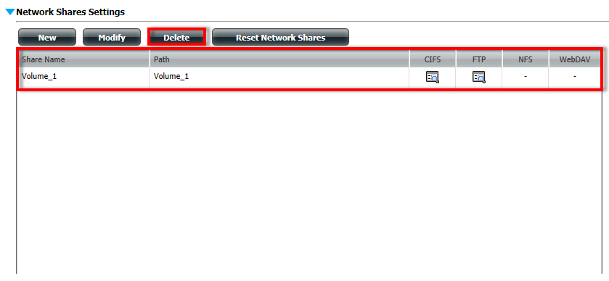
- Select “New”
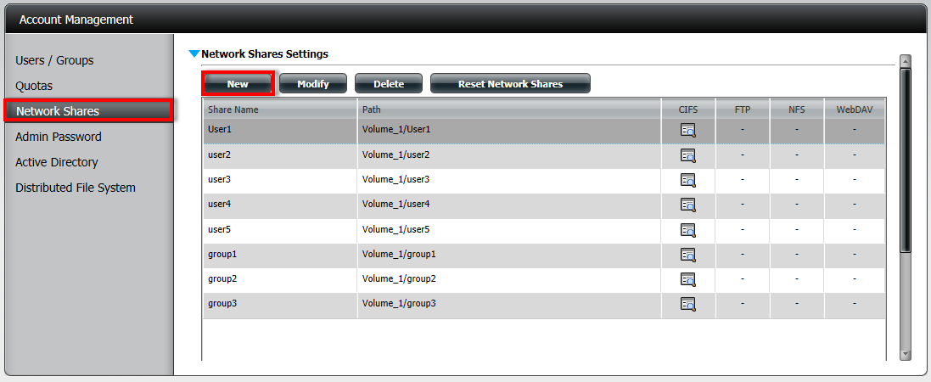
- On the First Page you can select “Next”
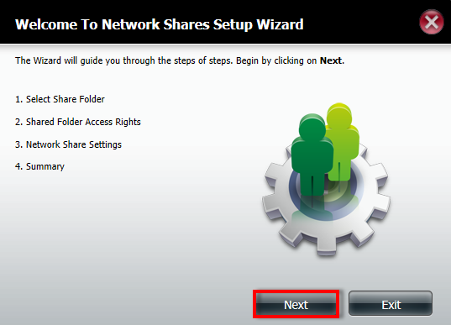

- Select the volume where you want to create the new folder for the user/group and select “New”
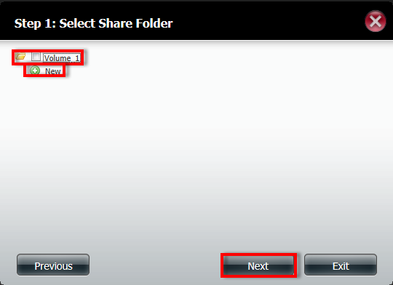
- Name the folder and select “OK”
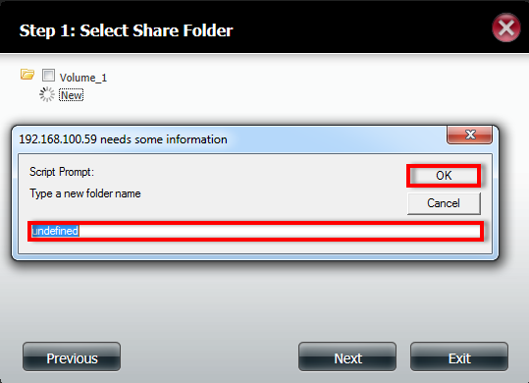

- Select the folder you have created and select “Next”
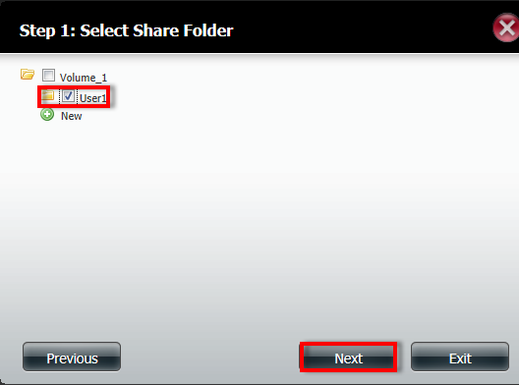
- Select “Specific user/group” and select next
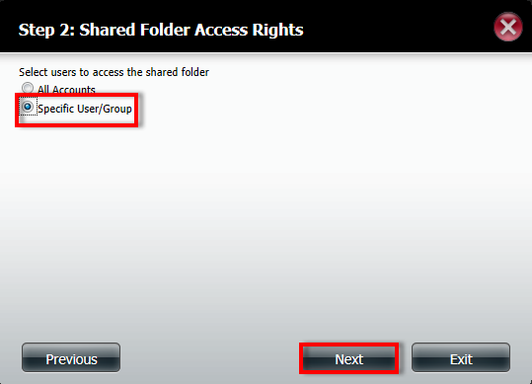
- Select which user will have what permissions on the folder (in my example user1 has read write permissions, which allows the user to create and read the content of the folder, all the other users do not have any permissions, so they can see the folder, but not the content of the folder) and select “Next”
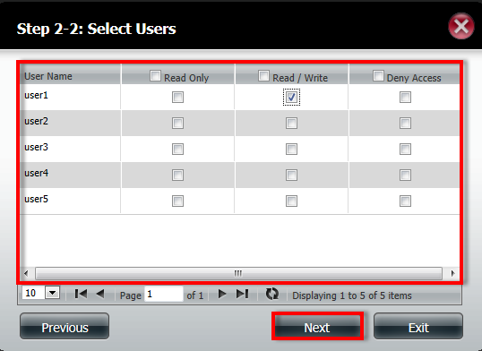
- Select what group has which permission on the folder and Select “Next”
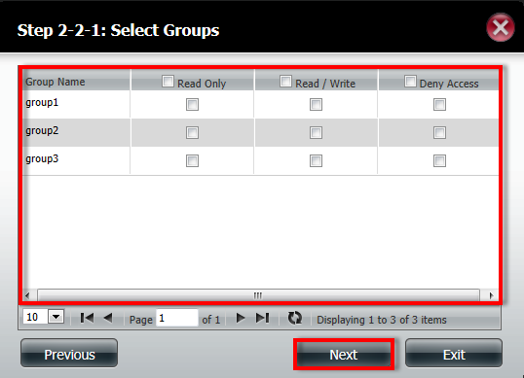
- Select what access methods are allowed on the folder, and select “Next”
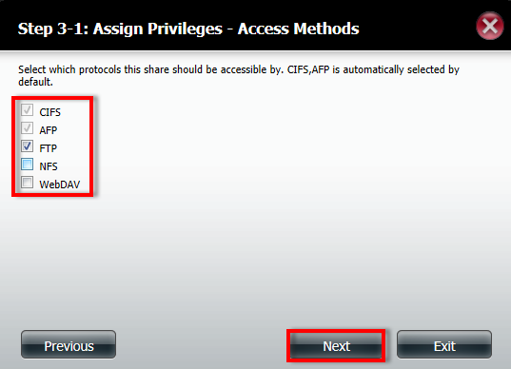
- Select “Finish” to complete the “Network Shares” wizard
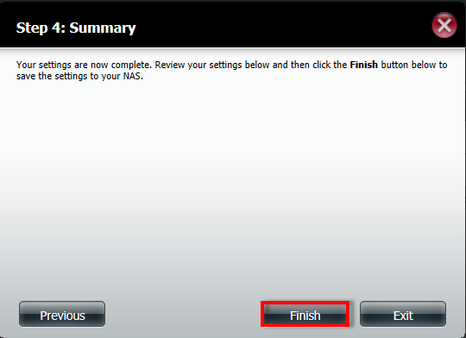

How to setup Network Shares for a Group.
- Please select “Network Shares” under Account Management” and select new
- At the first page you can select “Next”
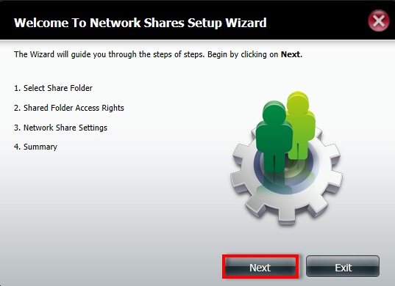

- Select the Volume where you want to create the folder and select “New”
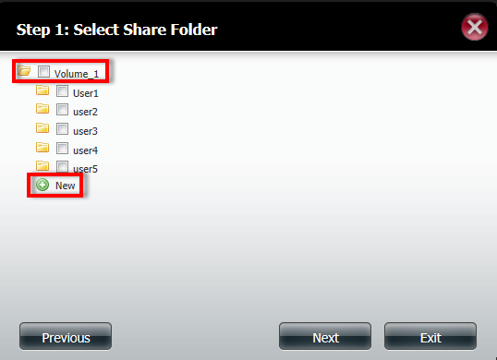
- Name the new folder and select “OK”
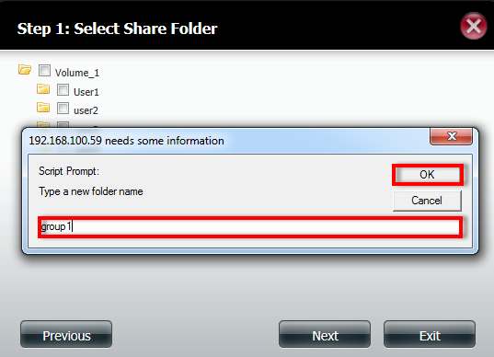
- After creating the folder select the folder and select “Next”
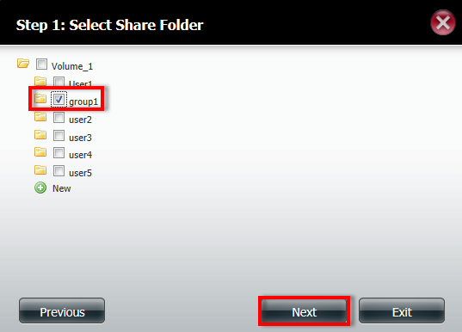
- Select “Specific User/Group” and select “Next”
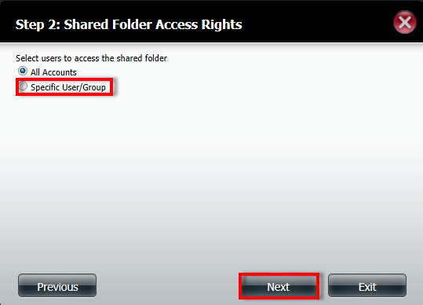
- As this is for a group you do not need to select an user, so you can only select “Next”
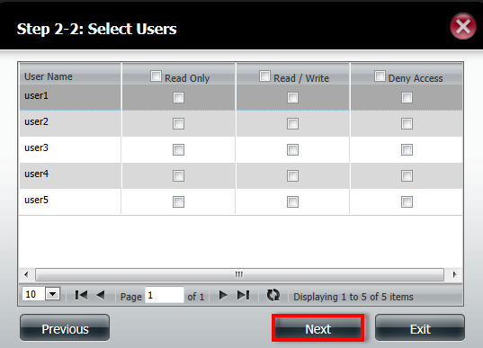
- Select the group and the permission and select “Next”
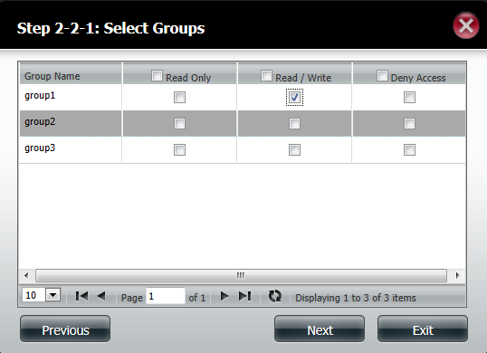
- Select the Network Shares settings and select “Next”
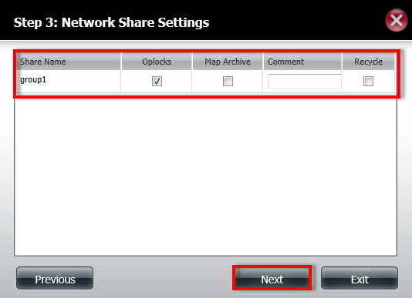
- Select the access methods allowed for the folder and select “Next”
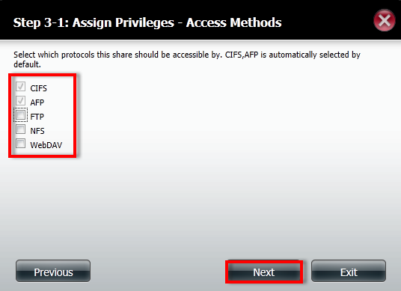
- Select “Finish” to complete the Network shares.
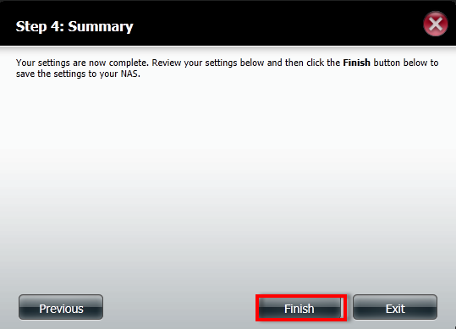

How to verify it is working:
- Type \\ and the IP address of the DNS-325/345 in to your browser and you should get access to the folders
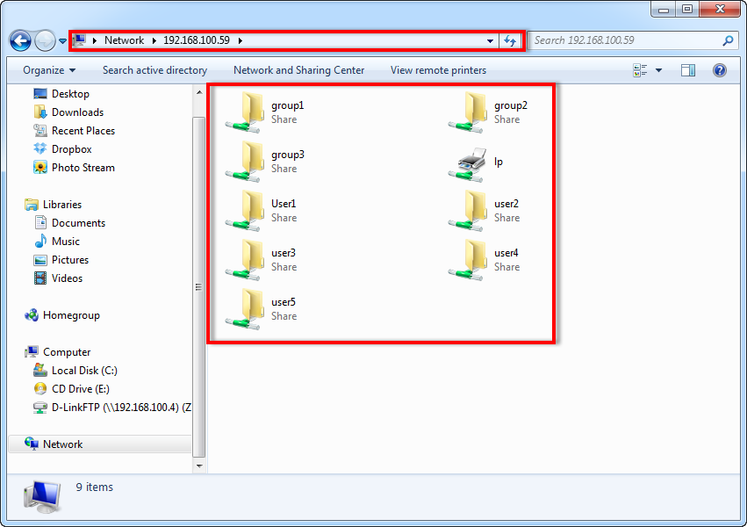
- When opening the folder it will ask for an username and password
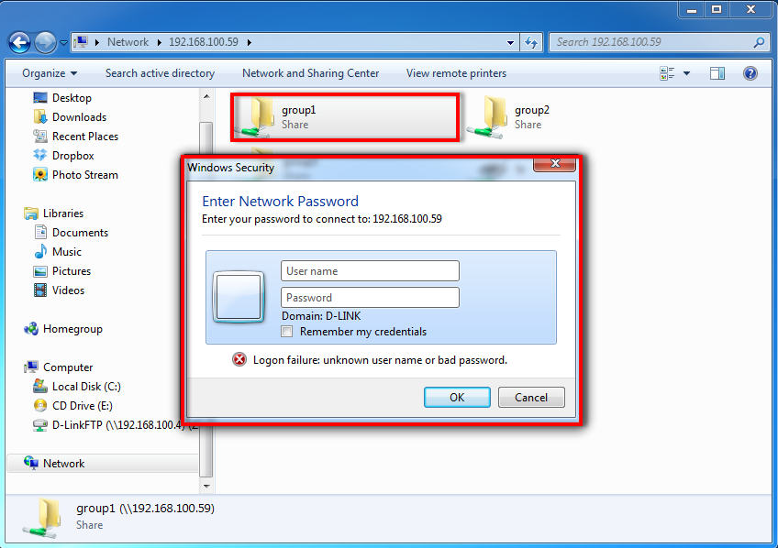

- If successful you should be able to access the folder and see the contents of the folder
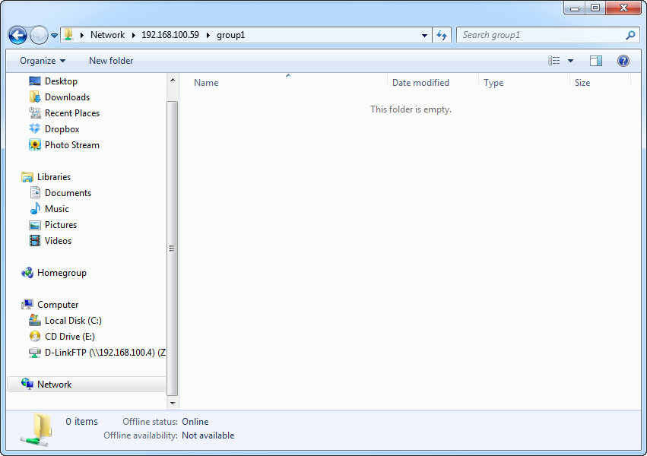
- If the user tries to access a folder that the user does not have access to the following message will pop-up
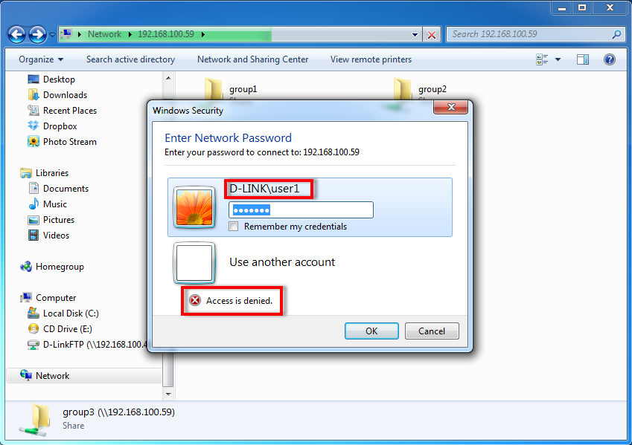
The END

