DFL-Routing Mode

Topology
ISP: 192.168.0.0/24

WAN1 IP: 192.168.0.10/24
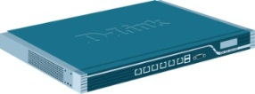
LAN IP: 1.1.1.1/24

IP: 1.1.1.10/24

- Change your firewall DNS IP address.
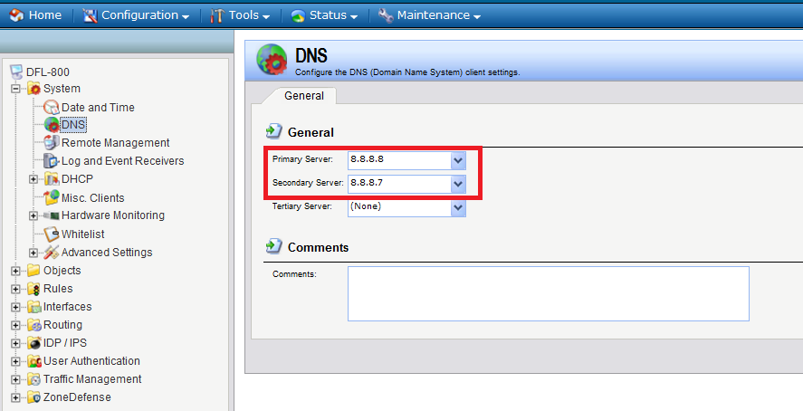
- Setup WAN1_IP. Do not use “default gateway”.
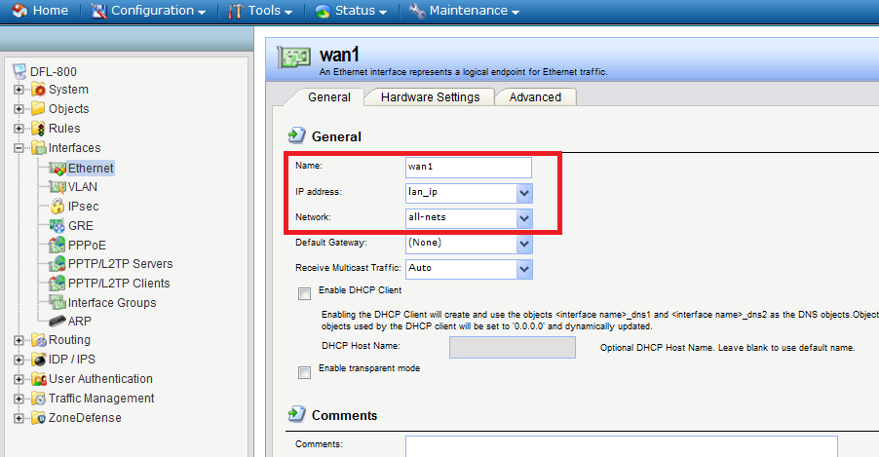

(3)Do not choose these two buttons.
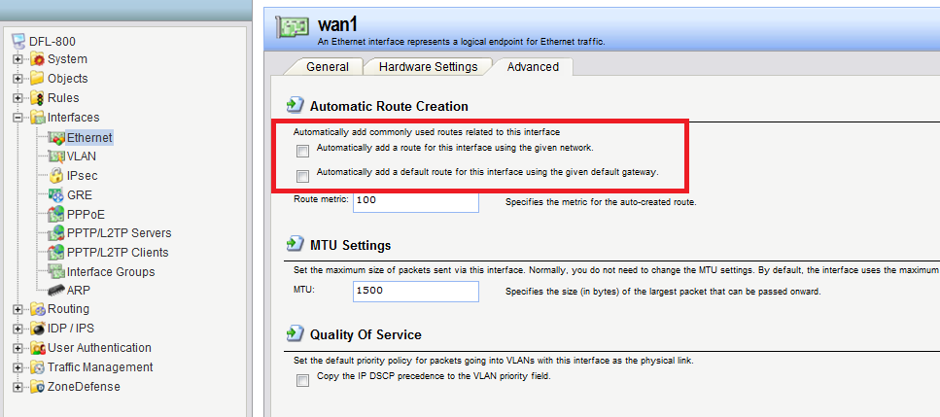
(4)Setup LAN_IP.
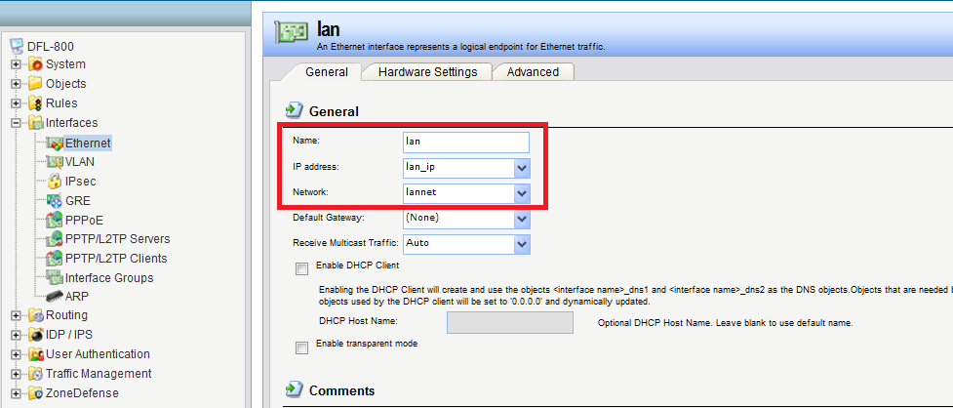

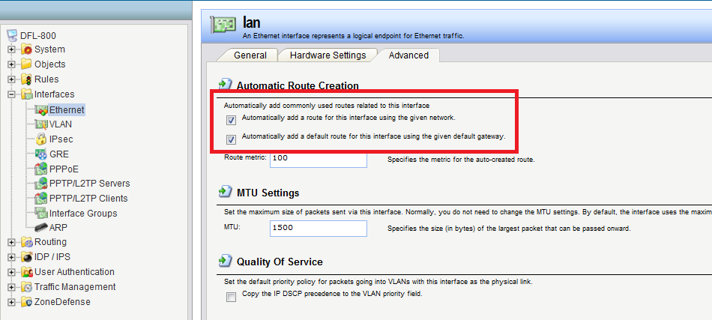
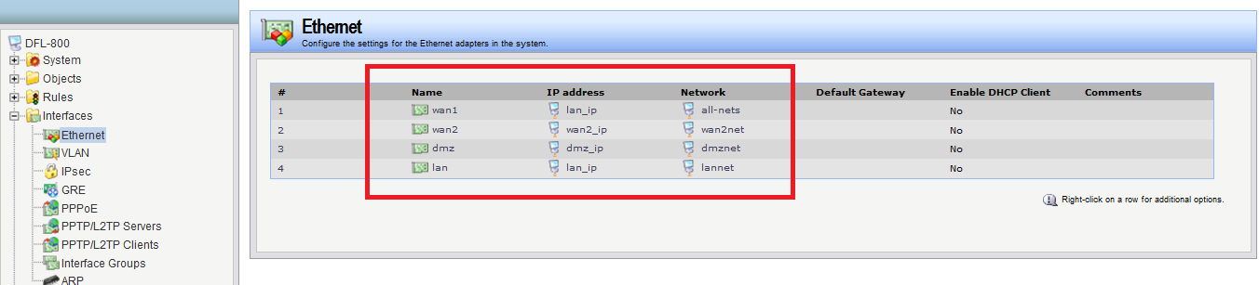
(5)Creating two new routing.
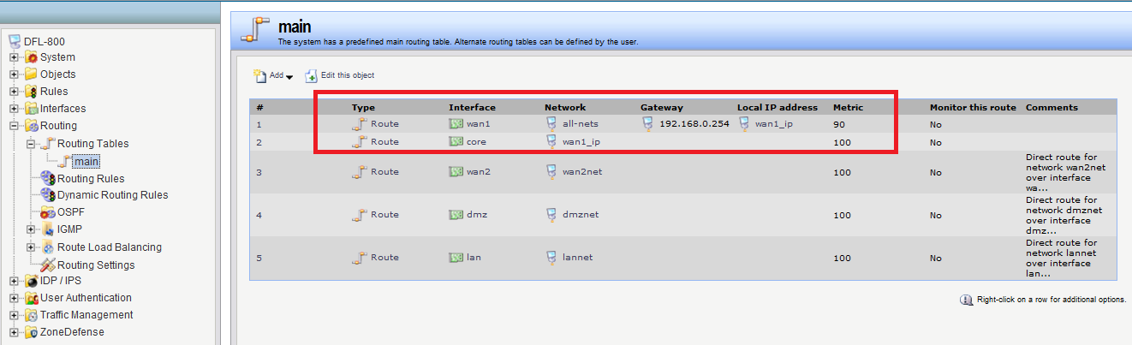

(6)Change IP rules. All IP rules are use “allow” and I create a new rule “all-service” for tested.
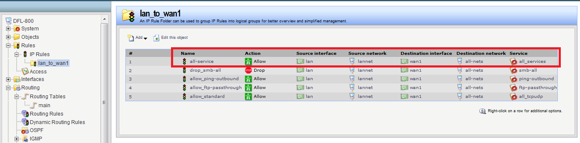
(7)Create a new IP rule for WAN1 to LAN1.
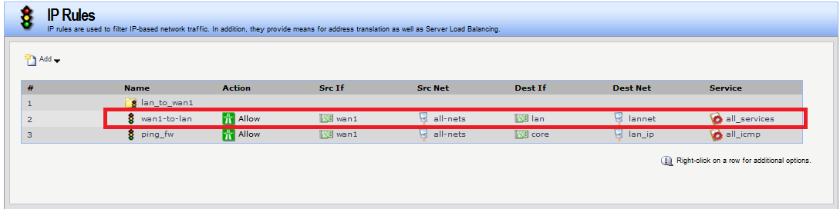
(8)Save configuration.
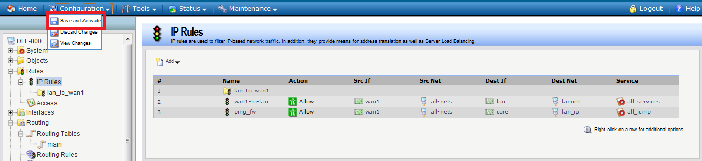

End

