How to setup DFL DNS relay

Topology:

DHCP client DFL-860E
DHCP server + DNS relay

- Go to address book. Add DHCP address pool.
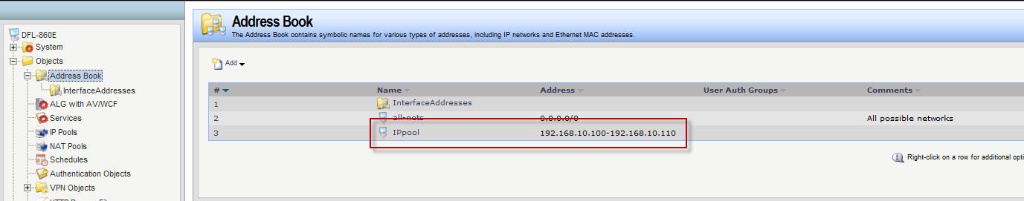

- Go to DHCP server. Add new DHCP server.
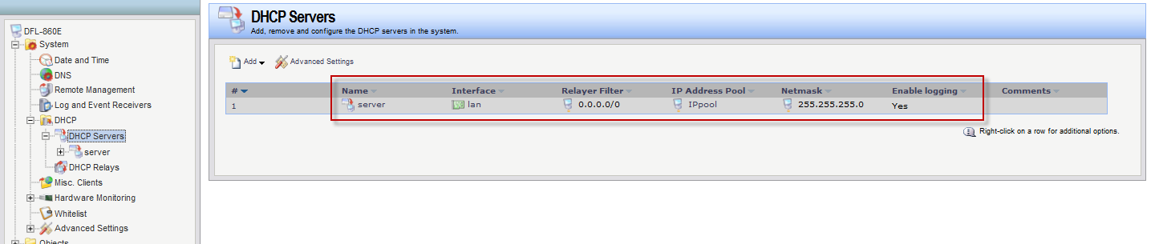

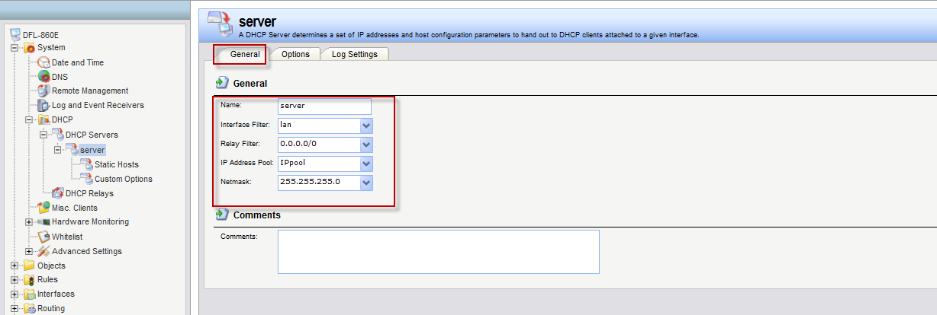

- DNS should be setup DFL LAN IPaddress.
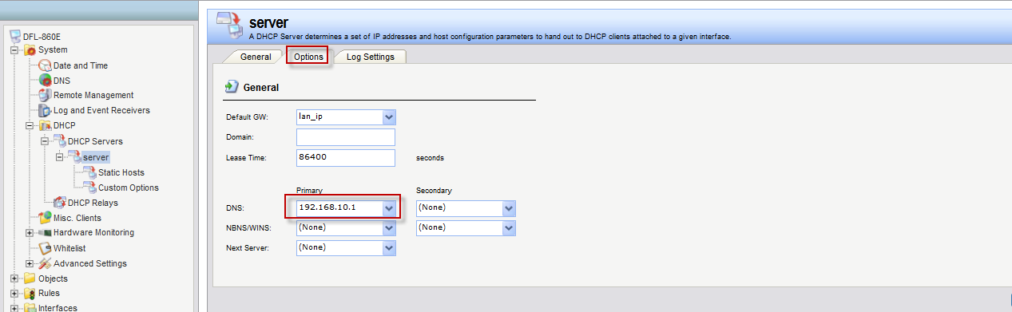

- Add 2 IP rules “SAT” + “NAT”, service type chooses “dns-all”.
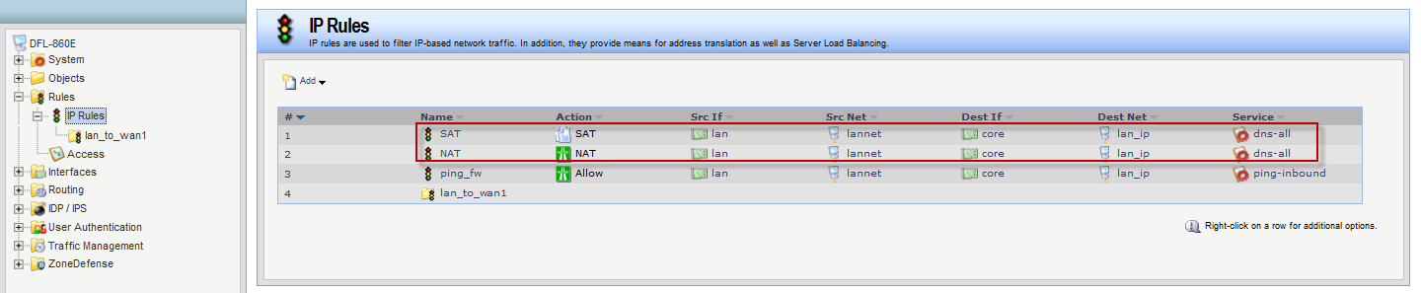

- SAT address you need to choose ISP DNS IP address.
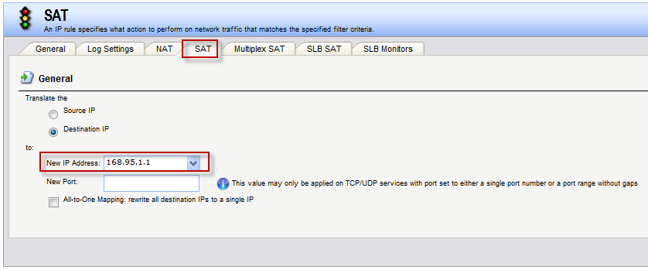

- Now, LAN PC use “nslookup 8.8.8.8” then DNS server IP address should be LAN IP address.
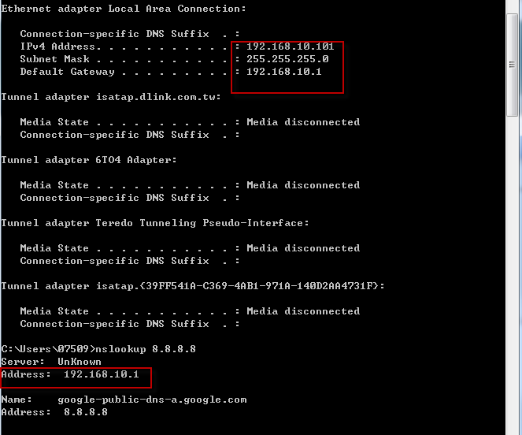
- Now, you are enable DNS relay function successful! DFL will help your LAN PC to forward DNS request information to ISP DNS server then tell your LAN PC correct DNS information.

END

