Network topology:
PC(10.90.90.200)----(10.90.90.90)
======================================================================
Configuration of DES7200

DES-7206#show running-config

Building configuration...
Current configuration : 2619 bytes

!
version v10.2.00(2), Release(32123)(Fri Jan 25 15:26:47 CST 2008 -ngcf49)
install 1 24gt/12sfp
!
!
rmon alarm 10 1.3.6.1.2.1.2.2.1.12.6 30 delta rising-threshold 20 1 falling-thre
shold 10 1 owner aaa1
rmon event 1 description "ifInNUcastPkts is too much " log trap rmon owner aaa1

!
vlan 1
!
!
no service password-encryption
!
!
!
!
!
!
!
!
!
!
!
!
!
cpu-protect type tp-guard pps 128
cpu-protect type arp pps 500
cpu-protect type dot1x pps 128
cpu-protect type rldp pps 128
cpu-protect type rldp pri 6
cpu-protect type rerp pps 128
cpu-protect type rerp pri 6
cpu-protect type bpdu pps 128
cpu-protect type bpdu pri 6
cpu-protect type dhcps pps 128
cpu-protect type gvrp pps 128
cpu-protect type ipv6mc pps 128
cpu-protect type dvmrp pps 128
cpu-protect type dvmrp pri 3
cpu-protect type igmp pps 128
cpu-protect type igmp pri 3
cpu-protect type ospf pps 128
cpu-protect type ospf pri 3
cpu-protect type pim pps 128
cpu-protect type pim pri 3
cpu-protect type rip pps 128
cpu-protect type vrrp pps 128
cpu-protect type vrrp pri 6
cpu-protect type unknown-ipmc pps 128
cpu-protect type err-ttl pps 128
cpu-protect type ospf3 pps 128
cpu-protect type ipv6-conh pps 128
cpu-protect type ttl0-ipv6 pps 128
cpu-protect type dhcp-relay-s pps 128
cpu-protect type dhcp-relay-c pps 128
cpu-protect type option82 pps 128
cpu-protect type udp-helper pps 128
!
!
!
!
interface GigabitEthernet 1/1
rmon collection stats 1 owner dview
rmon collection history 1 owner D-View buckets 1 interval 1
!
interface GigabitEthernet 1/2
!
interface GigabitEthernet 1/3
!
interface GigabitEthernet 1/4
!
interface GigabitEthernet 1/5
!
interface GigabitEthernet 1/6
!
interface GigabitEthernet 1/7
!
interface GigabitEthernet 1/8
!
interface GigabitEthernet 1/9
!
interface GigabitEthernet 1/10
!
interface GigabitEthernet 1/11
!
interface GigabitEthernet 1/12
!
interface GigabitEthernet 1/13
!
interface GigabitEthernet 1/14
!
interface GigabitEthernet 1/15
!
interface GigabitEthernet 1/16
!
interface GigabitEthernet 1/17
!
interface GigabitEthernet 1/18
!
interface GigabitEthernet 1/19
!
interface GigabitEthernet 1/20
!
interface GigabitEthernet 1/21
!
interface GigabitEthernet 1/22
!
interface GigabitEthernet 1/23
!
interface GigabitEthernet 1/24
!
interface VLAN 1
ip address 10.90.90.90 255.0.0.0
!
!
!
!
!
!
!
snmp-server host 10.90.90.200 traps public
snmp-server enable traps
snmp-server community public ro
snmp-server community private rw
line con 0
line vty 0 4
login
!
!
!
!
!
end
DES-7206#

- Show the D-view version:
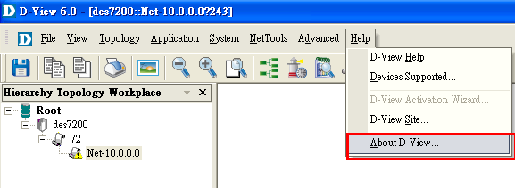

- My D-View version 6.001B03
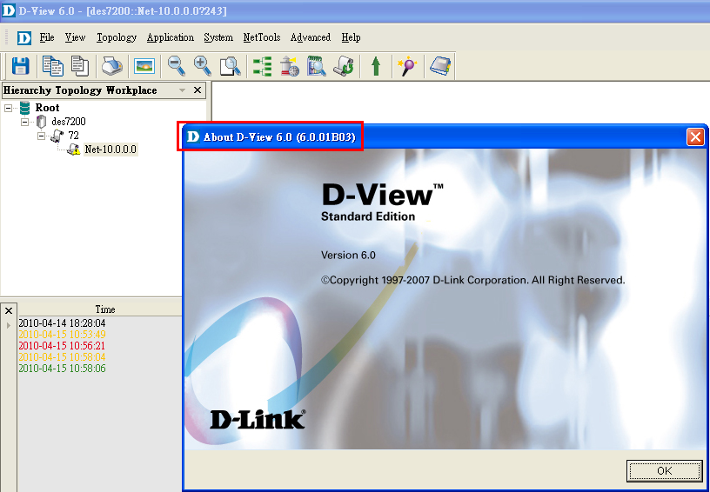

- > DES-7200 module from PMD: 10.2(2)release(32123)

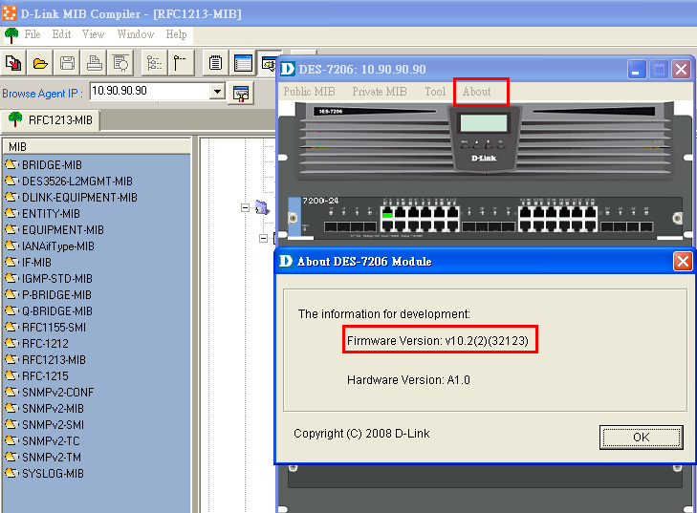

4.> Interface information
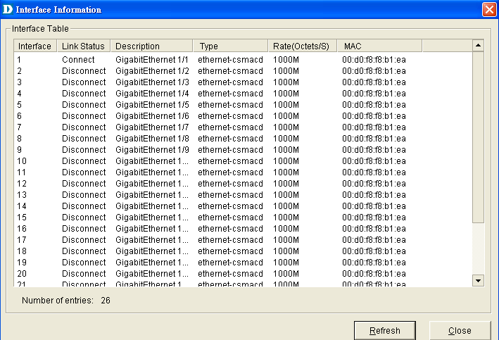

5.> Issue CLI command on DES-7200:
rmon collection stats 1 owner dview
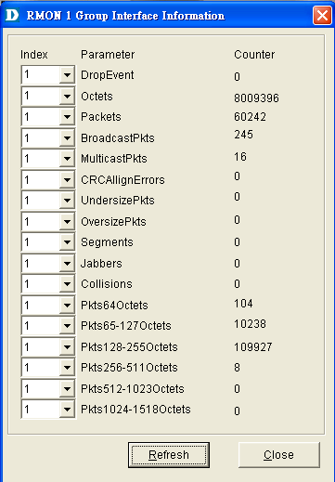

6.> Issue CLI command on DES-7200:
rmon collection history 1 owner D-View buckets 1 interval 1
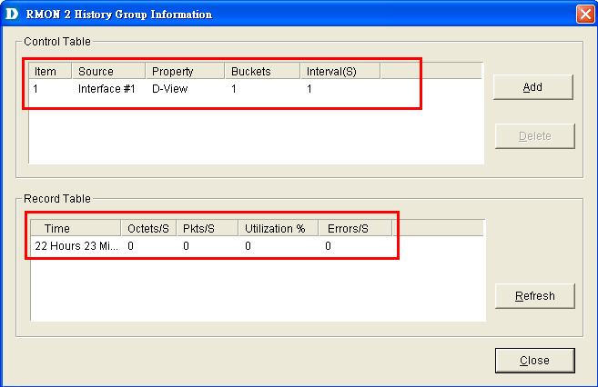

7. Issue CLI command on DES-7200:

For example, you want to configure the alarm function for a statistical MIB variable. The following example shows you how to set the alarm function to the instance ifInNUcastPkts.6 (number of non-unicast frames received on port 6; the ID of the instance is 1.3.6.1.2.1.2.2.1.12.6) in IfEntry table of MIB-II. The specific function is as follows: the switch checks the changes to the number of non-unicast frames received on port 6 every 30 seconds. If 20 or more than 20 non-unicast frames are added after last check (30 seconds earlier), or only 10 or less than 10 are added, the alarm will be triggered, and event 1 is triggered to do corresponding operations (record it into the log and send the Trap with ―community‖ name as ―rmon‖). The ―description‖ of the event is ―ifInNUcastPkts is too much‖). The ―owner‖ of the alarm and the event entry is ―aaa1‖.

rmon alarm 10 1.3.6.1.2.1.2.2.1.12.6 30 delta rising-threshold 20 1 falling-threshold 10 1 owner aaa1
rmon event 1 description "ifInNUcastPkts is too much " log trap rmon owner aaa1

