1.> Netwrok topology:
PC(D-view6)10.90.90.200---(P1/1)DES7200,10.90.90.90

2.> DES-7200 configuration:
interface VLAN 1
ip address 10.90.90.90 255.0.0.0
snmp-server community public RO
snmp-server community private RW
snmp-server enable traps
snmp-server host 10.90.90.200 public

3.> D-View6 setting
a.> Use Setup Wizard
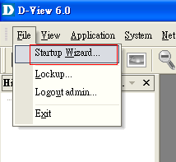

b.> Click Next
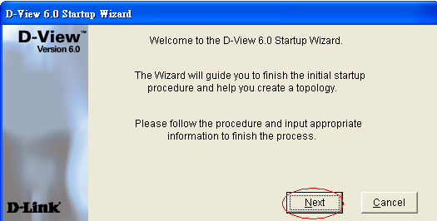
c.> Give a Domain name ‘test’
Click ‘Create’
Click ‘Next’
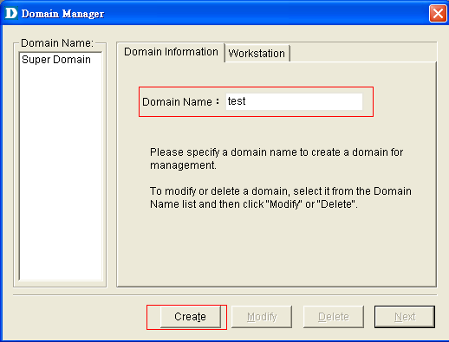

d.> Enter a name of NETMAP, click Next
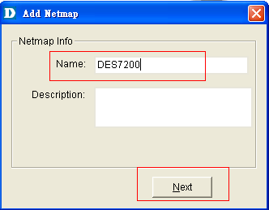

e.> Choose Designated Network
Give a name of Topology
Click Next
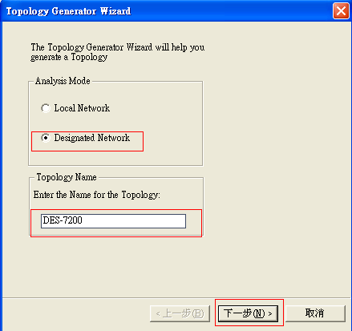

f.> Issue switch’s information & SNMP community string. Click Finish
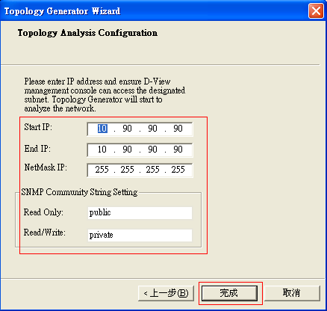

g.> Click Export

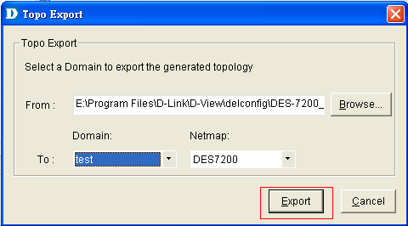

h.> Double click Net-10.0.0.0
Double click the DES7200’s icon
Select Private Mib-> CPU Utilization
