DCS-100 D-ViewCam Firmware Release Note
Firmware Version: 3.1-0528
Date: 2010/06/21

Notes for Using D-ViewCam 3.1.0.1 Application
- Windows 7 32bit supported
- Digital Watermark supported
- New language support: Czech, Danish, Greek, Farsi, Finland, Hebrew, Hungarian, Korean, Slovak, Turkey
- Device Pack* supported
- DVDROM backup supported
- When accessing cameras, the system only supports the account “admin” in cameras.
- The system will not disable PTZ panel/ focus icon in UI when connecting cameras which don’t support those functions. (However, the functions are invalid.)

*Device Pack: D-ViewCam supports a modular design of camera supports since D-ViewCam v3.1.0.1. New cameras can be added by installing an extra package—Device pack, and it’s released independently from D-ViewCam releases. New device packs are backward compatible with older versions of D-ViewCam as long as D-ViewCam’ s version is greater than 3.1. The software won’t operate without device pack, so please don’t remove device pack independently.

Problem Solved:
- Remove "MxPEG Video Encoder" from camera setting page

Enhancements:
- When insert camera, fix D-Link brand name.
- Show the number of channels by spec.
- Modify grip number from 36 to 32
- Playback—The default value of show record is “Enable”

Known Issues:
- Does not support AAC audio codec.
- O.S. might popup an error message when the following three action happened in the same time 1. Export AVI 2. Export with audio 3. Export a long time record. (DCS-100 will add an alert mechanism to display an alert message next version when this error happened)
- DCS-100 V3.1 displays the wrong MAC address with DCS-910/920. (it will be fixed next version)
- DCS-100 V3.1 might be no response after enable always recording for more than 60 hours in MS-Win server 2003.
- Home function cannot work in DCS-100 V3.1 main console. (it will be fixed next version)
- DCS-100 V3.1 cannot automatically find out DCS-6815 device. But user can manually add DCS-6815 into DCS-100 SW. (it will be fixed next version)

Device limitations:
- DCS-6510
    - When Use MPEG4 in 320x240 resolution, there’s low probability to have split screen. (version:1.02, firmware issue.)
- DCS-3710
    - The settings of enable/ disable microphone/speaker cannot be synchronized between the system and the camera web page. (version: 1.00, firmware issue; FW V1.1 fixed)
    - In MPEG4 mode, end users cannot modify option quality through Main console. (need to update SDK)
    - Bitrate value couldn't be shown correctly on DCS-3710 web interface. (version: 1.00.21, firmware issue; FW V1.1 fixed)
- DCS-6615/6815
    - DCS-100 doesn’t support AutoPan function.
    - The Mac address is incorrect from the device. (version: 1.01.03, firmware issue)
- DCS-2120
    - Mirror and flip function is not integrated into Main console. (DCS-100 doesn't support this function)
    - B/W mode is not integrated into Main console. (DCS-100 doesn't support this function)
    - Variable bitrate is not integrated into Main console. (DCS-100 doesn't support this function)
- DCS-3411
    - The value items of video parameter are different between Main console and the web page.
→ Main console: 0,1,2,..,100; web page: 0,20,40,..,100
→ need to update SDK
- DCS-3430/3411
    - Cannot choose the smallest resolution. (version: 1.02.4012, firmware issue; FW 1.02_4125 fixed)
- DCS-5605/5635
    - Zoom in/out levels are different between Main console and web page. (need to update SDK)
    - Camera will back to “home” if clicking preset points. (version: 1.01.4023, firmware issue; FW 1.01_4126 fixed)

HW Support List (v3.1 new support)
Camera Firmware tested
Model | 930 | 930L | 1100L | 1130L | 5230L | 6510 | 6511 | 310-1
Firmware | 1.00 build 2 | 1.00 build 2 | 1.03_4130 | 1.03_4130 | 1.02_4206 | 1.02 | 0.08 | 1.02

HW Support List (v3.01 has supported)
Camera Firmware tested
Model | 2102 | 2120 | 2120tw | 2121 | 3110 | 3410 | 3415 | 3420 | 5220Ax | 5220Bx | 5220tw | 5610 | 6110
Firmware | 1.04 | 1.04eu | 0201tw | 1.04 | 1.02 | 1.01 | 1.00 | 1.03 | 1.05 | 2.00 | 2.00tw | 1.01 | 1.00
Model | 6111 | 6620 | 6620G | 910 | 920 | 3411 | 1100 | 1130 | 6410 | 3430 | 7510 | 5230 | 7410
Firmware | 1.00 | 1.06 | 1.05 | 1.04 | 1.04 | 1.02 | 1.02 | 1.02 | 1.00 | 1.02 | 1.00 | 1.01 | 1.00
Model | 7510 | 3710 | 5300 | 5300G | 210-1 | 310-1 | 6815 | 5605 | 5635
Firmware | 1.00 | 1.00 | 1.06 | 2.05 | 1.5.9 | 1.5.9 | 1.01 | 1.01 | 1.01

Compatibility:
  - Windows
 | Windows 2000 | Windows XP | Windows Vista | Server 2003 | Server 2008 | Windows 7  32 bit
3.1.0.1 | N/A | Supported | Supported | Supported | N/A | Supported

  - Windows Internet Explorer Browser
 | IE 6 | IE 7 | IE 8
3.1.0.1 Remote Application | Supported | Supported | Supported*
* Refer to Appendix A for more details..
Appendix A – Windows Internet Explorer 8

In order to access the system with Windows Internet Explorer 8, we need to setup following settings to install ActiveX control.
Generally, there are two settings to make it work.

Note: Please make sure user has already installed vcredist_x86.exe

- Add the Server IP into Trusted Web Site.
  - Click Tools on IE toolbar, and then select Internet Options to start setting.
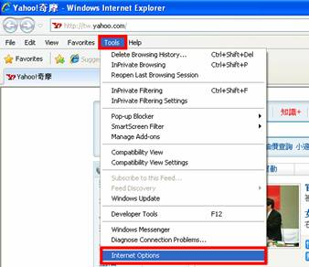
  - Switch to Security tab, select Trusted sites, and then click Sites to add server. 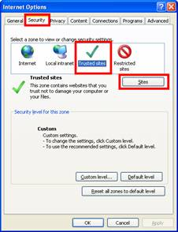
  - Enter IP address of the system and click on Add, then, the IP address will be listed on trust websites.
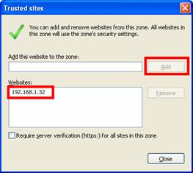
  - Back to Security tab of Internet Options window, click on Custom level… button to setup Security Settings.
Note: Please make sure that you have focus on Trusted sites section.
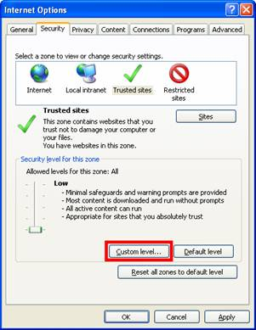
  - Select Low and click Reset… button to setup custom settings to Low. And then click OK to finish configuration.
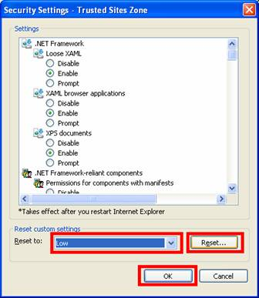

- Add the Server IP Compatibility View Setting
- Click Tools on IE toolbar, and then select Compatibility View Settings to start setting.
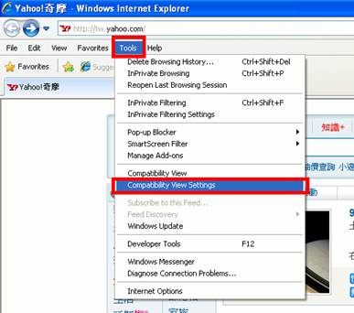
- Enter IP address of the system and click Add, then, the IP address will be set as compatibility views.
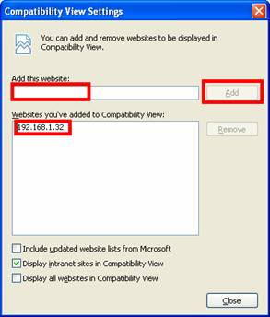
- After setting, the compatibility button will show on browser when connecting to the system.
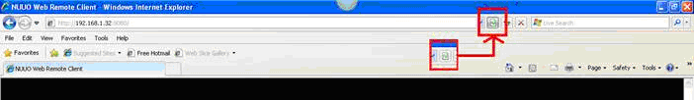

- If it still cannot work, try to use this step.
- Click Tools on IE toolbar, and then select Internet Options to start setting.
- Switch to Advanced tab, disable the Enable memory protection to help mitigate online attacks option of Security setting.
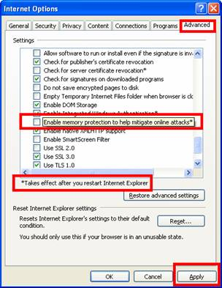
- Restart Internet Explorer after apply the new setting.

Appendix B – Minimum System Hardware Requirement

To ensure D-ViewCam system can maintain high video monitoring and recording performance, need to refer to the following table when establishing the system hardware.

Parameter definition:
M: parameter of resolution of camera.
Resolution | 5 M | 3 M | 2 M | 1 M | VGA / D1 | CIF
Value of M | 37 | 27 | 22 | 14 | 3 | 1
N: FPS of Camera
S=M*N

For example: 16 channel system
a) 8 camera at 1 Megapixel resolution with 10FPS
b) 3 cameras at D1 resolution with 15FPS
c) 5 cameras at CIF resolution with 30FPS

a) M=14; N=10, S=14*10=140
b) M=3; N=15, S=3*15=45
c) M=1; N=30, S=1*30=30
S of All Cam.=(8*140)+(3*45)+(5*30)=1405
Therefore, the minimum hardware requirement is C level.

Minimum Hardware Requirement
 | D | C | B | A
S of All Cam. | 2200~1400 | 1400~1050 | 1050~550 | 550~0
CPU | Intel Core I7 | Intel Core I5 | Intel Core 2 Quad Q9400 | Intel Core 2 Duo  E5300
RAM | 2 GB | 2 GB | 2GB | 1GB
Motherboard | Intel 55 or 57 chip or above, MB vendor Asus, Gigabyte or Intel with Intel Chipset recommended |  | Intel 35 or 33 chip or above, MB vendor Asus, Gigabyte or Intel with Intel Chipset recommended
Display card | ATI Radeon 4650 , nVIDIA GeForce GF-9600 or above (ATI recommended)
Ethernet | 100 baseT or above, Gigabit LAN recommended
Hard Disk | 250 GB or above
OS | MS Windows XP pro SP3 / 2003 / Vista SP1/ Win 7

