DCS-100 D-ViewCam Release Note
Version: 3.1.1
Date: 2010/08/30

Problem Solved:
- Support NAS—When the recording schedule to NAS has any interruption, the system will automatically choose another storage place and pup up an alarm message.
- Support NAS—Solve the problem that .rcd file won’t be created when recording with NAS.
- Setup.exe with D-Link company information.
- DCS-6815 Home invalid issue.
- DCS-6815 Preset value won’t sync with web UI
- Auto Scan can’t search DCS-6815 camera
- DCS-910/920 wrong MAC address
- DCS-5605/5635 Focus Near/Far opposite
- When export long video recording with audio, the system will discontinue because the memory too high.
- Use notify_streaming.cgi to replace io.cgi to get camera event.
- Disable UDP protocol alternative for VIVOTEK camera which don’t support UDP protocol.
- Playback “Show records” with wrong date info.
- Limit DCS-930/ 930L VGA resolution to 20 FPS.
- After modify model name of DCS-930/ 930L, DCS-100 can’t search DCS-930/ 930L model name.
- Show software version number in “About” information.
- Remove “Help” in “General Setting and Utilities”.

Known Issues:
- Does not support AAC audio codec.

Device limitations:
- DCS-3710/6510/6511/DVS-210-1/DVS-310-1:
    - When use MPEG4, users can’t set Bitrate and Quality at the same time.
- DCS-930/930L:
    - When DCS-910 put several hours, it will be disconnected, but Web UI won’t.
- DCS-6510
    - When Use MPEG4 in 320x240 resolution, there’s low probability to have split screen. (version:1.02, firmware issue.)
- DCS-3710
    - The settings of enable/ disable microphone/speaker cannot be synchronized between the system and the camera web page. (version: 1.00, firmware issue; FW V1.1 fixed)
    - In MPEG4 mode, end users cannot modify option quality through Main console. (need to update SDK)
    - Bitrate value couldn't be shown correctly on DCS-3710 web interface. (version: 1.00.21, firmware issue; FW V1.1 fixed)
- DCS-6615/6815
    - If need to modify preset value, user needs to cancel one preset point and add a new one.
    - DCS-100 doesn’t support AutoPan function.
    - The Mac address is incorrect from the device. (version: 1.01.03, firmware issue)
- DCS-2120
    - Mirror and flip function is not integrated into Main console. (DCS-100 doesn't support this function)
    - B/W mode is not integrated into Main console. (DCS-100 doesn't support this function)
    - Variable bitrate is not integrated into Main console. (DCS-100 doesn't support this function)
- DCS-3411
    - The value items of video parameter are different between Main console and the web page.
→ Main console: 0,1,2,..,100; web page: 0,20,40,..,100
→ need to update SDK
- DCS-3430/3411
    - Cannot choose the smallest resolution. (version: 1.02.4012, firmware issue; FW 1.02_4125 fixed)
- DCS-5605/5635
    - Camera will back to “home” if clicking preset points. (version: 1.01.4023, firmware issue; FW 1.01_4126 fixed)
HW Support List
Device | DCS-910 | DCS-920 | DCS-930 | DCS-930L | DCS-1100 | DCS-1100L | DCS-1130 | DCS-1130L | DCS-2102 | DCS-2120 | DCS-2120(TW)
Name
Final FW | 1.04_build_5 | 1.04_build_5 | 1.00 build 9 | 1.00 build 9 | 1.02_3522 | 1.03_4130 | 1.02_3522 | 1.03_4130 | 1.04_3227 | 1.04_3227 | 2.01tw
Device | DCS-2121 | DCS-3110 | DCS-3410 | DCS-3411 | DCS-3415 | DCS-3420 | DCS-3430 | DCS-3710 | DCS-5220Ax | DCS-5220Bx | DCS-5220(TW)
Name
Final FW | 1.04_3227 | 1.02 | 1.01_2812 | 1.02_4125 | 1 | 1.03 | 1.02_4125 | 1 | 1.05 | 2 | 2.00tw
Device | DCS-5230 | DCS-5230L | DCS-5300 | DCS-5300G | DCS-5605 | DCS-5610 | DCS-5635 | DCS-6110 | DCS-6111 | DCS-6410 | DCS-6620
Name
Final FW | 1.02_4317 | 1.02_4317 | 1.06 | 2.05 | 1.01_4126 | 1.01 | 1.01_4126 | 1 | 1 | 1.00_3014 | 1.06
Device | DCS-6620G | DCS-6510 | DCS-6511 | DCS-6615 | DCS-6616 | DCS-6815 | DCS-6817 | DCS-6818 | DCS-7110 | DCS-7410 | DCS-7510
Name
Final FW | 1.05 | 1.02 | 0.08 | 1.01 | 1.01 | 1.01 | 1.01 | 1.01 |  | 1.00_3710 | 1.00_3909
Device | DVS-210-1 | DVS-310-1
Name
Final FW | 1.00.01 | 1.02

Compatibility:
  - Windows
 | Windows 2000 | Windows XP | Windows Vista | Server 2003 | Server 2008 | Windows 7  32 bit
3.1.1 | N/A | Supported | Supported | Supported | N/A | Supported

  - Windows Internet Explorer Browser
 | IE 6 | IE 7 | IE 8
3.1.1 Remote Application | Supported | Supported | Supported*
* Refer to Appendix A for more details..
Appendix A – Windows Internet Explorer 8

In order to access the system with Windows Internet Explorer 8, we need to setup following settings to install ActiveX control.
Generally, there are two settings to make it work.

Note: Please make sure user has already installed vcredist_x86.exe

- Add the Server IP into Trusted Web Site.
  - Click Tools on IE toolbar, and then select Internet Options to start setting.
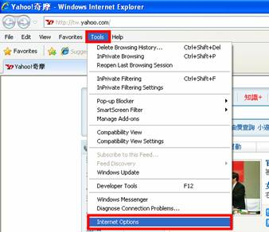
  - Switch to Security tab, select Trusted sites, and then click Sites to add server. 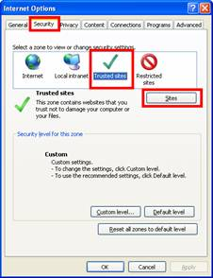
  - Enter IP address of the system and click on Add, then, the IP address will be listed on trust websites.
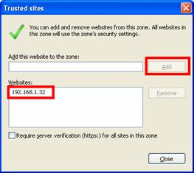
  - Back to Security tab of Internet Options window, click on Custom level… button to setup Security Settings.
Note: Please make sure that you have focus on Trusted sites section.
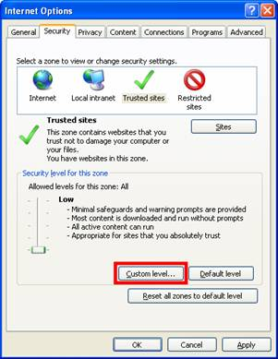
  - Select Low and click Reset… button to setup custom settings to Low. And then click OK to finish configuration.
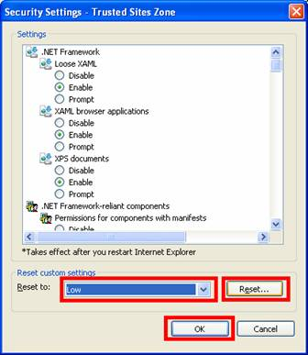

- Add the Server IP Compatibility View Setting
- Click Tools on IE toolbar, and then select Compatibility View Settings to start setting.
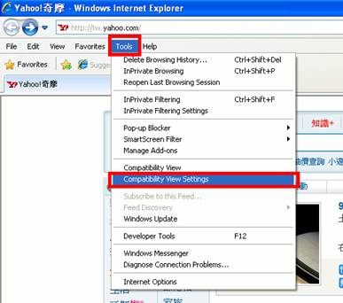
- Enter IP address of the system and click Add, then, the IP address will be set as compatibility views.
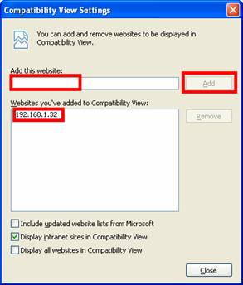
- After setting, the compatibility button will show on browser when connecting to the system.
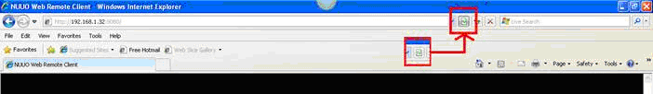

- If it still cannot work, try to use this step.
- Click Tools on IE toolbar, and then select Internet Options to start setting.
- Switch to Advanced tab, disable the Enable memory protection to help mitigate online attacks option of Security setting.
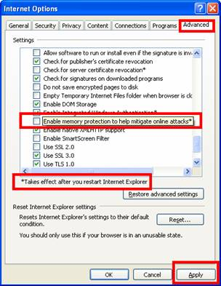
- Restart Internet Explorer after apply the new setting.

Appendix B – Minimum System Hardware Requirement

To ensure D-ViewCam system can maintain high video monitoring and recording performance, need to refer to the following table when establishing the system hardware.

Parameter definition:
M: parameter of resolution of camera.
Resolution | 5 M | 3 M | 2 M | 1 M | VGA / D1 | CIF
Value of M | 37 | 27 | 22 | 14 | 3 | 1
N: FPS of Camera
S=M*N

For example: 16 channel system
a) 8 camera at 1 Megapixel resolution with 10FPS
b) 3 cameras at D1 resolution with 15FPS
c) 5 cameras at CIF resolution with 30FPS

a) M=14; N=10, S=14*10=140
b) M=3; N=15, S=3*15=45
c) M=1; N=30, S=1*30=30
S of All Cam.=(8*140)+(3*45)+(5*30)=1405
Therefore, the minimum hardware requirement is C level.

Minimum Hardware Requirement
 | D | C | B | A
S of All Cam. | 2200~1400 | 1400~1050 | 1050~550 | 550~0
CPU | Intel Core I7 | Intel Core I5 | Intel Core 2 Quad Q9400 | Intel Core 2 Duo  E5300
RAM | 2 GB | 2 GB | 2GB | 1GB
Motherboard | Intel 55 or 57 chip or above, MB vendor Asus, Gigabyte or Intel with Intel Chipset recommended |  | Intel 35 or 33 chip or above, MB vendor Asus, Gigabyte or Intel with Intel Chipset recommended
Display card | ATI Radeon 4650 , nVIDIA GeForce GF-9600 or above (ATI recommended)
Ethernet | 100 baseT or above, Gigabit LAN recommended
Hard Disk | 250 GB or above
OS | MS Windows XP pro SP3 / 2003 / Vista SP1/ Win 7

